Project information
CALL FOR PROPOSALS | 2
e-MS Code: | RORS-241
PRIORITY AXIS: | 1 Employment promotion and services for an inclusive growth
OBJECTIVE: | 1.2 Health and social infrastructure
PROJECT TITLE: | Healthy aging and dementia - better life
ACRONYM: | HEAD
DURATION: | 29.05.2019 – 28.11.2021 (30 Months)
Interreg-IPA  FUNDS CONTRACTED: | €999.243,00
TOTAL FUNDS CONTRACTED: | €1.175.580,00
ABSORPTION RATE (%): | 97,13%
PROJECT OBJECTIVE(S): | - Improve the quality of care for people with dementia.  - Identify the risk factors of dementia in the border region.  - Increase awareness and understanding of dementia.
SHORT DESCRIPTION OF THE PROJECT: | The specific goals of the project were: to increase the capacity of the hospital in Vrsac, Serbia, to identify the significant risk factors for dementia in the border region, and to reduce the stigmatisation and social exclusion risk of dementia patients. The project's main output was constructing a residential facility dedicated to preventing, diagnosing, treating and caring for patients with dementia in Vrsac and equipping the health care institution in Resita with modern equipment for the prevention, diagnosis and treatment of dementia.  In Vrsac, a garden was built to provide a safe space for people with dementia to go outdoors, enjoy nature, socialise or perform other external activities. Nature is included in the new therapeutic approach in Serbia, contributing to their health and well-being. The project created the conditions for more efficient treatment of dementia and significantly improved the lives of patients and their families.
DEGREE OF ACHIEVEMENT OF INDICATORS: | 13.329 citizens involved in project activities in cultural, social health care services. (128,41%)  2 investments in health care and social services infrastructure. (100%)  600 disadvantaged persons involved in projects activities. (100%)  154.492 people covered by improved health services. (110,35%)
RESULTS ACHIEVED: | 13.221 persons benefited from public campaign regarding awareness of dementia. (128,11%)  108 health care professionals improved knowledge and practical skills. (180%)  1 construction of Dementia Health Care Center in Vrsac Serbia. (100%)  1 set of equipment provided for the Health Care Center in Resita, Romania. (100%)  600 dementia patients from both counties were included in a science research study - identifying dementia risk factors. (100%)  154.492 people benefitted from improved health care services in border area. (110,35%)

Partnership information
 |  | COUNTRY | COUNTY/DISTRICT | BUDGET(EURO) | CONTACT DETAILS
LEAD PARTNER: | Special Hospital for Psychiatric Diseases "Dr Slavoljub Bakalovic" Vrsac | SERBIA | Juznobanatski | 697.305,00 | Podvrsanska no. 13, 26300, Vrsac  npbvrsac@gmail.com
PARTNER 2: | County Emergency Hospital Resita | ROMÂNIA | Caras-Severin | 478.275,00 | 18 Fagarasului, 320210 Kikinda  sjuresita@gmail.com

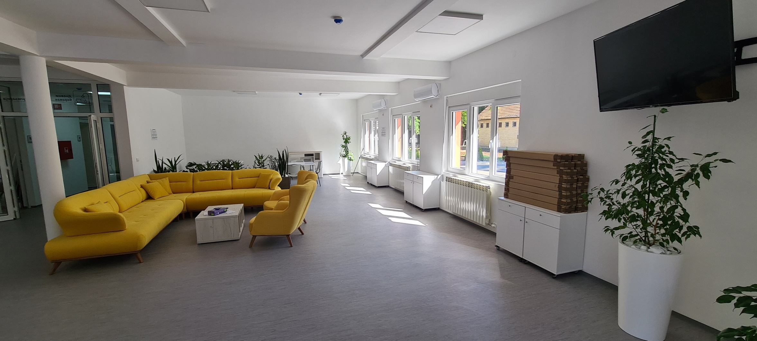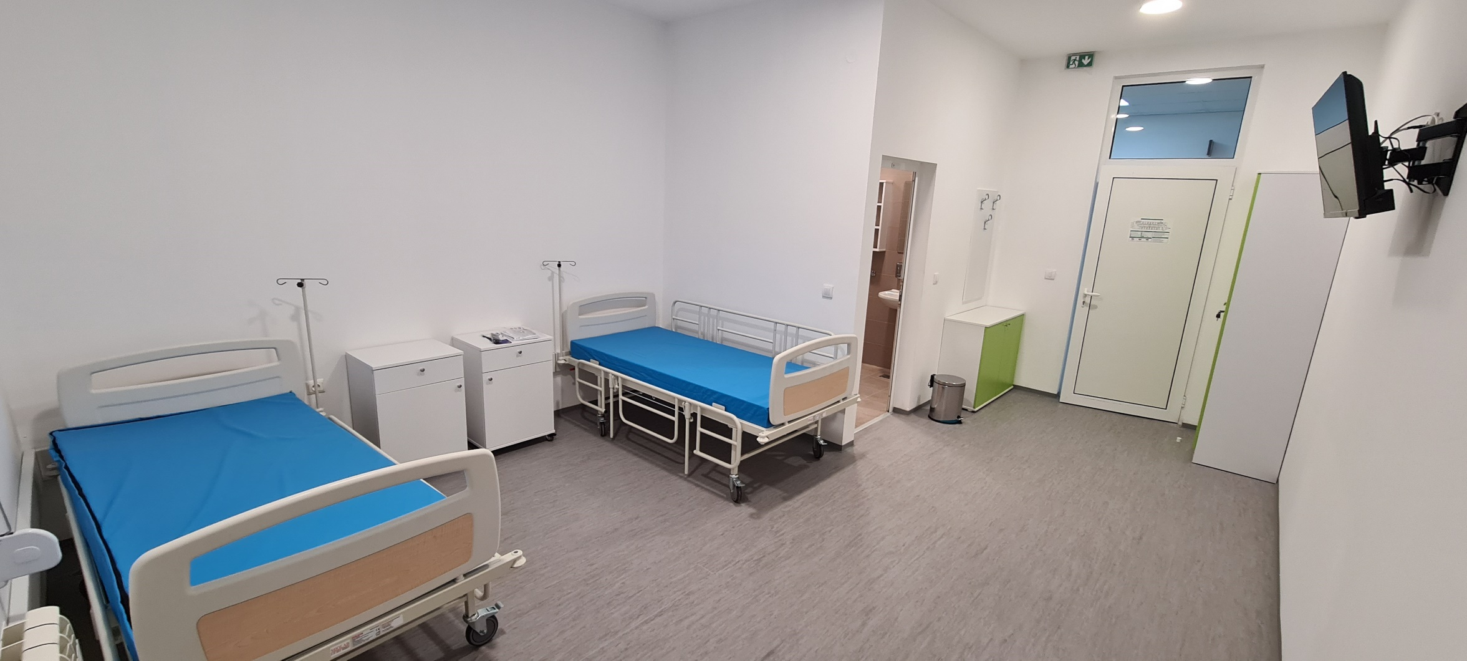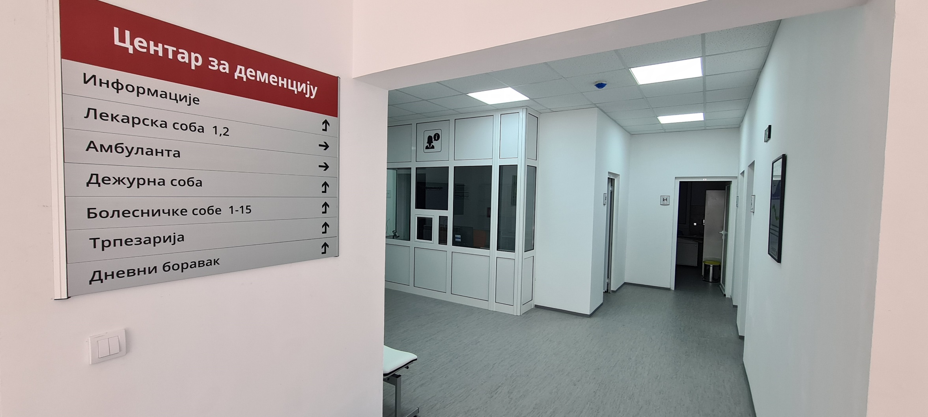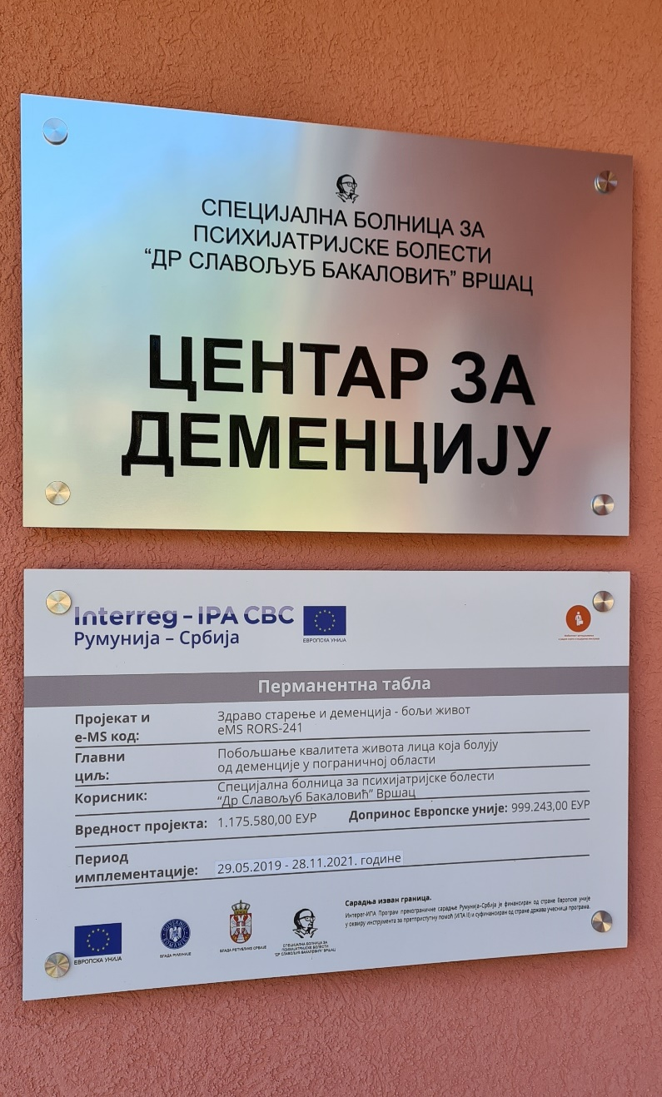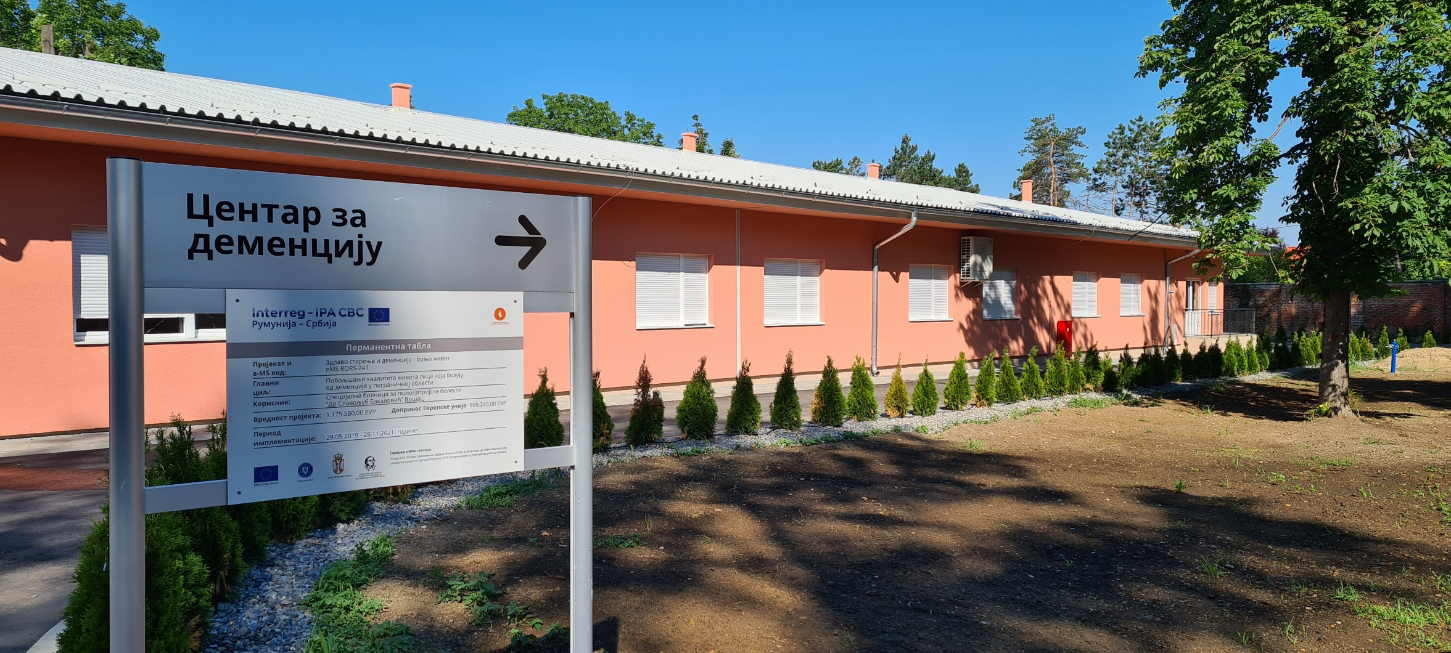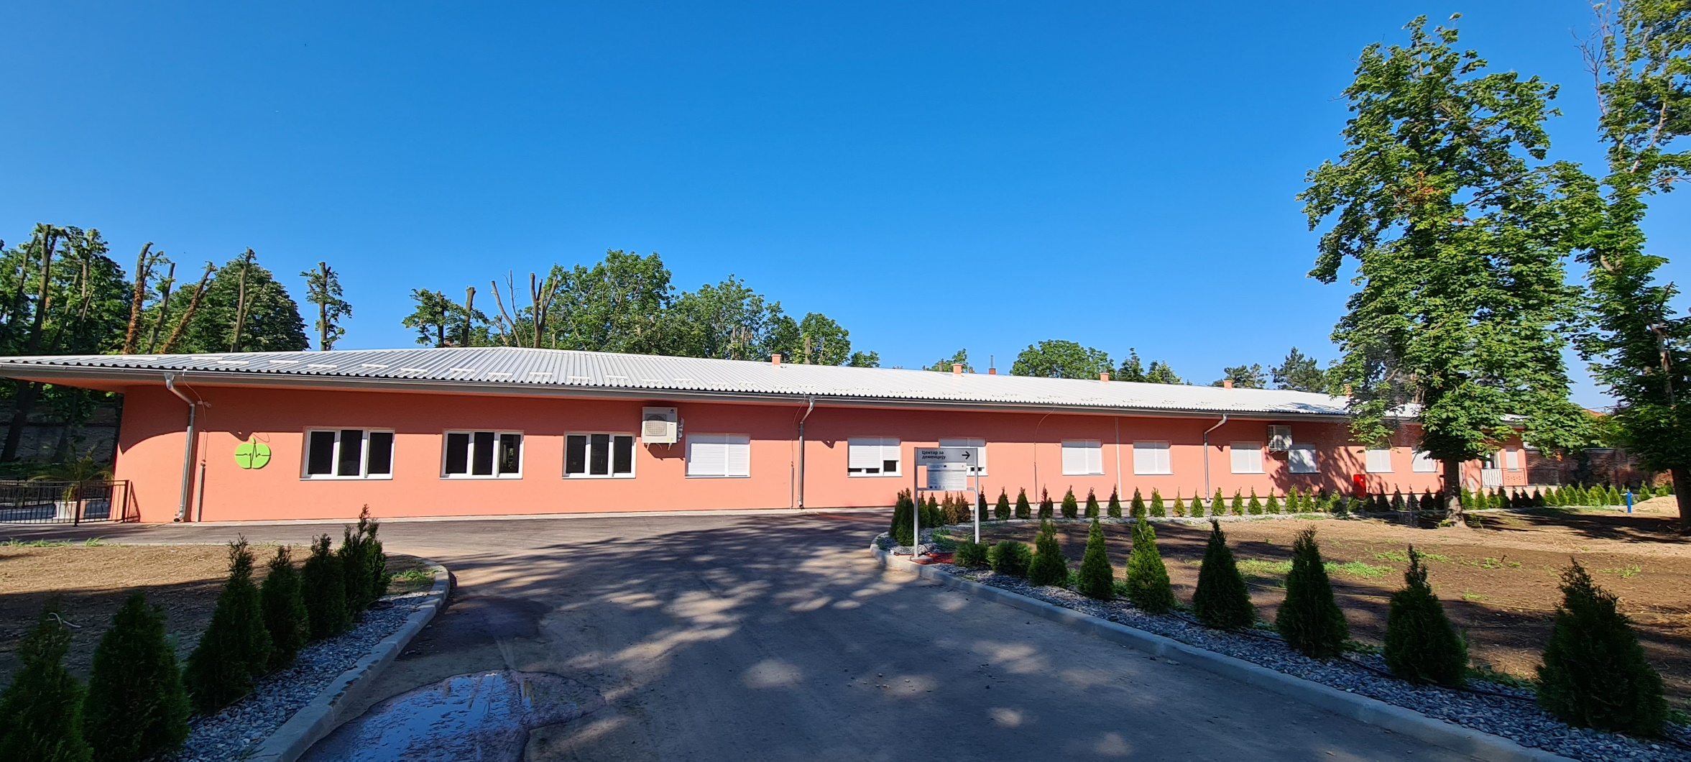

the implementation period (including extensions)
total funds spent/total funds contracted *100

