Project information
CALL FOR PROPOSALS | 1
e-MS Code: | RORS-24
PRIORITY AXIS: | 4 Attractiveness for sustainable tourism
OBJECTIVE: | 4.2 Capacity building initiatives for the improvement of quality and innovation of tourism services and products
PROJECT TITLE: | Challenge and opportunity for tourism development in our common county
ACRONYM: | -
DURATION: | 05.05.2017 – 04.07.2018 (14 months)
Interreg-IPA  FUNDS CONTRACTED: | €196.894,42
TOTAL FUNDS CONTRACTED: | €231.640,50
ABSORBTION RATE (%): | 77,74 %
PROJECT OBJECTIVE(S): | Support the development of cross-border tourist offers.  Support the creation of a common brand and the improvement of quality standards of the services offered.  Trainings for the improvement of tourism services.
SHORT DESCRIPTION OF THE PROJECT: | The Danube region is characterised by a broad heritage of dense and diverse histories, cultures, ethnicities, religions, markets, societies and states. In line with international conventions in the field of culture (with special reference to the UNESCO Conventions) culture can promote values of inclusiveness, openness, and acceptance of the other based on mutual respect. Regions involved in the project offer tourism destinations with high potential. Each of the partners in this project share various “bundles” of territorial challenges: tourism promotion for seniors; design and implementation of IT applications for information and tourist orientation; reviving the traditional and creating one new manifestation by promoting the "Gastronomy FAIR” in order to increase the number of tourists; activities to promote the spirit of togetherness of the population in our region; nature, culture and Danube offer special experiences for potential tourists. For these reasons, the overall objective of the project was cross-border cultural cooperation and mutual knowledge, with direct impact on valuing and highlighting the industrial and cultural heritage common to the two geographical areas of the project.
DEGREE OF ACHIEVEMENT OF INDICATORS: | Cross border cooperation structures/ initiatives supported in the field of tourism - 100%;  Number of participants attending training initiatives - 100%;  Partnerships for the exchange of good practices and the promotion of joint initiatives established – 100%;
RESULTS ACHIEVED: | 3 gastronomic fairs organized in Resita (Romania), Veliko Gradiste (Serbia) and Moldova Noua (Romania);  1 IT application containing information about touristic objectives in the project region created (www.discoverbanat.eu);  7 hiking trails marked and equipped with specific furniture;  3 training activities concerning tourism, gastronomy and folkloric dance organized;  1 film presenting health tourism and religion produces;  150 CDs presenting the Romanian and Serbian touristic objectives produced;  3 study tours organized.

Partnership information
 |  | COUNTRY | COUNTY/DISTRICT | BUDGET(EURO) | CONTACT DETAILS
LEAD PARTNER: | Activity Foundation | Romania | Caras-Severin | 103.036,50 | 13 Pandurilor Street, 320085, Resita  potoceanunadia@gmail.com
PARTNER 2: | Municipality of Veliko Gradiste | Serbia | Branicevski | 62.643,00 | 1 Zitni Square, 12220, Veliko Gradiste  sovgradiste@ptt.rs
PARTNER 3: | Moldova Noua City Hall | Romania | Caras-Severin | 65.961,00 | 26 Nicolae Balcescu Street, Moldova Noua  pmn_invest@yahoo.com

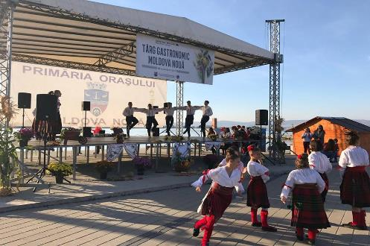
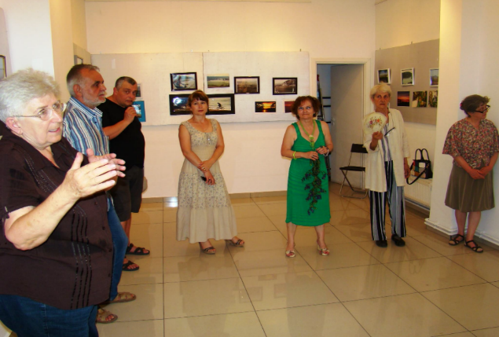
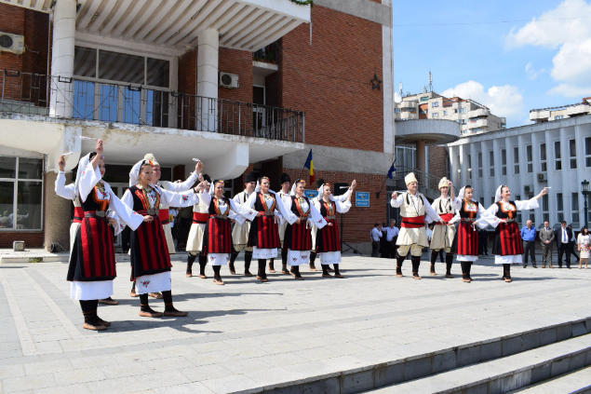
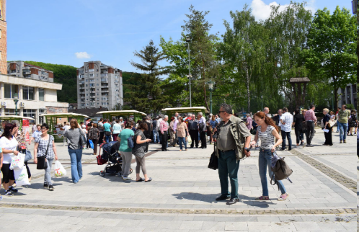

the implementation period (including extensions)
total funds spent/total funds contracted *100
indicators and level of achievement against targets set

