Project information
CALL FOR PROPOSALS | 2
e-MS Code: | RORS-232
PRIORITY AXIS: | 2 Environmental protection and risk management
OBJECTIVE: | 2.1 Environmental protection and sustainable use of natural resources
PROJECT TITLE: | Development of the intervention infrastructure and common services in case of emergency situations in the cross-border area Drobeta Turnu Severin - Kladovo
ACRONYM: | Development
DURATION: | 30.07.2019 - 29.07.2021 (24 Months)
Interreg-IPA  FUNDS CONTRACTED: | €607.145,61
TOTAL FUNDS CONTRACTED: | €714.288,96
ABSORPTION RATE (%): | 97,70
PROJECT OBJECTIVE(S): | Strengthening the preparedness and intervention capacity in case of future possible emergency situations for the Municipalities of Drobeta-Turnu Severin, Romania and Kladovo, Serbia and developing an awareness towards climate changes and its link towards risks development.  Endowment of the two municipalities with the proper intervention equipment for emergency situations and preparedness in case of emergency situations.  Raising awareness of the population from the two cities regarding the climate change in the cross-border area and the link to disaster risks and development.
SHORT DESCRIPTION OF THE PROJECT: | Disasters strike unexpectedly worldwide and frequently cause significant damage to populations and infrastructure. Numerous countries have had to deal with the tragic consequences of natural or man-made disasters in the last two decades. As the Danube Strategy 2020 stipulates, there are many natural and industrial risk sites in the Danube Basin.  In this context, the project aimed to bring together the two municipalities to share their experience with emergencies they have been facing for an extended time and help each other strengthen their preparedness and intervention capacity in case of possible future situations.  The two municipalities have a specialized office each: the Emergency Situations Voluntary Compartment of the Municipality of Drobeta-Turnu Severin and the Municipal Emergency Headquarters of the Municipality of Kladovo, with thematic competencies regarding civil protection.  Since its creation in 2005, the Emergency Situations Voluntary Compartment of the Municipality of Drobeta-Turnu Severin has accumulated experiences in solving over 300 flood interventions alongside the county inspectorate, over 100 vegetation fires, and 2 landslides.  In 2014, the Municipality of Kladovo suffered from catastrophic floods. Heavy rainfall caused heavy floods, landslides and the demolition of bridges on the main and local road infrastructure. There was an interruption in the communications of the electronic, fixed and mobile telephone network, road traffic from Kladovo to Niš and Belgrade and in the supply of electricity and water. Unfortunately, besides great material damage, there were human victims.  The Emergency Situation Headquarters declared a state of emergency. With all its available resources, equipment and machinery, and the help of the army, donors and volunteers, pumps of greater capacity from other locations in Serbia were borrowed to restore the natural order of things.  Therefore the major problem that the project was trying to solve is the lack of proper specific intervention vehicles, types of machinery and equipment from both partners for the preparedness and intervention capacity in case of future emergency situations in the cross border area. Also, through the proper specific equipment, the two municipalities aim for a better response in the sector of flood protection.  The second important objective of the project was to organize seminars for the population of the two cities to raise awareness in case of emergency situations.
DEGREE OF ACHIEVEMENT OF INDICATORS: | Infrastructure, equipment built/ installed/ modernized in the field of cross border services for environmental protection:  - 91 equipment purchased through the project for the two partners.  Participants to project initiatives and events for information and awareness rising:  - 208 participants to the project awareness raising seminars with the theme of climate change.  Population benefiting from flood protection measures:  - 3.333 people from the area benefiting from the purchased emergency situation equipment.
RESULTS ACHIEVED: | 2 awareness raising seminars were organized in Kladovo with 102 participants (102%)  2 awareness raising seminars were organized in Drobeta-Turnu Severin with 106 participants (106%)  37 equipment purchased for the Municipality of Drobeta-Turnu Severin (100%)  54 equipment purchased for the Municipality of Kladovo (100%)  Office equipment was purchased for the Municipality of Drobeta-Turnu Severin and Municipality of Kladovo (100%)

Partnership information
 |  | COUNTRY | COUNTY/DISTRICT | BUDGET(EURO) | CONTACT DETAILS
LEAD PARTNER: | Municipality of Drobeta Turnu Severin (UAT) | ROMANIA | Mehedinti | 449.988,00 | Maresal Averescu no. 2, 220131, Drobeta Turnu Severin  nod_2006@yahoo.com
PARTNER 2: | Municipality of Kladovo | SERBIA | Borski | 264.300,96 | Kralja Aleksandra no. 35, 19320, Kladovo  mnovakovic@kladovonet.com

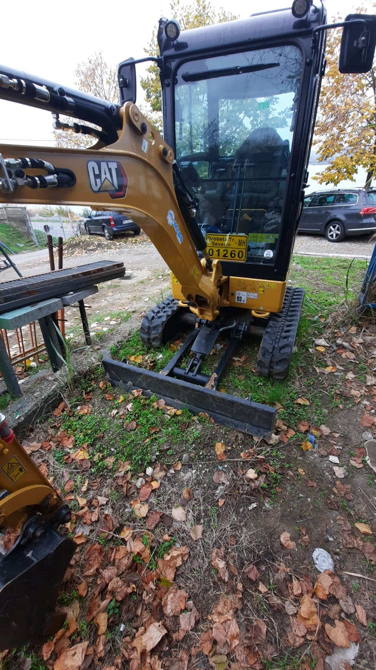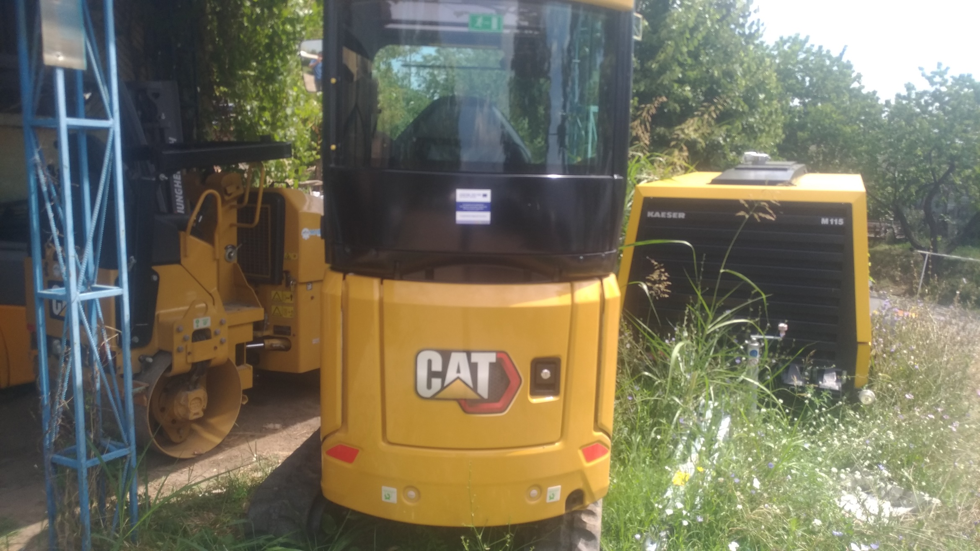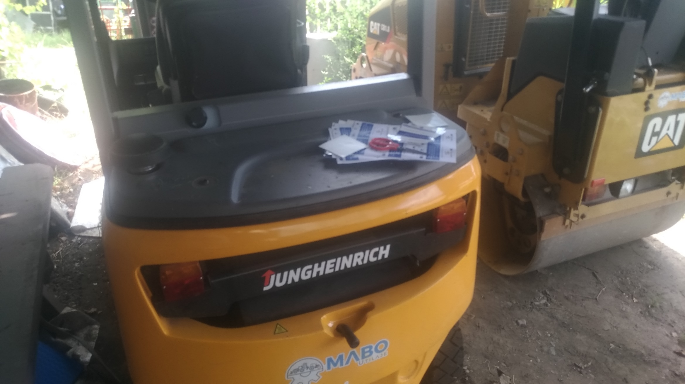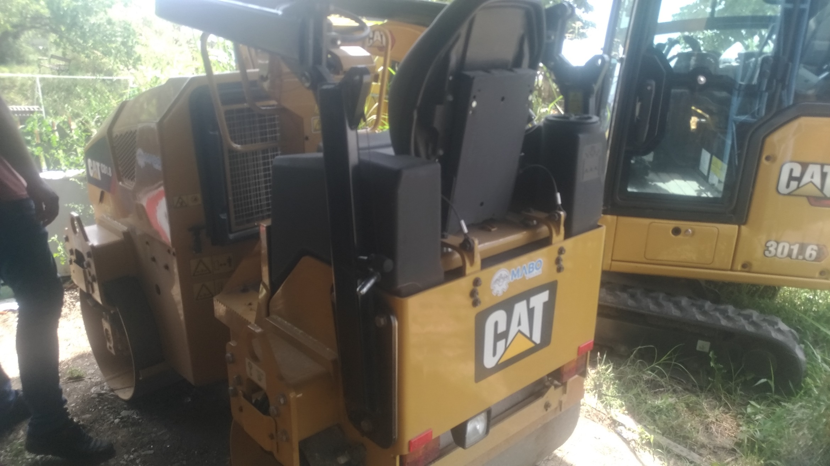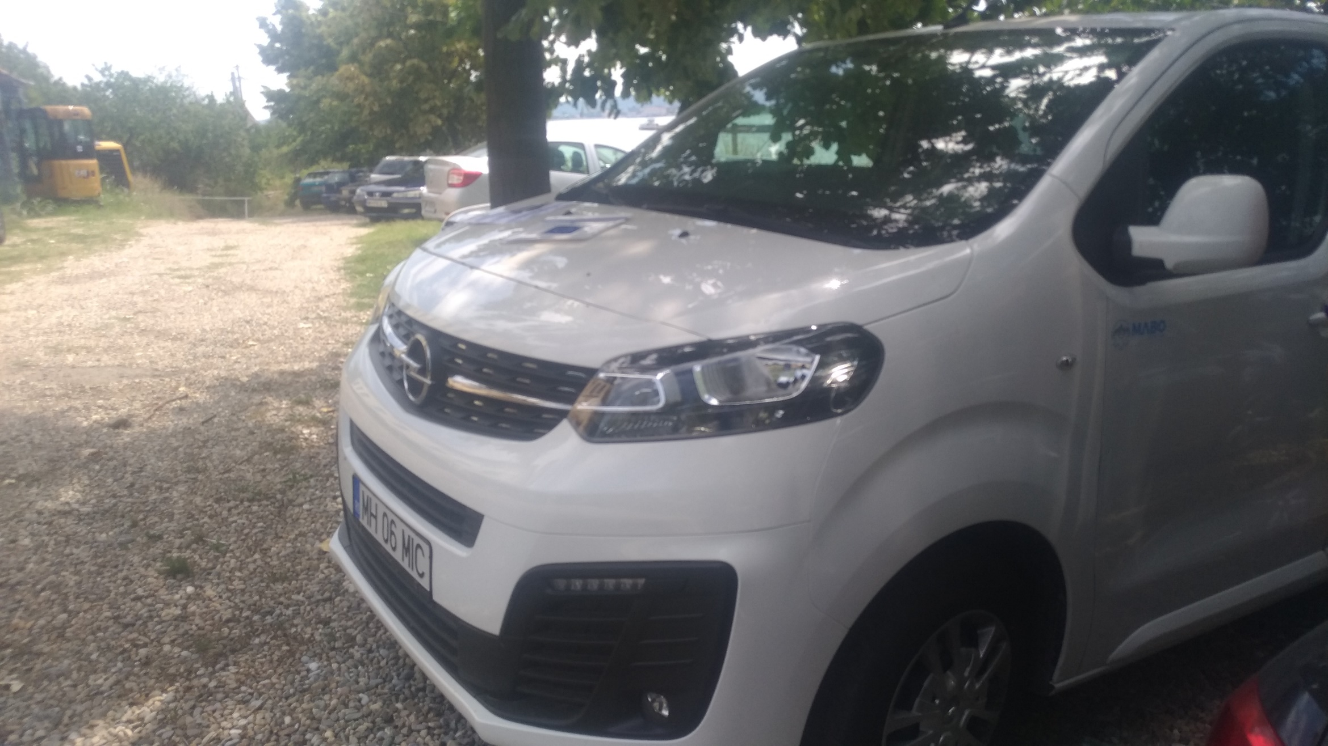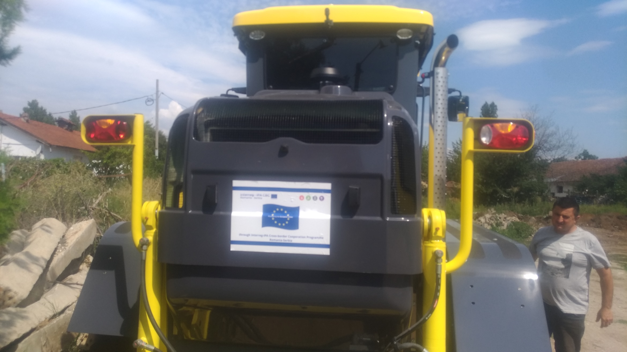

the implementation period (including extensions)
total funds spent/total funds contracted *100

