Project information
CALL FOR PROPOSALS | 1
e-MS Code: | RORS-23
PRIORITY AXIS: | 1 Employment promotion and basic services strengthening for an inclusive growth
OBJECTIVE: | 1.3 Social and cultural inclusion
PROJECT TITLE: | Cross-border football for social inclusion
ACRONYM: | CB FOOTINC
DURATION: | 05.05.2017 – 04.11.2018 (18 Months)
Interreg-IPA  FUNDS CONTRACTED: | €182.427,00
TOTAL FUNDS CONTRACTED: | €214.620,00
ABSORBTION RATE (%): | 90,34 %
PROJECT OBJECTIVE(S): | Establish of joint cross-border actions in the field of football in order to promote sport and healthy living.  Theoretical and practical development of sporting activities and competencies.  To provide necessary goods and sport equipment to facilitate social inclusion.
SHORT DESCRIPTION OF THE PROJECT: | The main benefit of the project was the strengthening role of sports in steady and sustainable development of the region. Stronger relations of the two clubs and of people living in these two settlements of the Banat region can be considered a significant result. The activities realized within this project brought numerous results even in the social sector, since they provided a leisure activity to the youth that helped them preserve their health and prevented them from various forms of deviant behaviour (drug use, crime). With joint preparation and competition, the participating sportsmen showed a good example to other young people who attended the events and may want in the future to participate in sports activities, and thus they contributed to sustaining the inhabitants’ health in the region. On the educational level, this project enabled the transfer of valuable knowledge and professional sport techniques across the border. In addition, the project invested in the training of sports trainers and physical education teachers, thus bringing the sports practiced at the two clubs to a higher professional level. Finally, from an economic viewpoint, the project helped improve the base of sporting resources, especially for the economically less advantaged Serbian side of the project. By supplying the two clubs with primary sport goods and equipment, this project provided a crucial help for their further development.  The cross-border approach of the project is expressed in improved people-to-people relations. Project activities were realized on both sides of the border through close cooperation of project partners. Direct contacts between the partners but also between wider target groups were achieved on both sides of the border, having football as a connecting factor. Getting to know the methods and the experience of the “other side”, strengthening the existing relationships, and thus eliminating the dividing role of the borderline, was achieved through workshops, joint training camps and joint championships organized on both sides of the border.
DEGREE OF ACHIEVEMENT OF INDICATORS: | 1 joint action targeting vulnerable groups (youth, women, disabled, ethnic minorities) established for the prevention of early school leaving, for cultural inclusion – 100 %  471 participants in projects promoting gender equality, equal opportunities and social inclusion across borders – 112 %
RESULTS ACHIEVED: | Joint training camp for juniors (15+15 players) in Dumbrava, Romania; in Totovo Selo, Serbia the training camp for adolescents was organized (15+15 players), the joint training camp, together for the juniors (15+15 players) and adolescent teams (15+15 players).  The two partners had supplied their teams with sets of football costumes (120 costumes) and balls (40). The lead beneficiary from Romania had equipped the sport hall from Dumbrava with a complete set of fitness equipment, while the project partner from Serbia delivered mobile dressing cabins, each consisting of 3 parts: specific sanitary cabins, dressing containers and dressing rooms for referees. These containers were placed next to football playground from Totovo Selo, so the players, referees and other professional staffs would have a direct accessibility to the field.  The partners organized a mini championship of six-member teams of adolescents -football competition between 4 boys` teams: Dumbrava, Faget, Orom and Totovo Selo; and a competition between 2 girls` teams from Dumbrava and Kanjiza.  A mini championship of six-member teams of juniors was organized - between 6 teams from Dumbrava, Faget, Tomesti and Totovo Selo, Hajducovo.  The adult matches were played by 31 football players from the 2 involved localities: 15 from Dumbrava and 16 from Totovo Selo.  1 social media project profile was made:  https://www.facebook.com/Interreg-IPA-CBC-Cross-border-football-for-social-inclusion-743900782480121/?hc_ref=ART0MqDApTjvGQXIQMjCJzW2VCE2yJy3Fbj44Qb5IUf0lgKxy04cTBh4XuG6SN8yAEA&fref=nf)

Partnership information
 |  | COUNTRY | COUNTY/DISTRICT | BUDGET(EURO) | CONTACT DETAILS
LEAD PARTNER: | Dumbrava Commune | ROMÂNIA | Timiş | 99.960,00 | 336 Dumbrava, 307155, Timis County, Romania  primardumbrava@yahoo.ro
PARTNER 2: | Sports Association Academy Njers Istvan | SERBIA | Severnobanatski | 114.660,00 | 4 Košutova, 24427, Totovo Selo, Serbia  utasij@tippnet.rs

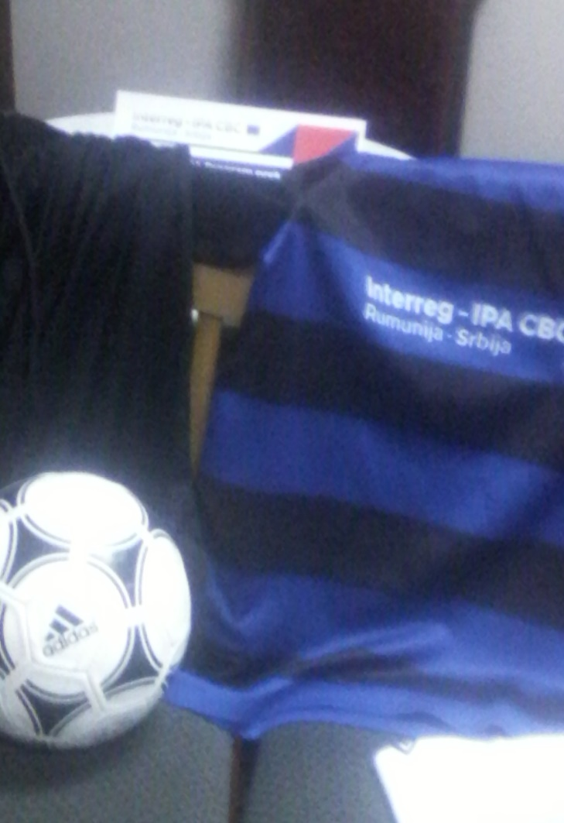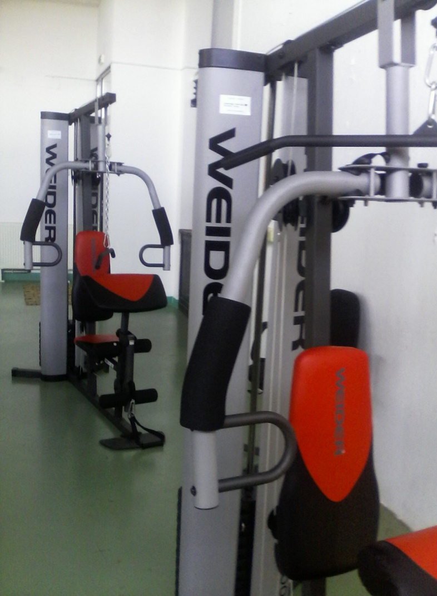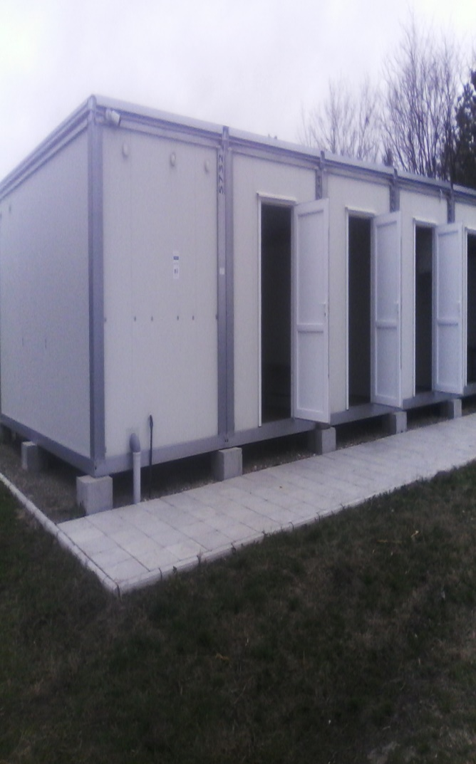

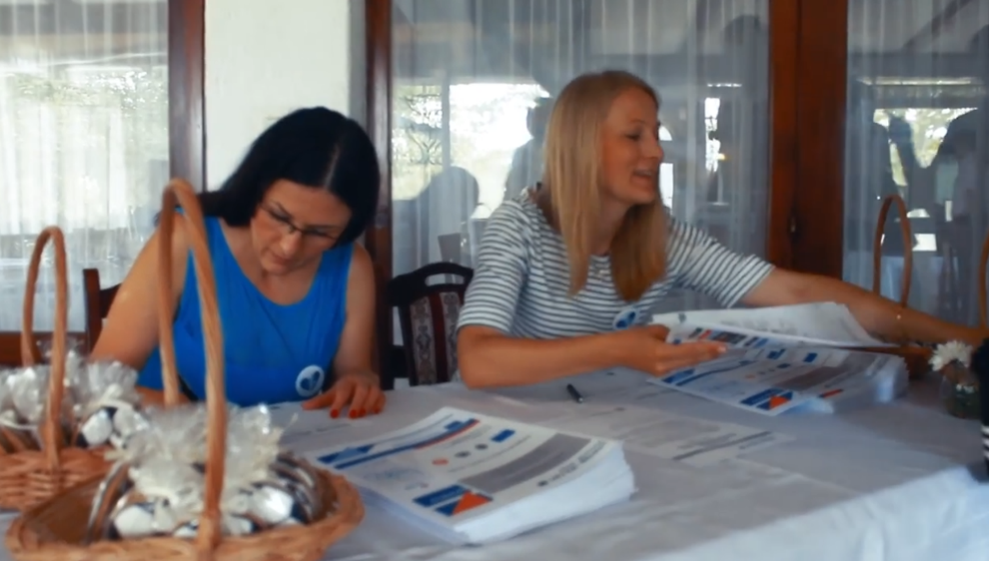
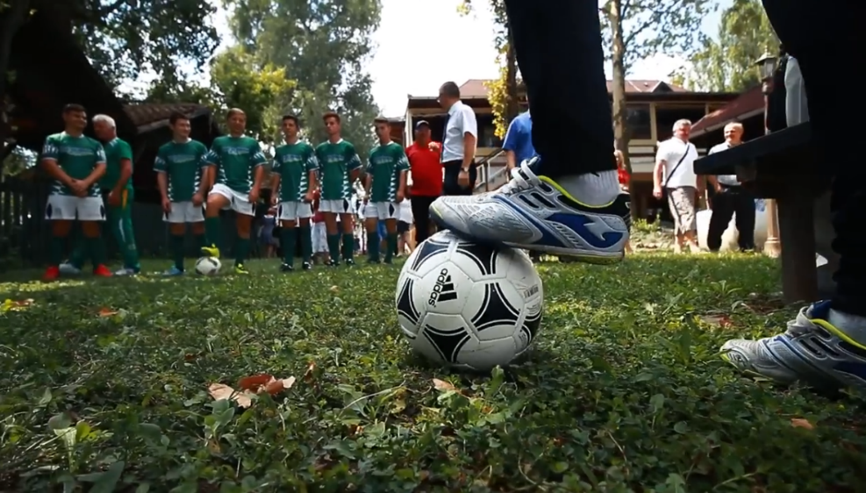
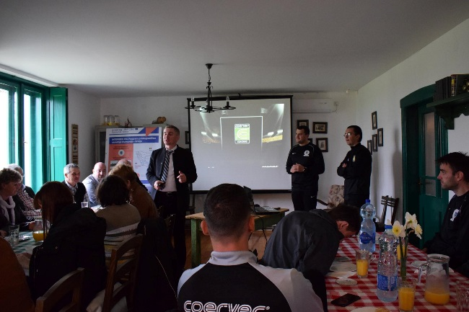
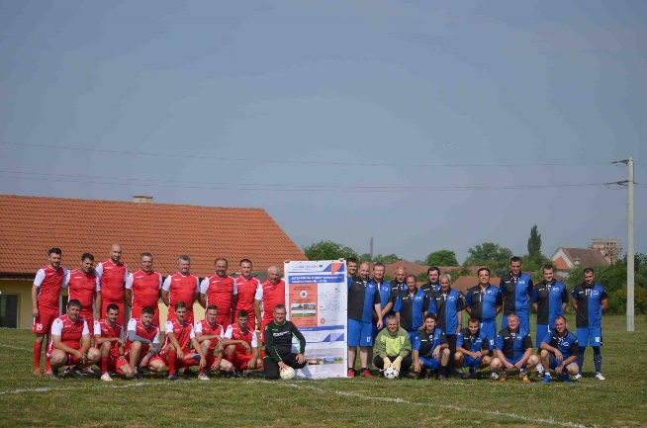
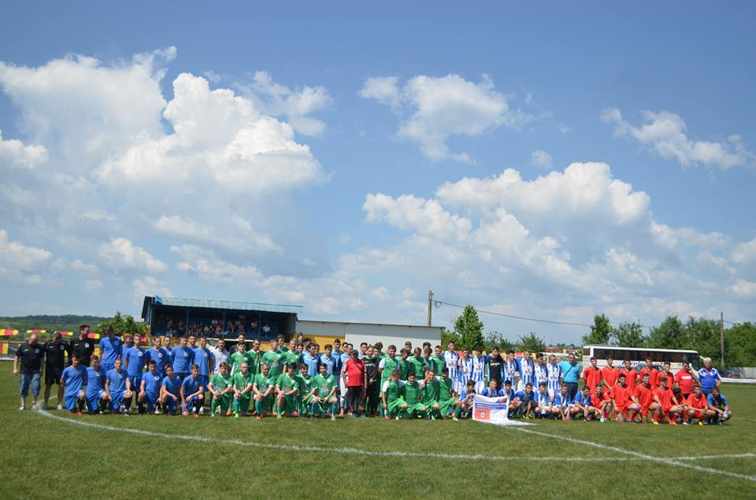

the implementation period (including extensions)
total funds spent/total funds contracted *100
indicators and level of achievement against targets set

