Project information
CALL FOR PROPOSALS | 2
e-MS Code: | RORS-224
PRIORITY AXIS: | 1 Employment promotion and services for an inclusive growth
OBJECTIVE: | 1.3 Social and cultural inclusion
PROJECT TITLE: | Banat Schoolingua
ACRONYM: | BASCOL
DURATION: | 27.08.2019 - 26.08.2021 (24 months)
Interreg-IPA  FUNDS CONTRACTED: | €185 817.60
TOTAL FUNDS CONTRACTED: | €218 608.95
ABSORPTION RATE (%): | 68%
PROJECT OBJECTIVE(S): | The overall objective was to contribute to the quality of life of youth in the border area, by raising the quality of education for students of secondary schools and increasing educational, social, and cultural exchanges.
SHORT DESCRIPTION OF THE PROJECT: | The common challenge was finding an innovative response to overcome language barriers by establishing a multifunctional language classroom in Vrsac, Serbia and Timisoara, Romania, to improve high-school students' capacities and prepare them to get more effective once they enrol in universities and get employed. The necessity of providing an accessible, high-quality education is of great importance for the population residing in the cross-border area to establish a sustainable joint platform and enhance highly educated persons to take part as professionals in the vibrant cross-border market.  The overall objective was to contribute to the quality of life for youth in the border area by raising students' quality of education and increasing educational, social, and cultural exchanges. Through the project, mutual understanding was to be promoted as well as tolerance and respect for cultural diversity and innovative solutions for social problems of vulnerable groups (affected by and marginalized due to poverty or disability, i.e. youth, women, disabled, ethnic minorities etc.) by increasing educational effectiveness and availability, social challenges, and cultural exchanges among youth from Banat region.
DEGREE OF ACHIEVEMENT OF INDICATORS: | 1 a cross-border network of Centers for Language Studies was established. 100%  1 Campaign to raise the quality of students' knowledge, and success on admission tests at higher education institutions was organized. 100%  80 students from vulnerable groups acquired new knowledge on sociology and psychology. 100%  60 held debate club on youth life in the border region and social integration. 100%  240 held a series of knowledge quizzes. 100%
RESULTS ACHIEVED: | 1. cross-border Centers for Language Studies created. 100%  2. mother tongue workshops for students organized. 100%  3. workshops for students from vulnerable groups on the theme of sociology and psychology organized. 100%  4. knowledge quiz organized. 100%  5. debates organized. 100%  6. survey students final grade. 100%  7. promotion of higher education institutions realized. 100%  8. testing students. 100%  9. analysis of the success of students of both schools at higher education institutions. 100%

Partnership information
 |  | COUNTRY | COUNTY/DISTRICT | BUDGET(EURO) | CONTACT DETAILS
LEAD PARTNER: | Grammar School ”Borislav Petrov Braca” | SERBIA | Južnobanatski | 110.530,35 | Mihajla Pupina Street no 1, 26300, Vrsac  www.vrsackagimnazija.edu.rs  administracija@vrsackagimnazija.edu.rs  +381 13 836448
PARTNER 2: | Theoretical Grammar School “Dositej Obradovic” | ROMANIA | Timiş | 108.078,60 | B-dul Dragalina no 6, Timisoara  dobradovici@yahoo.com  0256491624

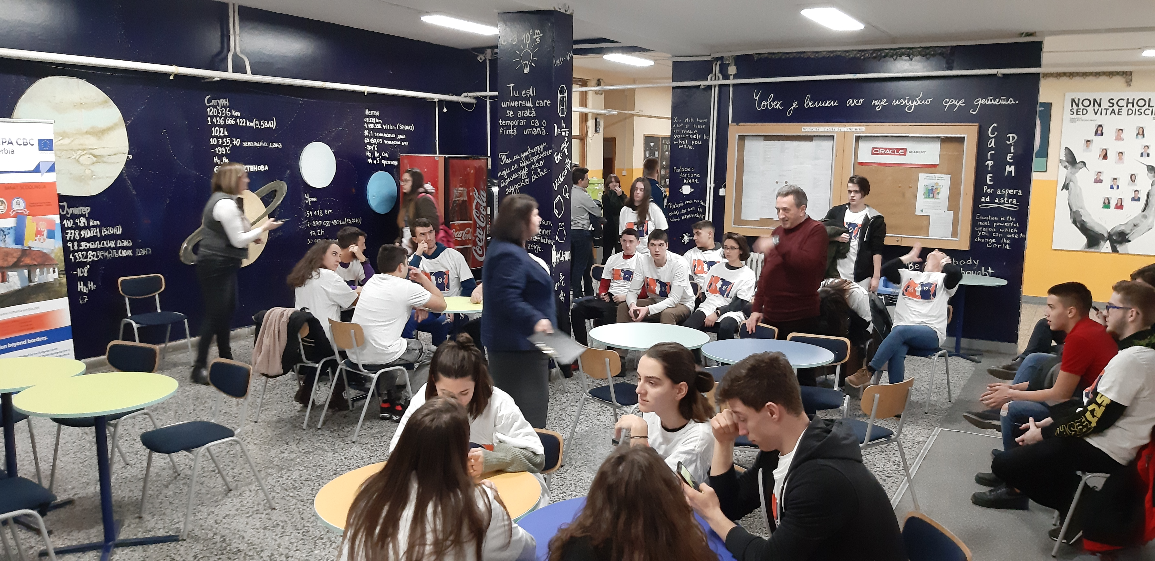

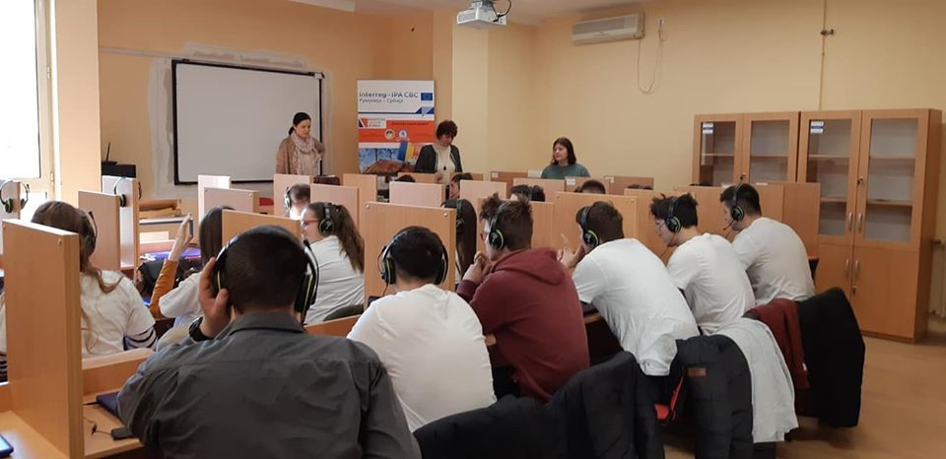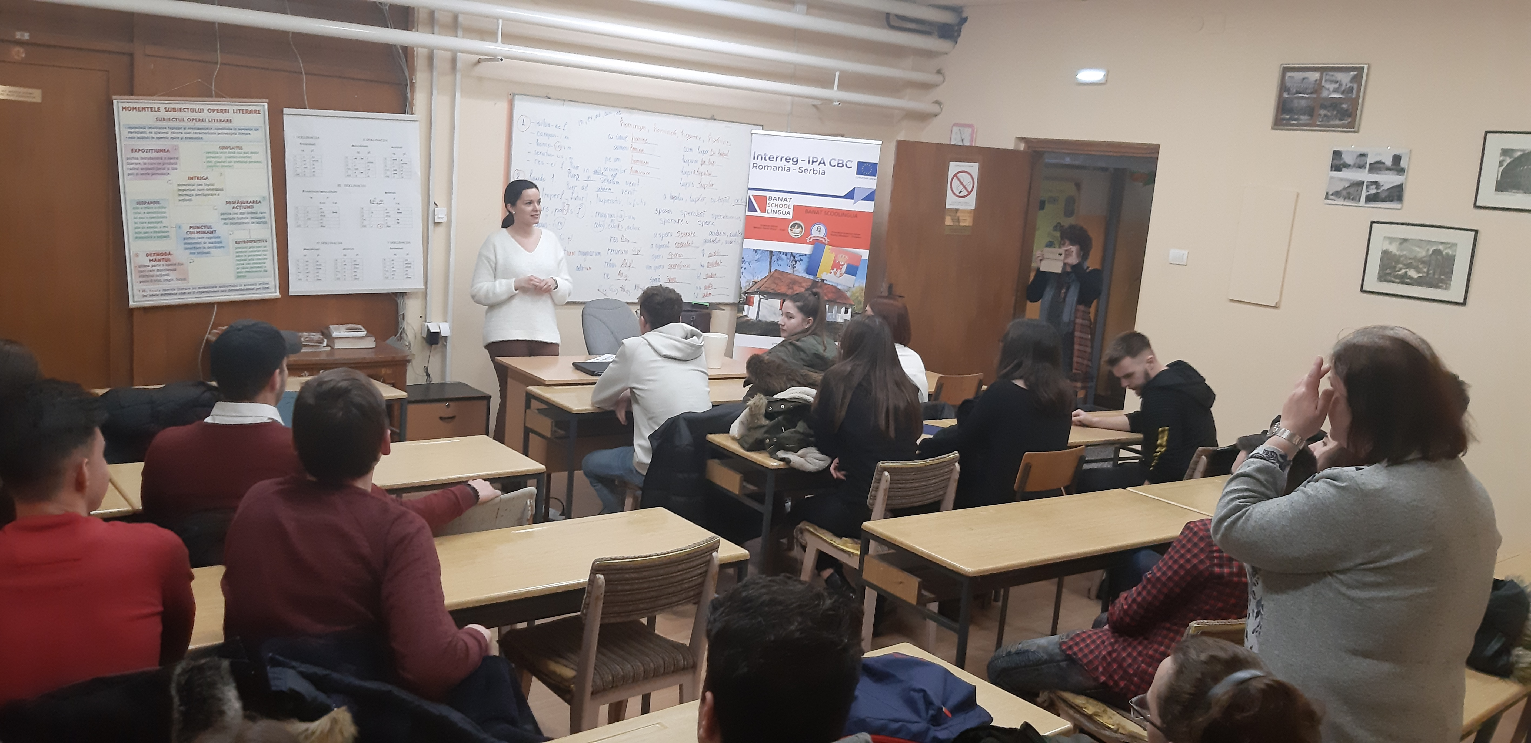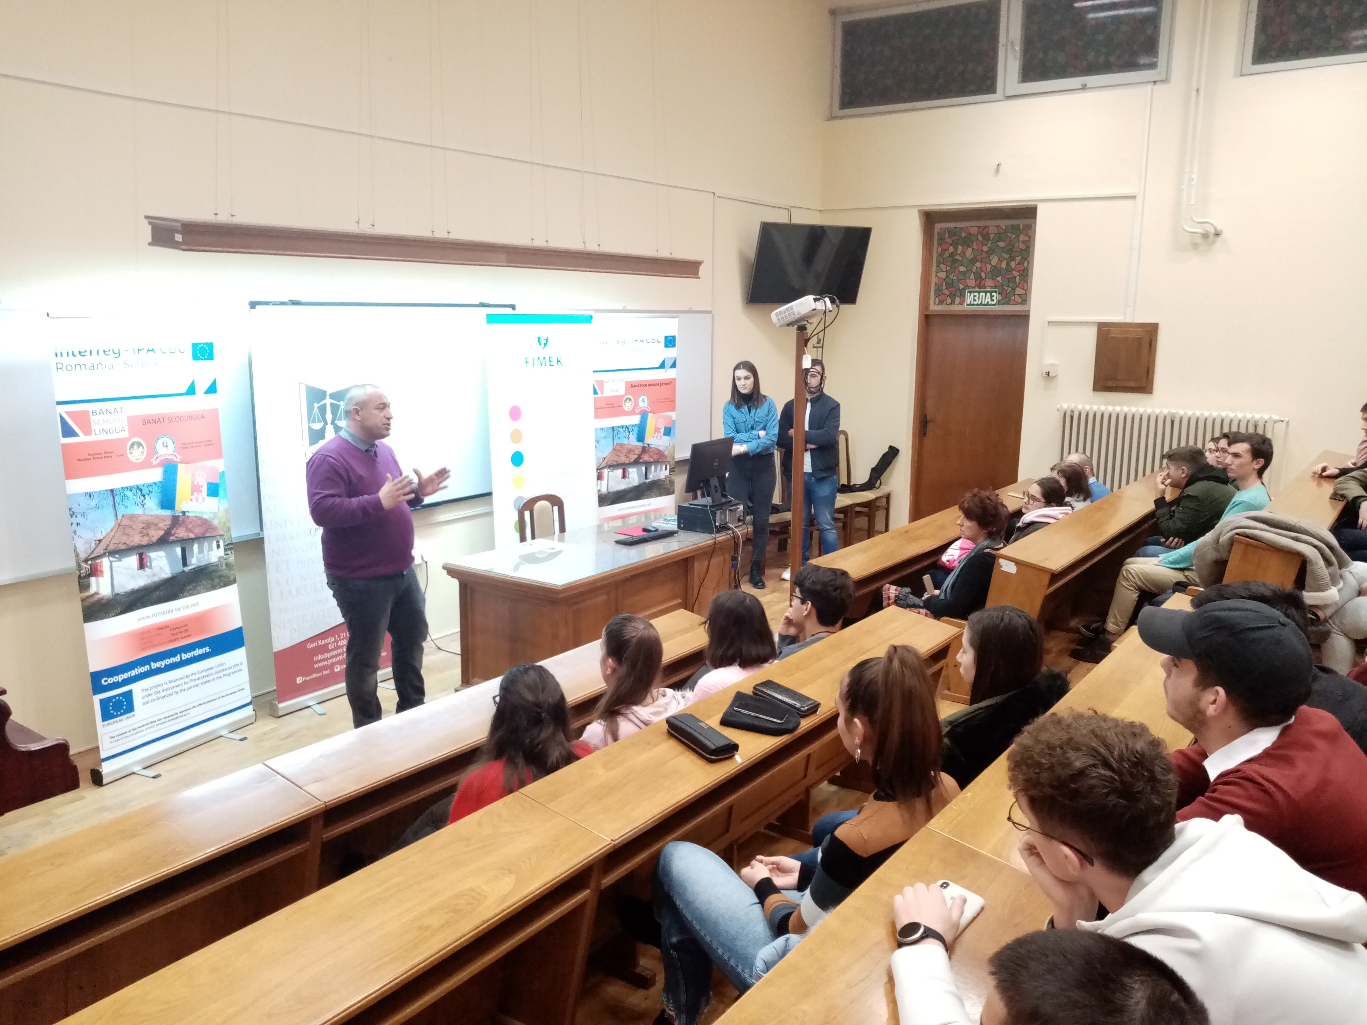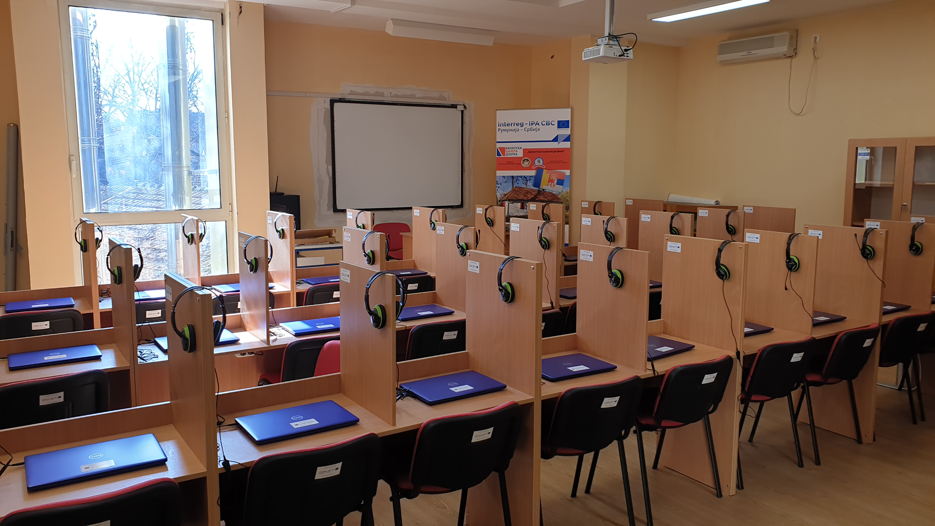

the implementation period (including extensions)
total funds spent/total funds contracted *100
indicators and level of achievement against targets set

