Project information
CALL FOR PROPOSALS | 1
e-MS Code: | RORS-20
PRIORITY AXIS: | 4 Attractiveness for sustainable tourism
OBJECTIVE: | 4.2 Capacity building initiatives for the improvement of quality and innovation of tourism services and products
PROJECT TITLE: | Local Heritage for Active Tourism in Banat
ACRONYM: | HerA
DURATION: | 19.05.2017 – 18.11.2018 (18 Months)
Interreg-IPA  FUNDS CONTRACTED: | €293.943,08
TOTAL FUNDS CONTRACTED: | €345.815,40
ABSORBTION RATE (%): | 90,11 %
PROJECT OBJECTIVE(S): | Defining and developing innovative touristic products to ensure the joint promotion of cross- border heritage and increase the attractiveness of tourism offer.  To develop cultural and touristic entrepreneurship in order to use socio-economic potential of the natural and cultural heritage.  Setting up cross border facilities for joint action and promotion of heritage and tourism potential.
SHORT DESCRIPTION OF THE PROJECT: | The overall objective of the project has been constructed starting from the need of better cross-border collaboration in tourism both in valorising regional and local cultural heritage, as potential resource for communitarian sustainable development, economic growth and social cohesion and also as social involvement and responsibility. Developing from an empiric and scientific approach, the project proposed a proactive involvement in communities from both sides of the border, while it enabled people to create bridges based on their shared heritage as well as to transform individuals on a personal level, taking into account criteria such as gender equality, environmental consciousness or social inclusion. The core activity package dealt with scientific research which laid the basis of further activities. After identifying well-kept traditions, local craftsmen and local arts and crafts, local cuisine and specificities, the project assisted communities’ in transforming their cultural resources into products that can attract tourists. By creating a tourist offer that includes local traditions and customs, folk crafts, traditional cookery, wines, the project increased the interest in cultural tourism in the Banat region of Romania and Serbia.
DEGREE OF ACHIEVEMENT OF INDICATORS: | 7 studies related to the implementation of selected projects or research and studies in the field of natural and cultural resources – 100%  50 participants attending training initiatives – 100%  1 joint action and communication instrument created – 100%  1 partnership for the exchange of good practices and the promotion of joint initiatives established - 100%
RESULTS ACHIEVED: | 7 research, studies and products in the field of heritage and tourism  50 trained persons  1 joint software platform created (https://hera.uvt.ro)  1 cross-border network for research, heritage and tourism created

Partnership information
 |  | COUNTRY | COUNTY/DISTRICT | BUDGET(EURO) | CONTACT DETAILS
LEAD PARTNER: | West University of Timisoara | ROMÂNIA | Timiş | 303.740,85 | 4 Vasile Pârvan Av., Timisoara  sorina.pautu@e-uvt.ro
PARTNER 2: | City of Kikinda | SERBIA | Severnobanatski | 29.566,95 | 12 Trg Srpskih Dobrovoljaca, 23300, Kikinda  sasa.tanackov@kikinda.org.rs
PARTNER 3: | National Museum of Kikinda | SERBIA | Severnobanatski | 12.507,60 | 21 Trg srpskih dobrovoljaca, 23300, Kikinda  lidijamil@gmail.com

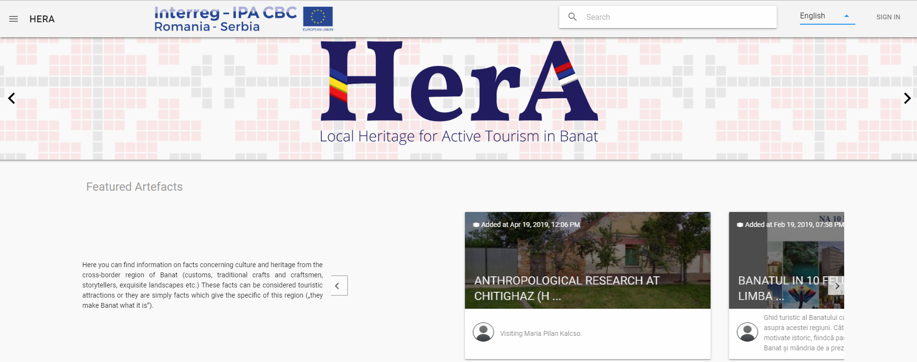

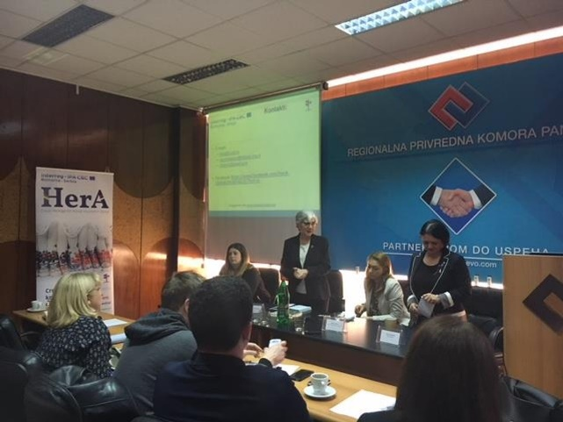
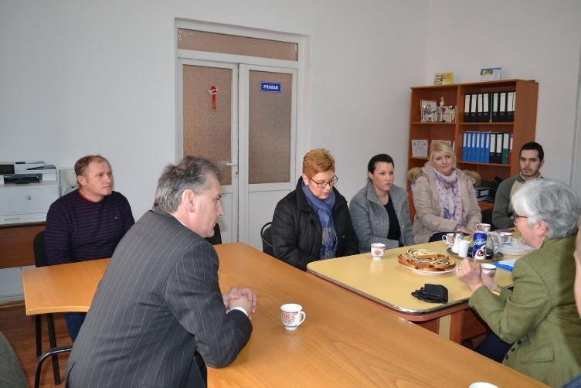

the implementation period (including extensions)
total funds spent/total funds contracted *100
indicators and level of achievement against targets set

