Project information
CALL FOR PROPOSALS | Strategic call for proposals
e-MS Code: | RORS-193
PRIORITY AXIS: | 1 Employment promotion and services for an inclusive growth
OBJECTIVE: | 1.2 Health and social infrastructure
PROJECT TITLE: | Romania-Serbia joint initiative against cancer in cross-border region: improved diagnosis and treatment of malignant tumours
ACRONYM: | ROSECAN
DURATION: | 10.08.2017 - 09.06.2022 (58 Months)
Interreg-IPA  FUNDS CONTRACTED: | €9.933.198,61
TOTAL FUNDS CONTRACTED: | €11.686.116,02
ABSORPTION RATE (%): | 77,10% (Will be updated after the final progress report is submitted and approved.)
PROJECT OBJECTIVE(S): | - To develop, improve and modernize diagnosis methods for cancer by extending the network between hospitals in the Romania-Serbia border region through the implementation of telediagnostic software and the upgrade of existing IT equipment.  - To transform and develop surgical treatment methods and transfer knowledge between specialists.  - To develop an evidence-based cancer treatment policy on European best practices enabling and supporting national programmes in both countries devoted to personalized treatment in cancer to improve diagnostic.
SHORT DESCRIPTION OF THE PROJECT: | Health is one of the most vital aspirations of today and is closely and inextricably linked to economic and social development. It is an inalienable right of all people and must be understood as “a complete welfare of physically, mentally and socially” and not just the absence of disease or infirmity. One of the common territorial challenges shared by the border region of the Romania-Serbia Programme area is the prevalence of cancer among the population as one of the leading causes of death, especially when we consider the ageing of the population, which is an additional factor of the high occurrence of malignant diseases.  The overall objective of the project is to foster collaboration in the field of oncology between medical institutions on the two sides of the border to provide access to modern and efficient specific healthcare services for all oncologic patients resident in the region, to improve their lifespan/survival/life expectancy and quality of life.  The team based the project on the personalized medicine concept, which is widely accepted and used in developed countries but is still at an early stage in Romania and Serbia. It represents state-of-the-art cancer diagnosis and treatment for countries like the USA, the UK and Germany, which are running even national programmes in the field.  Even though the number of patients affected by malignant diseases has continuously increased in the last decades, healthcare development in the region couldn’t catch up with growing treatment and diagnosis needs. Modernization of equipment, improved knowledge base and networking are needed to improve cancer patients’ treatment results.  The project addressed all these needs. Additionally to modernizing medical equipment and facilities, it included the modernization of computer and communications hardware and software and cross-border communication to share resources and knowledge base and complement the partners` deficiencies. Establishing a cross-border partnership in the field of healthcare by enabling access to medical expertise on the design, development and deployment of a complete diagnostic software tool, which will help the oncologists choose a better therapeutic strategy for solid tumours (breast, pancreas, colon, and lungs) patients, the project significantly increases the chances for better cancer treatment in the region. Additionally, the project included the policy development aspect to provide more comprehensive strategic results and improve the response to cancer treatment in healthcare systems in both countries. The successful implementation of project activities resulted in improved medical expertise, modernized equipment capacities, enhanced human resources that enable more proficient and cost-efficient cancer treatment protocols, and evidence-based healthcare policies, which will consequently lead to more significant economic and social development in the region.
DEGREE OF ACHIEVEMENT OF INDICATORS: | Investment in health-care and social services infrastructure.  Population covered by improved health services.
RESULTS ACHIEVED: | Joint personalized working protocols for cancer patients developed.  Based on project partnership between physicians and researchers on the two sides of the border acting in the field of oncology the project implements activities that enable knowledge transfer and better communication between researchers and physicians as well as activities relating to modernization of healthcare and R&D facilities in order to ensure more precise and faster diagnosis, accurate/appropriate monitoring of the therapeutic response of patients and as a result the provision of more efficient and cost-effective treatment for cancer patients. By improving the effects and cost-efficiency of provided care for cancer patients, the entire healthcare system will benefit, not to mention the patients themselves. The project also includes the policy-development aspect based on the achieved scientific and practical outcomes, consequently enabling a wider-range strategical effect.  - 20 medical Seminars organized.  - 1 study “Development of advanced diagnostic procedures for personalized treatment of cancer in both countries” elaborated.  - 2 Scientific International Conferences organized.  - 1 software "Expert System Software for diagnosis and treatment for oncologic patients" implemented.  - 1 Substantiation Report developed under the supervision of the Ministries of Health from Romania and Serbia and under auspices of the National Oncological Societies to improve the system of treatment of cancer patients and enable the implementation of medical and administrative procedures with the possibilities of Serbian patients receiving diagnosis from Romania, and Romanian patients receiving treatment in General Hospital Pozarevac.  - Established network of all hospitals and institutions included in the project partnership plus all hospitals in the Serbian programme area – min. 15 members.  - Installed secured system for storage and transmission of medical information in Romanian partner institutions and all health institutions in the Serbian programme area – min 15 equipment’s.  - Finalized new hospital building in Pozarevac with six new operation rooms and other relevant departments for most common cancer types.  - Modernized and upgraded equipment relevant for treatment of cancer patients in all partner institutions.  - Regional Centre for the Prevention, Early detection and Control of Malignant Diseases established in Pozarevac.

Partnership information
 |  | COUNTRY | COUNTY/DISTRICT | BUDGET(EURO) | CONTACT DETAILS
LEAD PARTNER: | General Hospital Pozarevac | SERBIA | Branicevski | 4 672 630.52 | 135 Bratstva jedinstva, 12000, Pozarevac  office@rosecan.rs
PARTNER 2: | Ministry of Health of the Republic of Serbia | SERBIA | Belgrad | 1 085 910.00 | 22-26 Nemanjina, 11000, Belgrade  aleksandar.rankovic@zdravlje.gov.rs
PARTNER 3: | Emergency Clinical County Hospital “Pius Branzeu” Timisoara | ROMANIA | Timis | 3 161 770.50 | 10 Iosif Bulbuca Boulevard, 300736, Timisoara  cbunu@umft.ro
PARTNER 4: | County Emergency Hospital Resita | ROMANIA | Caras-Severin | 2 765 805.00 | 18 Fagarasului st., Resita  sjuresita@gmail.com

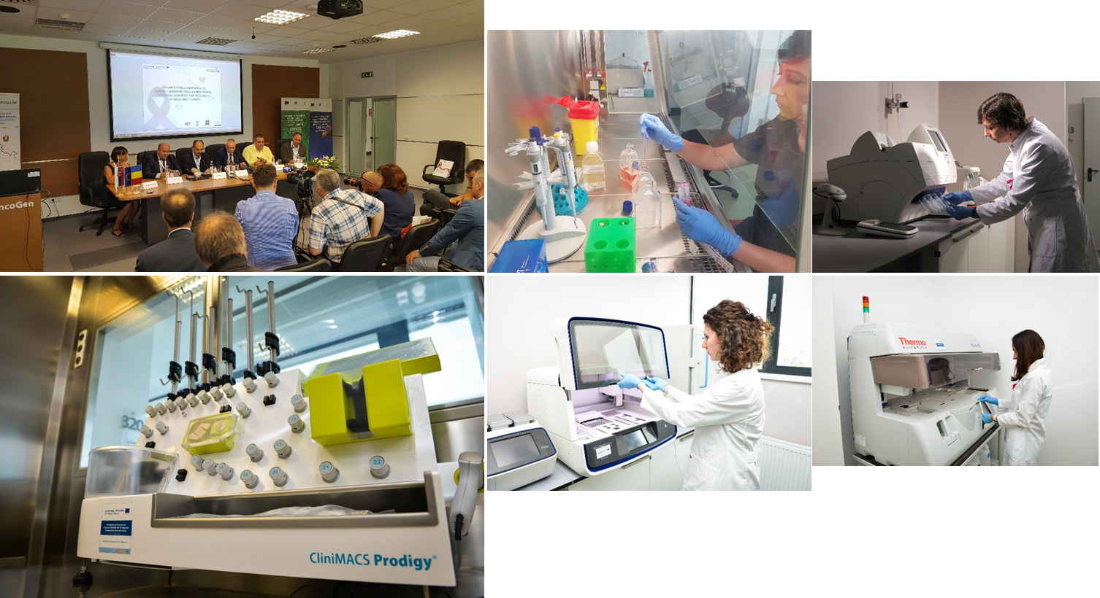
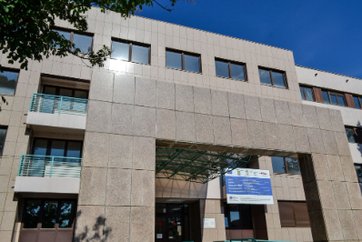
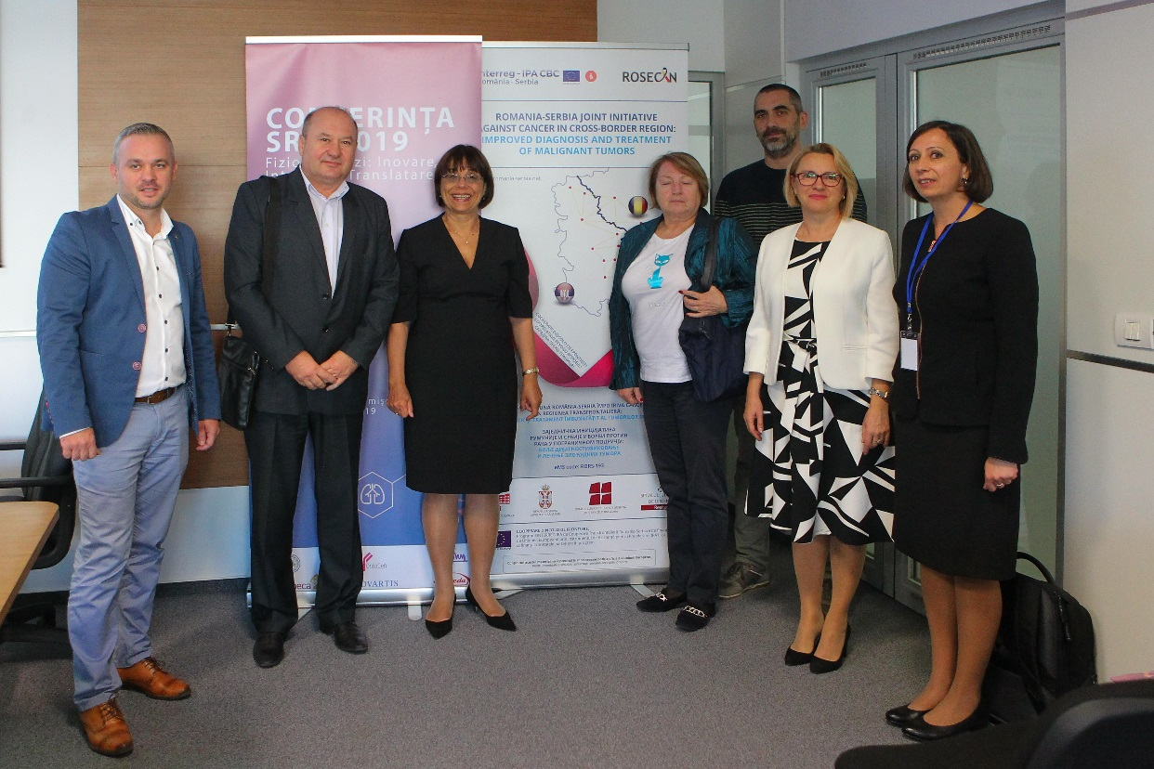
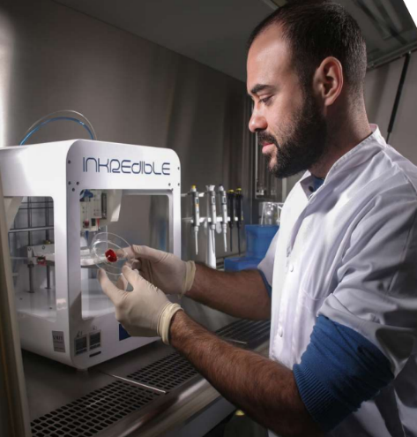

the implementation period (including extensions)
total funds spent/total funds contracted *100
indicators and level of achievement against targets set

