Project information
CALL FOR PROPOSALS | 1
e-MS Code: | RORS-17
PRIORITY AXIS: | 1 Employment promotion and basic services strengthening for an inclusive growth
OBJECTIVE: | 1.3 Social and cultural inclusion
PROJECT TITLE: | Together for an Inclusive Community
ACRONYM: | -
DURATION: | 23.06.2017 – 22.12.2018 (18 Months)
Interreg-IPA  FUNDS CONTRACTED: | €198.937,35
TOTAL FUNDS CONTRACTED: | €234.043,95
ABSORPTION RATE (%): | 82,47 %
PROJECT OBJECTIVE(S): | The cross border assessment of the level of social, educational and cultural inclusion for children from disadvantaged groups in Timis County, Romania and South Banat, Serbia.  Community involvement to increase the level of social, educational and cultural inclusion for children from disadvantaged groups in the border area of Timis county, Romania and South Banat, Serbia.  To develop an inclusive educational model of good practice implemented in five schools in communities defined by the project for a minimum of 500 children and 75 teachers.
SHORT DESCRIPTION OF THE PROJECT: | Through the project, the partners aimed to increase the level of social, educational and cultural inclusion for children from disadvantaged groups in the border area of Timis County, Romania and South Banat, Serbia. The community had the first evaluation of the level of social, educational and cultural inclusion of children from disadvantaged groups in Banloc and Livezile, Timis county, Romania and Plandiste in South Banat Serbia; also the main barriers that hinder their inclusion in the community was identified.  Another change that the project brought was to establish a special interest group made up of stakeholders and other representatives of the community, to increase the level of social, educational and cultural inclusion for children from disadvantaged groups in Banloc and Livezile, Timis county, Romania and Plandiste in South Banat Serbia. Through their involvement, the community achieved an action plan for increasing social, educational and cultural inclusion for children belonging to disadvantaged groups in the border area of Timis County, Romania and South Banat, Serbia.  5 schools identified their level of inclusion and benefited from an innovative model of good practice in inclusive education.  82 teachers from 5 schools in Romania and Serbia obtained new skills in the management of diversity and education for all and became the educational inclusion resource persons in the community.  The children involved in the project, including those who belonged to a disadvantaged group, acquired new personal growth skills, increased their self-esteem, developed non-discriminative attitudes, tolerance and understanding that will later facilitate their social, educational and cultural inclusion. Social, psychological, educational and cultural inclusive activities were organized and carried out for the children involved in the project.  The community obtained an inclusive education best practice guide that can be used as a model for other organizations or institutions to develop inclusive practices in communities and schools in other areas.
DEGREE OF ACHIEVEMENT OF INDICATORS: | 317 Disadvantaged persons involved in projects activities. – 126 %  1 Joint action targeting vulnerable groups (youth, women, disabled, ethnic minorities) established for the prevention of early school leaving, for cultural inclusion – 100 %  733 participants in projects promoting gender equality, equal opportunities and social inclusion across borders – 225 %
RESULTS ACHIEVED: | 3 successive training groups were organized and carried out for the teachers in the 5 schools.  651 children from the five schools benefited from several meetings, each group having a set of themes tailored to their educational, social and emotional needs.  A special interest group for social, educational and cultural inclusion opportunities for children from disadvantaged groups was created in the Banloc, Livezile and Plandiste communities.  82 teachers from 5 schools in Romania and Serbia were trained as resource persons in the management of diversity in school and education for all.  Support material was developed for the inclusive activities at the five schools.  The community and the five schools were supported to implement the action plan.  Inclusive psycho-socio-educational and cultural activities were organized and conducted for 968 children out of which 317 belonged to the disadvantaged group.  Four cultural activities were organized and carried out.  A 7-day friendship camp was organized and carried out with 55 children from the 5 schools.  A guide to good practice in inclusive education has been developed, which can be used as a model for other organizations or institutions to develop inclusive community and school practice in other areas.

Partnership information
 |  | COUNTRY | COUNTY/DISTRICT | BUDGET(EURO) | CONTACT DETAILS
LEAD PARTNER: | Rehabilitation Foundation Hope | ROMÂNIA | Timiş | 132.291,60 | 17 Aurel Popovici, Timisoara, Timis County, Romania  menina.danci@gmail.com
PARTNER 2: | Save The Children Timisoara Branch | ROMÂNIA | Timiş | 28.465,50 | 1 Blv. Republicii, Ap. 7, Timisoara, Timis County, Romania  bajireanud@gmail.com
PARTNER 3: | Municipality of Plandiste | Serbia | Južnobanatski | 10.993,03 | 38 VojvodePutnika, 26360, Južnobanatski, Serbia  rodika.grujesku@plandiste-opstina.rs

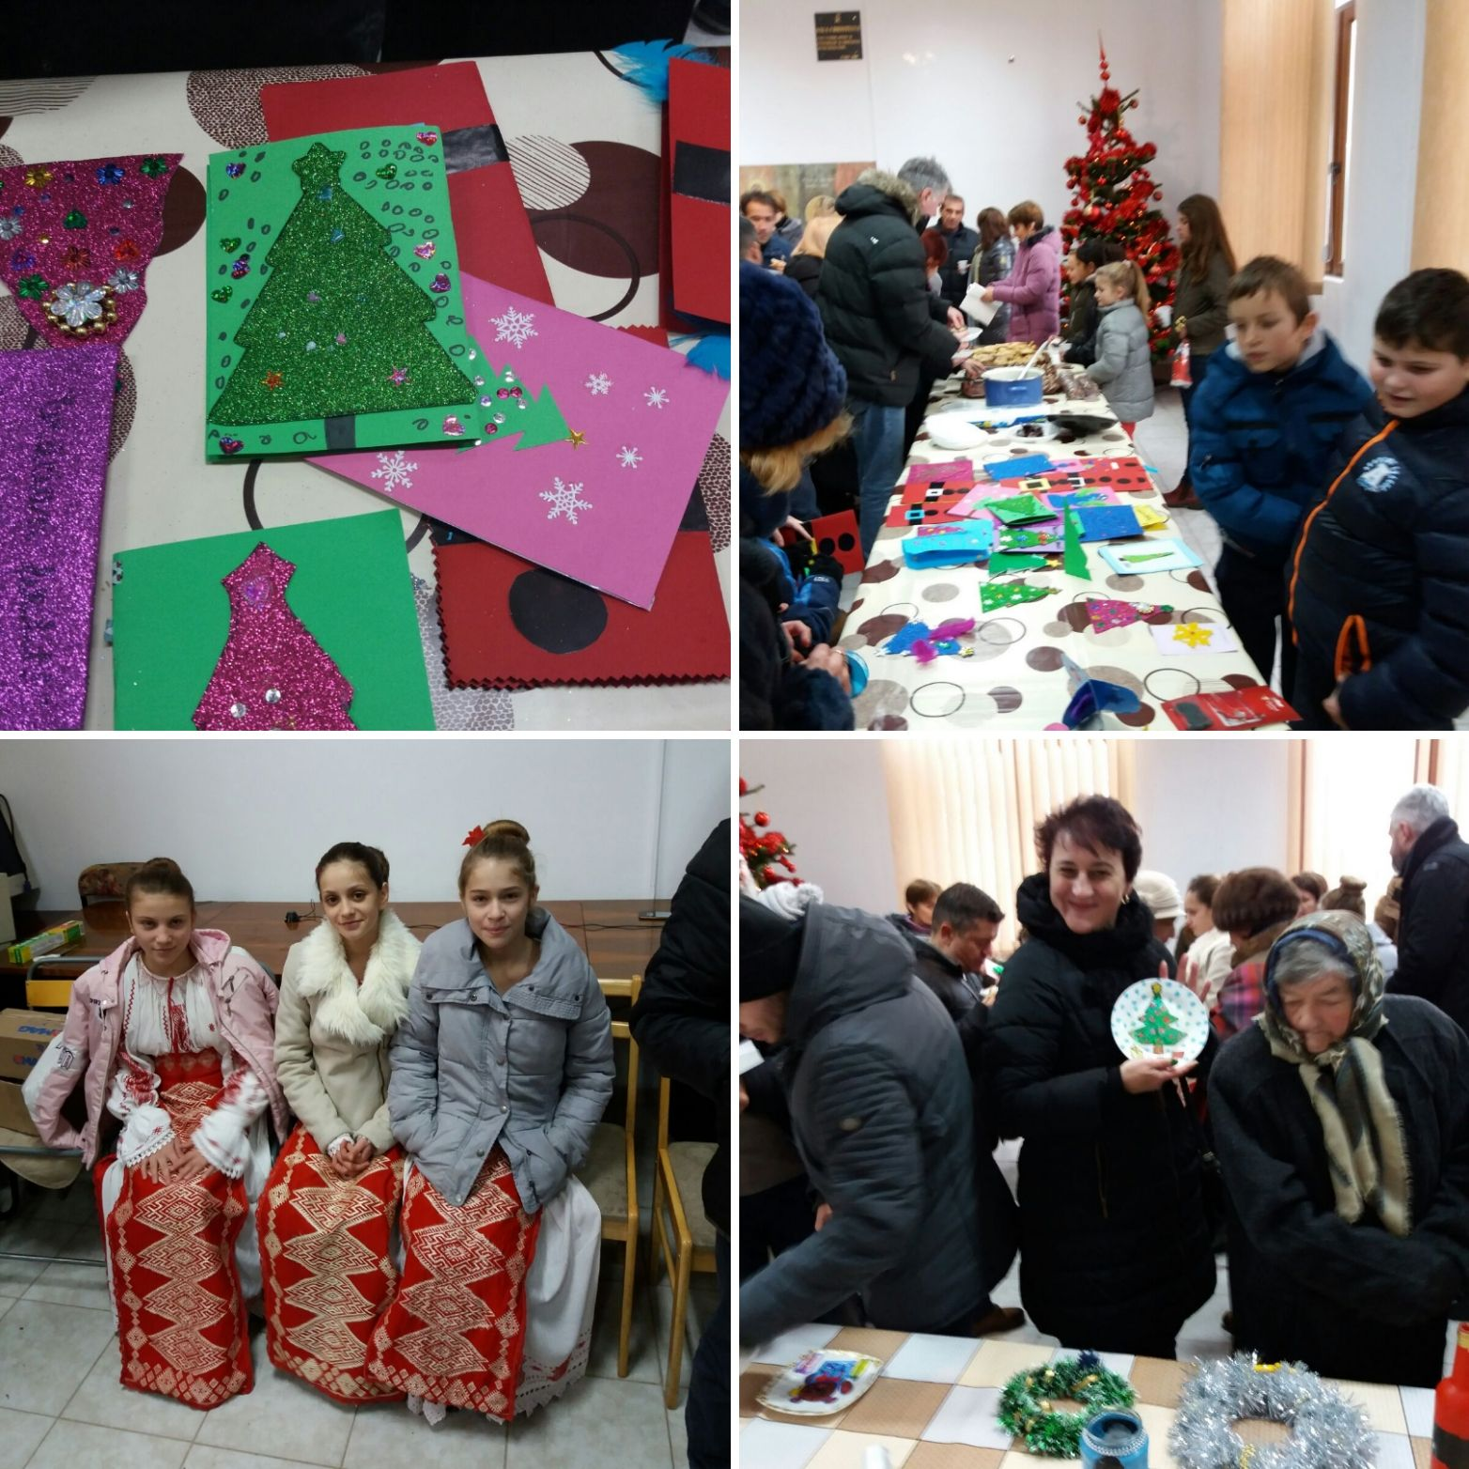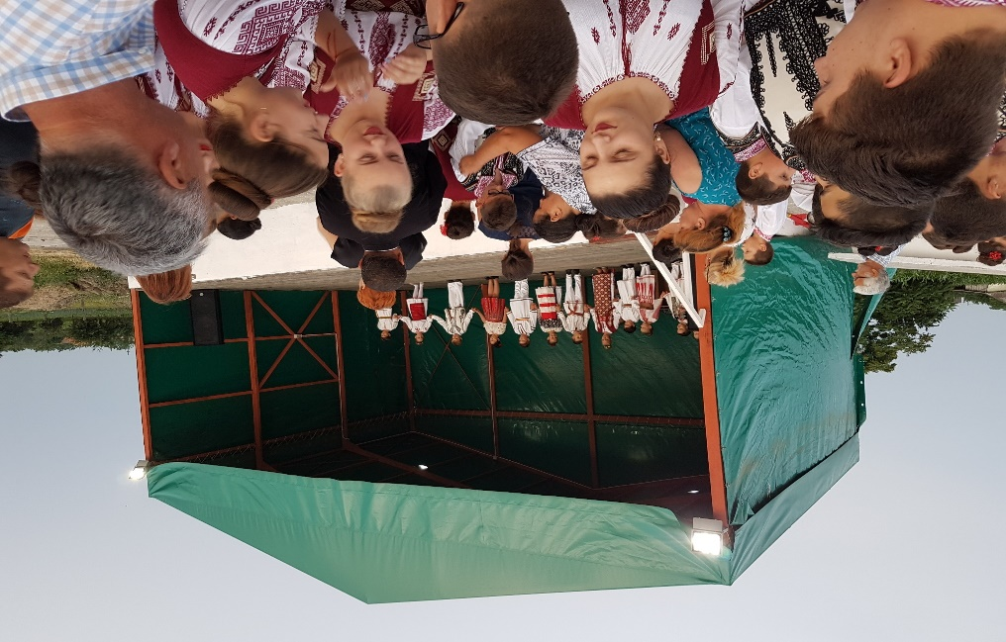
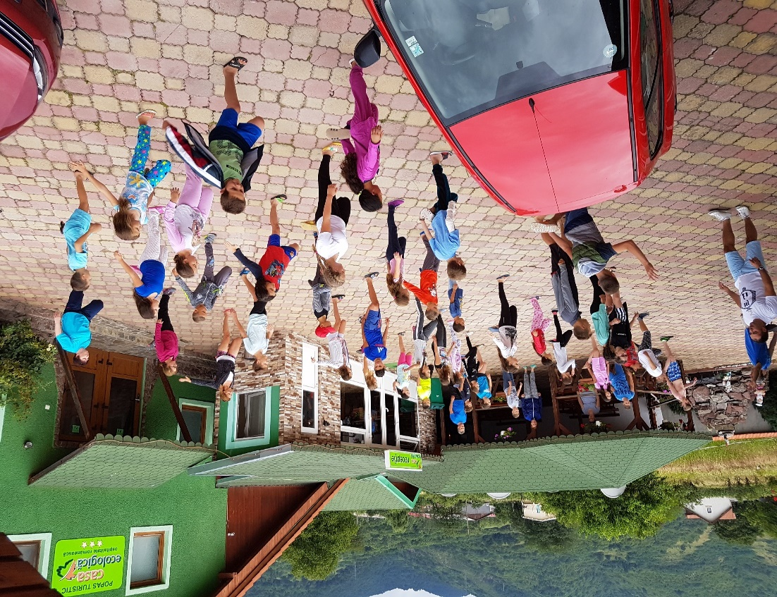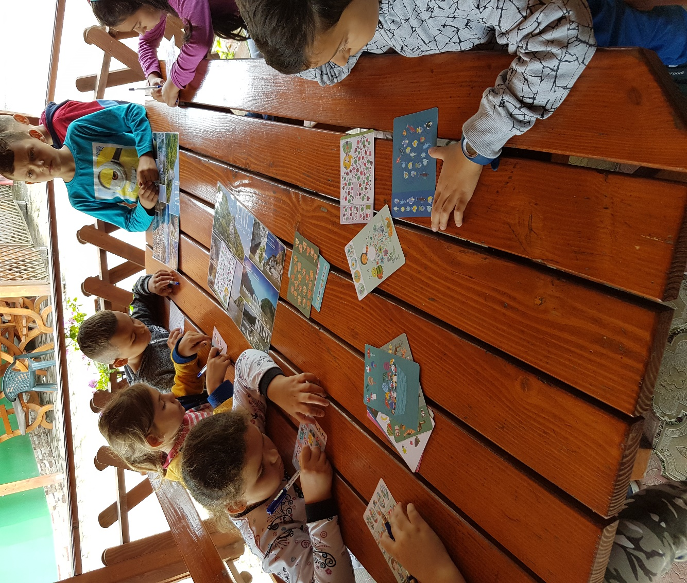

the implementation period (including extensions)
total funds spent/total funds contracted *100
indicators and level of achievement against targets set

