Project information
CALL FOR PROPOSALS | 1
e-MS Code: | RORS-15
PRIORITY AXIS: | 3 Sustainable mobility and accessibility
OBJECTIVE: | 3.1 Mobility and transport infrastructure and services
PROJECT TITLE: | The repairing of the navigation infrastructure on Bega Canal
ACRONYM: | BEGA
DURATION: | 03.08.2017 - 02.05.2022 (57 months)
Interreg-IPA  FUNDS CONTRACTED: | €11.583.859,14
TOTAL FUNDS CONTRACTED: | €13.628.069,56
ABSORPTION RATE (%): | 99.24%
PROJECT OBJECTIVE(S): | Increasing cross–border competitiveness by improving the accessibility and connectivity of the cross-border region through raising the transport and mobility infrastructure standard.  Enhancing Bega Canal Area as an internationally recognized, green, visitor-friendly destination.
SHORT DESCRIPTION OF THE PROJECT: | Bega Canal is, from more points of view, one of the key linkers of the Romanian and Serbian communities, being the only living boulevard connecting the two countries.  Considering that the Bega Canal is one of the significant waterways for Zrenjanin, Zitiste and Timisoara, its revival concerning navigation, even if only in line with the original parameters, would mean connecting Banat, both to the Black Sea and the North Sea, through the existing system of canals in Serbia DTD (Danube – Tisa - Danube) and the Rhine-Main-Danube Canal. An essential common challenge and an opportunity to develop the region by boosting tourism in the area is reopening the navigability on the Bega Canal.  Some measures had to be taken before reopening the navigability of the Bega Canal. The main common challenge of the project was to improve the general accessibility and mobility of people and goods on the Bega Canal. Mobility is one of the most fundamental characteristics of economic activity. It satisfies the basic need of going from one location to another, a condition shared by passengers, freight and information.  We obtained the following results:  - the repairing of the hydro complex Sanmihaiul Roman, Klek and Srpski Itebej,  - the construction of a working inspection/bicycle path,  - the technical documentation for dredging the Bega Canal,  - providing equipment for dredging and maintaining the Bega Canal.  The results of this project will also motivate, create and develop corresponding transport links on both sides of the border and promote good neighbourliness and cooperation between Romania and Serbia.  The project was rewarded by the DKMT representatives with the Excellence award in recognition of its contribution to the development of cooperation in the Danube - Kris - Mures - Tisa Euroregion.  More about the results here:  https://www.youtube.com/watch?v=WJ2dqKetj_U
DEGREE OF ACHIEVEMENT OF INDICATORS: | Cross-border cooperation structures supported in the field of transport and public utilities; (100%)  Studies related to the implementation of selected projects or the realisation of actions in the field of transport and mobility infrastructure; (100%)  Investments in transport and utilities infrastructure, including improvement, enhancement of existing infrastructure; (100%)  Participants to information/ training/ awareness raising initiatives in the field of transport and public utilities; (100%)  Joint initiatives on improvements of public transport and intermodal connections; (100%)
RESULTS ACHIEVED: | - Project Technical Committee Appointed;  6 Joint Studies and Technical Documentation developed for the realization of actions in the field of transport and mobility infrastructure;  30 trained persons;  6 specific IT equipment purchased;  7 specific on site-equipment purchased: 2 terrain vehicles, 2 multipurpose dredger, 1 aquatic weed harvester, 1 barge, 1 motor barge;  1 repaired and functional Hydro-complex at Sannmihaiul Roman (Romania);  - repaired and operational Hydro-complex Klek and Srpski Itebej (Serbia);  - constructed working inspection path/cycle path;  1 constructed floating dock and mooring points;

Partnership information
 |  | COUNTRY | COUNTY/DISTRICT | BUDGET(EURO) | CONTACT DETAILS
LEAD PARTNER: | Banat River Basin Administration | Romania | Timis | 6.739.026,20 | 32 Mihai Viteazu Blvd, 300222, Timisoara  mihaela.jurculet@dab.rowater.ro
PARTNER 2: | Timis County Council | Romania | Timis | 99.183,00 | 17 Revolutiei din 1989 Blvd., 300034, Timisoara  adrian.luput@cjtimis.ro
PARTNER 3: | Provincial Secretariat for Interregional Cooperation and Local Self-Government | Serbia | South Bačka | 128.718,45 | 16 Mihajla Pupina Blvd, 21000, Novi Sad  roland.kokai@vojvodina.gov.rs
PARTNER 4: | Public Water Management Company “Vode Vojvodine” | Serbia | South Bačka | 6.661.141,91 | 25 Mihajla Pupina Blvd, 21000, Novi Sad  silincic@vodevojvodine.rs

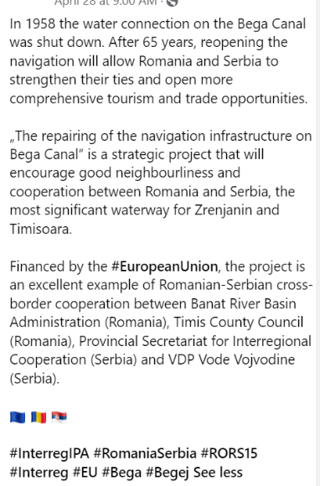
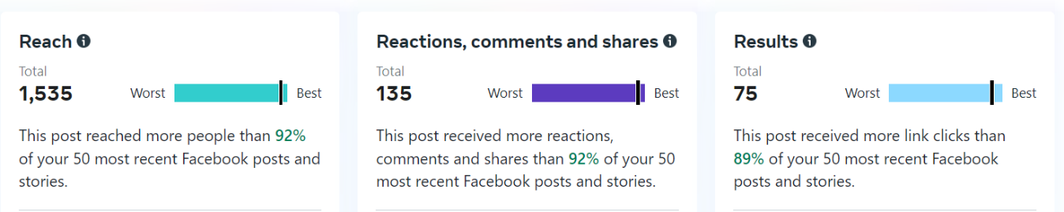
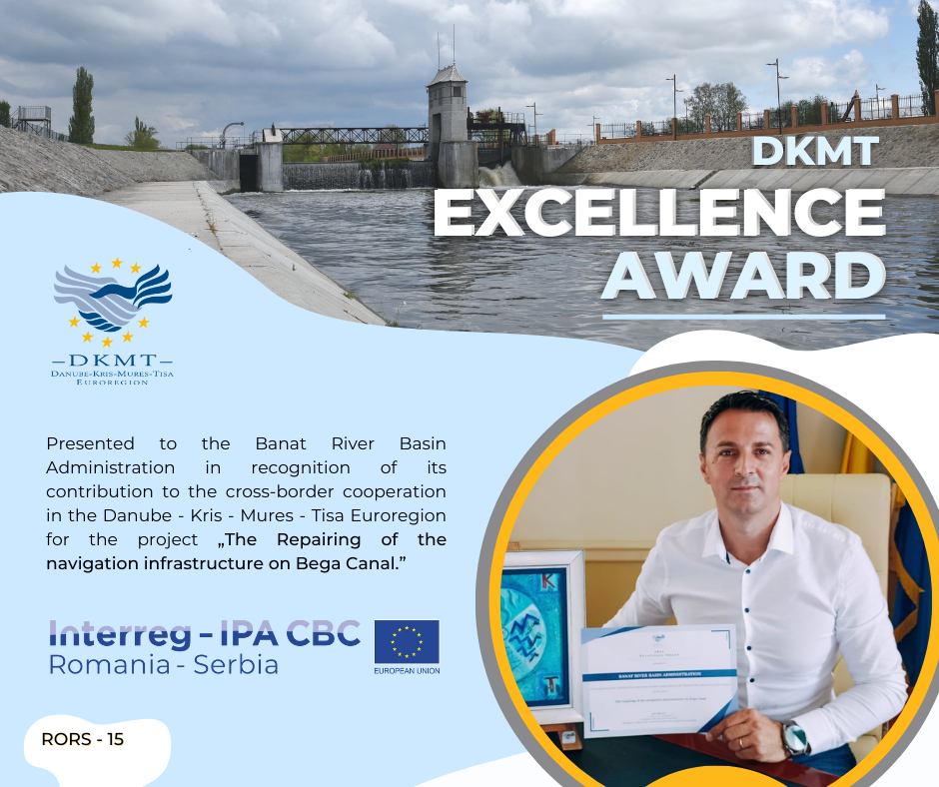
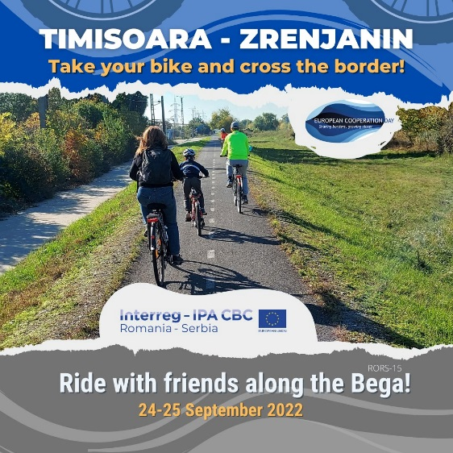

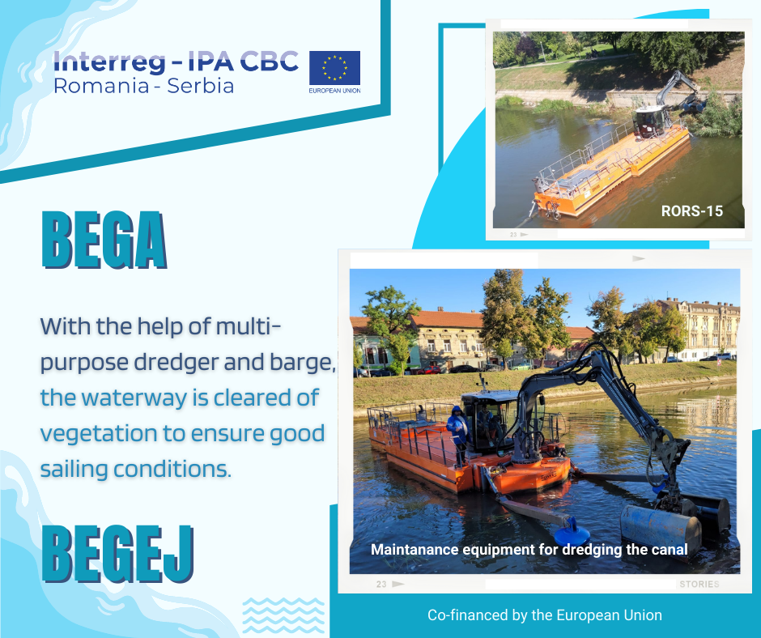
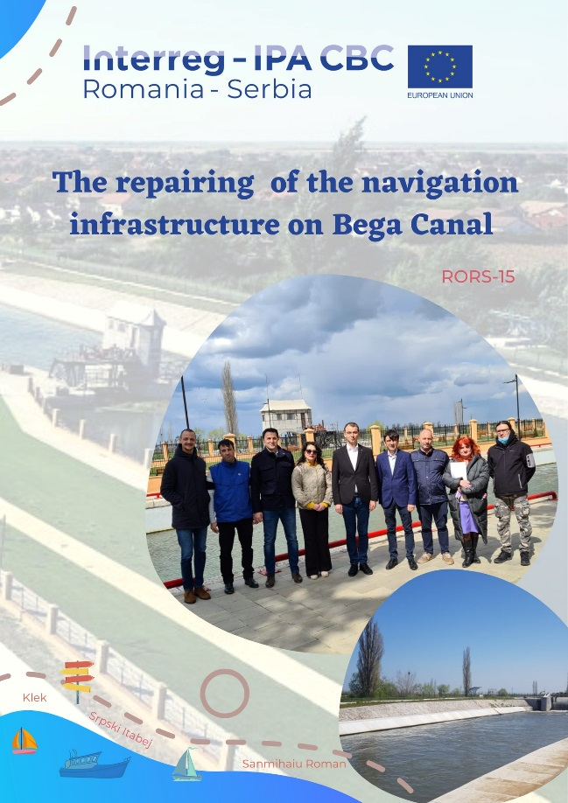
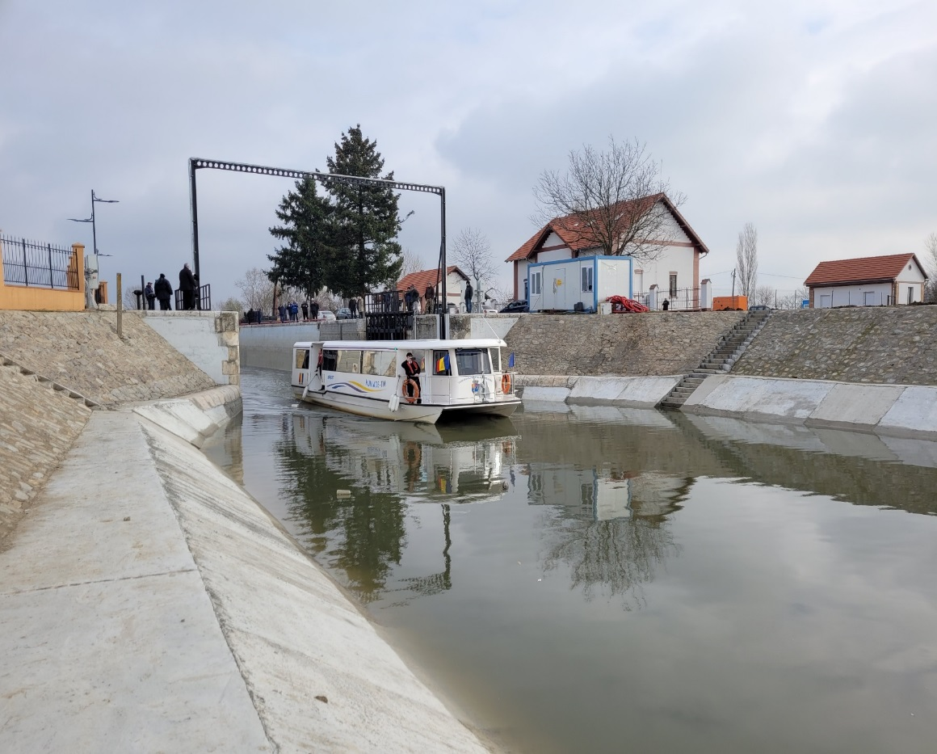

the implementation period (including extensions)
total funds spent/total funds contracted *100
indicators and level of achievement against targets set

