Project information
CALL FOR PROPOSALS | 1
e-MS Code: | RORS-11
PRIORITY AXIS: | 1 Employment promotion and services for an inclusive growth
OBJECTIVE: | 1.2 Health and social infrastructure
PROJECT TITLE: | Regional Centre for advanced laser therapies in ophthalmology
ACRONYM: | RECALT
DURATION: | 04.05.2017 – 03.05.2019 (24 Months)
Interreg-IPA  FUNDS CONTRACTED: | €1.619.250,39
TOTAL FUNDS CONTRACTED: | €1.905.000,47
ABSORPTION RATE (%): | 97.20%
PROJECT OBJECTIVE(S): | Developing a network of specialists in eye surgery and diagnosis over the cross-border region;  Providing free high quality medical services for citizens from the cross-border area with ophthalmological pathologies;  Raising the awareness of the population from the cross border area with regards to the ophthalmological pathologies;
SHORT DESCRIPTION OF THE PROJECT: | Over the cross-border area, the prevalence of diabetic eye disease, corneal and retinal pathologies are extremely high. The reasons for such high prevalence compared to other parts of Europe consist in the general lifestyle of the population (which positions the cross-border area on the top spot at the European level for diabetes incidence), the lack of awareness of the population with regards to the causes and consequences of the pathologies mentioned above, the lack of proper diagnosis and treatment capacities at the regional level. The relatively low-income levels specific to the cross-border population generally don’t leave the option of searching for treatment overseas. The overall objective of the project was the improvement of the quality of life for the population from the cross-border area with specific eye pathologies.  Last-generation diagnosis, surgical equipment and advanced training for expert ophthalmologists ensured through the joint actions of the two project partners created access for the entire population of the cross–border area to modern, high-quality diagnosis and eye surgery services in Timisoara (Romania) and Nova Crnja (Serbia). Throughout the project, high-quality eye diagnosis and surgery services were available for free to all the citizens of the cross-border area (as early diagnosis and treatment are of particular importance for treating eye pathologies with progressive behaviour). In addition, the project partners committed to continuing to supply the diagnosis and surgery services for the citizens of the cross-border area without any direct charges after the end of the implementation period.  The European Commission chose the project as an example of good practice, and it was presented during the "European Week of Regions and Cities" event in Brussels in 2019.
DEGREE OF ACHIEVEMENT OF INDICATORS: | 19.323 Citizens involved in project activities in cultural, social health care services; - 109%  1 Investment in health care and social services infrastructure; - 100%  3.200 Disadvantaged persons involved in projects activities; - 150%  17.815 Population covered by improved health services; - 111%  19.508 Number of participants in projects promoting gender equality, equal opportunities and social inclusion across border; - 117%
RESULTS ACHIEVED: | 10.749 Medical tests for diabetes;  6.506 Free ophthalmological investigations;  560 Free eye surgery services;  61 Trained ophthalmologists;  200 Trained medical students;  306 Memberships to the network of specialists (www.recalt.umft.ro);  200 guides for best practices in the field of eye diseases diagnosis and treatment;  400 reports for patients, students and family doctors concerning the costs and benefits of eye surgery;  220 reports for hospitals, ophthalmologists and cost benefit analysis experts concerning the costs and benefits of eye surgery;  238 Roma citizens benefiting from conferences for awareness raising;  50 trained family doctors;  1 building rehabilitated destined to host the Regional Ophthalmological Laser Centre;  3.956 free medical investigations for disadvantaged persons;  324 free eye surgery services for disadvantaged persons;  17.255 citizens benefiting from improved health services;  18.035 citizens involved in the activities of the project;

Partnership information
 |  | COUNTRY | COUNTY/DISTRICT | BUDGET(EURO) | CONTACT DETAILS
LEAD PARTNER: | “Victor Babes” University of Medicine and Pharmacy Timisoara | Romania | Timis | 1.471.112,81 | 2A Eftimie Murgu Street, 300041, Timisoara
PARTNER 2: | Municipality of Nova Crnja | Serbia | Srednjebanatski | 433.887,66 | 110 JNA Street, 23218, Nova Crnja

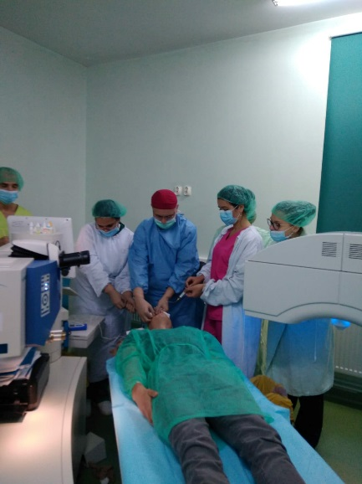
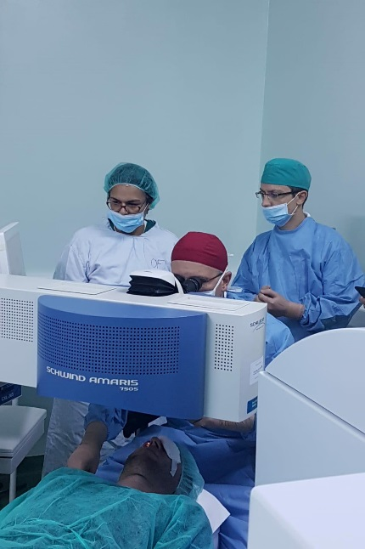
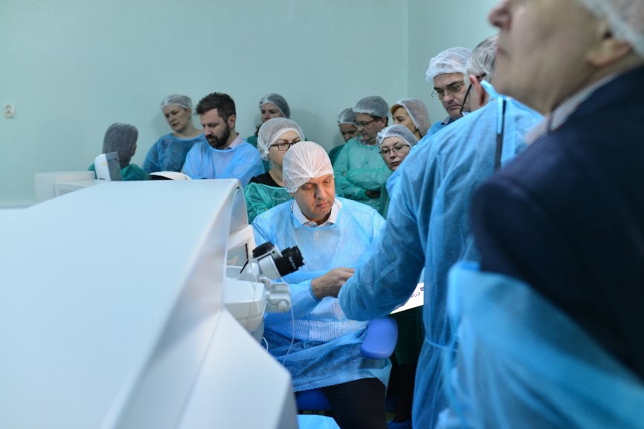
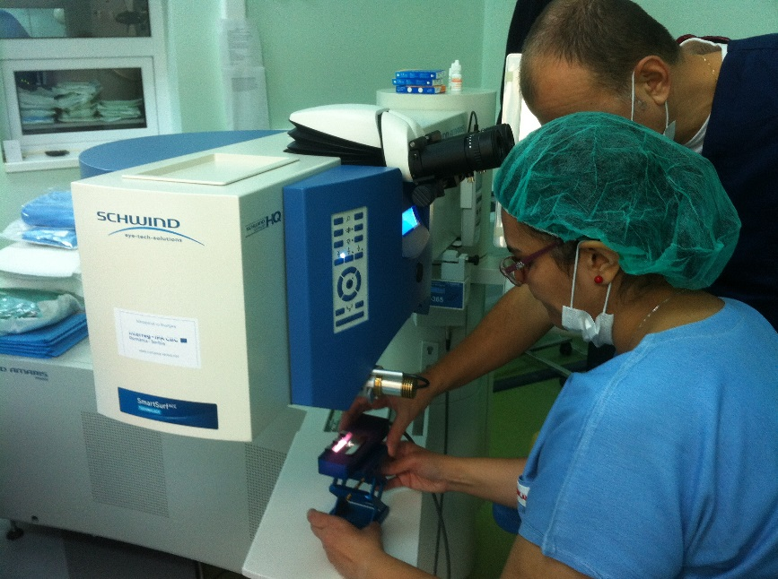

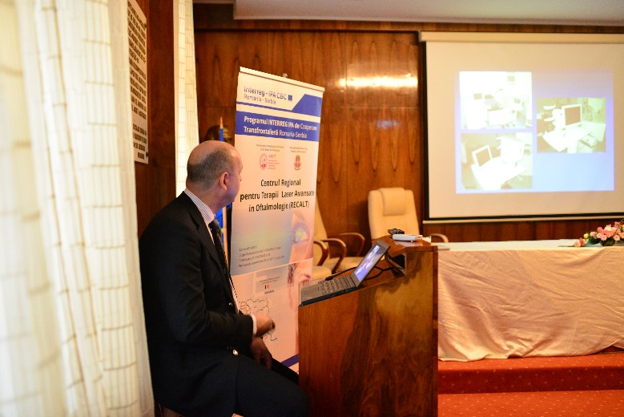
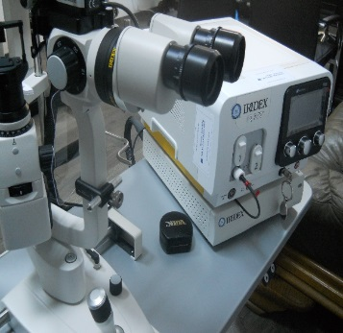
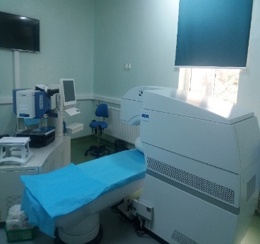
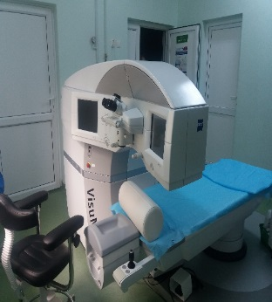
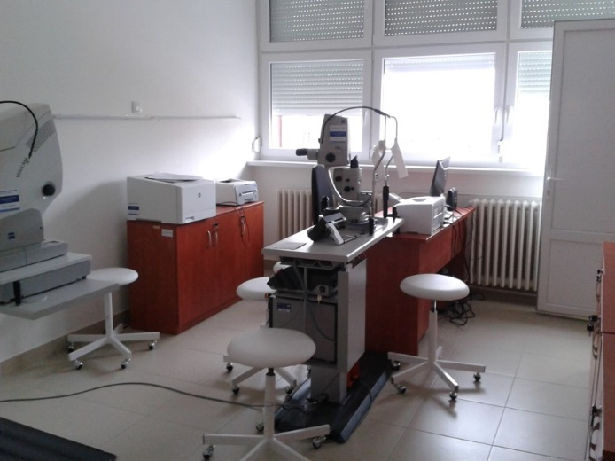
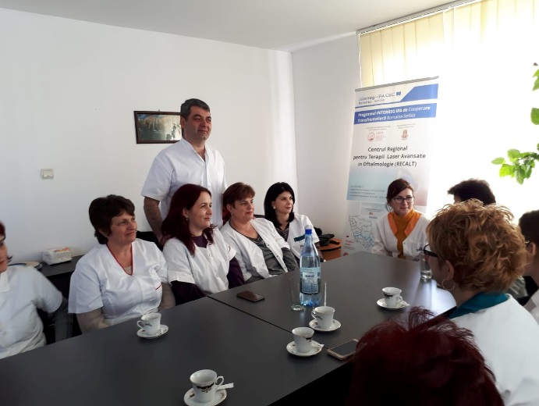
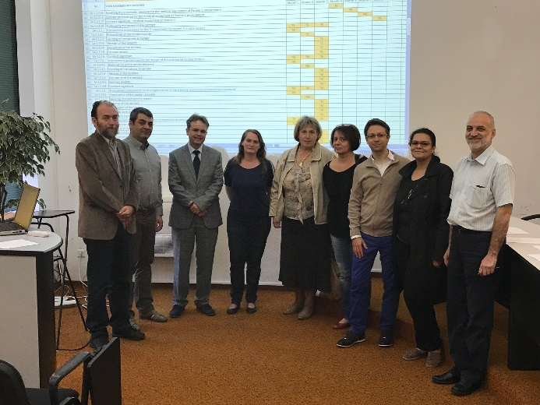

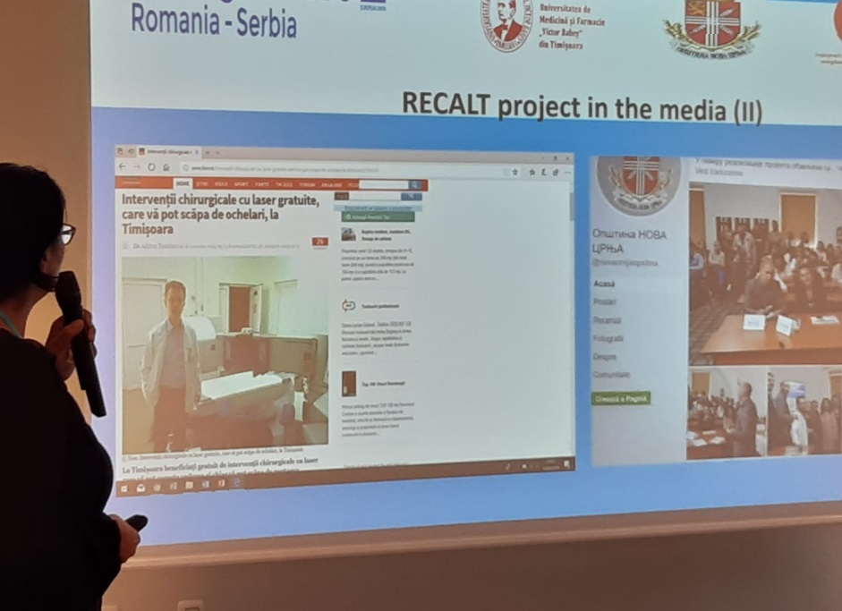
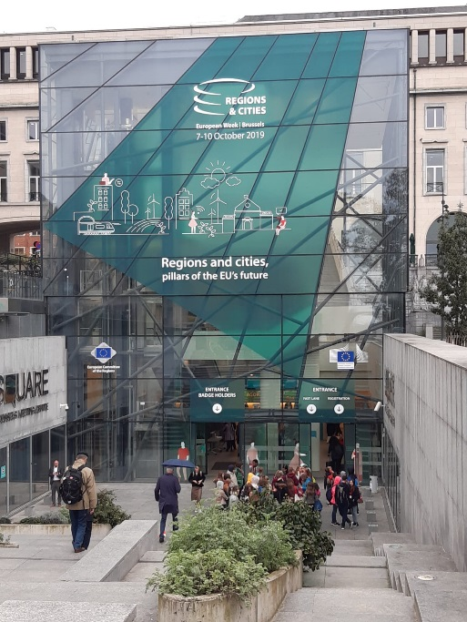
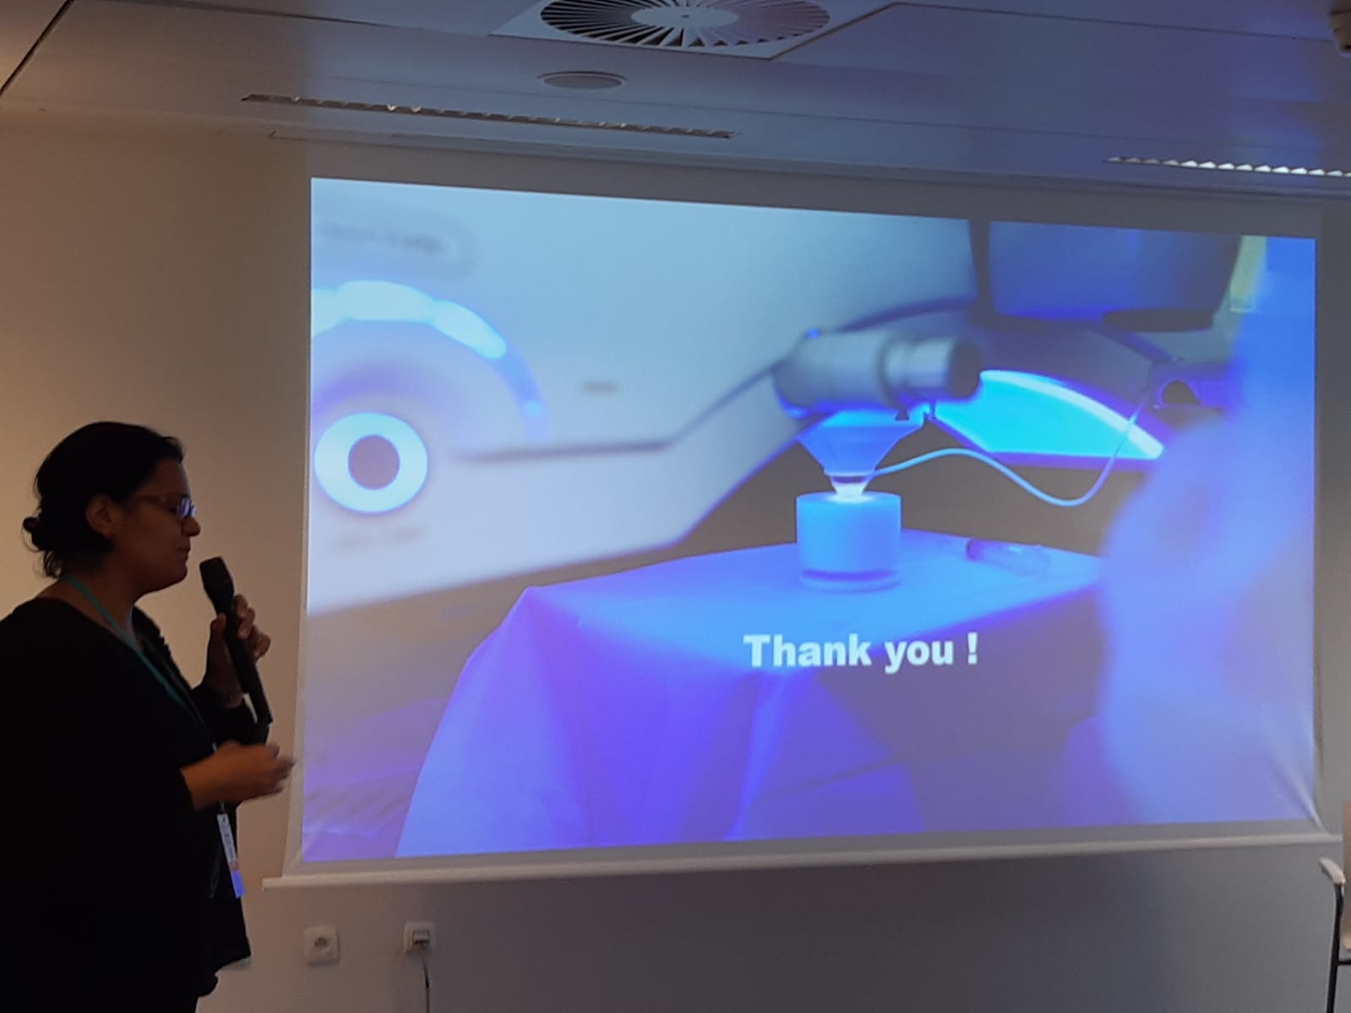

the implementation period (including extensions)
total funds spent/total funds contracted *100
indicators and level of achievement against targets set

