Project information
CALL FOR PROPOSALS | 1
e-MS Code: | RORS-10
PRIORITY AXIS: | 1 Employment promotion and services for an inclusive growth
OBJECTIVE: | 1.1 Employment and labour mobility
PROJECT TITLE: | A new chance for social inclusion of inmates
ACRONYM: | NECESINI
DURATION: | 16.05.2017 - 15.08.2018 (15 Months)
Interreg-IPA  FUNDS CONTRACTED: | €178.941,78
TOTAL FUNDS CONTRACTED: | €210.519,75
ABSORBTION RATE (%): | 90,11 %
PROJECT OBJECTIVE(S): | Supporting the social inclusion chances of inmates incarcerated in Timisoara Penitentiary (Romania) and Pancevo Penitentiary (Serbia).  Training 40 inmates in the area of drying vegetables, fruits, medicinal plants in view of increasing their chances of becoming their own bosses;  Arranging two workshops of drying and packing produce for developing practical skills of inmates in each of the partner penitentiaries;  Promoting the idea of providing equal employment chances to former inmates.
SHORT DESCRIPTION OF THE PROJECT: | The penitentiaries in Romania and Serbia have two very important missions – to ensure custody of incarcerated persons and to support the social reintegration of inmates. The reintegration of former inmates, especially in the labour market, is difficult in the cross border area due to lack of jobs, very low salaries and mainly discrimination upon employment. This project envisaged to improve the practical knowledge and skills of the inmates through a non-formal education program in the area of producing dry fruit, vegetables, herbs, and medicinal plants. Also, through the project, the chance of inmates to become small agriculture producers has been increased providing them new opportunities on the labour market. At the same time, by organizing the two events on promoting employment chance equality concerning former convicts the attention of the local community and business environment on the importance of diminishing the recidivism and increasing the safety of communities through the integration of the former convicts has been increased.
DEGREE OF ACHIEVEMENT OF INDICATORS: | 40 Disadvantaged persons involved in projects activities – 120%  3 Joint actions targeting smart (green) growth opportunities – 100%
RESULTS ACHIEVED: | 1 Educational Program (English, Romanian, and Serbian)  30 participants with increased knowledge on equality of chances for ex-inmate employment  2 adequate modular units for workshops  2 fully equipped, functional fruit and vegetable drying and packing workshops  1 small cargo utility vehicle  1 Website created (https://necesini.eu)

Partnership information
 |  | COUNTRY | COUNTY/DISTRICT | BUDGET(EURO) | CONTACT DETAILS
LEAD PARTNER: | Center for Promoting Lifelong Learning | ROMÂNIA | Timiş | 32.865,00 | 2 Aleea Inului, 4th floor, ap. 13, 300415, Timisoara  daiana.huber@cpip.ro
PARTNER 2: | Penal-correctional institute in Pančevo | SERBIA | Južnobanatski | 82.661,25 | Bavaništanski road, 26101, Pancevo  vukstanisic1980@gmail.com
PARTNER 3: | Timisoara Penitentiary | ROMÂNIA | Timiş | 94.993,50 | 7 Popa Șapcă, Timisoara  catalin.olaru@anp.gov.ro

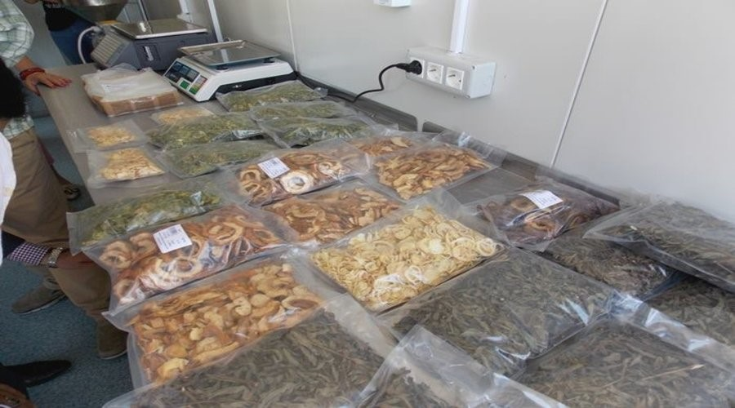
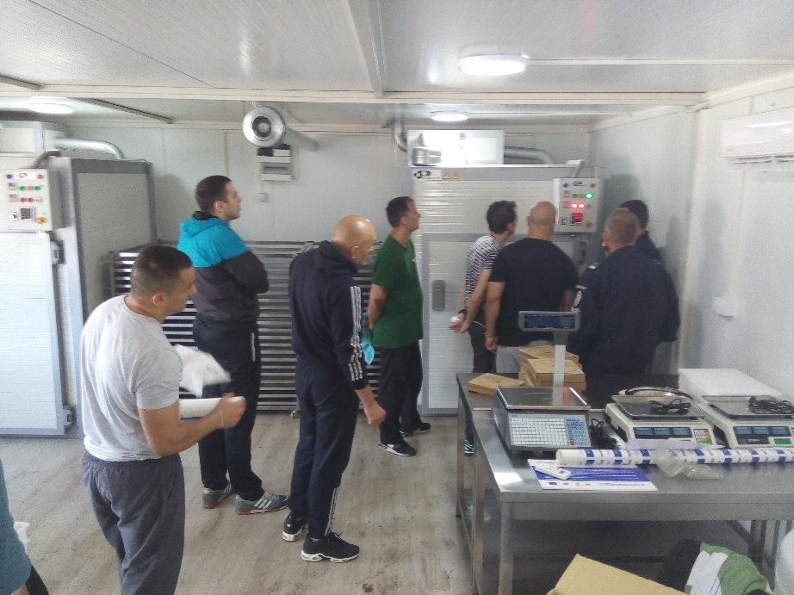

the implementation period (including extensions)
total funds spent/total funds contracted *100
indicators and level of achievement against targets set

