 | Project information
 | CALL FOR PROPOSALS |  | 2
 | MIS-ETC: |  | 1423
 | PRIORITY AXIS: |  | 2.Environment and Emergency Preparedness
 | MEASURE: |  | 2.3 More effective systems and approaches to emergency preparedness
 | PROJECT TITLE: |  | Centre for emergency response in case of floods in the river basins Moravica and Brzava
 | ACRONYM: |  | PMD CENTER FOR EMERGENCY
 | DURATION: |  | 04.12.2015 – 31.12.2016
 | IPA FUNDS CONTRACTED: |  | 591.716,45
 | TOTAL FUNDS CONTRACTED: |  | 696.137,00
 | ABSORBTION RATE (%): |  | 78,32
 | PROJECT OBJECTIVE(S): |  | Improved communication in solving the flood in the river basins of Brzava and Moravica.  Establishment of mechanisms and structures for co-ordination of emergency teams.  Creation of infrastructure for action in crisis situations.  Creation of physical infrastructure for the educational work, teaching and training teams for action in crisis situations.  Creation of professional knowledge programs and development of abilities to act in emergency situations through learning, education and training of teams for emergency situations.  Increased institutional capacity and readiness to react in an environmental emergency.  Improvement of communication and coordination in case of regional emergency.  Working with young people and reinforce humanistic values.  Improving the system for information, reporting and alarm in the region.
 | SHORT DESCRIPTION OF THE PROJECT: |  | The territory of the municipalities on the edges of the Banatian Mountains has had problems with floods for centuries. Tamiš, Begej, Moravica and Brzava rivers with their tributaries and occasionally uncontrolled confluents from the surrounding spacious mountain slopes of the Carpathian Mountains have created great problems in the lower parts, at the basis of the mountains. The Municipalities of Plandiste, Moravica and Denta are located in the area that is often in the flood way. This project has approached the systematic solving of flood protection in the municipalities` region. The institutions for support and education in emergency situations were created, which were based on the experience needed in preventive and educational sense. The project connected teams of neighbouring municipalities and cross-border regions through conferences, trainings and education. Through the project and with the support of the national Red Cross and other bodies, the physical infrastructure, facilities and place were created for training and education in the field of action in emergency situations.
 | DEGREE OF ACHIEVEMENT OF INDICATORS: |  | Indicator (1) Indicator value provisioned in the contract Present indicator value % 6= (5)/(3)*100  Output indicators (1) UM (2) Quantity (3) UM (4) Quantity (5)  Project indicators  Regional infrastructure built for action in crises A number of common documents and centre for action in crises set up 2 A number of common documents and centre for action in crises set up 2 100%  Enhanced technical capacity for action in crises Number of new purchased equipment 3 Number of new purchased equipment 3 100%  Enhanced capacity for action in crises The number of conferences, education and training 2 The number of conferences, education and training 2 100%  Result indicators  Increased cross-border cooperation in environment protection Number of actions that contribute to environmental protection 1 Number of actions that contribute to environmental protection 1 100%  Increase expertise and exchange of experience in the field of environment protection Number of conferences and trainings 2 Number of conferences and trainings 2 100%  Increase institutional capacity and preparedness in reacting to situations of environmental emergency Number of plans and joint training 2 Number of plans and joint training 2 100%  Improved implementation of national and EU environmental legislative framework Number of initiatives 1 Number of initiatives 1 100%
 | RESULTS ACHIEVED: |  | Increased cross-border cooperation in the field of emergency situations and flood protection. The connection of teams from neighbouring municipalities and cross-border regions, exchange of ideas and mutual cooperation.  The structure of emergency equipment was improved in Moravita, through the purchase of missing modern equipment for action in crisis situations in the region of the Moravica.  The physical infrastructure for training was created, the centre for training in emergency situations, programs of work at the centre for educations and training of teams for acting in emergency situations were made and tested.  The expertise of people who deal with action in emergency situations was increased.  The plans of actions in emergency situations were developed and communication on local level was established.  The system of information, reporting an alarm in the region inside the country and in the cross-border region was build.  The coordination and reaction mechanisms of regional teams for emergency situations was ensured.
Partnership information
 |  |  |  | COUNTRY | COUNTY/DISTRICT | BUDGET(EURO) | CONTACT DETAILS
LEAD PARTNER: |  | Municipality of Plandiste |  | Serbia | South Banat | 98.875,00 | Plandiste, Vojvode Putnika 38  Tel. 013 861033
PARTNER 2: |  | Moravita Municipality |  | Romania | Timis | 319.046,00 | Moravita, nr. 261  Tel. 0256397251
PARTNER 3: |  | Denta Municipality |  | Romania | Timis | 278.216,00 | Denta, No. 224  Tel. 0040256398403

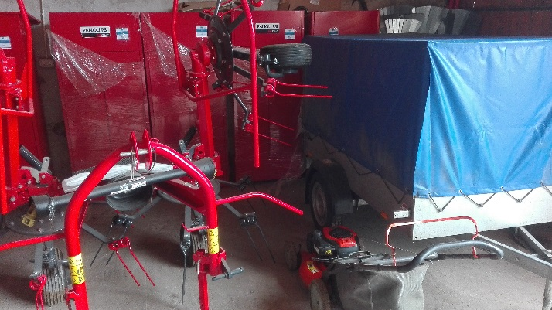
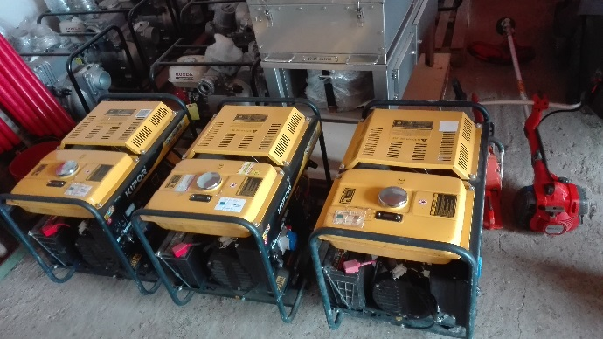
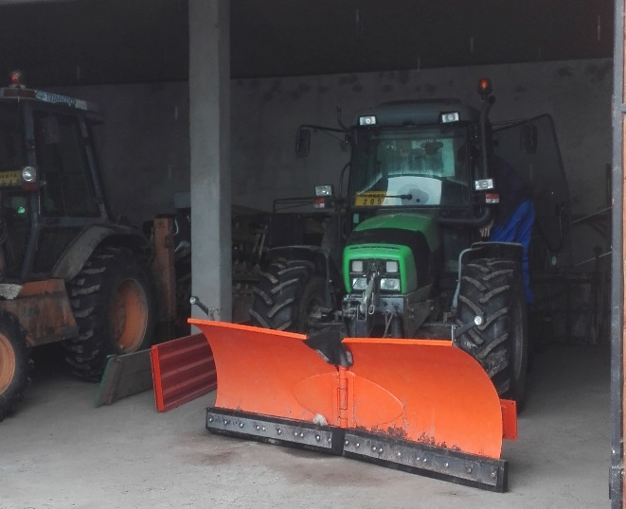
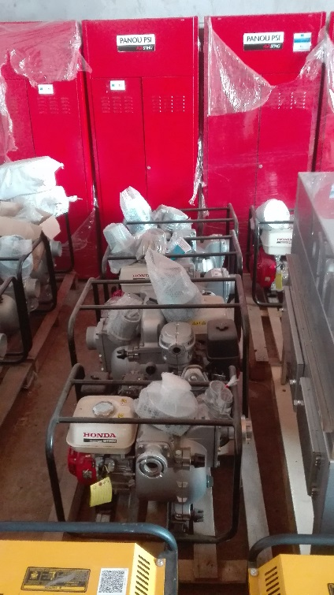
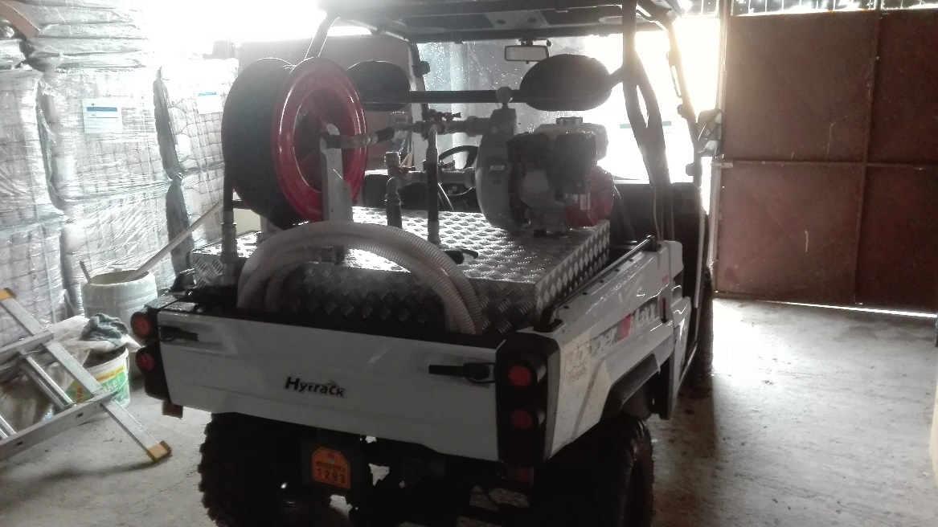
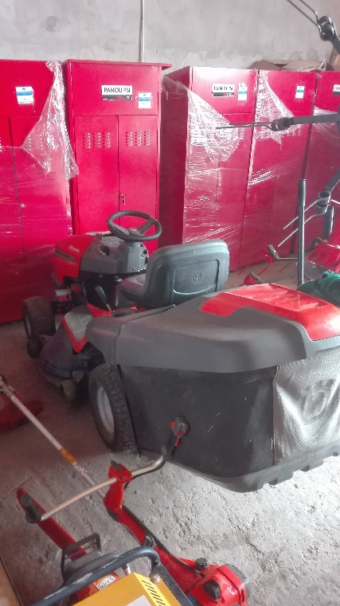

the implementation period (including extensions)
total funds spent/total funds contracted *100
indicators and level of achievement against targets set

