 | Project information
 | CALL FOR PROPOSALS |  | 2
 | MIS-ETC: |  | 1421
 | PRIORITY AXIS: |  | 2.Environment and Emergency Preparedness
 | MEASURE: |  | 2.3 More effective systems and approaches to emergency preparedness
 | PROJECT TITLE: |  | Joint management of the emergency situations in Caransebes - Juzno-Banatski cross-border area
 | ACRONYM: |  | E.M.S.I.M – EMergency SItuation Management
 | DURATION: |  | 25.04.2013 -24.04.2015
 | IPA FUNDS CONTRACTED: |  | 1.839.034,56
 | TOTAL FUNDS CONTRACTED: |  | 2.163.570,07
 | ABSORBTION RATE (%): |  | 94,06
 | PROJECT OBJECTIVE(S): |  | - Increasing the quality of life for the population of the Romania-Serbia border area by strengthening the institutional and technical management capacity in case of disaster and response in emergency situations.  - Strengthening the cooperation of the competent authorities of the Romania-Serbia border region, reflected in the two-way exchange of information.  - Increasing the monitoring and reaction capacity of the authorities in situations of natural disasters (fires, landslides, floods).
 | SHORT DESCRIPTION OF THE PROJECT: |  | The main outcome of the project was the implementation of the integrated cross-border information emergency management system, combining the latest IT technology and field equipment.  The IT component consisted of specialized software running on servers and powerful workstations that were used by employees of both partner institutions. In this way, they had a clear picture of the territory by using maps in GIS format, thus being able to identify the potential risks, existing resources and the best ways to intervene.  In close connection with this information system there was field equipment (especially for monitoring and intervention), which consisted of drones and field machines. This equipment was particularly valuable in difficult areas where access was difficult and intervention was impossible. The computer system displays at any time the availability and location of this equipment.  The computerized system also took the data sent from the field by drones or people in field vehicles, providing both-way communication.  A short video about the project is available at: https://www.youtube.com/watch?v=alxLFtCV0Bo&t=4s
 | DEGREE OF ACHIEVEMENT OF INDICATORS: |  | Indicator Indicator value provisioned in the contract Present indicator value % 6= (5)/(3)*100  Output indicators (1) UM (2) Quantity (3) UM (4) Quantity (5)  Monitoring and intervention system with fixed and mobile equipment (aerial) unit 1 unit 1 100%  System components of the Emergency Management Information System and Document Management unit 1 unit 1 100%  Joint actions in response to raise awareness of urgent situations unit 2 work-shops unit 2 100%  Result indicators  Increased cross-border cooperation in environmental protection event 2 work-shops event 2 100%  Institutional qualification in response to environmental emergencies event 2 work-shops event 2 100%  A wider implementation of the national and EU legislation in the field of environment action 1 action action 1 100%
 | RESULTS ACHIEVED: |  | Integrated cross-border system for management of emergency situations was developed and implemented.  Lead partner and Partner 2 installed and developed information systems. Lead partner procured equipment for emergency situations: Mobile UAV kit, Launching vehicle for drones, and Terrain vehicle for patrol. Partner 2 procured equipment for emergency situations: Mobile UAV kit.  2 joint awareness workshops were held. Promotional material was prepared and distributed. Final press conference was held on 22.April 2015 in Kovacica, Serbia. Press release was published on 24.April 2015 in local newspaper Vrsacka Kula.
Partnership information
 |  |  |  | COUNTRY | COUNTY/DISTRICT | BUDGET(EURO) | CONTACT DETAILS
LEAD PARTNER: |  | Ministry of Interior of the Republic of Serbia |  | Serbia | Belgrade | 1.034.057,12 | Belgrade, Kneza Miloša 103  Tel. +381 11 3617 294
PARTNER 2: |  | Caransebes City Hall |  | Romania | Caras-Severin | 1.129.512,95 | Caransebes, Piata Revolutiei Nr. 1  Tel. +4(0) - 0255-514885
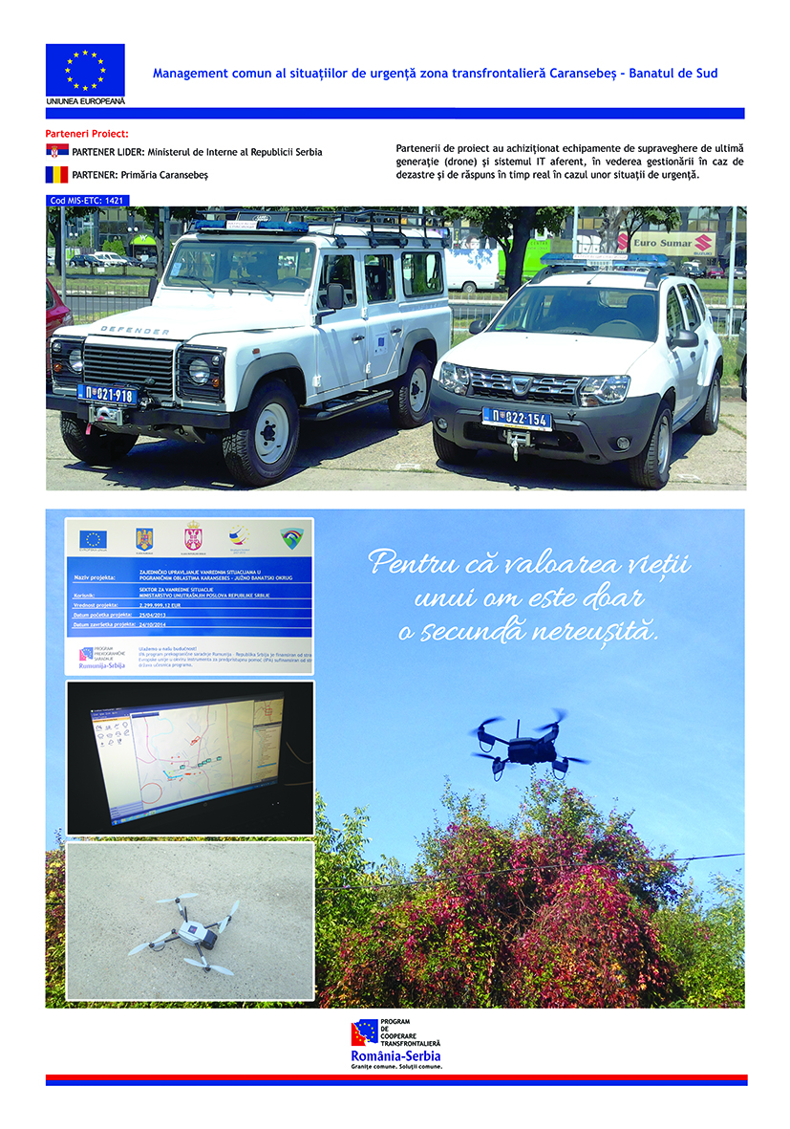

the implementation period (including extensions)
total funds spent/total funds contracted *100
indicators and level of achievement against targets set

