Project information
CALL FOR PROPOSALS | 2
MIS-ETC: | 1414
PRIORITY AXIS: | 3. Promoting “people to people” exchanges
MEASURE: | 3.3 Increase educational, social cultural and sporting exchanges
PROJECT TITLE: | Partnership for Promoting Green Energy in the Rural Area of the Romanian-Serbian Cross-border Region
ACRONYM: | GEROS
DURATION: | 06.10.2015 – 05.10.2016
IPA FUNDS CONTRACTED: | 159.214,13€
TOTAL FUNDS CONTRACTED: | 187.310,74€
ABSORBTION RATE (%): | 91,05%

PROJECT OBJECTIVE(S): | Increase the level of awareness and information regarding the use of green energy in rural areas by know-how transfer in the cross-border area.  Creation of a group of opinion leaders having know-how in the green energy domain.  Improvement of the infrastructure for insuring better cooperation and knowledge transfer regarding green energy in the cross-border area.  Supporting better preparation for people to develop new activities and to find new jobs in the green energy domain in the cross border-area.  Promoting the importance of using green energy sources for a sustainable development among the population in the cross-border area.

SHORT DESCRIPTION OF THE PROJECT: | Through this project was created a Green Energy Promotion and Counselling Centre, a virtual network focused on the cooperation between the partners in the field of Green Energy http://geros.ro/ro/acces-portal-geros-eu/, one study on the potential of renewable energy sources.

DEGREE OF ACHIEVEMENT OF INDICATORS: | Indicator Indicator value provisioned in the contract Present indicator value % 6= (5)/(3)*100  Output indicators (1) UM (2) Quantity (3) UM (4) Quantity (5)  Number of visits between partners for best practice exchange pc. 3 pc. 4 133.33%  Number of Centre for Promoting and Counselling developed in the partnership pc. 1 pc. 1 100%  Number of trainings for best practice dissemination pc. 2 pc. 2 100  Number of interactive information website regarding cross-border extracurricular activities within the project pc. 1 pc. 1 100  Result indicators  Increased social and cultural integration of people in the border areas Number of participants 200 Number of participants 284 142%  Increased cooperation between NGOs across the border in order to develop civil society capacity on border area Number of activities, action plans, initiatives. 2 Number of activities, action plans, initiatives 2 100%  Improved quality of life and increased attractiveness of the border communities as a living place Number of activities, actions, initiatives. 10 Number of activities, actions, initiatives 10 100%  Improved knowledge of culture, history, society, organizational and institutional structure, and language of the neighbouring country Number of participants gained knew knowledge in events. 40 Number of participants gained knew knowledge in events. 44 110%
RESULTS ACHIEVED: | - 3 presentation of opportunities for cooperation between NGO from Ioan Slavici Foundation and EkoPokretTorak at Zitiste and ROSENC Timișoara  - 10 presentation at Promotion and counselling centre in Zitiste  - 1 virtual network created;  - green energy promotion and counselling Centre;  - 2 training, 1 cross border caravan, 284 people informed about renewable energy problem, completed procurement for organizing of caravan;  - 1 school competition, 16 projects presented by participants;  - 1 study on the potential of renewable energy sources;  - 2 closing seminars in RO and SRB, respective 56 and 36 participants;  - Editing, designing, printing and distribution of Brochures for Study, training, Cross-border caravan (in RO, EN and SRB language), School project competition and closing seminars (RO-EN, SRB- EN)

Partnership information
 |  | COUNTRY | COUNTY/DISTRICT | BUDGET(EURO) | CONTACT DETAILS
LEAD PARTNER: | “Politehnica” University of Timisoara | Romania | Timis | 108.782,00 | Timisoara, P-ta Victoriei nr. 2  Tel. 0040-744.264.650
PARTNER 2: | Zitiste Municipality | Serbia | Central Banat | 49.583,74 | Zitiste, Cara Dusana 15  Tel. 00381-23-821-306
PARTNER 3: | “Ioan Slavici” Foundation for Culture and Education | Romania | Timis | 28.945,00 | Timisoara, 21 Dr. Ioan Bontila street ap.2  Tel. +40256/213108
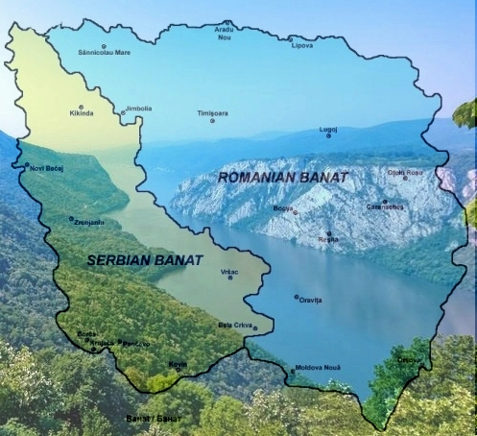
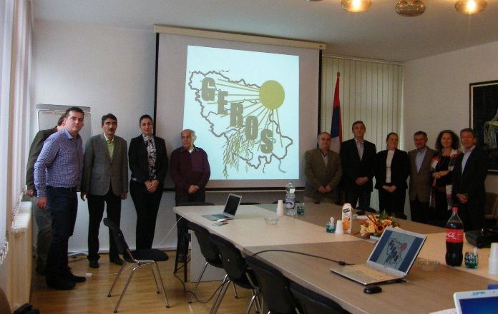
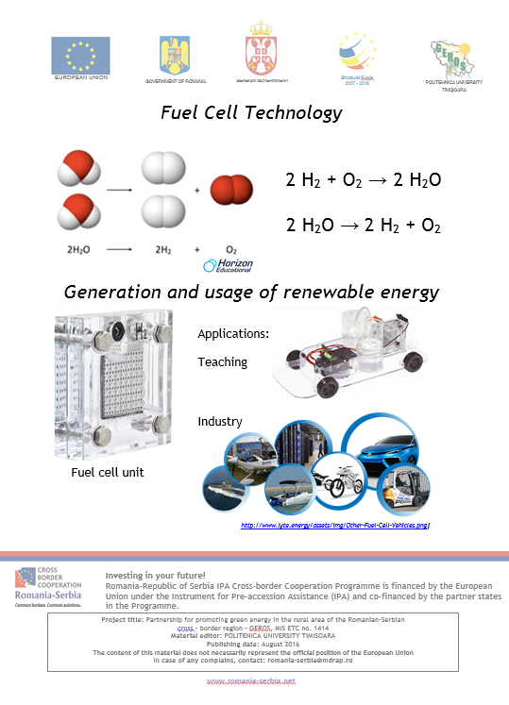
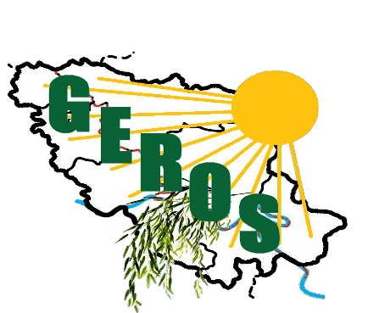

the implementation period (including extensions)
total funds spent/total funds contracted *100
indicators and level of achievement against targets set

