Project information
CALL FOR PROPOSALS | 2
MIS-ETC: | 1411
PRIORITY AXIS: | 3. Promoting “people to people” exchanges
MEASURE: | 3.3 Increase educational, social cultural and sporting exchanges
PROJECT TITLE: | Sustaining Excellence in Mathematical Education
ACRONYM: | SusMathEdu
DURATION: | 12.06.2013 – 11.12.2014
IPA FUNDS CONTRACTED: | 205548,87
TOTAL FUNDS CONTRACTED: | 241.822,20
ABSORBTION RATE (%): | 85,16

PROJECT OBJECTIVE(S): | Project succeed:  - to support the increase of knowledge exchange and resource sharing in the cross-border region amongst talented pupils from high schools from the Banat region and professors.  - to create joint educational material in order to improve the communication and exchange of information in the field of mathematic between talented pupils from high schools and professors from Banat region.  - To improve the quality of education in the field of mathematic in the border area.
SHORT DESCRIPTION OF THE PROJECT: | The project introduced interactive work with the high school pupils, focused on working with advanced and talented children, as an extension and not as a part of standard high school curricula. This project has been supported by a Mathematic portal providing constant and interactive work with the students, distribution of learning materials and online sessions. Through this portal pupils and students spent less time for searching information. They had the possibility to access directly materials, lessons in the field being organized on different levels and classes, to address professors from both countries having the possibility to put on-line questions. The Mathematic professors from the cross border region had the opportunity to work together and to prepare joint materials for the talented high school pupils different from the existent curricula, increasing the overall cooperation in the eligible area.

DEGREE OF ACHIEVEMENT OF INDICATORS: | Indicator Indicator value provisioned in the contract Present indicator value % 6= (5)/(3)*100  Output indicators (1) UM (2) Quantity (3) UM (4) Quantity (5)  Improved quality of life and increased attractiveness of the border communities as a living place Number of activities, actions, initiatives developing new or improving existing educational and social services, or improving other local living conditions 1 joint mathematical portal Number of activities, actions, initiatives developing new or improving existing educational and social services, or improving other local living conditions 1 100%  Improved knowledge of culture, history, society, organizational and institutional structure, and language of the neighbouring country Number of participants gained knew knowledge in events promoting/profiling the neighbouring country 400 users of the web portal Number of participants gained knew knowledge in events promoting/profiling the neighbouring country 535 133,75%  Result indicators  Solution integrated system for web portal Number 1 Number 1 100%  Pupils participating in workshops in Serbia and Romania Number 23 Number 27 115%  Weekly seminars with Olympic high school pupils in Timisoara Number 80 Number 131 163,80%  Pupils participating at weekly workshops – on line sessions Number 200 Number 221 110,5%

RESULTS ACHIEVED, INCLUDING PHOTOS: | R. 1. Meetings between all the partners  Seven working meetings were organized in Timisoara and Zrenjanin  R. 2. Workshops with pupils from Romania and Serbia  Two workshops with pupils from Romania and Serbia were organized.  R.3. The equipment items acquired  It was acquired: 7 Laptops, 2 Desktops, 1 Multifunctional office machine and 1 PC Multimedia System  R.4. Press conferences  Press conference was held after the Launching event in Zrenjanin at 20.11.2013, and during the Joint Workshop in Zrenjanin at 07.10.2014.  R.5 Conferences  Five conferences were organized. More information at: http://www.tfzr.uns.ac.rs/susmathedu/events.html  R.6 Workshops with pupils from High schools  Workshops were organized in six high schools in Banat, Romania and in Serbia for presenting the web portal to high school pupils and mathematics teachers and also examples of lectures and problems posted on the web portal. The workshops were held in period April-May 2014, with totally 354 participants (287 pupils). More information at: http://www.tfzr.uns.ac.rs/susmathedu/activities.html  R.7 Weekly on-line sessions  Sessions were conducted by math experts, while other team members provided necessary support.

Partnership information
 |  | COUNTRY | COUNTY/DISTRICT | BUDGET(EURO) | CONTACT DETAILS
LEAD PARTNER: | West University of Timisoara | Romania | Timiş | 171.559,20 | Timisoara, V. Parvan Bv. No. 4  Tel. 00.40.256.592.111
PARTNER 2: | Technical Faculty “Mihajlo Pupin” Zrenjanin | Serbia | Central Banat | 70.263,00 | Zrenjanin, Djure Djakovica bb  Tel. +38123550515
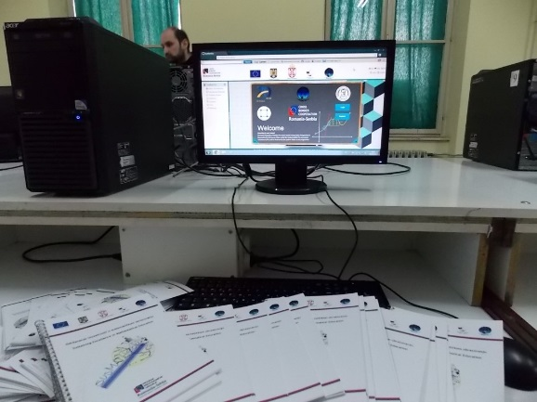
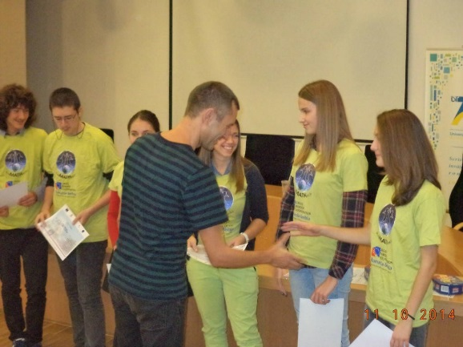
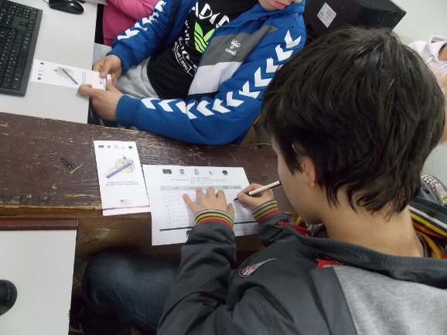
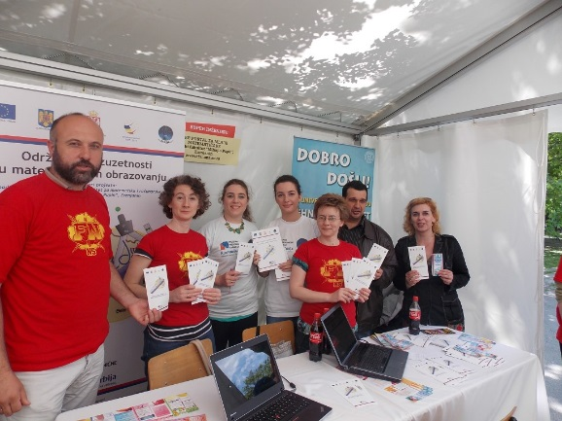
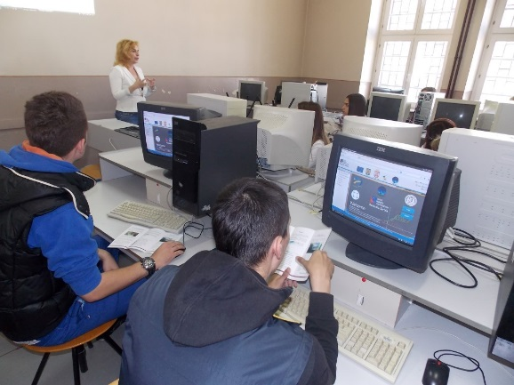
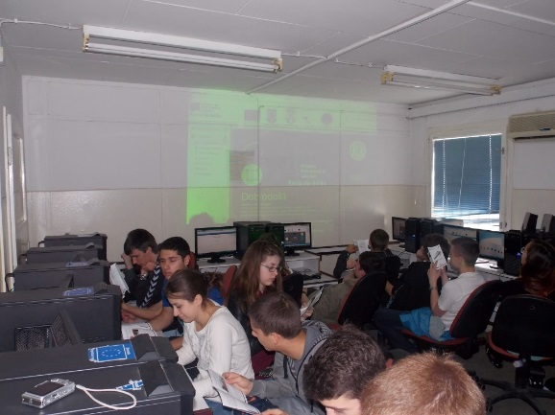
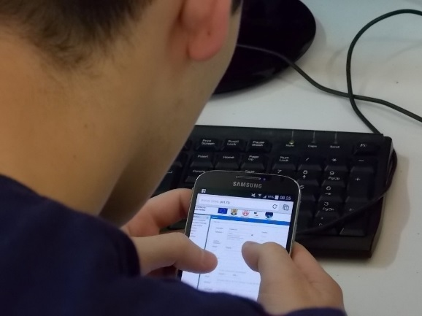
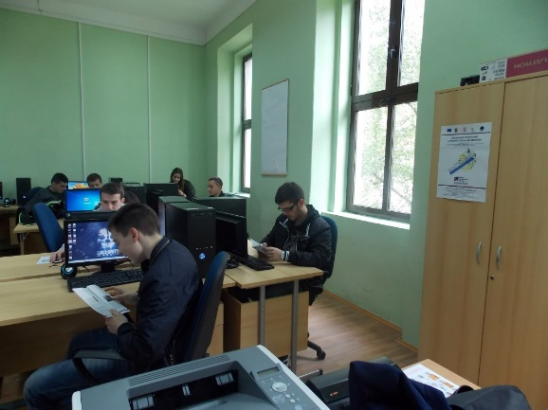

the implementation period (including extensions)
total funds spent/total funds contracted *100
indicators and level of achievement against targets set

