Project information
CALL FOR PROPOSALS |  | 2
MIS-ETC: |  | 1404
PRIORITY AXIS: |  | 3. Promoting “people to people” exchanges
MEASURE: |  | 3.3 Increase educational, social cultural and sporting exchanges
PROJECT TITLE: |  | Banat on the European Road
ACRONYM: |  | BER
DURATION: |  | 21.11.2013 – 20.11.2014
IPA FUNDS CONTRACTED: |  | 58.779,20€
TOTAL FUNDS CONTRACTED: |  | 69.152,00€
ABSORBTION RATE (%): |  | 92,44%
PROJECT OBJECTIVE(S): | - Increase in quality of education and implicitly in life quality by promoting cultural, educational and sports exchanges in both border regions.  - Getting to know cultural, historic, geographic identities, as well as the traditions within Serbian and Romanian ethnic minorities that are to be found in the two border regions by achieving a monographic work in common.  - Improvement of the teachers’ professional expertise in organizing extracurricular activities will be materialized in participation to common training workshops and also in encouraging any exchanges between partner institutions.  - Organizing meetings and exchanges between partner institutions by involving participants in sports, linguistic, artistic competitions as part of a children’s Olympics.  - Promoting cultural heritage and keeping local traditions alive with activities that sustain traditions of ethnics living in the border region.

SHORT DESCRIPTION OF THE PROJECT: | The project was born with the aim to develop sound collaborative intercultural activities in order to strengthen the relationship between the learning communities, including here schoolchildren and their parents, the teaching and supporting staff and their trainers, as well as representatives of public authorities from both sides of the border. The project involved pupils from both countries with ages between 8 and 15 years old, selected according to their interest in documentation and processing of information on The Banat Region (History, Geography, Ecology, Ethnography), to their language abilities, especially English language. Besides pupils, a number of 50 teachers from each partner country have been selected to implement the project according to their expressed interest and contribution to the design of the project, to their abilities to communicate in Serbian and/or English, to their specialization in the fields addressed by the project: (Pedagogy, History, Ethnology, Geography, Computer Studies, Photography, Journalism) and project management skills.

DEGREE OF ACHIEVEMENT OF INDICATORS: | Indicator Indicator value provisioned in the contract Present indicator value % 6= (5)/(3)*100  Output indicators (1) UM (2) Quantity (3) UM (4) Quantity (5)  Knowledge of the cultural, historical and geographic specific identity of both regions No. of persons implied in the project on both sides who have known the cultural, historical and geographical specific identity of both regions 500 No. of persons implied in the project on both sides who have known the cultural, historical and geographical specific identity of both regions 524 104,8%  No. of people who participated in the 2 larger joint activities in the project 200 No. of people who participated in the 2 larger joint activities in the project 291 145,5%  Improvement of professional training of teachers and their contribution to raising the quality of the educational process No. of teachers on both sides of the border who participated in the joint training workshops 161 No. of teachers on both sides of the border who participated in the joint training workshops 169 104,96%  The achievement of the monographic work at high quality professional level No. of copies distributed to schools 300 No. of copies distributed to schools 390 130%  Dissemination of the results of the good practice examples No. of people present at the dissemination activities 250 No. of people present at the dissemination activities 387 154,80%  Participation in 2 common activities with contribute to the development of social and communication competences and to valuing the children who are gifted in different areas No. of pupils who participated to the preparation of the monograph and to the other extracurricular activities 200 No. of pupils who participated to the preparation of the monograph and to the other extracurricular activities 339 169,50%  Improvement of key competencies (communication, intercultural, entrepreneurial) in children and teachers % of pupils and teachers realized the necessity to improve their key competencies (communication, intercultural, entrepreneurial) 25% % of pupils and teachers realized the necessity to improve their key competencies (communication, intercultural, entrepreneurial) From 161 teachers and 60 pupils 55 25% 100%  Discovery and supporting in both regions those pupils who have special gifts in different fields of human activity. Number of pupils, gifted in different fields who will participate in the planned activities 160 Number of pupils, gifted in different fields who will participate in the planned activities 160 100%  Extending the extracurricular activities to other institutions in both border regions number of school institutions from both border regions that will develop regularly joint extracurricular activities 40 number of school institutions from both border regions that will develop regularly joint extracurricular activities 44 110%
RESULTS ACHIEVED: | - The website of the project was designed, approved and launched at this address:  http://banateuropeanroad.ccd-timis.ro  2. Launching Conference was achieved with a participation of 101 persons (teachers and representatives of local authorities and of mass media) from both border regions.  3. Two professional development workshops were achieved in common with a view to promoting common cultural and natural heritage in the form of extracurricular activities and in cooperation with families. At least ¼ of all teachers of both border regions involved in the project improved communication and social skills and developed an entrepreneurial spirit. 96 teachers in both regions took part in a training course on how to improve organizing and developing extracurricular activities.  As a result, the quality of education and life in both regions increased. Following the workshops, a bilingual (Romanian - Serbian) publication was designed and printed in 100 copies containing the revised version of training textbooks. The publication is registered at Romanian National Library under ISBN codes: 978-606-93587-6-4 and ISBN: 978-973-108-578-4.  4. The students and expert teachers accomplished in common a monograph of Banat region including both border areas. The Monograph was published and offered to all participants at the Closing Conference a Closure event.  6. At least ¾ of all teachers, all the students and their parents, as well as other members of the communities of the 2 border regions found out about the specific of the cultural, historical and geographical identity  7. An Olympics for children in Banat was organized. This was included the following events:  - 1 science contest followed by a performance where habits and traditions from both regions was presented. 1/6 of all students from both partner regions involved in the project participated in these events.  - 2 sports competitions (Volleyball for girls and Football for boys), followed by a Final Conference

Partnership information
 |  | COUNTRY | COUNTY/DISTRICT | BUDGET(EURO) | CONTACT DETAILS
LEAD PARTNER: | Timiş County Teaching Corps Centre | Romania | Timiş | 44.934,00 | Timişoara, Piaţa Huniade nr. 3  Tel. 0040 256 490 452
PARTNER 2: | Centre for Professional Development Kikinda | Serbia | North Banat | 24.218,00 | Kikinda, Nemanjina 23  Tel. +381230404830

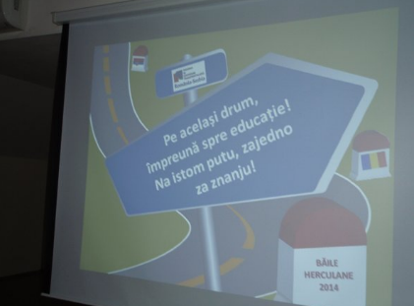
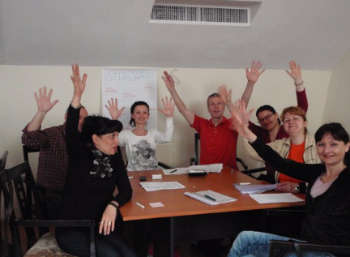
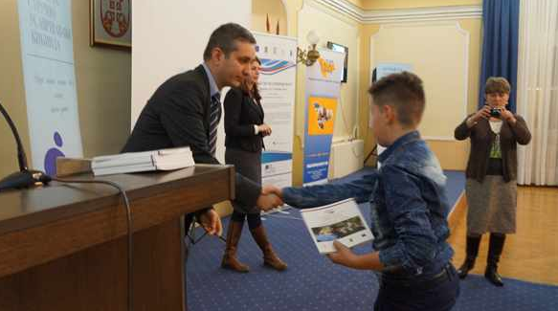

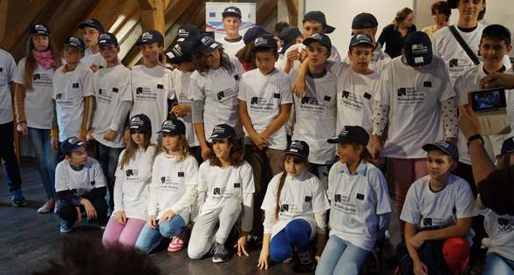
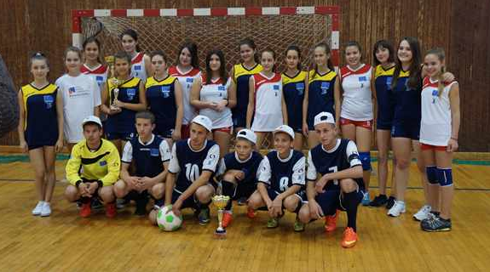
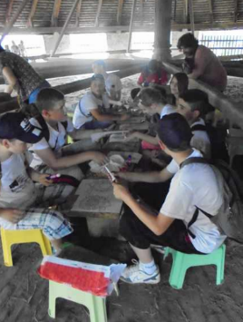
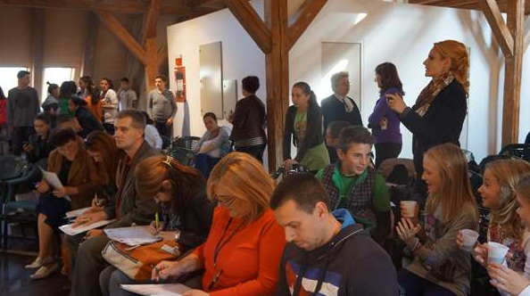
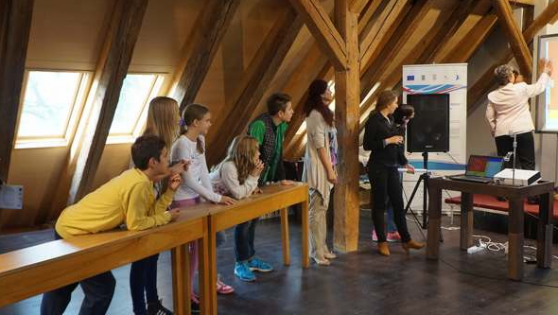

the implementation period (including extensions)
total funds spent/total funds contracted *100
indicators and level of achievement against targets set

