Project information
CALL FOR PROPOSALS |  | 2
MIS-ETC: |  | 1401
PRIORITY AXIS: |  | 3. Promoting “people to people” exchanges
MEASURE: |  | 3.3 Increase educational, social cultural and sporting exchanges
PROJECT TITLE: |  | BANAT’S CULTURAL PATRIMONY - A EUROPEAN PATRIMONY
ACRONYM: |  | BCP
DURATION: |  | 21.01.2014 – 20.07.2015
IPA FUNDS CONTRACTED: |  | 178.119,91€
TOTAL FUNDS CONTRACTED: |  | 209.552,84€
ABSORBTION RATE (%): |  | 65,95%
PROJECT OBJECTIVE(S): | Protection of the Banat Cultural Patrimony, by editing and disseminating a common trilingual monography in 3000 copies, organisation of 5 promotion events (2 scientific conferences and 3 exhibitions and conducting an intense promotion campaign on both shores of the Danube during 18 months).  Identification and adequate signalling of minimum 20 Romanian Cultural sights and monuments (Roman castrum and churches and monasteries) and of minimum 50 Serbian cultural sights and monuments during a period of 18 months.
SHORT DESCRIPTION OF THE PROJECT: | The project realised a signalling and tagging of monuments at an ampler and more diverse scale than the one already existing. The project also targeted the ecclesiastic, archeologic and industrial patrimony of the Banat province. Furthermore, the project had a special component, addressed to the local public administrations, which manage the historical patrimony of the area, raising the awareness related to the importance of the management of this segment of the public administration activity through the actions implemented. Identifying and signalling the monuments led to the knowledge and recognition on the spot of the monuments by a wide public who comes in contact individually or in organised groups with the historical monuments of the Banat region.

DEGREE OF ACHIEVEMENT OF INDICATORS: | Indicator value provisioned in the contract Present indicator value % 6= (5)/(3)*100  Output indicators (1) UM (2) Quantity (3) UM (4) Quantity (5)  Result indicators  Increased people-to-people exchange in the fields of education, culture and sports Persons participating in the events organised in the project 410 persons Persons participating in the events organised in the project 513 125%  Project indicators  Increased social and cultural integration of people in the border areas Number of Romanian and Serbian researches attending the 5 events organised in the project 40 specialists and researchers in the domain of protection of Romanian and Serbian cultural assets Number of Romanian and Serbian researches attending the 5 events organised in the project 79 197%  Improved knowledge of culture, history, society, organisational and institutional structure, and language of the neighbouring country Increase if the level of awareness and interest on the importance of protecting cultural assets in the two border areas. Total number of persons beneficiaries of all the events of the project, including the media campaign Min. 100,000 citizens (50,000 RO and 50,000 SE) Total number of persons beneficiaries of all the events of the project, including the media campaign 200000 200%  Increase of the level of awareness on the importance to signal and protect the monuments in their locality. Number of mayors and local councillor in the localities where tagging plates will be placed on monuments 770 persons (70 mayor and min 700 local councillors) Number of mayors and local councillor in the localities where tagging plates will be placed on monuments 1366 177%  Increase of the awareness degree of the citizens from the 70 localities on the importance to protect the monuments in their locality Number of citizens who will gain further awareness regarding the importance of the efforts to protect the monuments in their locality Around 42,000 citizens of the 70 localities where monuments will be tagged Number of citizens who will gain further awareness regarding the importance of the efforts to protect the monuments in their locality 63531 159%  Increase of the information degree of young people from Resita and Pancevo as regards the importance of knowing and protecting Banat’s cultural patrimony Number of students / young participants in the events organised in the project from Resita and Pancevo (the 5 manifestations conferences and exhibitions in Resita and Pancevo) min. 300 students from UEM and University of Pancevo Number of students / young participants in the events organised in the project from Resita and Pancevo (the 5 manifestations conferences and exhibitions in Resita and Pancevo) 300 100%

RESULTS ACHIEVED: | At least 200.000 persons were informed on the importance of the protection of the assets beginning to the Banat European cultural patrimony in the Downstream Danube area.  Identification and signalling of a number of 70 historical cultural sights and monuments (20 Romanian and 50 Serbian) for the awareness and recognition on the field of the monuments by people who come in contact with them individually or in organised groups  The trilingual monography BANAT'S CULTURAL PATRIMONY A EUROPEAN PATRIMONY was elaborated and published in 3000 copies, and has 317 pages, with 5 chapters (http://www.banatsculturalpatrimony.rs )  Organisation of 5 promotion events for the specialists in the domain and the general public  Raising the awareness and attention of Romanian local authorities which mange these sights and monuments acc. to Law of historical monuments no. 422/2001 and Serbian local authorities on the importance to preserve and elaborate a salvation and conservation strategy for the sights of the Banat cultural patrimony, a European patrimony

Partnership information
 |  | COUNTRY | COUNTY/DISTRICT | BUDGET(EURO) | CONTACT DETAILS
LEAD PARTNER: | “Eftimie Murgu” University of Resita | Romania | Caras-Severin | 152.989,28 | Resita, Traian Vuia Square 1-4  Tel. 0722341273
PARTNER 2: | Institute For The Protection Of Cultural Monuments Pancevo | Serbia | South Banat | 31.334,76 | Pancevo, Zarka Zrenjanina 17  Tel. 00381/13351472
PARTNER 3: | Caras-Severin County Council | Romania | Caras-Severin | 25.228,80 | Resita, Str. P-ţa 1 Dec. 1918, nr. 1  Tel. +40 255 213776

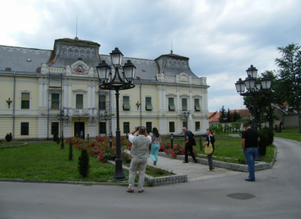
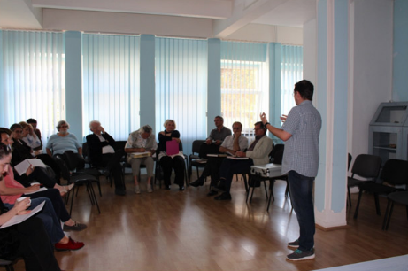
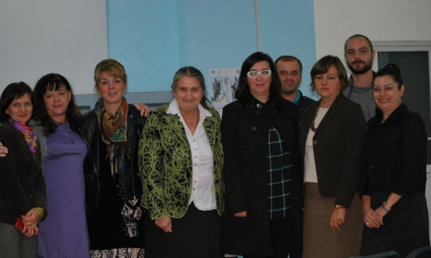
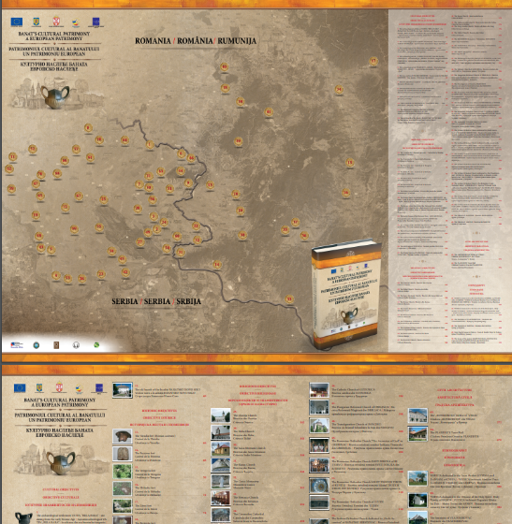
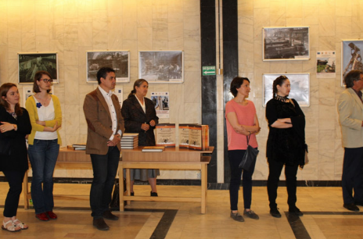
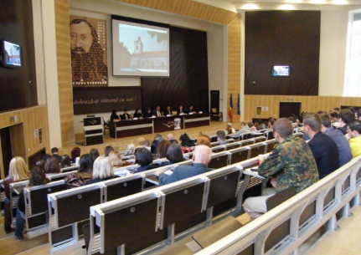

the implementation period (including extensions)
total funds spent/total funds contracted *100
indicators and level of achievement against targets set

