Project information
CALL FOR PROPOSALS | 2
MIS-ETC: | 1393
PRIORITY AXIS: | 3. Promoting “people to people” exchanges
MEASURE: | 3.2 Improve local governance in relation to the provision of local services to communities in the border areas
PROJECT TITLE: | Cultural Policy as a Tool for Community and Regional Development
ACRONYM: | Poles of Cultures
DURATION: | 06.06.2013 – 05.12.2014
IPA FUNDS CONTRACTED: | 267.649,28€
TOTAL FUNDS CONTRACTED: | 314.881,50€
ABSORBTION RATE (%): | 90,10%

PROJECT OBJECTIVE(S): | Contribution to the cultural and social cohesion of Romania-Serbia cross-border area by promoting a policy cooperation and an active participation in the development.  To improve the quality of public services delivery in the field of culture.  To raise the professional competences of the public employees and decision makers of the CBC area in the modern public policies cycle.  To raise the civil society capacities to play an active role in the process of elaboration, implementation and evaluation of public policies.  To promote the European values as catalysts for cooperation and EU integration.

SHORT DESCRIPTION OF THE PROJECT: | Through implementation of this project the partners improved the quality of public services delivery in the field of culture, promoted the European values as catalysts for cooperation and EU integration developing a Cultural strategy for Timisoara and Zrenjanin, the Cultural Cooperation Protocol, the Pilot Action “Banat Pavilion” – Contemporary Art Scene of Banat.
Short video about the project |  | https://www.youtube.com/watch?v=B9T3iZ5Jvy8

DEGREE OF ACHIEVEMENT OF INDICATORS: | Indicator Indicator value provisioned in the contract Present indicator value % 6= (5)/(3)*100  Output indicators (1) UM (2) Quantity (3) UM (4) Quantity (5)  Participatory public policy cycle, open to NGOs Number of NGOs involved in public policy cycle 50 Number of NGOs involved in public policy cycle 79 158%  Participatory public policy cycle, open to cultural institutions Number of cultural public institutions 50 Number of cultural public institutions 52 104%  Researches in the field of cultural policies in the region Research manager’s report on the conclusions of the four researches (Timisoara, Zrenjanin, Pančevo and Vršac) 1 Research manager’s report on the conclusions of the four researches (Timisoara, Zrenjanin, Pančevo and Vršac) 1 100%  Result indicators UM Quantity UM Quantity %  Increased social and cultural integration of people in the border areas Number of participants benefiting from cross-border social and cultural events 130 24 young people 20 public employees Min. 15 artists 10 team members Min. 20 participants to Pancevo round table Min. 50 participants to final conference in Timisoara 24 young people 20 public employees 16 artists 14 team members 70 participants to Pancevo round table 179 participants to final conference in Timisoara Total 323 248%  Increased cooperation between local and regional public authorities across the border to finding solutions to joint local problems in the border area Number of activities, actions, initiatives between local and regional public authorities in tackling joint problems, improving local service provision etc. 7 1 training for public employees 2 cultural strategies (Timisoara and Zrenjanin) 2 conferences (Pancevo and Timisoara) 1 Joint agenda of the cultural offer in the four location 1 Cultural Cooperation Protocol 1 training for public employees 2 cultural strategies (Timisoara and Zrenjanin) 2 conferences (Pancevo and Timisoara) 1 Joint agenda of the cultural offer in the four location 1 Cultural Cooperation Protocol 100%  Increased cooperation between NGOs across the border in order to develop civil society capacity on border area Number of activities, action plans, initiatives between NGOs in building capacity of civil society organisations, promoting local governance and civil rights. 5 4 public debates in Vršac 1 NGO action plan in Vršac 4 public debates in Vršac 1 NGO action plan in Vršac 100%  Improved quality of life and increased attractiveness of the border communities as a living place Number of activities, actions, initiatives developing new or improving existing educational and social services, or improving other local living conditions 14 4 researches in Timisoara, Zrenjanin, Pančevo and Vršac 6 focus groups (3 in Timisoara, 3 in Zrenjanin) 1 training for public employees 2 strategies (Timisoara and Zrenjanin) 1 Action Plan (Pančevo) 4 researches 14 focus groups in Timisoara 6 focus groups in Zrenjanin 1 training for public employees 2 strategies (Timisoara and Zrenjanin) 1 Action Plan (Pančevo) Total 28 200%  Improved knowledge of culture, history, society, organisational and institutional structure, and language of the neighbouring country Number of participants gained new knowledge in events promoting/profiling the neighbouring country 130 24 young people 20 public employees Min. 15 artists 10 team members Min. 20 participants to Pančevo round table Min. 50 participants to final conference in Timisoara 24 young people 20 public employees 16 artists 14 team members 70 participants to Pančevo round table 179 participants to final conference in Timisoara Total 323 248%
RESULTS ACHIEVED: | Researches were conducted in Timisoara (and Timis County), Zrenjanin, Pancevo and Vrsac and comparative research conclusion were published;  Experts involved in strategic planning, along with partners, trained;  Action plan for implementation of the existing cultural strategy in Pancevo, revised;  Public employees trained in project management;  Young leaders from the cross-border region, trained on active civic participation;  Research package conclusions published;  Action plan for civil society involvement in shaping public policies in Vrsac, finalised;  Cultural strategies for Timisoara and Zrenjanin, adopted and published;  Contemporary works of artists from the four locations, chosen through open call and exhibited;  Joint agenda of the cultural offer in the four locations, published;  Cultural cooperation Protocol, signed.  All the activities implemented in the framework of the Poles of Cultures project, with the support of Romania - Republic of Serbia IPA Cross-Border Cooperation Programme can also be seen as a significant contribution to the decision to award the Title of European Capital of Culture to the city of Timisoara for 2021. The fact that Novi Sad was also designated as European Capital of Culture in the same year, is putting the entire culture of the historical Banat region and of the cross-border region between Romania and Serbia in the spotlight at European level.  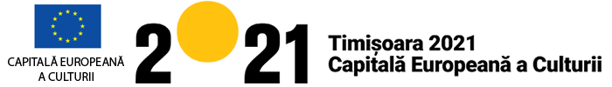

Partnership information
 |  | COUNTRY | COUNTY/DISTRICT | BUDGET(EURO) | CONTACT DETAILS
LEAD PARTNER: | Intercultural Institute Timisoara (IIT) | Romania | Timis | 144.902,50 | Timisoara, Bul. 16 Decembrie 1989, No. 8  Tel. 0256 498457
PARTNER 2: | Municipality of Timisoara | Romania | Timis | 70.169,50 | Timisoara, C.D.Loga nr.1  Tel. 0040256 204886
PARTNER 3: | City of Zrenjanin | Serbia | Middle Banat | 37.869,50 | Zrenjanin, Trg slobode 10  Tel. +381 23 3150097
PARTNER 4: | City of Pancevo | Serbia | South Banat | 41.494,50 | Pancevo, Trg Kralja Petra I 2-4  Tel. +38113308795
PARTNER 5: | Civic Parliament Vrsac | Serbia | South Banat | 20.445,50 | Vrsac, Feliksa Milekera no. 27  Tel. 013836317

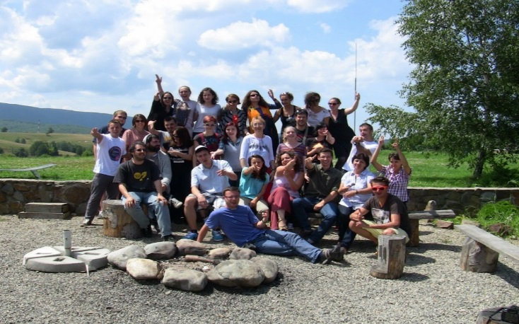
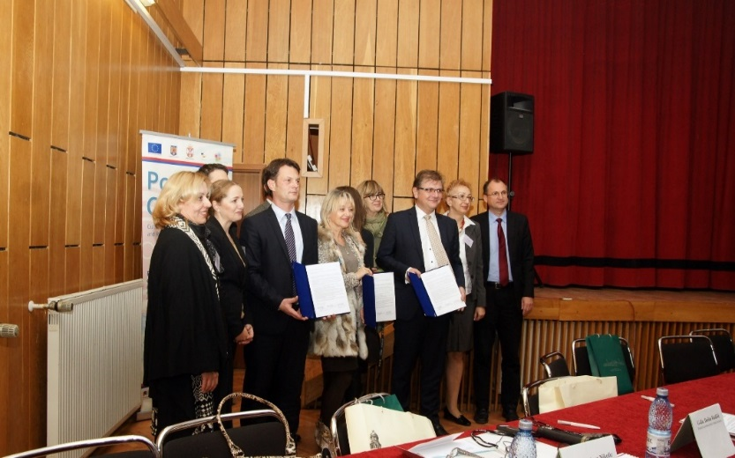
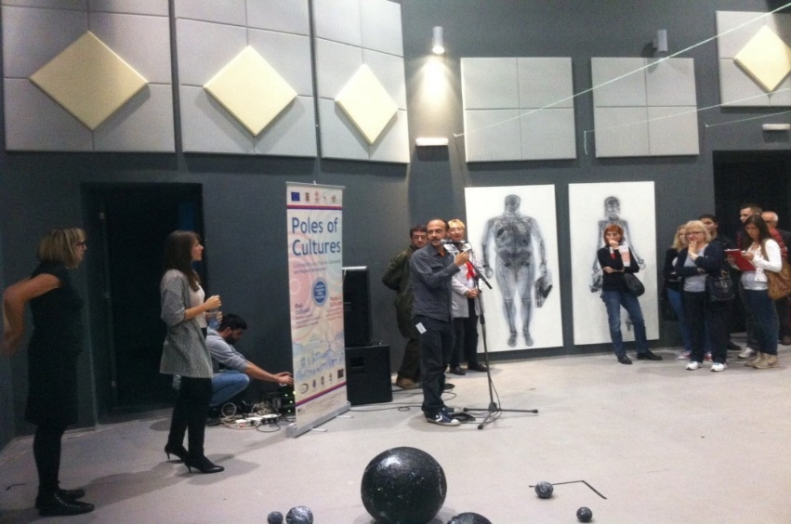
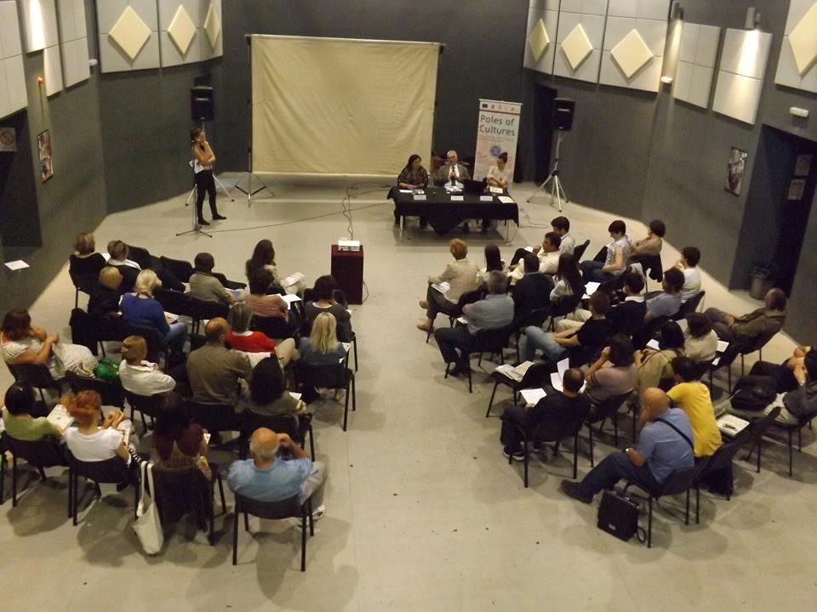
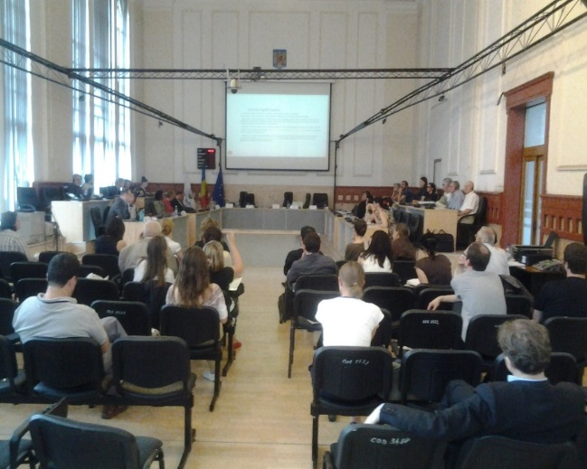
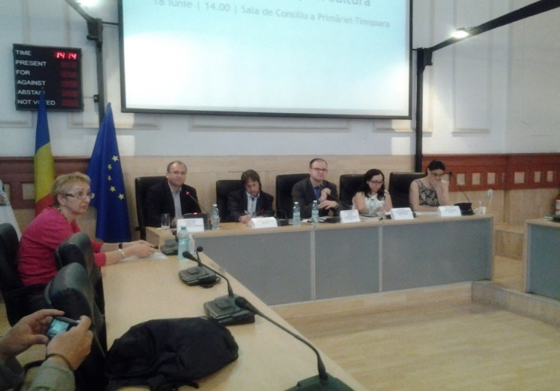
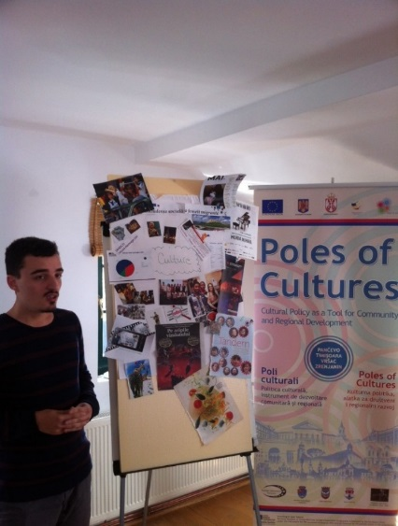

the implementation period (including extensions)
total funds spent/total funds contracted *100
indicators and level of achievement against targets set

