Project information
CALL FOR PROPOSALS | 2
MIS-ETC: | 1388
PRIORITY AXIS: | 1.Economic and Social Development
MEASURE: | 1.1 Support for local/regional economic and social infrastructure
PROJECT TITLE: | Introduction of modern transport technologies in Logistic connections of Banat
ACRONYM: | IMTILOCB
DURATION: | 12.06.2013 – 11.09.2014
IPA FUNDS CONTRACTED: | 258.195,15
TOTAL FUNDS CONTRACTED: | 303.759,00
ABSORBTION RATE (%): | 92,71
PROJECT OBJECTIVE(S): | To contribute to the socio-economic development of the region and to create conditions for faster economic development of the region by introducing modern technologies in transport.  To create conditions for the development of a high quality and efficient transportation service with the participation of all three systems – transport sectors (rail, road and water).  Mutual recognition of public authorities in Vrsac (Serbia) and Resita (Romania) as natural partners in economic and social collaboration through different joint investment programs.
SHORT DESCRIPTION OF THE PROJECT: | Within this project conditions were created for introductions of modern technologies in cross- border transport infrastructure in the form of an Intermodal Terminal in Vrsac and Logistic Centre in Resita by financing the Feasibility and Opportunity Studies.  Having in mind that the railroad between Serbia and Romania was passing through Vrsac, and the most goods between the two countries were transported that way, creation of this infrastructure had an impact on the regional economic development. Also a Study tour was organized by the partners in Austria, Slovenia an Italy to other intermodal centres in the EU.
DEGREE OF ACHIEVEMENT OF INDICATORS: | Indicator Indicator value provisioned in the contract Present indicator value % 6= (5)/(3)*100  Output indicators (1) UM (2) Quantity (3) UM (4) Quantity (5)  Feasibility studies regarding intermodal terminal and logistic centre in Vrsac and Resita Study 2 Study 2 100%  Result indicators  New or improved cross-border transport links and logistics capacity in the border area Feasibility of investment in new transport facilities proved 2 Feasibility of investment in new transport facilities proved 2 100%  New or improved cross-border transport links and logistics capacity in the border area Increased capacity of key local officials regarding IM terminals achieved 15 Increased capacity of key local officials regarding IM terminals achieved 15 100%
RESULTS ACHIEVED: | Two feasibilities studies created.  Increased capacities of relevant local authorities regarding the importance of modern transportation technologies implementation was achieved by performing the Study Visit to three modern Intermodal Facilities in Austria, Slovenia and Italy.  Increased awareness of the general, expert and business sector public regarding the benefits of implementation of modern technologies in the region.

Partnership information
 |  | COUNTRY | COUNTY/DISTRICT | BUDGET(EURO) | CONTACT DETAILS
LEAD PARTNER: | Municipality of Vrsac | Serbia | South Banat | 237.149,00 | Vrsac, TrgPobede 1  Tel. +381 (0) 13 800-501
PARTNER 2: | Caras-Severin County Council | Romania | Caras-Severin | 66.610,00 | Resita, P-ta 1 Decembrie 1918 nr. 1  Tel. 0255 211420
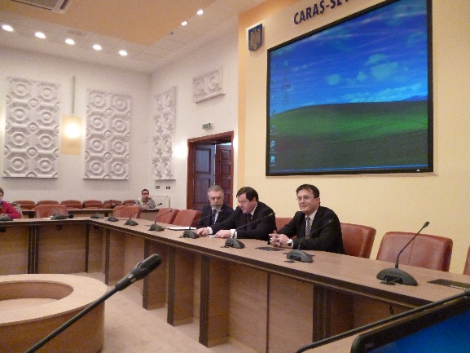
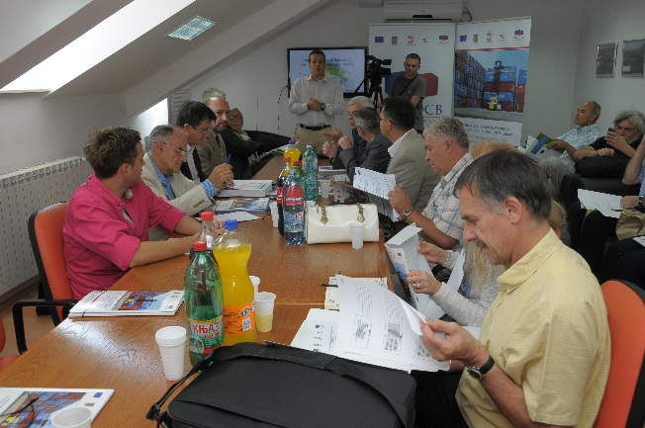
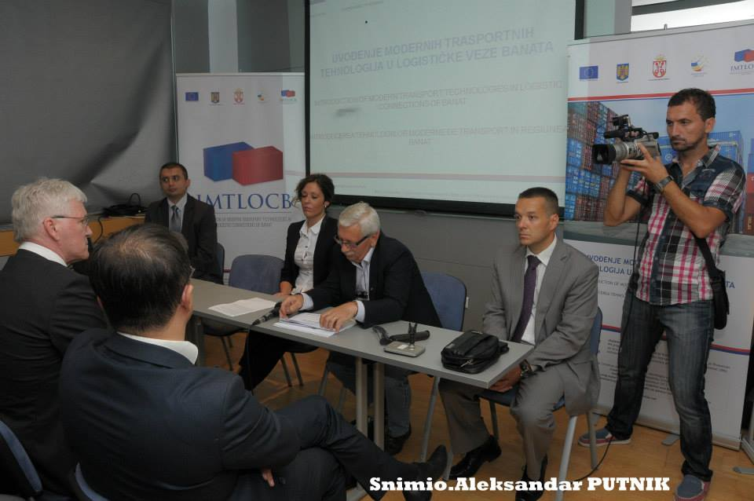

the implementation period (including extensions)
total funds spent/total funds contracted *100
indicators and level of achievement against targets set

