 | Project information
 | CALL FOR PROPOSALS |  | 2
 | MIS-ETC: |  | 1381
 | PRIORITY AXIS: |  | 3. Promoting “people to people” exchanges
 | MEASURE: |  | 3.1 Support the development of civil society and local communities
 | PROJECT TITLE: |  | EU MEDIA BRIDGE
 | ACRONYM:
 | DURATION: |  | 28.08.2013 – 27.08.2014
 | IPA FUNDS CONTRACTED: |  | 235.434,53
 | TOTAL FUNDS CONTRACTED: |  | 276.981,80
 | ABSORBTION RATE (%): |  | 83,14
 | PROJECT OBJECTIVE(S): |  | Developing communication networks between cross-border local communities and establishing a new way to exchange information.  Start-up cross-border interactive radio shows and newspaper for information exchange.  Raising the quality of education of journalists and media technicians in the border area through education and technical equipment.  Adjustment of standards and qualities that are prescribed conditions and standards for electronic media in the European Union in the process of digitizing.
 | SHORT DESCRIPTION OF THE PROJECT: |  | Partners established the cross-border radio information program called “Begej waves” (an interactive radio show) that addressed the problems of the border areas for both population groups and gave possible solutions to all interested. Also School of Journalism: “Language in Banat media”, media camp “Free words – free thought”, workshops for journalists, seminars, roundtables were organized and specific technical equipment was purchased - computers, printer, scanner, photocopier, sound system, projector, LCD, microphone, recorders.
 | DEGREE OF ACHIEVEMENT OF INDICATORS: |  | Indicator Indicator value provisioned in the contract Present indicator value % 6= (5)/(3)*100  Output indicators (1) UM (2) Quantity (3) UM (4) Quantity (5)  Improving the professional training of journalists and sound technician who are able to contribute to the quality media Number of journalists Number of sound technician in both regions who participated in training seminars Number of music editors 60 25 10 Number of journalists Number of sound technician in both regions who participated in training seminars Number of music editors 157 34 20 261% 136 % 200%  Disseminate examples of good practice and encourage experience exchange Number of joint seminars of information and organisations in the project Number of round tables organized in the project special workshops 3/7parts 1 2 Number of joint seminars of information and organisations in the project Number of round tables organized in the project special workshops 3/7 parts 1 2 100 % 100% 100%  Sharing experiences from projects % of the participants presented reports on the experience gained in carrying out projects specific to the event 50% % of the participants presented reports on the experience gained in carrying out projects specific to the event 60% 120%  Activities in order to discover students for events % of students participants on all events in both regions 30% % of students participants on all events in both regions 30% 100%  Improving social and communication skills and developing spirit of competition and tolerance % of participants are aware of the necessity of improving social and communication skills and developing spirit of competition and tolerance 50% % of participants are aware of the necessity of improving social and communication skills and developing spirit of competition and tolerance 60% 120 %  Lifting of journalism at the highest peaks of performance No of students (in both regions), very talented, for journalism and technical personnel 10 from both regions No of students (in both regions), very talented, for journalism and technical personnel 34 170%  Encourage the exchange of information between the two regions Participation of media number of radio shows number of issued and distributed magazine per year 5 local 5 from province 15 national 52 per year 72000 pieces participation of media number of radio shows number of issued and distributed magazine per year 20 17 15 56 72000 400 % 340 % 100 % 107% 100%  Result indicators  Improving communication skills in Serbian language for Serbian journalists and sound technician in Timis County No of Serbian journalists and sound technician Timis County that have improved their communication skills in Serbian language 80 No of Serbian journalists and sound technician Timis County that have improved their communication skills in Serbian language 80 100%  Improving communication skills in Romanian language for Romanian journalists and sound technician in Central Banat No of Romanian journalists and sound technician in Central Banat that have improved their communication skills in Romanian language 60 No of Romanian journalists and sound technician in Central Banat that have improved their communication skills in Romanian language 123 205%  Knowledge of national, historical, geographical and religious particularities of both regions No of participants familiarized with national ,historical, geographical and religious particularities of both regions 80 No of participants familiarized with national, historical, geographical and religious particularities of both regions 90 112,5%  Familiarising with the our system and with journalists and sound technician in both regions No of participants that familiarised with the education system and with journalists and sound technician in both regions 80 No of participants that familiarised with the education system and with journalists and sound technician in both regions 90 112,5%
 | RESULTS ACHIEVED: |  | Journalism School: “Language in the Banat medias”;  Interactive programs were established;  Starting the cross-border magazine: “BEGEJ PRESS-BEGA PRES”;  Seminars: “Journalist approach to EU integration subject on local level”;  Roundtable “Position of Radio Station in Serbia/Romania in Timisoara”;  “Media camp” conducted in Buzias;  The media presentation of project results in Zrenjanin.
Partnership information
 |  |  |  | COUNTRY | COUNTY/DISTRICT | BUDGET(EURO) | CONTACT DETAILS
LEAD PARTNER: |  | Public company “Radio Zrenjanin” |  | Serbia | Middle Banat | 151.866,20 | Zrenjanin, 1 Narodne omladine  Tel. +381 23 5 111 78
PARTNER 2: |  | The Regional Centre for Continuous Training Of Local Public Administration Timisoara |  | Romania | Timis | 125.115,60 | Calea Sever Bocu, nr. 49, Timisoara, Romania;  Tel. +40256 200 282;

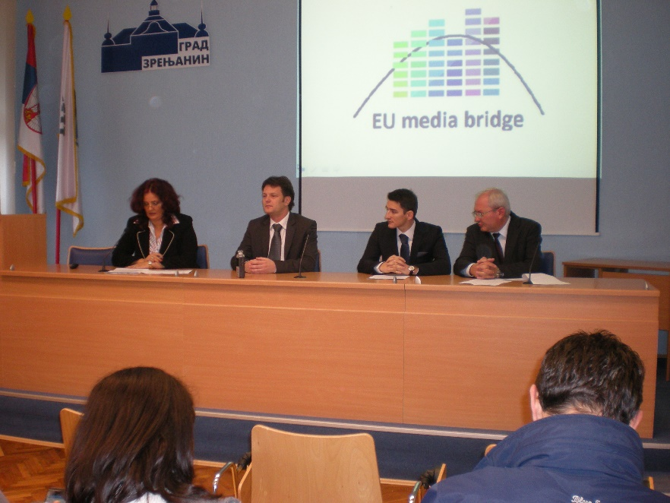
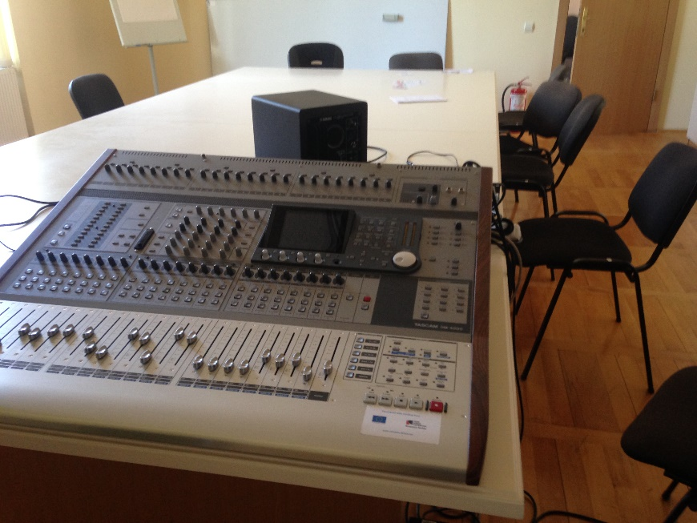
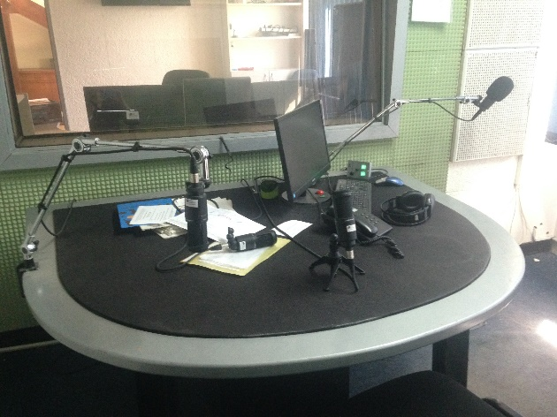

the implementation period (including extensions)
total funds spent/total funds contracted *100
indicators and level of achievement against targets set

