Project information
CALL FOR PROPOSALS |  | 2
MIS-ETC: |  | 1365
PRIORITY AXIS: |  | 3. Promoting “people to people” exchanges
MEASURE: |  | 3.1 Support the development of civil society and local communities
PROJECT TITLE: |  | EuroBanat Internet TV
ACRONYM: |  | EB-ITV
DURATION: |  | 01.05.2013 – 31.10.2014
IPA FUNDS CONTRACTED: |  | 293.658,00 €
TOTAL FUNDS CONTRACTED: |  | 345.480,00 €
ABSORBTION RATE (%): |  | 82,13%
PROJECT OBJECTIVE(S): | To provide innovative cross-border information services through advanced broadcasting technologies.  To improve the multilingual communications, information supply and awareness in the border region through delivery of high quality media content.
SHORT DESCRIPTION OF THE PROJECT: | With this project partners managed to start-up a regional multilingual television station, and in this way the project managed to open-up the access to quality multilingual broadcasting service in the region by creating a high-quality digital medium through which information could be more easily located and retrieved. In order to achieve all project results, the partners procured specific equipment’s such as: Shooting-filming set TV Media desk system, Audio system, HD Broadcasting system, editing system, Studio lightning system, Mobile lightning set, Cable system for television (video cables, adapters, power cables) and organized 12 Journalism and television courses. A Joint Editorial Board was created with the journalists and TV experts from Timisoara and Zrenjanin, and also media services offices in both Zrenjanin and Timisoara.  The Production of TV programme is covering the following subjects: Regional/Cross-border cooperation, Culture & Arts, Education & News and information.

DEGREE OF ACHIEVEMENT OF INDICATORS: | Indicator Indicator value provisioned in the contract Present indicator value % 6= (5)/(3)*100  Output indicators (1) UM (2) Quantity (3) UM (4) Quantity (5)  Development of new information / communication network – Euro Banat Internet TV Number of regional multilingual internet television 1 Number of regional multilingual internet television 1 100%  Number of new media services offices formed 2 Number of new media services offices formed 2 100%  Number of average multilingual broadcast hours per month 91.5 Number of average multilingual broadcast hours per month 120 131%  Number of expert publications regarding media standards and policies 1 Number of expert publications regarding media standards and policies 1 100%  Number of trainings in journalism and television 12 Number of trainings in journalism and television 12 100%  Number of people trained 40 Number of people trained 40 100%  Promotion of new on-line media service in the Romania-Serbia cross-border region Number of sets of promotional materials 2 Number of sets of promotional materials 2 100%  Number of publicizing actions 4 Number of publicizing actions 4 100%  Result indicators UM (2) Quantity (3) UM (4) Quantity (5) %  Improved quality of life and increased attractiveness of the border communities as a living place Number of activities, actions, initiatives developing new or improving existing educational and social services, or improving other local living conditions - 1 new multilingual information and news service - 1 new internet-based TV programme related to the regional culture, cooperation, art, education Number of activities, actions, initiatives developing new or improving existing educational and social services, or improving other local living conditions - 1 new multilingual information and news service - 1 new internet-based TV programme related to the regional culture, cooperation, art, education 100%  Improved knowledge of culture, history, society, organisational and institutional structure, and language of the neighbouring country Number of participants gained new knowledge in events promoting/ profiling the neighbouring country - 40 young people trained in journalism and television courses - audience, citizens of Banat region, over 500.000 people with access to Internet Number of participants gained new knowledge in events promoting/ profiling the neighbouring country - 40 young people trained in journalism and television courses - audience, citizens of Banat region, over 500.000 people with access to Internet 100%

RESULTS ACHIEVED, INCLUDING PHOTOS: | First multilingual Romanian-Serbian Internet Television established and broadcast started;  Journalism and television courses organized;  Euro Banat Internet TV guidelines prepared and published.

Partnership information
 |  | COUNTRY | COUNTY/DISTRICT | BUDGET(EURO) | CONTACT DETAILS
LEAD PARTNER: | City of Zrenjanin | Serbia | Middle Banat | 183.190,00 | Zrenjanin, Trg slobode 10  Tel. +381 23 564 585
PARTNER 2: | Business Incubator Zrenjanin | Serbia | Middle Banat | 76.920,00 | Zrenjanin, K.A.I Karađorđevića 2  Tel. +38123512260
PARTNER 3: | Fii Mehedintiului Association | Romania | Timiş | 85.370,00 | Timisoara, str. Enric Baader, nr.13  Tel. 0040749.272.199
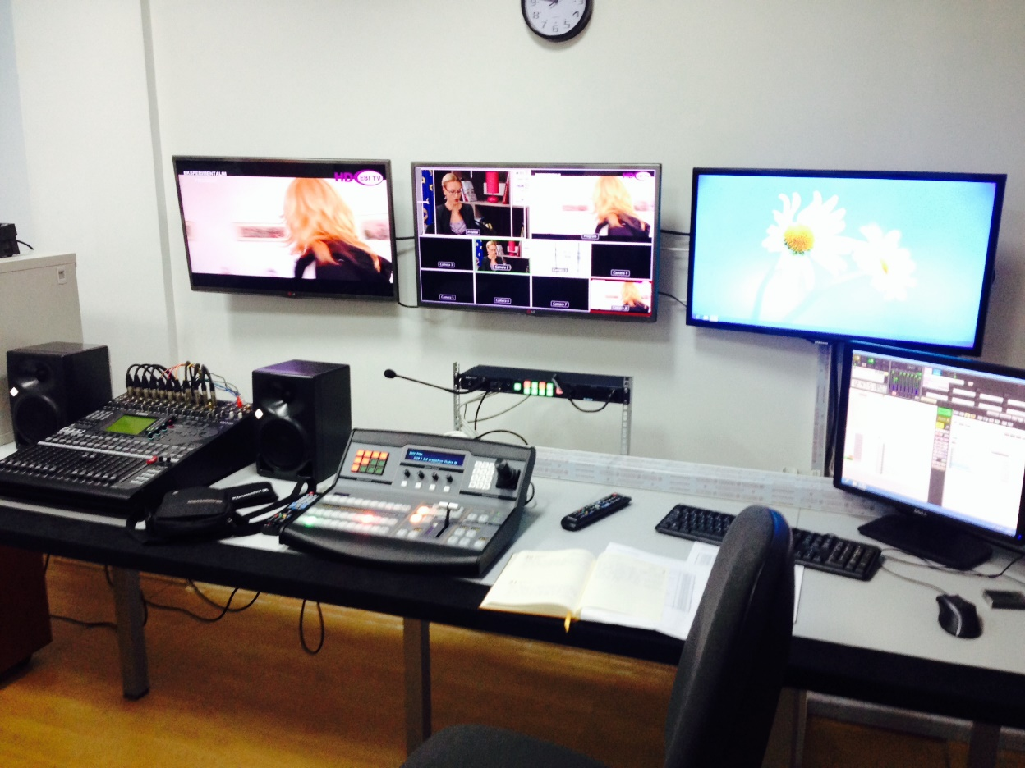
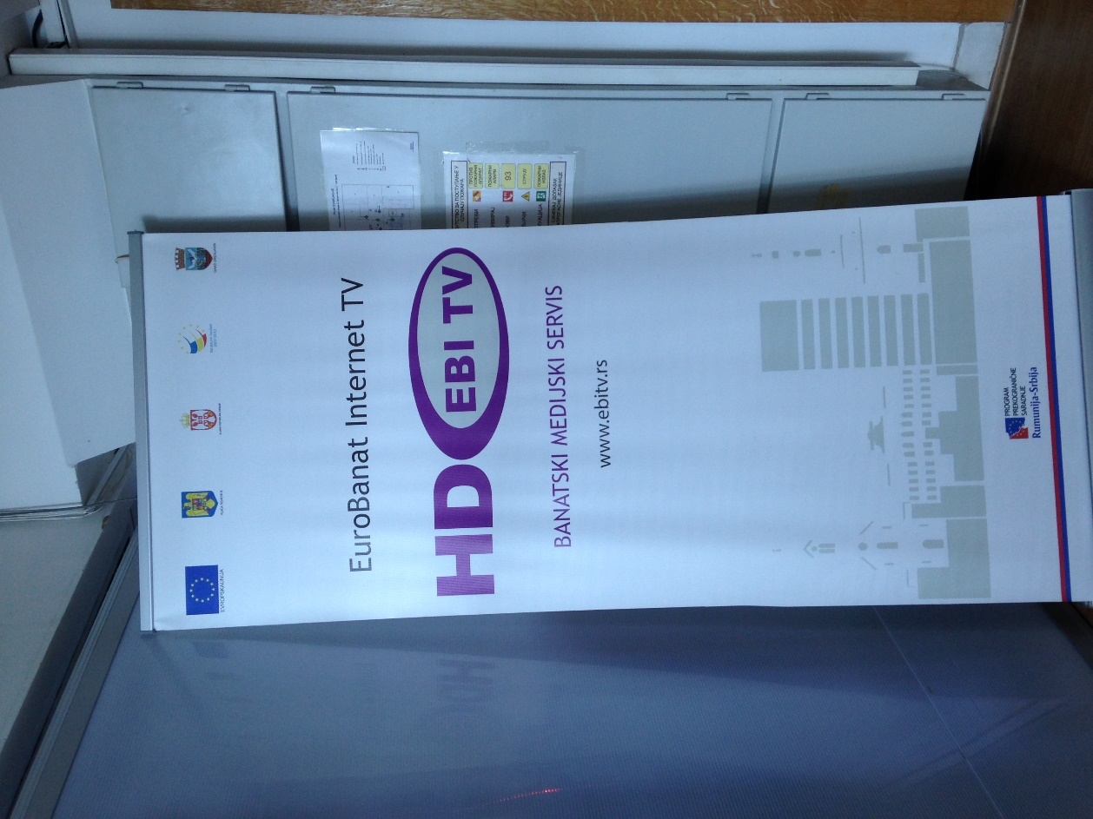

the implementation period (including extensions)
total funds spent/total funds contracted *100
indicators and level of achievement against targets set

