Project information
CALL FOR PROPOSALS | 2
MIS-ETC: | 1347
PRIORITY AXIS: | 1.Economic and Social Development
MEASURE: | 1.1 Support for local/regional economic and social infrastructure
PROJECT TITLE: | The development of a regional cross-border system of excellency medical centres specialised in the prenatal diagnosis of fetal malformations in the Timisoara-Vrsac area
ACRONYM: | PRENATAL DIAGNOSIS NETWORK
DURATION: | 03.04.2013 – 02.04.2015
IPA FUNDS CONTRACTED: | 1.712.754,64
TOTAL FUNDS CONTRACTED: | 2.015.005,45
ABSORBTION RATE (%): | 78,82
PROJECT OBJECTIVE(S): | Development of regional cross-border system of excellence medical centres for the improvement of prenatal diagnosis of fetal malformations in the Timisoara-Vrsac region.  Provision of a balanced social and economic development and improvement of quality of life of the inhabitants in the Timisoara-Vrsac area by means of common cross-border actions (Romanian-Serbian) to improve health services infrastructure and increase population access to new health services.  Increased quality of the medical act by increase of the competences and abilities of the involved medical personnel.  Increase in the level of health education of the population.
SHORT DESCRIPTION OF THE PROJECT: | A common problem of Timisoara and Vrsac cities is the high rate of births with malformations, due to lack of a specialized medical centre in the antenatal diagnosis of fetal malformations. Implementation of the project allowed for the common use of the created infrastructure: pregnant women who after the echography exam performed at the General Hospital of Vrsac are susceptible of genetic syndrome, came to the Obstetrics and Gynaecology Hospital in Timisoara for invasive investigations. Patients’ scheduling for these investigations have performed on the project intranet by the members of the Common Medical Council.  Common trainings needed in antenatal diagnosis for the medical staff of the two hospitals have been organized, the harmonization of medical equipment acquisition and use, the creation of a common online system in the diagnosis and coordination of the patients in the region.  A short video about the project is available at: https://www.youtube.com/watch?v=7b-gMB7gnAE
DEGREE OF ACHIEVEMENT OF INDICATORS: | Indicator value provisioned in the contract Present indicator value % 6= (5)/(3)*100  Output indicators (1) UM (2) Quantity (3) UM (4) Quantity (5)  Improved physical infrastructure in the border area  Improved capacity and cross-border contacts of SMEs and in R&D sector  People in labour force with qualifications received/improved from joint training activities  Result indicators  Increased importance of R&D/innovation in the border area Number of innovative actions 4 Number of innovative actions 4 100  Project indicators  Number of medical staff commonly trained in the antenatal diagnosis of fetal malformations person 60 person 139 231  Fully equipped and fitted Excellency Medical Centres for antenatal diagnosis number 2 number 2 100  medical offices (antenatal diagnosis) in Timisoara and Vrsac number 10 number 10 100  Increase of the number of patients that come to the two hospitals for antenatal diagnosis Person/month 400 Person/month 400 100  Common workshops number 4 number 4 100  Reduction of the birth rate of fetal malformed children in the cross-border region % 1.3 % 1.3 100  Reduction of births of malformed children in the Timisoara-Vrsac area/year number 93 number 93 100  Common system for establishing the diagnosis – increase of cross-border cooperation number 1 number 1 100  Chorial villosity biopsies and umbilical cord punctures performed number 20 number 34 160  Increase of non-invasive investigations number – blood chemistry tests, karyotype Number/month 60 Number/month 60 100  Amniocentesis performed Number/month 8 Number/month 8 100  Common web platform number 1 number 1 100  Educational brochure edited in collaboration number 1 number 1 100  Research report on the fetal malformations in the Timisoara-Vrsac area number 1 number 1 100  Population information campaign on the risk factors in the occurrence of fetal malformations number 1 number 1 100
RESULTS ACHIEVED: | 2 Excellency Medical Centres (1 Timisoara, 1 Vrsac) equipped with state of the art equipment;  1 Common system for the research and diagnosis of fetal malformations;  1 Bilingual research report on the frequency and causes of fetal malformations;  1 Medical staff training program in the field of fetal malformations;  60 physicians, trained in the proposed fields;  800 women who benefited from specialized medical assistance in the Excellence medical centres (EMC) in antenatal diagnosis;  2 awareness sessions with the general population regarding the risk factors of malformations;  2000 educational brochures on avoiding risk factors in pregnancy malformations, edited and distributed;  Information and publicity materials created and distributed: 200 folders, 1000 flyers, 100 posters;  1 common medical web platform;  5000 women in the TM-VS area informed on the risk factors of fetal malformations.

Partnership information
 |  | COUNTRY | COUNTY/DISTRICT | BUDGET(EURO) | CONTACT DETAILS
LEAD PARTNER: | Municipality of Timisoara | Romania | Timis | 1.423.816,53 | Timisoara, 1 Blvd. C.D.Loga  Tel. 0040-256-408342
PARTNER 2: | "Dr. D. Popescu" Clinical Hospital of Obstetrics and Gynaecology | Romania | Timis | 90.287,70 | Timisoara, B-dul 16 Decembrie 1989 nr. 22-24,  Tel. 0040256-491707
PARTNER 3: | General Hospital Vrsac ( GHV) | Serbia | South Banat | 500.901,22 | Vrsac, Abraševićeva bb  Tel. +381 63 380 827

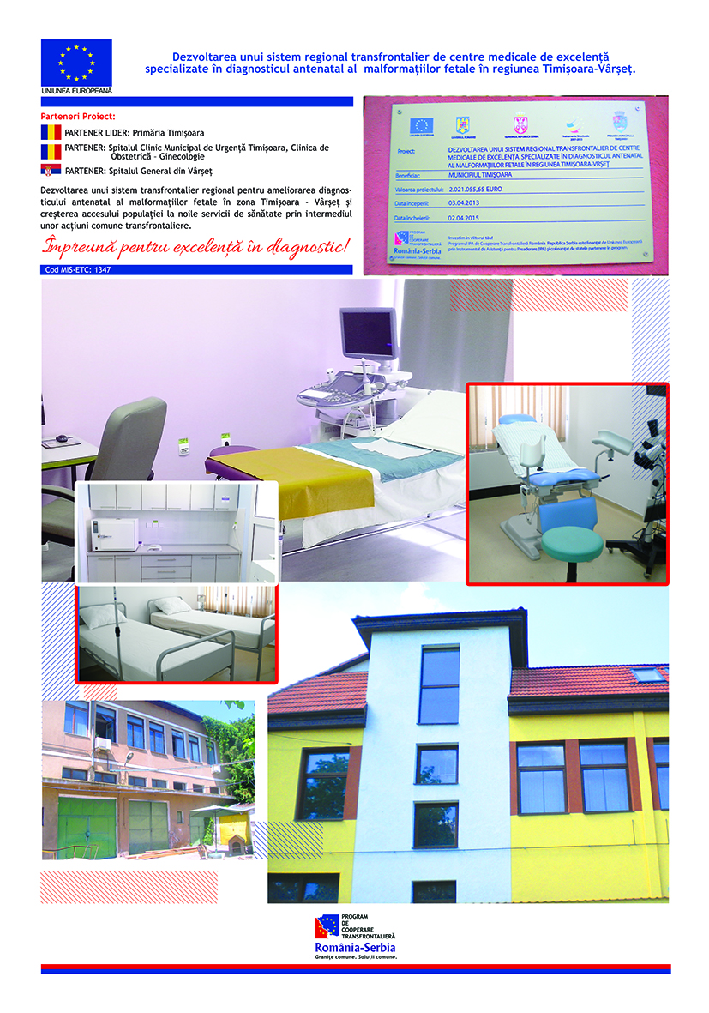

the implementation period (including extensions)
total funds spent/total funds contracted *100
indicators and level of achievement against targets set

