 | Project information
 | CALL FOR PROPOSALS |  | 2
 | MIS-ETC: |  | 1344
 | PRIORITY AXIS: |  | 2.Environment and Emergency Preparedness
 | MEASURE: |  | 2.1 Improve systems and approaches to address cross-border environmental challenges, protection and management
 | PROJECT TITLE: |  | Studies for achieving shore protection of wetland area Divici-Pojejena
 | ACRONYM: |  | WetPro
 | DURATION: |  | 26.04.2013 – 25.04.2015
 | IPA FUNDS CONTRACTED: |  | 478.288,20
 | TOTAL FUNDS CONTRACTED: |  | 562.692,00
 | ABSORBTION RATE (%): |  | 93,92
 | PROJECT OBJECTIVE(S): |  | To identify the approaches and systems needed to prevent joint natural and technological risks in the wetland protected areas of Danube cross-border sector.  To perform studies for achieving shore protection of wetland area Divici-Pojejena.  To select suitable approaches and systems in agreement with sustainable development principles.  To perform impact studies for selected approaches and systems.
 | SHORT DESCRIPTION OF THE PROJECT: |  | The project generated a common applicable solution for the existing wetlands together with the improving/setting up the infrastructure in protected areas (i.e. places for visitors) of common interest and also defined an optimal solution to reduce the pollution factors. At the same time the project collected data, information and stimulated the know-how exchange on the cross-border area’s natural resources protection, on climate change impacts in order to estimate the impact of the proposed solutions. On this basis joint action plans were developed for reducing these impacts. The selected approaches and systems based on the studies lead to the protection of natural heritage and a sustainable development of tourism in the areas.
 | DEGREE OF ACHIEVEMENT OF INDICATORS: |  | Indicator Indicator value provisioned in the contract Present indicator value % 6= (5)/(3)*100  Output indicators (1) UM (2) Quantity (3) UM (4) Quantity (5)  Prevention of technological and natural risks in wetland areas and mitigation of the consequences Number of studies 2 Number of studies 2 100%  Optimal solution for prevention of technological risks derived from intensive operation of hydro plant concomitant with natural risks and climate change effects Number of feasibility studies 1 Number of feasibility studies 1 100%  Optimal solution for waste water management system in Veliko-Gradiste area Number of feasibility studies 1 Number of feasibility studies 1 100%  Evaluation of the environmental impact of proposed solutions Number of studies 2 Number of studies 2 100%  Establishing of flooding levels for the shore interest area Number of studies 1 Number of studies 1 100%  Planning of sustainable development of tourism sector in cross-border wetlands Number of plans 1 Number of plans 1 100%  Result indicators  Increased cross-border cooperation in environment protection Number of actions, activities, initiatives protecting or preserving the environment 2 Number of actions, activities, initiatives protecting or preserving the environment 2 100%  Increased expertise and exchange of experience in the field of environment protection Number of actions, activities, initiatives increasing expertise or exchange of experience in environment protection topics 2 Number of actions, activities, initiatives increasing expertise or exchange of experience in environment protection topics 2 100%
 | RESULTS ACHIEVED: |  | Results from the investigation of the relation between wetlands characteristic parameters and natural and technological risks: methodology for selecting appropriate parameters; set of parameters; methodology for collecting the data; set of data for characterizations.  Current characterization of wetland areas in the cross-border Divici-Pojejena-Veliko Gradiste region.  Feasibility study for shore protection in Divici-Pojejena wetland.  Feasibility study for wastewater management system in Veliko-Gradiste.  Impact study for shore protection.  Flooding study for shore protection.  Impact study for wastewater management system.  Plan for sustainable development of tourism sector in cross-border wetlands.
Partnership information
 |  |  |  | COUNTRY | COUNTY/DISTRICT | BUDGET(EURO) | CONTACT DETAILS
LEAD PARTNER: |  | Caras-Severin County Council |  | Romania | Caras-Severin | 410,472.00 | Resita, Piata 1 decembrie, no.1  Tel. 0255 211420
PARTNER 2: |  | Municipality of Veliko Gradiste |  | Serbia | Branicevski | 152,220.00 | Veliko Gradiste, Zitni trg 1  Tel. +381 12 662 120

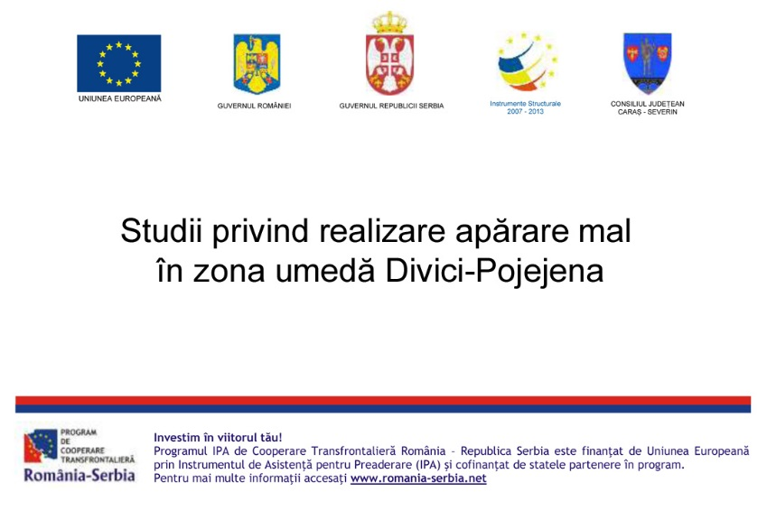
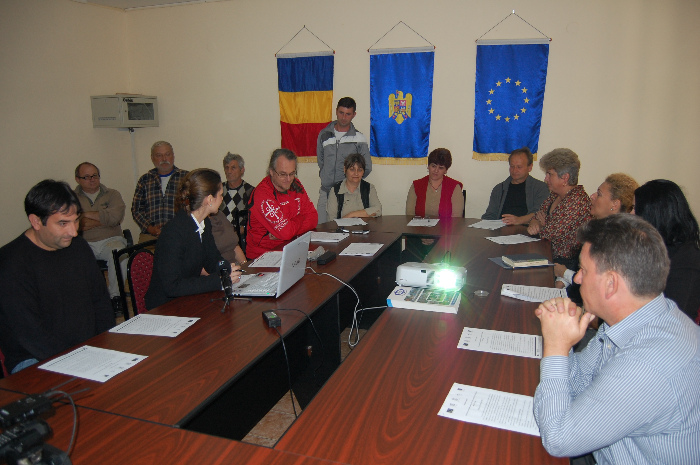
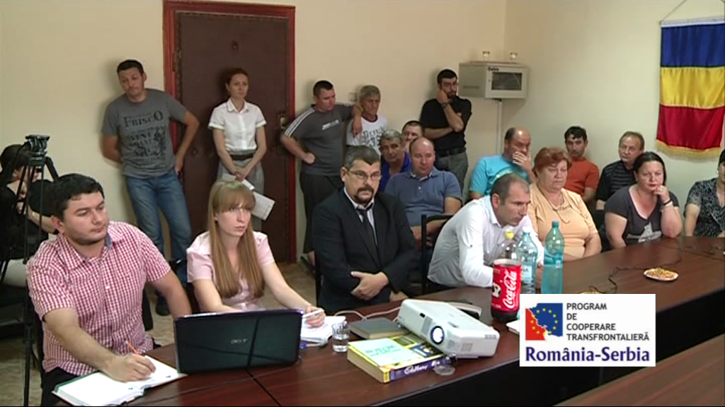

the implementation period (including extensions)
total funds spent/total funds contracted *100
indicators and level of achievement against targets set

