Project information
CALL FOR PROPOSALS | 2
MIS-ETC: | 1317
PRIORITY AXIS: | 1.Economic and Social Development
MEASURE: | 1.1 Support for local/regional economic and social infrastructure
PROJECT TITLE: | Green Lights for Safety and Sustainability of Roads
ACRONYM: | GLOSS
DURATION: | 11.12.2013 – 10.12.2015
IPA FUNDS CONTRACTED: | 586.945,81
TOTAL FUNDS CONTRACTED: | 690.524,48
ABSORBTION RATE (%): | 93,92
PROJECT OBJECTIVE(S): | - Achieving a more balanced and sustainable socio-economic development of the Romanian-Serbian border area.  - The development of tourism in Vrsac and Deta through the modernization of the infrastructure in order to access tourism attractions.  - Achieving joint development and promotion of tools and techniques to encourage the sustainable use of resources.  - Promoting the exchange of good practice.  - Improvement of the quality of life for the communities of the border area.
SHORT DESCRIPTION OF THE PROJECT: | The project consisted of the introduction of new technology in illumination which increased the attractiveness of the road, and thus contributed to economic development through increased tourists’ visits to the region. 874 new street lights were installed in Vrsac and 50 in Deta.  The goal of the project was to encourage sustainable use of energy through effective technology of street lighting. Partners procured a car and equipment: FLIR thermal imaging camera and luxmeter DeltaOhm. An automatic control and data acquisition system for public lighting was installed in Vrsac.
DEGREE OF ACHIEVEMENT OF INDICATORS: | Indicator Indicator value provisioned in the contract Present indicator value % 6= (5)/(3)*100  Output indicators (1) UM (2) Quantity (3) UM (4) Quantity (5)  Modernization of streets lighting in Vrsac Number of new street lights 287 Number of new street lights 874 304,5 %  Modernization of streets lighting in Deta Number of new street lights 50 Number of new street lights 50 100%  Energy savings from Modernization of streets lighting in Vrsac and Deta [kWh/a] 270,000 [kWh/a] 286.740 (Vrsac) 56,000 (Deta) 127 %  Cost savings from Modernization of streets lighting in Vrsac and Deta [€/a] 15,000.00 [€/a] 23,926.34 (Vrsac) 4,000.00 (Deta) 186%  Reduction in greenhouse gas emissions [t/a] 270 [t/a] 301.08 (Vrsac) 56.00 (Deta) 132%  Increasing of visitors due to Modernization of streets lighting in Vrsac and Deta Number of visitors 7000 Number of visitors 20,000 (Vrsac) 3,000 (Deta) 328%  Increasing of income from tourism due to Modernization of streets lighting in Vrsac and Deta [€/a] 560,000.00 [€/a] 587,452.00 (Vrsac) 120,000.00 (Deta) 126%  Result indicators  Improved physical infrastructure in the border area Number of infrastructure investment projects (calculated also by type). 2 Number of infrastructure investment projects (calculated also by type). 2 100%
RESULTS ACHIEVED: | - 100,000 citizens of Vrsac and Deta informed about the project and the energy and cost savings and its environmental impact (organized press conferences and workshops in Vrsac and Deta, printing and distribution of brochures and promotional materials, TV and radio spot etc.)  - Purchased the equipment (Car Dacia Duster, FLIR thermal imaging camera and luxmeter DeltaOhm, automatic control and data acquisition system for public lighting) in Vrsac.  - Prepared technical documentation for infrastructure works in Vrsac and Deta.  - Realized rehabilitation works for the public lighting in Vrsac and Deta.

Partnership information
 |  | COUNTRY | COUNTY/DISTRICT | BUDGET(EURO) | CONTACT DETAILS
LEAD PARTNER: | Public Enterprise “Varos” (now City of Vrsac) | Serbia | South Banat | 440.013,60 | Vrsac, Dvorska 10a  Tel. +381 13821614
PARTNER 2: | Deta Municipality | Romania | Timis | 250.510,88 | Deta, Victoriei, No 32  Tel. +40 723 686 786
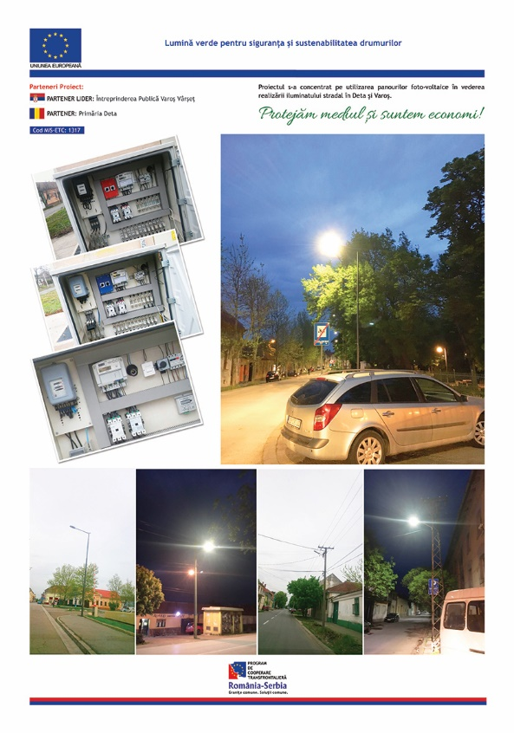

the implementation period (including extensions)
total funds spent/total funds contracted *100
indicators and level of achievement against targets set

