 | Project information
 | CALL FOR PROPOSALS |  | 2
 | MIS-ETC: |  | 1302
 | PRIORITY AXIS: |  | 2.Environment and Emergency Preparedness
 | MEASURE: |  | 2.1 Improve systems and approaches to address cross-border environmental challenges, protection and management
 | PROJECT TITLE: |  | Monitoring and control system of the physical, chemical and biological parameters of the Danube River in the area of Drobeta Tr.Severin (Romania) and Kladovo (Serbia) for a better quality of the water
 | ACRONYM: |  | CleanWater
 | DURATION: |  | 29.12.2012 – 28.12.2014
 | IPA FUNDS CONTRACTED: |  | 756.933,91
 | TOTAL FUNDS CONTRACTED: |  | 890.510,48
 | ABSORBTION RATE (%): |  | 98,73
 | PROJECT OBJECTIVE(S): |  | Danube water quality monitoring.  Developing the environmental monitoring capacity.  Experience growth in cross-border environmental issues.  Control of factors which influence the integrity and biodiversity of Danube River water.  Promote the cleaning of pollution river waters for tourism potential.  Monitor the pollution risks.  Monitor the industrial pollution feeds in the Danube.
 | SHORT DESCRIPTION OF THE PROJECT: |  | The project implementation leads to a high technological solution which increased the capacity for a better cross-border monitoring of the environment (in this case, the Danube River water), which contributed to a more safe and accurate technological and physical infrastructure for water parameters measurement and, accordingly, the adequate technical solution for better water treatment. By simultaneously informing both Romanian and Serbian local public authorities, a joint technical preparedness in reacting to the different situations of environmental emergency can be set in place. Also, by providing the appropriate information and warnings via local TV and radio stations, as well as via electronic displays and teletext installed in the most important places of the two cities, Romanian and Serbian citizens have access to the real-time information concerning the quality of the Danube water, contributing to an increased public awareness in the field of environmental protection.
 | DEGREE OF ACHIEVEMENT OF INDICATORS: |  | Indicator value provisioned in the contract Present indicator value % 6= (5)/(3)*100  Output indicators (1) UM (2) Quantity (3) UM (4) Quantity (5)  Result indicators  Increased cross-border cooperation in environment protection No. of bilateral meetings of experts, as well as the no. of the workshops /seminars/ public debates with larger citizens’ participation 10 bilateral meetings No. of bilateral meetings of experts, as well as the no. of the workshops /seminars/ public debates with larger citizens’ participation 10 bilateral meetings 100  2 workshops 2 workshops 100  2 debate 2 debate 100  2 press conferences 2 press conferences 100  Increased public awareness in the field of environment protection No. of seminars/public debates 2 public debates on the water quality issues with 150 participants from the both cities No. of seminars/public debates 2 public debates on the water quality issues with 150 participants from the both cities 100  Project indicators  On line real-time measurement of the Danube water parameters No. of on-line measured parameters 14 No. of on-line measured parameters 24 171  Real-time information of the local public authorities No. of local authorities involved 7 No. of local authorities involved 7 100  More people aware of the importance of the environment protection No. of people attending the seminar or public debates on Danube water quality and other environmental issues 150 No. of people attending the seminar or public debates on Danube water quality and other environmental issues 300 200
 | RESULTS ACHIEVED: |  | Improvement of the quality of life for the communities in the area.  Development of common systems and structures on both sides of the Danube.  Better real-time information of the responsible people and organizations in the emergency situation.  Better information for the citizens.  Improvement of the water plant performances.  Installation of the monitoring, warning and control system including also the soft, with the reinforced concrete based platform, installation of the building and of the equipment, bringing of the needed utilities close to the platform and shelter, on-site calibrations, testing of hardware and software were realized during the project implementation.  During the project in Drobeta Tr. Severin (Romania) and in Kladovo (Serbia) 2 workshops/debates were organized with a large citizen participation, 2 technical seminars, which were attended by experts/specialists from the target group Romanian and Serbian institutions and 2 press conferences for providing details about the project, system and its importance for a better life of the citizens and local economy.  Technical project for the “turn-key system” and Technical project for the concrete based platform were realized.  After the installation of the monitoring unit there were regular on-line real-time measurements of the Danube water parameters and real-time information of the local public authorities regarding these parameters.
Partnership information
 |  |  |  | COUNTRY | COUNTY/DISTRICT | BUDGET(EURO) | CONTACT DETAILS
LEAD PARTNER: |  | Municipality of Drobeta Turnu Severin |  | Romania | Mehedinti | 815.536,48 | Drobeta Turnu Severin, 2 Maresal Averescu Street  Tel. 0040252314379
PARTNER 2: |  | Municipality of Kladovo |  | Serbia | Borski | 74.974,00 | Kladovo, Kralja Aleksandra 35  Tel. +381 19 808 066

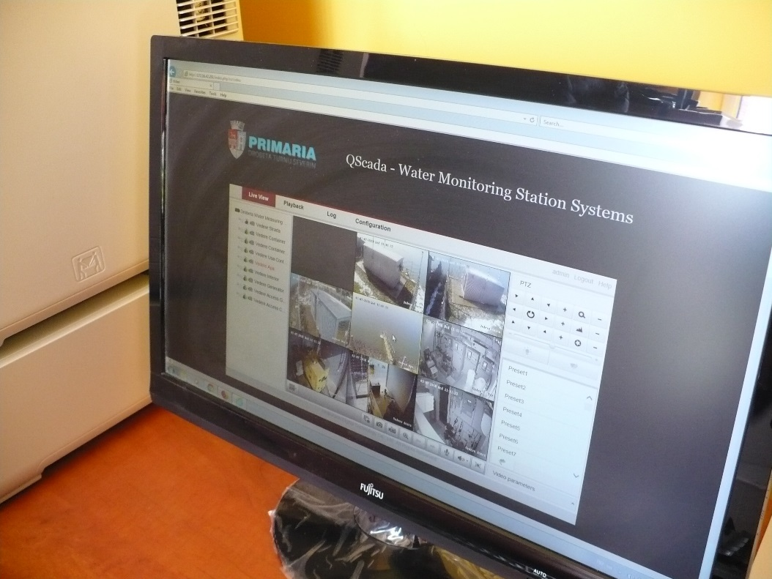
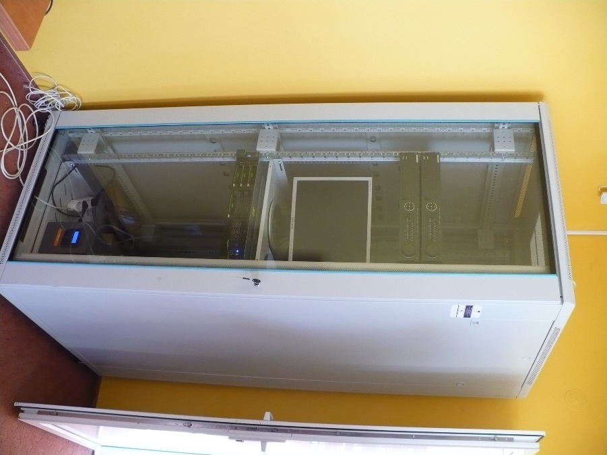
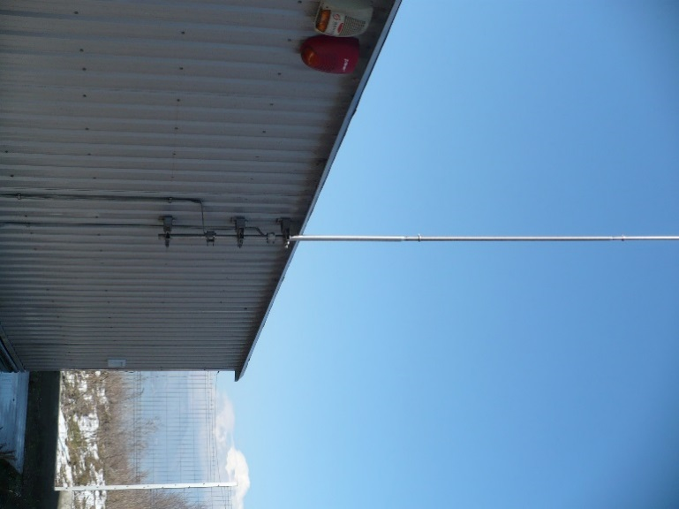
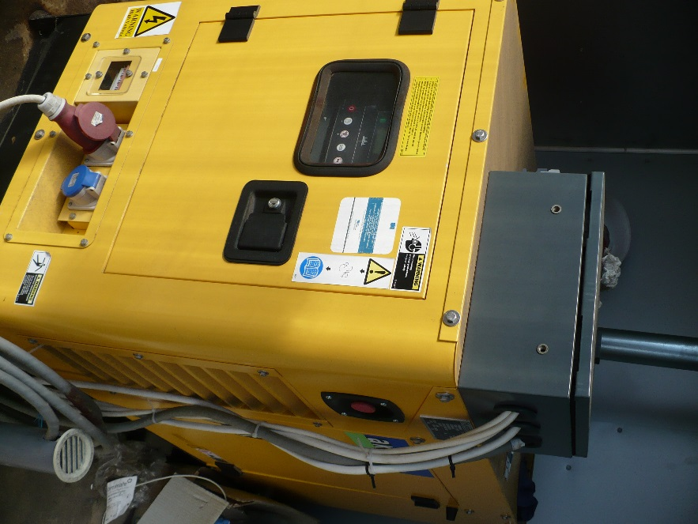
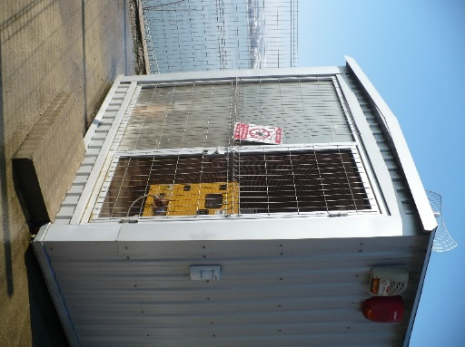

the implementation period (including extensions)
total funds spent/total funds contracted *100
indicators and level of achievement against targets set

