Project information
CALL FOR PROPOSALS | 2
MIS-ETC: | 1296
PRIORITY AXIS: | 1.Economic and Social Development
MEASURE: | 1.2 Develop the tourism sector, including the strengthening of the regional identity of the border region as a tourist destination
PROJECT TITLE: | New Development start in cross border tourism between Bela Crkva and Ghilad
ACRONYM: | NEWCROSS
DURATION: | 15.06.2013 – 14.06.2015
IPA FUNDS CONTRACTED: | 406.941,98€
TOTAL FUNDS CONTRACTED: | 478.755,27€
ABSORBTION RATE (%): | 92,33%

PROJECT OBJECTIVE(S): | Local development acceleration in the cross-border area Ghilad and Bela Crkva on cooperation in promoting cultural tourism-sport weekend.  Supporting cross-border tourism from Bela Crkva and Ghilad correlated with the promotion of local products and other leisure activities (tourism, cultural, outdoor recreation) by improving the local infrastructure to host cultural and sporting event "Tourism in Banat" and the development of promotional materials for this purpose.
SHORT DESCRIPTION OF THE PROJECT: | Through this project, a various cultural, tourism, sports and culinary events have been organized, as well the construction of a Multipurpose Arena capable of hosting events in Ghilad up to 1000 visitors.

DEGREE OF ACHIEVEMENT OF INDICATORS: | Indicator Indicator value provisioned in the contract Present indicator value % 6= (5)/(3)*100  Output indicators (1) UM (2) Quantity (3) UM (4) Quantity (5)  Multifunctional Indoor Arena in Ghilad town, Timiş County, Romania" and "for arrangement (reconstruction) of an existing football field in Grebenac Number of Infrastructure objectives 2 Number of Infrastructure objectives 2 100  Increase level of economic activity Number of newly established companies 10 Number of newly established companies 10 100  Strengthening of the cross-border economic contacts Number of conferences, experts’ meetings held 4 Number of conferences, experts’ meetings held 4 100  Better connectedness between entrepreneurs in the region Number of participants on fairs 20 Number of participants on fairs 20 100  Analysis and studies of marketing approach Number of analysis and studies 2 Number of analysis and studies 2 100  Increasing level of communication Website 1 Website 1 100  Visibility Number of published articles, press conferences held 8 Number of published articles, press conferences held 12 150  Result indicators  New or improved cross-border tourism products and services Number of activities, actions, initiatives focusing on promoting tourism in the border area 2 Number of activities, actions, initiatives focusing on promoting tourism in the border area 2 100

RESULTS ACHIEVED: | A multipurpose arena capable of hosting cultural, sports, seminars events in Ghilad with up to 1000 participants  Reconstruction of an existing football field in Grebenac for sport, cultural and tourism activities  Two seminars of promoting cross-border tourism:  1. Promoting cultural tourism, weekend competitions that leverage the development of rural tourism in border areas Ghilad Bela Crkva seminar hosted by the municipality. 65 - people of which 15 Romanian  2. Modalities and efficient ways to exploit the tourism potential of the rural border area Ghilad - Bela Crkva joint seminar hosted by Ghilad. 65 people including 15 Serbs.  Two tourist itineraries. One in each country, observing the practice objectives of tourist areas presented in the seminar.  Cultural, tourism, sports and culinary event competitions launched. The fair, crafts and local products, "Tourism in Banat" stages: Ghilad - Bela Crkva, conducted in two stages:  Stage I or edition at Bela Crkva (Grebenac):  - three football games  - a cultural show  - a tourist route in Vojvodina Region  - presentation fair of local products, artisan scale exhibitions, etc  The first event "Tourism in Banat", held in Grebenac, with 100 Romanian participants and 350 Serbian participants.  Stage II or edition at Ghilad:  - three football games  - a cultural show  - a tourist route in Timis County  - fair of local products, artisan scale exhibitions, etc

Partnership information
 |  | COUNTRY | COUNTY/DISTRICT | BUDGET(EURO) | CONTACT DETAILS
LEAD PARTNER: | Primaria Ghilad | Romania | Timiş | 422.125,07 | Ghilad, NR.972/A  Tel. 0256/418221
PARTNER 2: | Municipality Bela Crkva | Serbia | South Banat | 56.630,20 | Bela Crkva, Svetozara Miletića 2  Tel. 381 013-853-346

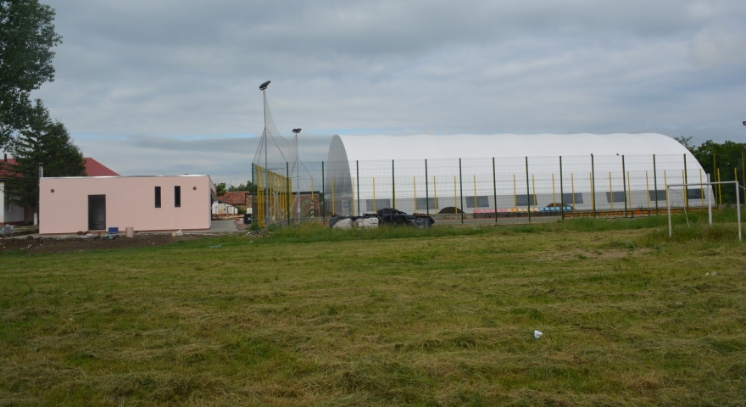
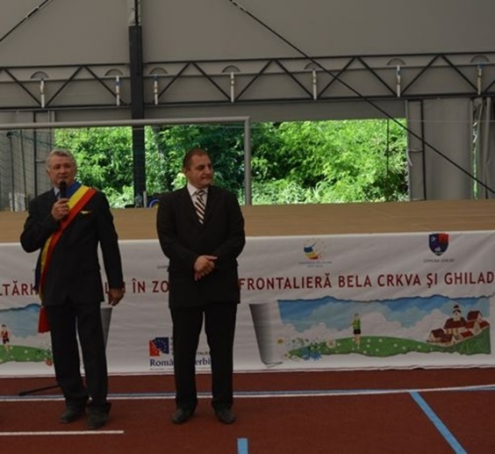
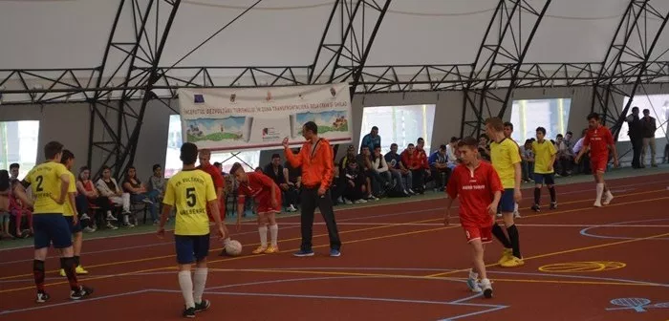

the implementation period (including extensions)
total funds spent/total funds contracted *100
indicators and level of achievement against targets set

