Project information
CALL FOR PROPOSALS | 2
MIS-ETC: | 1289
PRIORITY AXIS: | 1.Economic and Social Development
MEASURE: | 1.3 Promote SME development
PROJECT TITLE: | Made in Banat
ACRONYM: | MIB
DURATION: | 02.11.2013 – 01.05.2015
IPA FUNDS CONTRACTED: | 306.936,09
TOTAL FUNDS CONTRACTED: | 361.101,28
ABSORBTION RATE (%): | 94,78
PROJECT OBJECTIVE(S): | - Increase the competitiveness of Romanian and Serbian SMEs producing regional, specific products.  - Stimulate the capacity of cross-border SMEs to promote, innovate and sell regional products and increase product quality.  - Promote the economic growth of cross-border SMEs and launch regional products under the brand “Made in Banat”.  - Stimulate cross-border cooperation and balanced development.
SHORT DESCRIPTION OF THE PROJECT: | Procedure for awarding the brand “Made in Banat” to products from Banat region was made in this project. The brand acted as a promotion tool certifying the quality of products thus increasing the competitiveness of the companies which bear the brand.
DEGREE OF ACHIEVEMENT OF INDICATORS: | Indicator value provisioned in the contract Present indicator value % 6= (5)/(3)*100  Output indicators (1) UM (2) Quantity (3) UM (4) Quantity (5)  Improved capacity and cross-border contacts of SMEs  Joint marketing approaches  Result indicators  Increased SMEs capacity in the border area No. of fairs for SMEs No. of fairs for SMEs No. of SME participating in exhibitions, from which: -social enterprises -SME’s lead by women - SME’s of the minority 3 No. of fairs for SMEs No. of SME participating in exhibitions, from which: -social enterprises -SME’s lead by women - SME’s of the minority 4 133  60 SMES RO 62 SMES RO 103  60 SMES SE 90 SMES SE 150  No. of activities, actions, initiatives focusing on promoting SME’s activity. 228 No. of activities, actions, initiatives focusing on promoting SME’s activity. 349 153  Types of activities, actions, initiatives focusing on quality of life 7 Types of activities, actions, initiatives focusing on quality of life 14 200  Competitiveness work-shops 10 Competitiveness work-shops 10 100  Project indicators  Increased capacity of institutions to absorb and use European funds No of persons trained in project management (specific IPA) 20 No of persons trained in project management (specific IPA) 30 150  Joint marketing approach to promote regional quality products “Made in Banat” Procedure 1 “Made in Banat” Procedure 1 100  Increasing the cross-border SMEs access to information required for higher competitiveness Joint economic cooperation network 1 Joint economic cooperation network 1 100  Data base with specific web site 1 Data base with specific web site 1 100  Companies participating in competitiveness work-shops 20 Companies participating in competitiveness work-shops 65 325  Increased importance of innovation in the border area Concept/procedure 1 Concept/procedure 1 100  Improving quality of life in border region Media campaigns 1 Media campaigns 4 400  Virtual platform/ mall 1 Virtual platform/ mall 1 100  Increased importance of local produces in the border area Brand awarded to share of total target group of which: social-enterprise - SME’s -lead by women - SME’s -lead by minorities 16% Brand awarded to share of total target group of which: social-enterprise - SME’s -lead by women - SME’s -lead by minorities 23% 143  Improving quality of life in border region Share of consumer products 47.400 Share of consumer products 88008 186  No. of online accesses 10.000 No. of online accesses 13113 131  Increased importance of environmental protection in SME’s activity No. of brands awarded 16% No. of brands awarded 30% 190
RESULTS ACHIEVED: | - “Made in Banat” procedure: 1 procedure with criteria, work principles, work group (PSC+ experts), 13 company awarded with the brand Made in Banat.  - Cross-border economic cooperation network: 28 cooperation pacts signed.  - Organization of “Made in Banat” show room.  - Organization of “Made in Banat” cross-border exhibition in Zrenjanin and Timisoara.  - 1 online platform /mall with 42 virtual shops “Banat Mall”.

Partnership information
 |  | COUNTRY | COUNTY/DISTRICT | BUDGET(EURO) | CONTACT DETAILS
LEAD PARTNER: | Timis Chamber of Commerce, Industry and Agriculture | Romania | Timis | 266.620,00 | Timisoara, Piata Victoriei nr.3  Tel. +40-256-219173
PARTNER 2: | Timis County Council – ADETIM, The Agency for Economic and Social Development of Timis County | Romania | Timis | 36.789,00 | Timisoara, Bd. Revolutiei din 1989, nr.17  Tel. +40 (0)256 494 131
PARTNER 3: | Regional Chamber of Commerce and Industry Pancevo | Serbia | South Banat | 49.024,00 | Pancevo, 1a Zmaj Jovina  Tel. + 381 13 343 475
PARTNER 4: | Regional Chamber of Economy Zrenjanin | Serbia | Central Banat | 46.714,00 | Zrenjanin, Kralja Petra I. 3/1  Tel. +381 23 535-890
PARTNER 5: | Regional Chamber of Commerce and Industry Kikinda | Serbia | North Banat | 30.678,00 | Kikinda, Trg srpskih dobrovoljaca 48  Tel. +381 (0)230 21-080

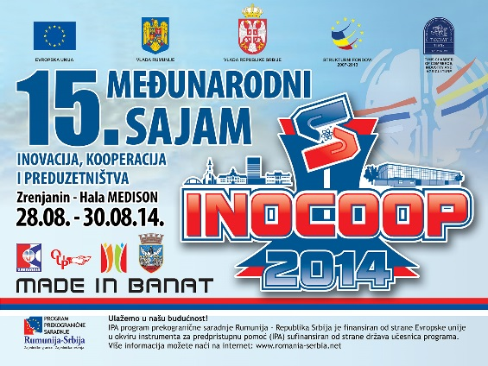
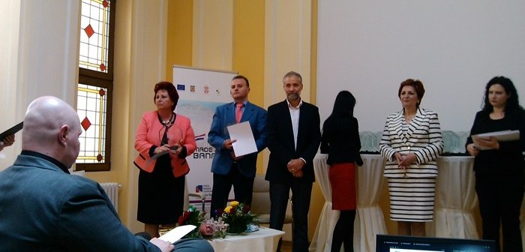
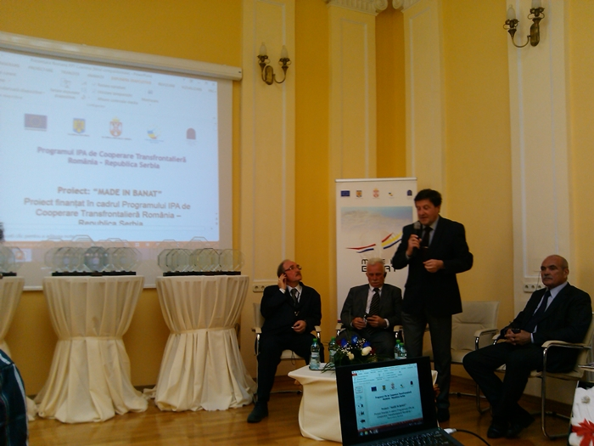
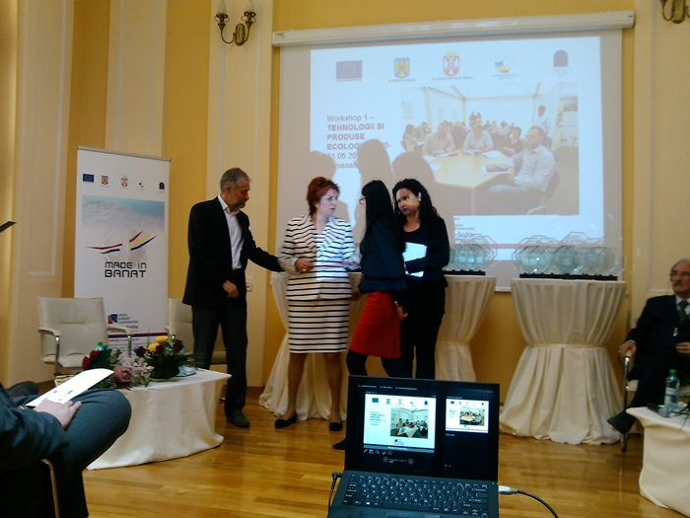
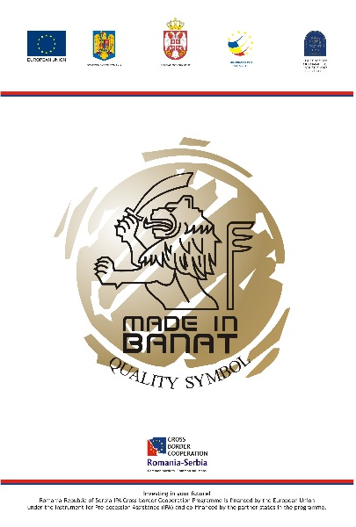
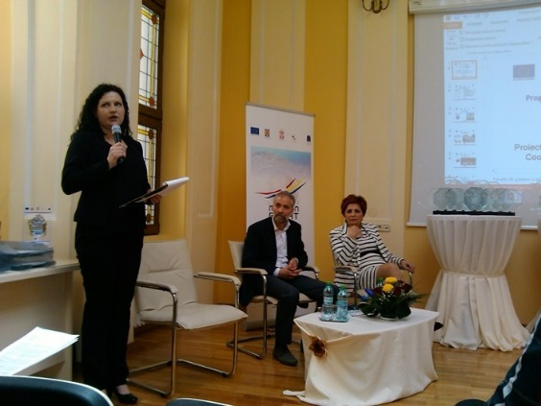

the implementation period (including extensions)
total funds spent/total funds contracted *100
indicators and level of achievement against targets set

