Project information
CALL FOR PROPOSALS | 2
MIS-ETC: | 1287
PRIORITY AXIS: | 3. Promoting “people to people” exchanges
MEASURE: | 3.2 Improve local governance in relation to the provision of local services to communities in the border areas
PROJECT TITLE: | Revival of the cross-border tourism through innovative services for the benefit of the local communities
ACRONYM: | BanaTour
DURATION: | 16.10.2012 – 15.04.2014
IPA FUNDS CONTRACTED: | 283.566,80 €
TOTAL FUNDS CONTRACTED: | 333.608,00 €
ABSORBTION RATE (%): | 86,54%

PROJECT OBJECTIVE(S): | Strategic, efficient, and high-impact promotion of the cross-border tourism offer and potential, for the benefit of the local communities, through a customized package of innovative tools and services.  Creation of an integrated package of added-value tools and services in the tourism sector such as a web portal, a common database, and printed materials.  Setting up, institutional building, and competence development within two cross-border tourism promotion entities.  Creation and activation of a wide network of public and private tourism stakeholders aiming at unlocking the potential of local communities.  Supporting the local governance towards sustaining the cross-border tourism brand.

SHORT DESCRIPTION OF THE PROJECT: | The project created two new entities acting in the tourism sector: a regional tourism office in Romania and an agency for tourism development in Serbian Banat, which actively support and promote the tourism sector through innovative and high-impact tools and services. The cross-border network of tourism stakeholders created through the project enlarged the base for cross-border cooperation by encouraging and supporting the wide participation of local communities and institutions in joint projects and activities. This network, being composed, inter alia, of local and regional authorities, contributed, through its activities, to the improvement of local governance, especially in strategic tourism development plans.
DEGREE OF ACHIEVEMENT OF INDICATORS: | Indicator value provisioned in the contract Present indicator value % 6= (5)/(3)*100  Output indicators (1) UM (2) Quantity (3) UM (4) Quantity (5)  Increased integration of the local communities from border area Number 1 Number 1 100  Result indicators  Increased cooperation between local and regional public authorities across the border to finding solutions to joint local problems in the border area Number 3 Number 3 100  Improved quality of life and increased attractiveness of the border communities as a living place Number 3 Number 3 100  Improved knowledge of culture, history, society, organisational and institutional structure, and language of the neighbouring country Number 80 Number 211 264  Project indicators  New initiatives and support actions for the cross-border tourism, based on the policy recommendations issued by the project Number 5 Number 7 140  New tourist products developed by cross-border stakeholders Number 10 Number 11 110  Tourism portal visits Number 500 Number 4124 824  New tourists attracted in the cross-border area Number 50 Number 50 100

RESULTS ACHIEVED: | Development and implementation of innovative tools and services for tourism promotion and marketing, namely a cross-border tourism portal and a joint coherent database;  Two cross-border tourism entities set up;  A cross-border network of 50 tourism stakeholders from public and private sectors;  Tourism promotion materials printed and distributed;  Cross-border tourism brand and common regional identity created;  A policy report containing the recommendations of the Advisory Group on tourism;

Partnership information
 |  | COUNTRY | COUNTY/DISTRICT | BUDGET(EURO) | CONTACT DETAILS
LEAD PARTNER: | Tehimpuls Association – The Regional Innovation and Technological Transfer Centre | Romania | Timiş | 253.362,00 | Timisoara, 5, Proclamaţia de la Timişoara Street  Tel. +40 356 178753
PARTNER 2: | Regional Agency for Socio-Economic Development – Banat Ltd. | Serbia | Middle Banat | 80.246,00 | Zrenjanin, Čarnojevićeva 1  Tel. +381(0)23 510 567

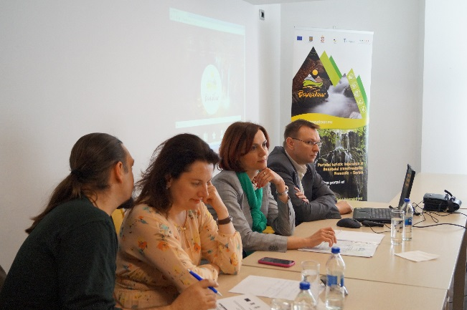
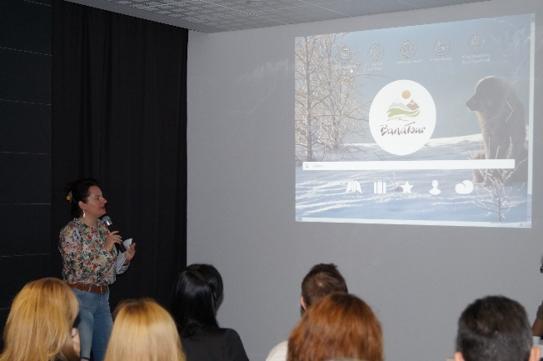
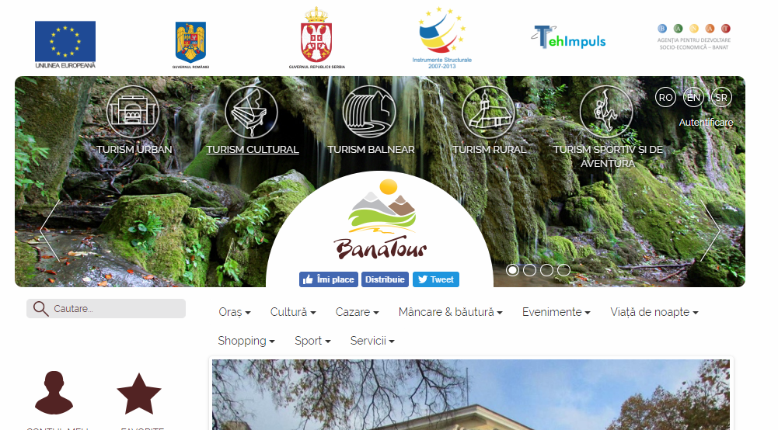
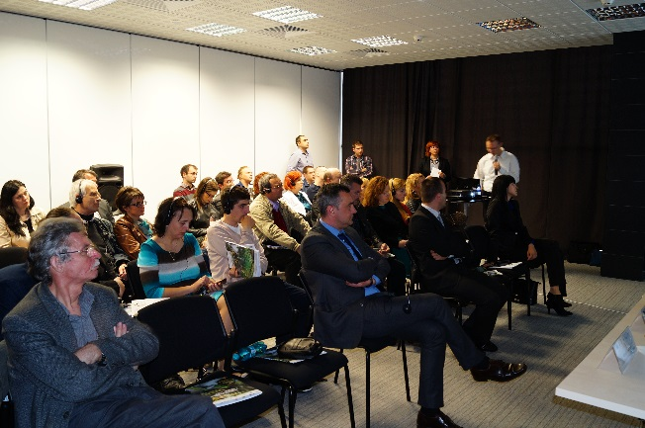

the implementation period (including extensions)
total funds spent/total funds contracted *100
indicators and level of achievement against targets set

