Project information
CALL FOR PROPOSALS | 2
MIS-ETC: | 1268
PRIORITY AXIS: | 1.Economic and Social Development
MEASURE: | 1.2 Develop the tourism sector, including the strengthening of the regional identity of the border region as a tourist destination
PROJECT TITLE: | Common actions, common values - Resita and Kikinda, together for the future
ACRONYM: | Together for the future
DURATION: | 16.11.2012 – 15.01.2014
IPA FUNDS CONTRACTED: | 362.024,35
TOTAL FUNDS CONTRACTED: | 425.911,00
ABSORBTION RATE (%): | 70,84
PROJECT OBJECTIVE(S): | Achieving a more sustainable and balanced socio-economic development of Resita and Kikinda, on the basis of a joint cross-border tourism development and the increase of tourist’s number with at least 20%, project promotion and common actions by stakeholders in the tourism sector from the two cities.  The improvement of life quality for the communities from Resita and Kikinda through the development of tourism sector, due to the full exploitation of the important tourism potential of the two towns.
SHORT DESCRIPTION OF THE PROJECT: | The project achieved to develop tourism on both sides of the border through 20 electronic information display panels and 20 info-touch points in Resita, 10 electronic information panels and 10 info-tourist points set up in Kikinda, 2 Tourism Info Centers- one in Resita and upgraded the one in Kikinda.
DEGREE OF ACHIEVEMENT OF INDICATORS: | Indicator Indicator value provisioned in the contract Present indicator value % 6= (5)/(3)*100  Output indicators (1) UM (2) Quantity (3) UM (4) Quantity (5)  New or improved cross-border tourism products, joint marketing approaches / activities or joint tourism information services developed  New cross-border joint tourism programme Number of activities focusing on developing a joint tourism offer 1 Number of activities focusing on developing a joint tourism offer 1 100%  New cross-border tourism service Number of activities focusing on creating a new tourism service 1 Number of activities focusing on creating a new tourism service 1 100%  Increased number of promotion actions and visibility for the tourism potential of Resita and Kikinda Number of activities focusing on promoting tourism in Resita and Kikinda 8 Number of activities focusing on promoting tourism in Resita and Kikinda 8 100%  Increased number of contacts between the municipalities of Resita and Kikinda for developing a cross border joint offer for tourism services and products Number of meetings between Resita’s and Kikinda’s staff 10 Number of meetings between Resita’s and Kikinda’s staff 10 100%  Increased number of contacts between people from Resita and Kikinda Number of experience exchanges between Resita and Kikinda 2 Number of experience exchanges between Resita and Kikinda 2 100%  Result indicators  New or improved cross-border tourism products and services Number of activities, actions, initiatives focusing on promoting tourism in the border area 9 Number of activities, actions, initiatives focusing on promoting tourism in the border area 9 100%
RESULTS ACHIEVED: | - 20 tourism stakeholders participated at the tourism program development;  - production and distribution of a touristic guide and 5500 tourism promotional materials edited (brochures and leaflets);  - 15 representatives of the local and regional mass media visited the towns of Resita and Kikinda, for the promotion of their tourism offer;  - One feasibility study for Resita developed during the project cycle;  - One tourism programme developed;  - Two Tourism Info Centers, one in Resita created and one in Kikinda modernized;  - 20 electronic information display panels and 20 info-touch points set up in Resita, promoting the tourist attraction in both municipalities;

Partnership information
 |  | COUNTRY | COUNTY/DISTRICT | BUDGET(EURO) | CONTACT DETAILS
LEAD PARTNER: | Municipality of Resita | Romania | Caras-Severin | 264.004,00 | Resita, Piata 1 Decembrie 1918, no. 1 A  Tel. 0255/215314
PARTNER 2: | Municipality of Kikinda | Serbia | North Banat | 161.907,00 | Kikinda, Trg srpskih dobrovoljaca 12

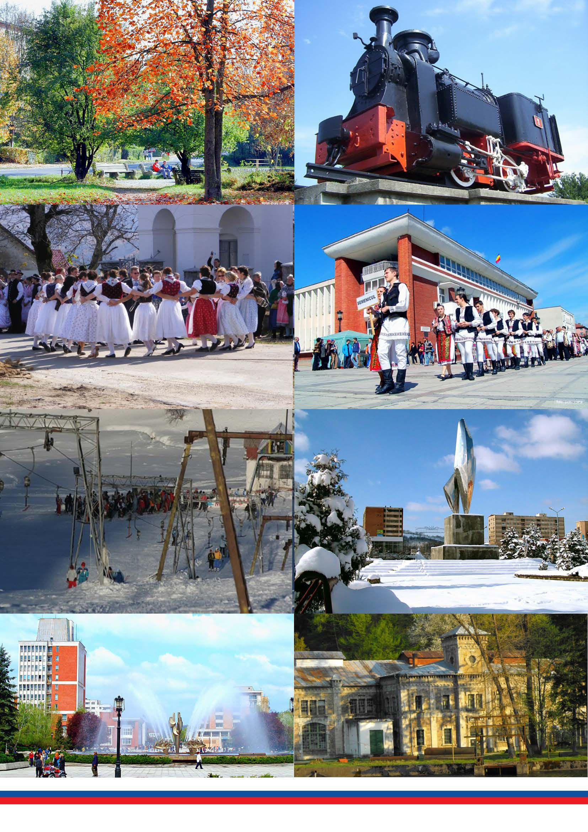
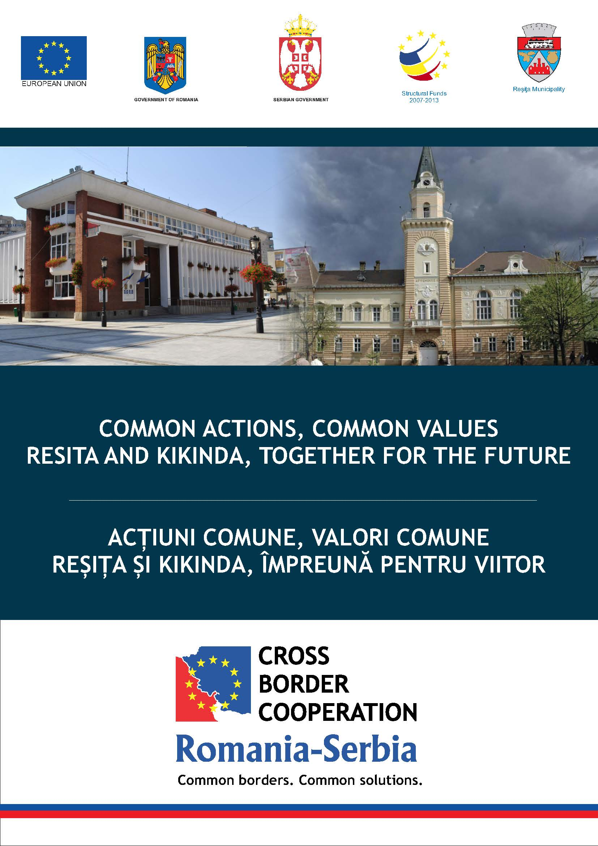
Flyer

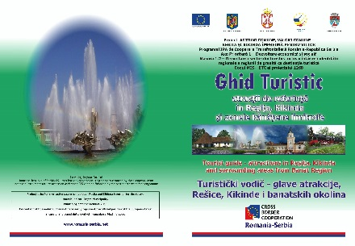

the implementation period (including extensions)
total funds spent/total funds contracted *100
indicators and level of achievement against targets set

