Project information
CALL FOR PROPOSALS | 2
MIS-ETC: | 1266
PRIORITY AXIS: | 3. Promoting “people to people” exchanges
MEASURE: | 3.1 Support the development of civil society and local communities
PROJECT TITLE: | Through education to strengthening capacities of SMEs and entrepreneurs from Central Banat for participating on European tenders
ACRONYM: | Participating on EU tenders
DURATION: | 29.12.2012 – 28.12.2013
IPA FUNDS CONTRACTED: | 54.264,00€
TOTAL FUNDS CONTRACTED: | 63.840,00€
ABSORBTION RATE (%): | 87,23%
PROJECT OBJECTIVE(S): | To increase the competitiveness of the economy in Central Banat District and contacts between businessmen in the Romanian-Serbian cross–border region.  To strengthen administrative capacities of civil societies and organizations for business support regarding consulting and support services for the participation on European tenders.  To train SMEs and entrepreneurs as part of the civil society to participate on EU tenders.  To promote their business in the cross-border area, to make new business contacts with companies from Romania and to become more competitive on the EU market.
SHORT DESCRIPTION OF THE PROJECT: | Within the project was organized a training for persons from Regional Commerce Chamber Zrenjanin staff and representatives of business support organizations in order to strengthen the capacities of civil organizations that offer institutional support to the business sector and to increase the quality of human resources, to create new experts for tender procedures.  Also, it was organized a training for SME representatives, where 50 SMEs and entrepreneurs from Central Banat were selected to participate on a training about European Tender Procedures and filling out Tender Documentation.  At the end of these trainings each participant received a certificate.  In order to make it easier for SMEs and entrepreneurs from the cross–border region to communicate a Romanian / Serbian language course was held. Both chambers organized language courses. RCE Zrenjanin organized a course of Romanian language for 10 businessmen from Central Banat and representatives of civil organizations, while CCIA Caras-Severin organized a course of Serbian language for 10 businessmen from Caras–Severin County and representatives of the civil organizations.  For a better understanding of the European Tender Procedures, a group of 15 representatives of the MSEs and entrepreneurs and mass-media from Central Banat took part on a Study Tour to Caras–Severin County in order to get familiar with examples of Best Practice from Romania, meaning enterprises that are successful in participating at EU tenders and selling products and services that way. Also, a Business – to – business (B2B) meeting was organized by the Chamber of Commerce, Industry and Agriculture Caras–Severin to make new business contacts between companies and entrepreneurs from Central Banat District and Caras–Severin County.  After finishing the trainings, a data base was created with all companies that passed the training and offer their services and goods for acquisitions in EU funded projects.

DEGREE OF ACHIEVEMENT OF INDICATORS: | Indicator value provisioned in the contract Present indicator value % 6= (5)/(3)*100  Output indicators (1) UM (2) Quantity (3) UM (4) Quantity (5)  Stronger civil society of the border area  Result indicators  Stronger civil society of the border area Number NGOs implementing joint capacity building actions 9 Number NGOs implementing joint capacity building actions 13 144  Increased people – to – people exchange Number of people participating in cross – border people – to – people exchanges events 225 Number of people participating in cross – border people – to – people exchanges events 309 137  Project indicators  Increased capacities of business sector of the cross – border region Number of SMEs and entrepreneurs participating at capacity building trainings 9 Number of SMEs and entrepreneurs participating at capacity building trainings 13 144  113 118 104  Increased knowledge of culture, history, society, organizational and institutional structure and language of the neighbouring country Number of participants gained new knowledge in events promoting / profiling the neighbouring country 132 Number of participants gained new knowledge in events promoting / profiling the neighbouring country 289 219

RESULTS ACHIEVED: | One 10-days training was organized for the Regional Chamber of Economy Zrenjanin staff and representatives of business support organizations.  Ten 3-days trainings for representatives of the business sector were organized.  Romanian/Serbian language courses were organized: 17 participants from Central Banat finished Romanian language course and 10 participants from Caras-Severin County finished the Serbian language course.  One Study tour in combination with B2B meeting was organized for participants from Serbia and Romania.  One data base was created. This data base contains 101 business entities and business support organizations  One Help - Desk for tenderers was funded and 3 experts were engaged.

Partnership information
 |  | COUNTRY | COUNTY/DISTRICT | BUDGET(EURO) | CONTACT DETAILS
LEAD PARTNER: | Regional Chamber of Economy Zrenjanin | Serbia | Central Banat | 45.241,90 | Zrenjanin, Kralja Petra I. 3/1  Tel. +381 23 535-890
PARTNER 2: | Caras-Severin Chamber of Commerce, Industry and Agriculture | Romania | Caras-Severin | 18.598,10 | Resita, str. Petru Maior nr. 71  Tel. +40 (0)255 210208
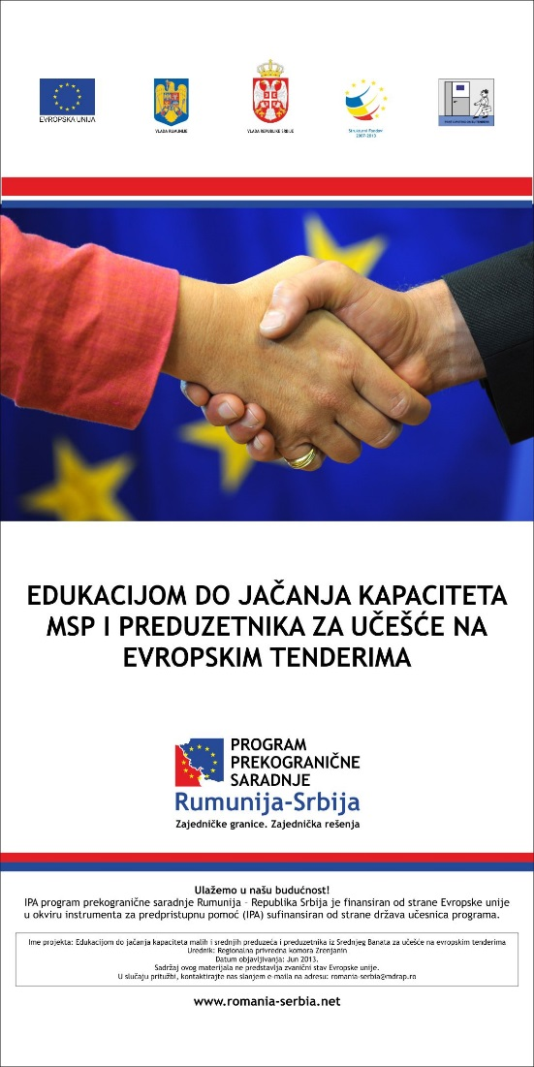

the implementation period (including extensions)
total funds spent/total funds contracted *100
indicators and level of achievement against targets set

