|  |  |  |  |  |  |  |  |
| --- | --- | --- | --- | --- | --- | --- | --- |
| **Project information** | | | | | | | |
|  | |  | | | | | |
| CALL FOR PROPOSALS | | 2 | | | | | |
| MIS-ETC: | | 1258 | | | | | |
| PRIORITY AXIS: | | 3. Promoting “people to people” exchanges | | | | | |
| MEASURE: | | 3.3 Increase educational, social cultural and sporting exchanges | | | | | |
| PROJECT TITLE: | | **Gems of the Romanian and Serbian Folkloric Thesaurus- Preservation and promotion of cultural traditions in Resita, Lugoj and Veliko Gradiste** | | | | | |
| ACRONYM: | | FOLKLORIC GEMS | | | | | |
| DURATION[1]: | | 09.03.2013 – 08.03.2014 | | | | | |
| IPA FUNDS CONTRACTED: | | 276.425,44 | | | | | |
| TOTAL FUNDS CONTRACTED: | | 325.206,40 | | | | | |
| ABSORBTION RATE (%)[2]: | | 91,92 | | | | | |
| PROJECT OBJECTIVE(S): | | The development of sustainable cultural and social relations in the Romania-Serbia border area.  The preservation and promotion of cultural traditions specific to the Romania-Serbia cross-border area through the organization of folklore festivals in Resita, Lugoj and Veliko Gradiste. | | | | | |
| SHORT DESCRIPTION OF THE PROJECT: | | Through the project the partners were equipped with equipment and goods (3 multifunctional stages, 3 sound reinforcement and stage lighting systems, 100 folkloric costumes); four folkloric festivals were organized through which the cultural traditions specific to the Romania-Serbia cross-border area in Resita, Lugoj and Veliko Gradiste were promoted. | | | | | |
| DEGREE OF ACHIEVEMENT OF INDICATORS[3]: | | |  |  |  |  |  |  | | --- | --- | --- | --- | --- | --- | |  | **Indicator value provisioned in the contract** | | **Present indicator value** | | **%**  **6= (5)/(3)*100** | | **Output indicators**  **(1)** | **UM**  **(2)** | **Quantity**  **(3)** | **UM**  **(4)** | **Quantity**  **(5)** |  | | Increased people-to-people exchange in the fields of education, culture and sports | | | | | | | Increased integration of the local communities from border area | | | | | | | **Result indicators** | | | | | | | Increased social and cultural integration of people in the border areas | Number of participants benefiting from cross-border social and cultural events | 16.000 | Number of participants benefiting from cross-border social and cultural events | 16.000 | 100 | | Increased cooperation between local and regional public authorities across the border to finding solutions to joint local problems in the border area | Number of activities, actions, initiatives between local and regional public authorities in tackling joint problems, improving local service provision etc. | 1 | Number of activities, actions, initiatives between local and regional public authorities in tackling joint problems, improving local service provision etc. | 1 | 100 | | Improved quality of life and increased attractiveness of the border communities as a living place | Number of activities, actions, initiatives developing new or improving existing educational and social services, or improving other local living conditions | 6 | Number of activities, actions, initiatives developing new or improving existing educational and social services, or improving other local living conditions | 6 | 100 | | Improved knowledge of culture, history, society, organizational and institutional structure, and language of the neighbouring country | Number of participants gained knew knowledge in events promoting / profiling the neighbouring country | 105 | Number of participants gained knew knowledge in events promoting / profiling the neighbouring country | 105 | 100 | | **Project indicators** | | | | | | | Cultural and artistic cross-border events organized in the border area that includes the three municipalities | event | 6 | event | 6 | 100 | | | | | | |
| RESULTS ACHIEVED: | | 4 folkloric festivals: 2 in Resita, 1 in Lugoj, 1 in Veliko Gradiste  2 workshops, 105 participants  3 multifunctional stages  3 sound reinforcement and stage lighting systems  100 folkloric costumes  105 folkloric artists will hold performances at each of the 4 festivals  16,000 spectators at the four festivals  80,000 citizens of Resita, Lugoj and Veliko Gradiste informed about the project and its cultural and artistic events  1 documentary film on DVD, 500 DVDs | | | | | |
|  | |  | | | | | |
| **Partnership information** | |  | | | | | |
|  | |  | | COUNTRY | COUNTY/DISTRICT | BUDGET(EURO) | CONTACT DETAILS |
| LEAD PARTNER: | | MUNICIPALITY OF REŞIŢA | | Romania | Caraş-Severin | 131.872,80 | Reşiţa, Piaţa 1 Decembrie, Nr. 1 A  Tel. 004/0255/215314 |
| PARTNER 2: | | MUNICIPALITY OF LUGOJ | | Romania | Timiş | 104.672,80 | Piața Victoriei, Nr. 4, Lugoj  Tel. 004/0256/352240 |
| PARTNER 3: | | MUNICIPALITY OF VELIKO GRADISTE | | Serbia | Branicevski | 88.660,80 | VELIKO GRADISTE, ZITNI TRG 1  Tel. +381 12 662 120 |

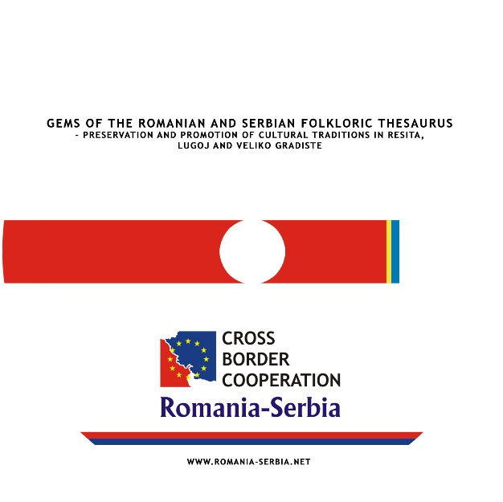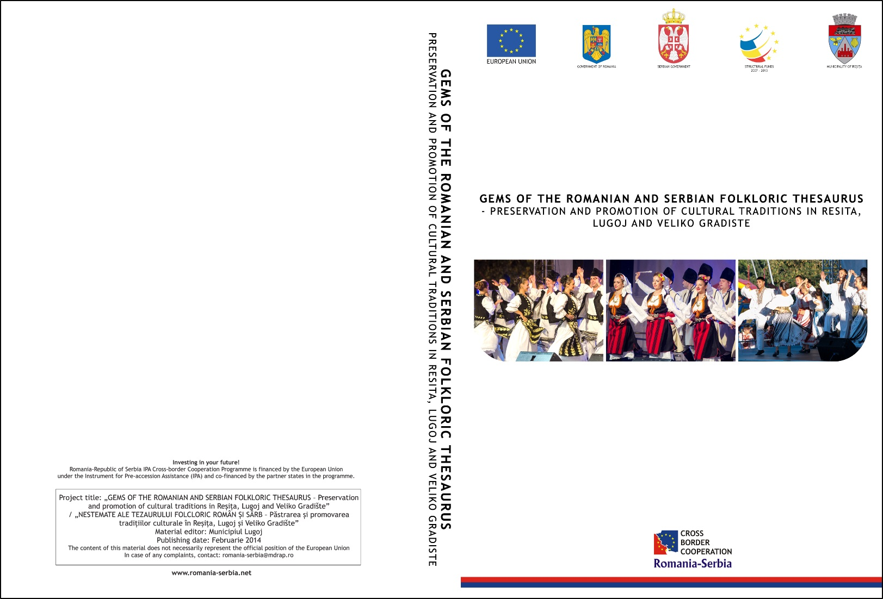

DVD



1. the implementation period (including extensions)
2. total funds spent/total funds contracted *100
3. indicators and level of achievement against targets set