 | Project information
 | CALL FOR PROPOSALS |  | 2
 | MIS-ETC: |  | 1255
 | PRIORITY AXIS: |  | 3. Promoting “people to people” exchanges
 | MEASURE: |  | 3.3 Increase educational, social cultural and sporting exchanges
 | PROJECT TITLE: |  | Multidisciplinary Tests - Key to European Education
 | ACRONYM: |  | MYTKEE
 | DURATION: |  | 04.04.2013 – 03.10.2014
 | IPA FUNDS CONTRACTED: |  | 237.728,00
 | TOTAL FUNDS CONTRACTED: |  | 279.680,00
 | ABSORBTION RATE (%): |  | 89,23
 | PROJECT OBJECTIVE(S): |  | Improvement of the quality of life for the communities of the border through training teachers and students with the purpose of obtaining better results in transdisciplinary evaluation at both national and international level in the domain of mathematics and science.  Increasing the quality of the education process and the level of teachers’ training through participation in joint training seminars, the development and dissemination of new and modern methods of teaching and by encouraging exchanges of any kind between the partner institutions.  Good practice experiences dissemination through organizing specific activities.  Organizing meetings and experience exchanges between the partner institutions through the development of entrepreneurship, linguistic, artistic and educational activities.  Promoting the preservation of cultural heritage and local traditions will be done by supporting activities related to the identity and traditions of communities in the border area.
 | SHORT DESCRIPTION OF THE PROJECT: |  | Within the project there were activities of: teacher training, elaboration of multidisciplinary tests, testing of schoolchildren, printing of informative brochures and practice of English communication.  In the most important activity 25 Serbian teachers and 25 Romanian teachers teaching disciplines which are part of the curricular area "Sciences" have participated in a 90-hour training course to obtain a basic level of communication in English.  In the project implementation 150 Romanian and Serbian schoolchildren from the 9th grade and 150 from the 10th grade were tested within the project.  In this project copies of bilingual brochures containing 40 tests developed within the project were printed, 300 schoolchildren from each region have improved their communication, social and entrepreneurial skills.  Also 20 tests were developed for each class for the transdisciplinary evaluation of 9th and 10th grade schoolchildren. (40 tests in total)
 | DEGREE OF ACHIEVEMENT OF INDICATORS: |  | Indicator value provisioned in the contract Present indicator value % 6= (5)/(3)*100  Output indicators (1) UM (2) Quantity (3) UM (4) Quantity (5)  Increased people-to-people exchange in the fields of education, culture and sports  Result indicators  Increased social and cultural integration of people in the border areas Number of participants benefiting from cross-border social and cultural events 900 Number of participants benefiting from cross-border social and cultural events 900 100  Improved knowledge of culture, history, society, organisational and institutional structure, and language of the neighbouring country Number of participants gained knew knowledge in events promoting/profiling the neighbouring country 500 Number of participants gained knew knowledge in events promoting/profiling the neighbouring country 500 100  Project indicators  Improving the professional training of teachers who contribute to the quality of educational No. of teachers from both regions attended the four stages of joint training 50 No. of teachers from both regions attended the four stages of joint training 50 100  Making together the didactic materials-tests needed in interdisciplinary teaching , in applying modern methods of teaching and learning No. of teaching /didactic materials-tests, made in common 40 No. of teaching /didactic materials-tests, made in common 40 100  Knowing the full identity of the specific cultural, social, linguistic and historical from the two ethnic groups in both regions No. of Serbian and Romanian persons involved in the project from both regions who have completed specific knowledge relating to cultural identity, social, linguistic, historical. No of persons who participated in the joint activities related to each specific category 600 No. of Serbian and Romanian persons involved in the project from both regions who have completed specific knowledge relating to cultural identity, social, linguistic, historical. No of persons who participated in the joint activities related to each specific category 600 100  Disseminating examples of good practice resulting from the conduct of projects in both regions No. of persons participating in the round-table and symposiums, which presents essays which disseminates good practice experiences 40 No. of persons participating in the round-table and symposiums, which presents essays which disseminates good practice experiences 40 100  Improving the students communication and social skills of develop entrepreneurship. % of students which are aware of the need to improve communication skills and social development and entrepreneurship 50 % of students which are aware of the need to improve communication skills and social development and entrepreneurship 50 100  Discovery and affirmation in both regions of pupils with artistic talent No. of talented students in different artistic branches which will follow a special training 80 No. of talented students in different artistic branches which will follow a special training 80 100
 | RESULTS ACHIEVED: |  | - Cross-border cooperation in the field of education and in the field of culture has been established.  - All teachers involved in the project have enriched their educational and professional skills in order to be able to provide high quality education to their students.  - The teachers developed 20 tests for each class for the transdisciplinary evaluation of 9th and 10th graders. (a total of 40 tests)  - 150 Romanian and Serbian students, from the 9th grade and 150 students from the 1Oth grade were tested in the project.  - 200 copies of bilingual (Romanian - Serbian) booklets were printed containing the 40 tests developed by teachers in the project.  - The partner institutions took part in a joint symposium where there was a dissemination of good practice as a follow-up to using the Smartboard in the transdisciplinary educational process.  - 300 students from each region have improved their communication skills, social abilities and have developed their entrepreneurial sense. These actions are decisive for the success of the career of any young person and implicitly for the success of this cross-border project.  - 25 Serbian teachers and 25 Romanian teachers that teach subjects belonging to the Science curricular area took part in a 90 hour training course to develop competence and abilities to project multidisciplinary lessons and tests.  - 25 Serbian teachers and 25 Romanian teachers that teach subjects belonging to the Science curricular area took part in a 90 hour training course to obtain a basic level of communication in English.  - All teachers involved in this project were asked to access information regarding the educational systems in countries with good results in transdisciplinary testing.  - The test was developed as a means of evaluation not so much in terms of acquiring school curriculum, but rather in terms of knowledge and skills necessary in the adult life.  - Already having this experience, it was useful to make preparation material for future tests available for students from other schools, as well as those in partner institutions.
Partnership information
 |  |  |  | COUNTRY | COUNTY/DISTRICT | BUDGET(EURO) | CONTACT DETAILS
LEAD PARTNER: |  | School Inspectorate of Timis County |  | Romania | Timis | 164.680,00 | Timisoara, Bld.C.D.Loga Nr. 3  Tel. 0040256305799
PARTNER 2: |  | Chemical and Medical High School Vrsac |  | Serbia | South Banat | 115.000,00 | Vrsac, Sterijna 113  Tel. +381 64 7075 300

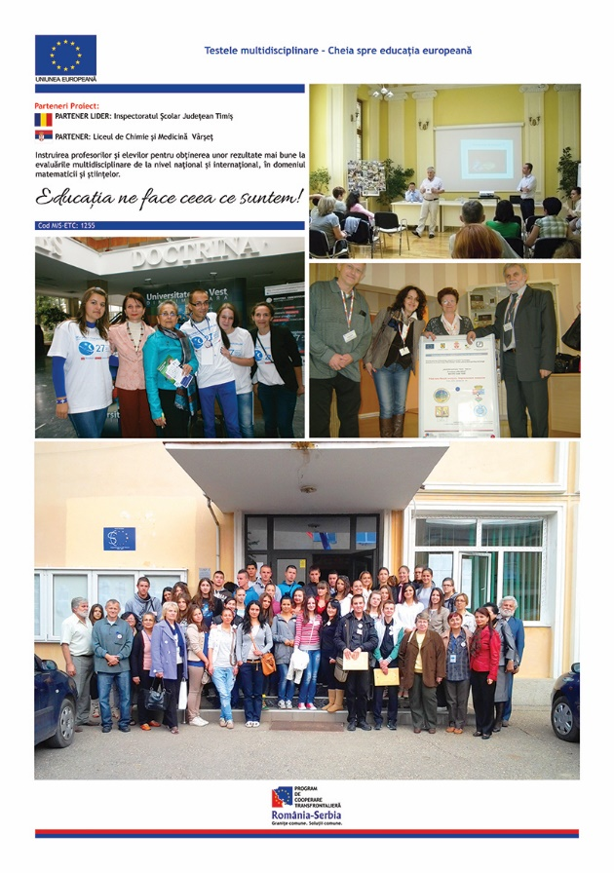

the implementation period (including extensions)
total funds spent/total funds contracted *100
indicators and level of achievement against targets set

