Project information
CALL FOR PROPOSALS | 2
MIS-ETC: | 1254
PRIORITY AXIS: | 3. Promoting “people to people” exchanges
MEASURE: | 3.3 Increase educational, social cultural and sporting exchanges
PROJECT TITLE: | Valorisation and Preservation of Folklore in the Cross-Border Area
ACRONYM: | Romanians songs
DURATION: | 01.01.2016 -31.12.2016
IPA FUNDS CONTRACTED: | 30.345,00 €
TOTAL FUNDS CONTRACTED: | 35.700,00 €
ABSORBTION RATE (%): | 81,01%

PROJECT OBJECTIVE(S): | Identification folk singers and old folk songs.  Symposium organization.  Folk collections publishing.  Folk festival organization.
SHORT DESCRIPTION OF THE PROJECT: | The project identified folk singers and collections of folk songs, published two folk collections and organized symposiums and a folk festival.

DEGREE OF ACHIEVEMENT OF INDICATORS: | Indicator Indicator value provisioned in the contract Present indicator value % 6= (5)/(3)*100  Output indicators (1) UM (2) Quantity (3) UM (4) Quantity (5)  Project indicators  Improving the visibility degree No. TV shows 2 No. TV shows 2 100%  No. of leaflets distributed 1000 No. of leaflets distributed 1000 100%  No. of folklore collections 1000 No. of folklore collections 1000 100%  Result indicators  Increased social and cultural integration of people in the border areas Number 20 Number 20 100%  Improved quality of life and increased attractiveness of the border communities as a living place Number 6 Number 6 100%  Improved knowledge of culture, history, society, organisational and institutional structure, and language of the neighbouring country Number 150 Number 150 100%

RESULTS ACHIEVED: | During the projects implementation folk singers were identified and a number of 1000 folklore collections;  2 TV shows, 1000 leaflets distributed;  Two folk collections were published and symposiums and a folk festival were organized.

Partnership information
 |  | COUNTRY | COUNTY/DISTRICT | BUDGET(EURO) | CONTACT DETAILS
LEAD PARTNER: | Lumina Cultural Foundation | Romania | MEHEDINŢI | 31.700,00 | Drobeta Turnu Severin, Anghel Saligny 12 B street  Tel. 00 40 723806 431
PARTNER 2: | ”Ariadnae Filum” – Association for Culture of the Vlachs – Romanians from the North-East of Serbia | Serbia | Borski | 4.000,00 | Bor, Street 3 octombrie no 87 Ap18  Tel. 00381-60-4854900
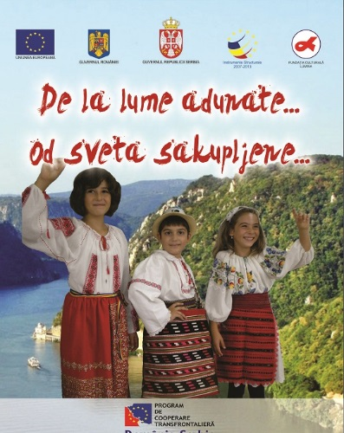

the implementation period (including extensions)
total funds spent/total funds contracted *100
indicators and level of achievement against targets set

