Project information
CALL FOR PROPOSALS | 2
MIS-ETC: | 1244
PRIORITY AXIS: | 3. Promoting “people to people” exchanges
MEASURE: | 3.1 Support the development of civil society and local communities
PROJECT TITLE: | Youth Essentials
ACRONYM: | YOUTH
DURATION: | 13.10.2012 – 21.04.2014
IPA FUNDS CONTRACTED: | 218.042,00
TOTAL FUNDS CONTRACTED: | 256.520,00
ABSORBTION RATE (%): | 83,07
PROJECT OBJECTIVE(S): | Improving the quality of life for the inhabitants of Timis county and Severno-Banatski district by enhancing the capacities of local public institutions and local NGOs in identifying and answering the specific needs of the inhabitants (especially young people).  Ensure share of good practices and promote pilot actions addressed to offering opportunities to young people, in order to prevent and reduce criminality among youngsters through employment, education and activation opportunities and integrated services at the local level.  Enhancing the capacities of local public institutions and NGOs in identifying and addressing services for the local population in order to promote and improve social and professional inclusion of youngsters (in particular youth at risk).  Creating a professional development context for specialists from both sides of the Romanian-Serbian border through experience exchanges and joint activities (workshops, seminars) in order to improve their abilities in working with vulnerable categories (in particular youth at risk) through integrated services at the local level.
SHORT DESCRIPTION OF THE PROJECT: | Through this project 8 joint events were organized, 14 info-centres for youth were created and developed, 2 local consultative groups were created, one Joint Strategy regarding social cohesion and social inclusion was elaborated and published and one Good practice guide was disseminated.
DEGREE OF ACHIEVEMENT OF INDICATORS: | Indicator value provisioned in the contract Present indicator value % 6= (5)/(3)*100  Output indicators (1) UM (2) Quantity (3) UM (4) Quantity (5)  Stronger civil society of the border area (2 NGOs implementing joint capacity building actions/ action plans and strategies for developing the civil society of the cross-border area) number 2 number 2 100  Increased people-to-people exchange in the fields of education, culture and sports (122 people participated in cross-border people-to-people exchanges events) number 122 number 155 127  Increased integration of the local communities from border area (6 public events –organised for integrating local communities from both side of the border: 2 experience exchange modules, 2 camps, 2 joint work-shops) number 6 number 6 100  Result indicators  Increased social and cultural integration of people in the border areas Number of participants benefiting from cross-border social and cultural events 122 Number of participants benefiting from cross-border social and cultural events 155 127  Increased cooperation between local and regional public authorities across the border to finding solutions to joint local problems in the border area Number of activities, actions, initiatives between local and regional public authorities in tackling joint problems, improving local service provision etc. 32 (8 cross-border and 24 local) Number of activities, actions, initiatives between local and regional public authorities in tackling joint problems, improving local service provision etc. 31 (8 cross-border and 23 local) 97  Increased cooperation between NGOs across the border in order to develop civil society capacity on border area Number of activities, action plans, initiatives between NGOs in building capacity of civil society organisations, promoting local governance and civil rights. 1 Number of activities, action plans, initiatives between NGOs in building capacity of civil society organisations, promoting local governance and civil rights. 1 100  Improved quality of life and increased attractiveness of the border communities as a living place Number of activities, actions, initiatives developing new or improving existing educational and social services, or improving other local living conditions 14 Number of activities, actions, initiatives developing new or improving existing educational and social services, or improving other local living conditions 14 100  Improved knowledge of culture, history, society, organisational and institutional structure, and language of the neighbouring country Number of participants gained knew knowledge in events promoting/profiling the neighbouring country 122 Number of participants gained knew knowledge in events promoting/profiling the neighbouring country 155 127  Project indicators  Increased opportunities for young people in the cross-border area Number of events facilitating share of good practices addressed to offering opportunities to young people 8 Number of events facilitating share of good practices addressed to offering opportunities to young people 8 100  Number of actions addressed to offering opportunities to young people 14 Number of actions addressed to offering opportunities to young people 14 100  Enhanced capacities of local public institutions and NGOs in identifying and addressing services for the local population in order to promote and improve social and professional inclusion of youngsters Number of NGO’s and public institutions participating in the project and benefiting of the joint events 14 Number of NGO’s and public institutions participating in the project and benefiting of the joint events 22 158  Improved abilities of professionals working with vulnerable categories Number of events facilitating the improvement of the professional abilities 4 Number of events facilitating the improvement of the professional abilities 4 100  Number of professionals participating in the joint events 76 Number of professionals participating in the joint events 98 129
RESULTS ACHIEVED: | 8 types of activities designed for capacity building of public institutions and NGOs as in the cross-border region, in answering the specific needs of the inhabitants (joint experience exchanges, joint work-shops, joint camps, creation and functioning of local consulting groups, joint strategy on social cohesion), opening (in Serbia) and development (in Romania) of the info-centres, local campaigns promoting the info-centres, publishing the Good Practice Guide resulted from the exchanges.  2 Experience exchange modules between police departments and other relevant public services  4 Joint Workshops on promoting opportunities for youth,  1 Peer review to local consulting groups for the promotion of good practices in integrated services in employment, education and service policies  4 Info centres for youth opened in Serbian schools – 12 volunteers involved  10 Info centres developed in schools from Timis county – 30 volunteers involved  2 Local campaigns for dissemination of information about the activity of the info-centres  2 camps organized, one in Romania and one in Serbia for 46 people  3 small grants implemented through partners in the cross-border region  2 local consulting groups established to promoting integrated services in employment, education and service policies with overall 10 members with 12 meetings in each of the countries  1 Joint cross-border strategy elaborated  46 beneficiaries (police and other relevant public institutions representatives) participating in experience exchanges  16 beneficiaries (NGO and public institutions representatives) involved in joint work-shops  16 members of the local consultative groups involved in elaborating the Joint Cross-border strategy on social cohesion and social inclusion

Partnership information
 |  | COUNTRY | COUNTY/DISTRICT | BUDGET(EURO) | CONTACT DETAILS
LEAD PARTNER: | Bethany Social Services Foundation | Romania | Timis | 177.540,00 | Timisoara, Dorobantilor, No. 4  Tel. 0040256499431
PARTNER 2: | Association of citizens “Duga” Ada | Serbia | Norh Banat | 78.980,00 | Ada, Vuka Karadzica 20  Tel. +381 24 851 138
PARTNER 3: | Timis County Police Inspectorate | Romania | Timis | 0 | Timisoara, Take Ionescu Boulevard, 44-46  Tel. +40256 402004
PARTNER 4: | Municipality of Ada, Poverty Reduction Committee | Serbia | Norh Banat | 0 | Ada, Trg Oslobodjenja 1  Tel. 024/851-138

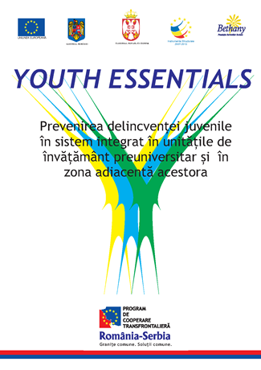
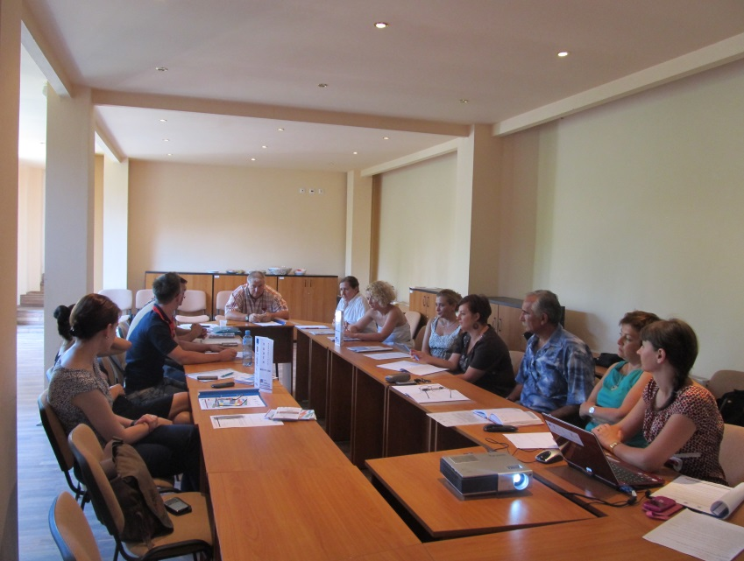
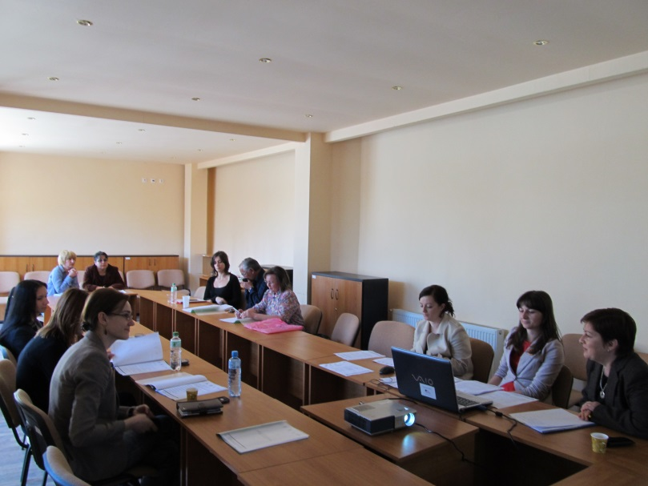
Awareness sessions
Consultative Group
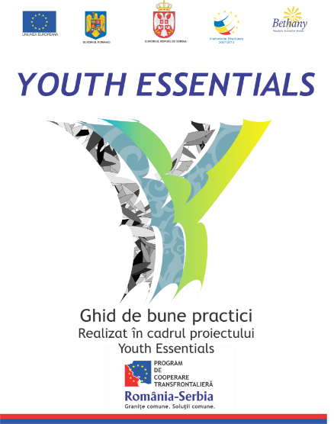
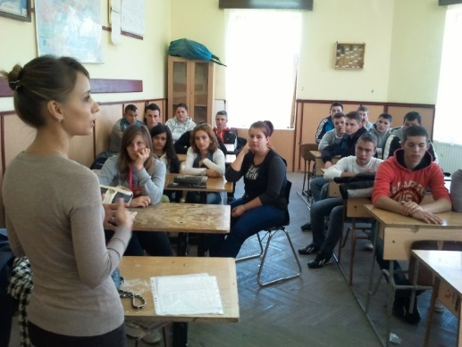
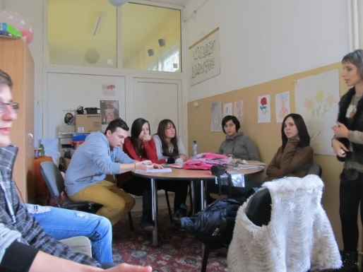
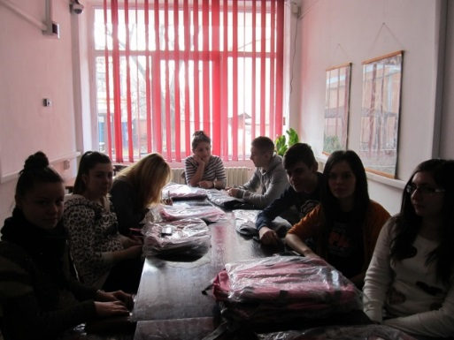
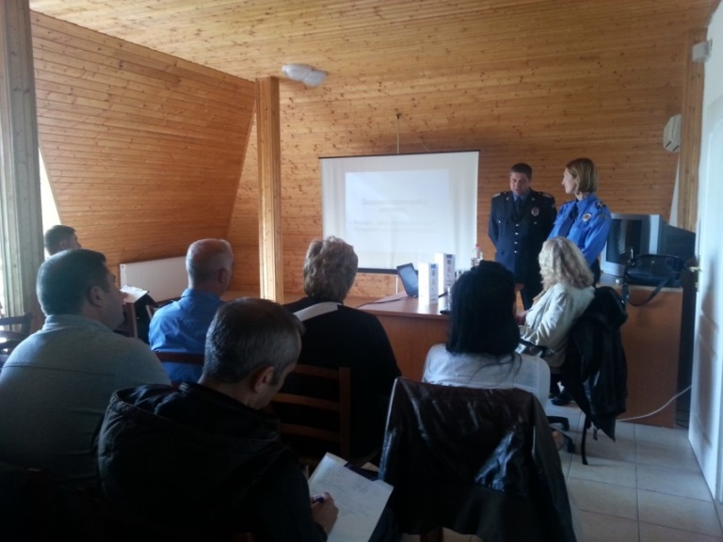
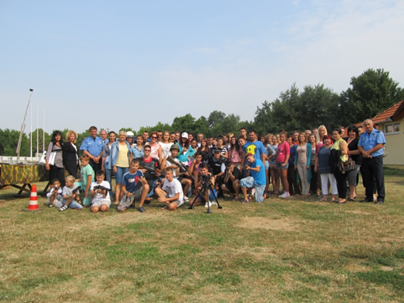
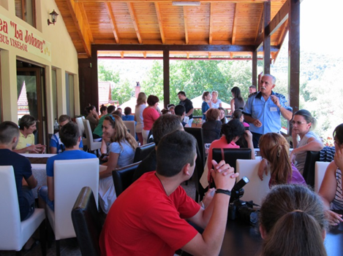
Camps

the implementation period (including extensions)
total funds spent/total funds contracted *100
indicators and level of achievement against targets set

