Project information
CALL FOR PROPOSALS | 2
MIS-ETC: | 1235
PRIORITY AXIS: | 1 Economic and Social Development
MEASURE: | 1.2 Develop the tourism sector, including the strengthening of the regional identity of the border region as a tourist destination
PROJECT TITLE: | Made in Iron Gates
ACRONYM: | M.I.G.
DURATION: | 19.03.2013 – 18.09.2014
IPA FUNDS CONTRACTED: | 299.820,70
TOTAL FUNDS CONTRACTED: | 352.730,24
ABSORBTION RATE (%): | 94,75
PROJECT OBJECTIVE(S): | Create the premise for a socio - economic growth based on the development of the quality of cross-border tourism  Development of tourism in the cross-border area by increasing interest in regional identity  Labor market development in tourism in the cross-border region  Improvement of tourism services in the cross-border region
SHORT DESCRIPTION OF THE PROJECT: | Through its activities the project offered opportunities to develop the labour market in the tourism sector, and to increase the interest in the Iron Gates region as tourist area. By engaging the local communities in the project activities the project raised the awareness of the communities with regard to the opportunity to stimulate the tourism industry and promote tourism landmarks. The project implemented a campaign to promote the tourism raising the quality of tourism in an area with proven tourist attractions. By involving the local communities in activities, raising their awareness on ways to promote by tourism the area and existing tourist landmarks through their work represent important steps in the beginning of tourist activities aimed for the social and economic development. The project created the preconditions for a tourism that renews the interest in the identity of the region as a tourist destination.
DEGREE OF ACHIEVEMENT OF INDICATORS: | Indicator value provisioned in the contract Present indicator value % 6= (5)/(3)*100  Output indicators (1) UM (2) Quantity (3) UM (4) Quantity (5)  Improved capacity and cross-border contacts of SMEs and in the R&D sector No. 1 No. 1 100  People in labour force with qualifications received/ improved from joint training activities No. 1 No. 1 100  New or improved cross-border tourism products, joint marketing approaches/activities or joint tourism information services developed No. 1 No. 1 100  Result indicators  New or improved cross- border tourism products and services logo “Made in Iron Gates” 1 logo “Made in Iron Gates” 1 100  tourist objectives models 10 tourist objectives models 10 100  models of tourism souvenirs 2 models of tourism souvenirs 2 100  Handicraft workshops 2 Handicraft workshops 2 100  Book of the artisans in Iron Gates 1 Book of the artisans in Iron Gates 1 100  Exhibition “Made in Iron Gates” 1 Exhibition “Made in Iron Gates” 1 100  Campaign to promote the tourist area 1 Campaign to promote the tourist area 1 100  Increased SME’s capacity in the border area training session for guest house managers 1 training session for guest house managers 1 100  Guide „ How to capitalize the natural and human potential of villages” 1 Guide „ How to capitalize the natural and human potential of villages” 1 100  conference "Joint tourism development in the Iron Gates" 1 conference "Joint tourism development in the Iron Gates" 1 100  Project indicators  Improved knowledge on environment-friendly approaches handicraft workshops 2 handicraft workshops 2 100  training session for guest house managers 1 training session for guest house managers 1 100  Strengthen the collaboration with the Serb partner and capacity to develop cross border projects successful implementation of the project "Made in the Iron Gates" 1 successful implementation of the project "Made in the Iron Gates" 1 100  Romanian-Serbian association to promote tourism 1 Romanian-Serbian association to promote tourism 1 100
RESULTS ACHIEVED, INCLUDING PHOTOS: | 1 data base  1 logo “Made in Iron Gates”  10 models with tourist objectives  5 seminars on entrepreneurial skills topics  20 Romanian locals trained to manufacture tourist souvenirs  5 Serbian locals trained to manufacture tourist souvenirs  20 models of souvenirs were created  1000 copies of Book of the artisans in the IG area  25 people trained as guesthouse managers  1000 copies of the guide "How to capitalize the natural and human potential of villages"  1 Romanian-Serbian conference  1 souvenirs exhibitions  1 Romanian-Serbian association for Joint tourism in Iron Gates  10 tourist feature reports „Made in The Iron Gates”  1000 DVDs with the 10 tourist feature reports  1 virtual tourist information center “Made in Iron Gates”  A short video about the project is available at:  https://promehedinti.ro/category/made-in-iron-gates/

Partnership information
 |  | COUNTRY | COUNTY/DISTRICT | BUDGET(EURO) | CONTACT DETAILS
LEAD PARTNER: | Association Pro-Mehedinti | Romania | Mehedinti | 307.627,04 | Drobeta Turnu Severin , Str. Decebal nr.40,bl. A1, sc. 1, Ap. 35  Tel. 40252.311.126
PARTNER 2: | Tourist Organization of Municipality Majdanpek (TOOM) | Serbia | Bor | 45.103,20 | Donji Milanovac, Kralja Petra I bb  Tel. +381 (0)30 596 184

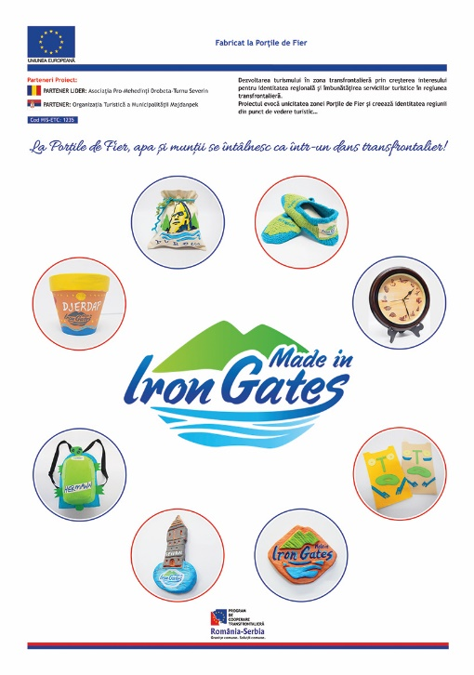

the implementation period (including extensions)
total funds spent/total funds contracted *100
indicators and level of achievement against targets set

