Project information
CALL FOR PROPOSALS | 2
MIS-ETC: | 1234
PRIORITY AXIS: | 3. Promoting “people to people” exchanges
MEASURE: | 3.3 Increase educational, social cultural and sporting exchanges
PROJECT TITLE: | Increasing quality of life through cross-border cooperation activities between Giulvaz and Marghita (Plandiste)
ACRONYM: | IQLGM
DURATION: | 24.10.2013 – 23.10.2014
IPA FUNDS CONTRACTED: | 68.680,00€
TOTAL FUNDS CONTRACTED: | 80.800,00€
ABSORBTION RATE (%): | 85,29%

PROJECT OBJECTIVE(S): |  | - To increase the cooperation between communities of Municipalities Giulvaz and Margita (Plandiste) and to establish a long-term partnership and cooperation in education, cultural and social activities, to contribute to better understanding of each other and finding solutions to joint local problems in the border area and improve the quality of life.  - To intensify the cross-border cultural activities during the project implementation between the people from, Giulvăz (Romania) and Margita, Serbia.  - To put in value, during the project implementation, the customs and traditions of the minorities from Giulvaz and Margita.  - To improve the collaboration between the local authorities from the two Municipalities, Giulvaz (Romania) and Margita (Serbia) during the project and to create and operate a network of communication, collaboration and sustainable cooperation across borders to support cultural and educational activities.  - To improve knowledge of cultural, tourism and language from the neighbouring country for a better integration of the local communities from border area.
SHORT DESCRIPTION OF THE PROJECT: |  |  | The project equipped the partners with audio-video systems, chairs and folk costumes for organizing a different number of cultural and educational activities.
DEGREE OF ACHIEVEMENT OF INDICATORS: | Indicator Indicator value provisioned in the contract Present indicator value % 6= (5)/(3)*100  Output indicators (1) UM (2) Quantity (3) UM (4) Quantity (5)  Result indicators  Increased social and cultural integration of people in the border areas Number of participants benefiting from cross-border social and cultural events 1400 Number of participants benefiting from cross-border social and cultural events 1400 100  Increased cooperation between local and regional public authorities across the border to finding solutions to joint local problems in the border area Number of activities, actions, between local and regional authorities in tackling joint problems improving local service provision, etc 4 Number of activities, actions, between local and regional authorities in tackling joint problems improving local service provision, etc 4 100  Improved quality of life and increased attractiveness of the border communities as a living place Number of activities, actions, initiatives developing new or improving existing educational and social services, or improving other local living conditions 6 Number of activities, actions, initiatives developing new or improving existing educational and social services, or improving other local living conditions 6 100  Improved knowledge of culture, history, society, organizational and institutional structure, and language of the neighbouring country Number of participants gained knew knowledge in events promoting/profiling the neighbouring country 1400 Number of participants gained knew knowledge in events promoting/profiling the neighbouring country 1400 100  Project indicators  The number of folk dances and learning specific steps for participants Number 2 Number 2 100  Cultural events Number 4 Number 4 100  Exchange of experience Number of visits organized 8 Number of visits organized 8 100  Minutes of meetings Reports 8 Reports 8 100  Closing events Number of events organized 2 Number of events organized 2 100  Meetings between public administration and new idea for the future projects Number 4 Number 4 100  Visibility Number of published articles, conferences 6 Number of published articles , conferences 6 100

RESULTS ACHIEVED: | - 16 young people (8 from Margita and 8 from Giulvaz) trained to present a variety of Romanian and Serbian folk dances;  - two folk shows with Serbian and Romanian folkloric dances and traditions containing a new repertoire supported by members of Giulvaz and Margita were organized;  - increasing of the experience of both partners in project management;  - increasing the cooperation between partners, between local and regional authorities, between the neighbour communities;  - acquisition of equipment and goods, necessary for a better development of present and future cultural activities.

Partnership information
 |  | COUNTRY | COUNTY/DISTRICT | BUDGET(EURO) | CONTACT DETAILS
LEAD PARTNER: | Municipality of Giulvaz | Romania | Timiş | 40.000,00 | Giulvaz, No. 172  Tel. 0256-416201
PARTNER 2: | Municipality of Plandiste | Serbia | South Banat | 40.800,00 | Plandiste, Vojvode Putnika 38  Tel. 013 861033

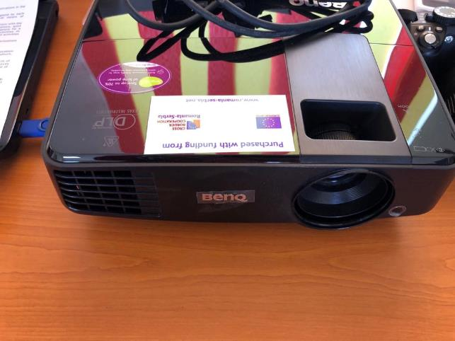
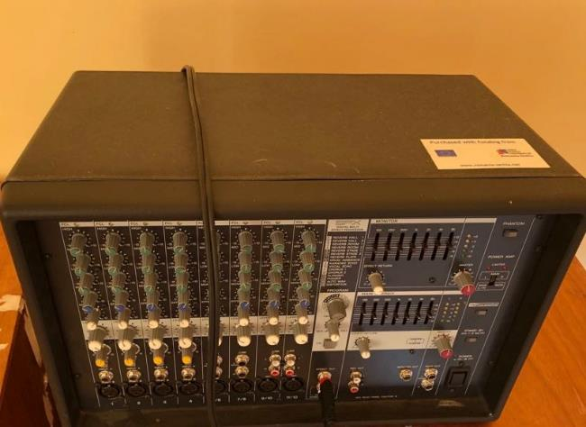
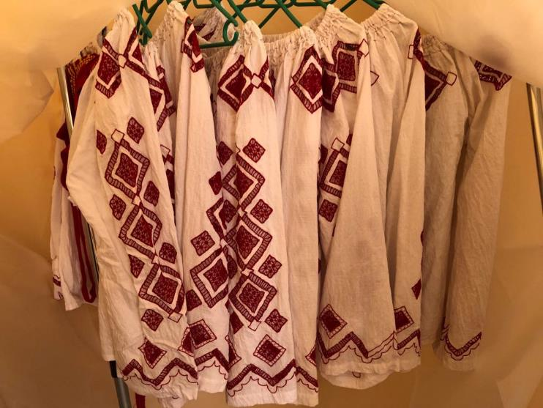

the implementation period (including extensions)
total funds spent/total funds contracted *100
indicators and level of achievement against targets set

