Project information
CALL FOR PROPOSALS | 1
MIS-ETC: | 385
PRIORITY AXIS: | 1. Economic and Social Development
MEASURE: | 1.4 Support increased levels of R&D and innovation in the border region
PROJECT TITLE: | SUSTAINABLE DEVELOPMENT FOR BANAT REGION BY MEANS OF ACADEMIC EDUCATION AND SCIENTIFIC RESEARCH & DEVELOPMENT IN TRANSBOUNDARY AIR QUALITY MONITORING ISSUES
ACRONYM: | BANATAIR
DURATION: | 15.12.2010 – 14.12.2011
IPA FUNDS CONTRACTED: | 322.819,80 €
TOTAL FUNDS CONTRACTED: | 379.788 €
ABSORBTION RATE (%): | 87,71%
PROJECT OBJECTIVE(S): | Politehnica University of Timisoara and University of Novi Sad joined their knowledge into a cross-border project that provided the necessary equipment for monitoring the air quality in the Banat Region.  Strengthening the cross-border cooperation between Banat Universities for the benefit of the quality of life.  Identifying of common environmental air quality related problems.  Improvement of the quality of air in Banat region and improvement of the collaboration between Banat region universities.  Improvement & development of a regional research network for cross-border air quality monitoring.  Increasing the importance of R&D in the field of environmental protection in border area by involving young scientists.  Cross-border area development in the Banat region by means of education and innovation.  Dissemination of know-how to specialists, young researchers, population and authorities.
SHORT DESCRIPTION OF THE PROJECT: | Romania, as a member state of the EU, and the Republic of Serbia, as a candidate state, must fulfil specific criteria regarding the environmental protection and air quality standards in order to ensure a sustainable development of living standards. Politehnica University of Timisoara (Romania) and University of Novi Sad (Republic of Serbia) joined their knowledge into a cross-border project that provided the necessary equipment for monitoring the air quality in the Banat Region and also focused on knowledge transfer and scientific research between the involved Universities.  The general objectives of the project focus on strengthening the cross-border cooperation between two of the most important Universities from the Romanian – Serbian cross-border area for the benefit of the quality of life in order to identify common environmental air quality related problems and to improve the quality of air in the area.  The implemented project allows the project partners to increase the importance of R&D and innovation in the field of environmental protection by involving PhD researchers and young scientists and disseminating the results and the know-how to the interested public.  In the future, the Faculty of Mechanical Engineering within Politehnica University of Timisoara and the Technical Faculty "Mihajlo Pupin" from Zrenjanin within Novi Sad University will educate and provide to society qualified technicians who will use the air quality monitoring stations in order to fulfil the EU citizens’ expectations regarding the air quality in the Banat Region.  Strengthened cross-border cooperation between Banat universities for the benefit of quality of life has been achieved, identifying common issues related to air quality by creating a knowledge transfer center. Developing a regional research network for cross-border air quality monitoring, improving air quality in the Banat region and improving collaboration between Banat universities.
DEGREE OF ACHIEVEMENT OF INDICATORS: | Indicator value provisioned in the contract Present indicator value % 6= (5)/(3)*100  Output indicators (1) UM (2) Quantity (3) UM (4) Quantity (5)  Increased importance of R&D/Innovation in the border area number 1 number 1 100  Improved physical infrastructure in the border area number 1 number 1 100  Result indicators  Increased importance of R&D/Innovation in the border area Workshop activities, young scientist participation, promotional materials and book 2 Workshop activities, young scientist participation, promotional materials and book 2 100  Improved physical infrastructure in the border area Number of infrastructure (R&D laboratories) 2 Number of infrastructure (R&D laboratories) 2 100  Project indicators  Cross-border academic collaboration in R&D field Number of activities and actions 1 Number of activities and actions 1 100  Increased R&D capabilities for cross-border Universities Number of improved or created physical structures 2 Number of improved or created physical structures 2 100  Improvement of cross-border joint staffing, development and implementation capabilities for academic institutions Number of cross-border R&D projects 1 Number of cross-border R&D projects 1 100
RESULTS ACHIEVED, INCLUDING PHOTOS: | During the implementation period from the project funds were purchase the following equipment: DOAS instrument – 1 pcs. – LP; NOx reference analyser -1 pcs. – LP; AIRPOINTER – 1 pcs. – P2; PC and Printer – 1 pcs. – P2  The Serbian partner organized one Knowledge transfer workshop where knowhow regarding environmental legislation and quality monitoring techniques and equipment were transferred.  Promotional materials regarding the air quality monitoring campaigns in Serbia and Romania and project activities were made.  During the implementation period 10 air quality monitoring campaigns were performed in Serbian Banat and Rumanian Banat, where both team members participated.  Dissemination activities for the project through newspaper article, local television station, seminar, exhibition were achieved.  A book presenting the project results was edited during the implementation period.
 | Project presentation movie: https://www.youtube.com/watch?v=PTHr8k34t5E

Partnership information
 |  | COUNTRY | COUNTY/DISTRICT | BUDGET(EURO) | CONTACT DETAILS
LEAD PARTNER: | UNIVERSITY “POLITEHNICA” from TIMISOARA | Romania | Timis | 234.832 | Timisoara, P-ta Victoriei no.2  Tel. +4.0256.403670
PARTNER 2: | University of Novi Sad, Technical Faculty “Mihajlo Pupin” Zrenjanin | Serbia | Middle Banat | 144.956 | Zrenjanin , bb Djure Djakovića St.  Tel. +381 23 550 515

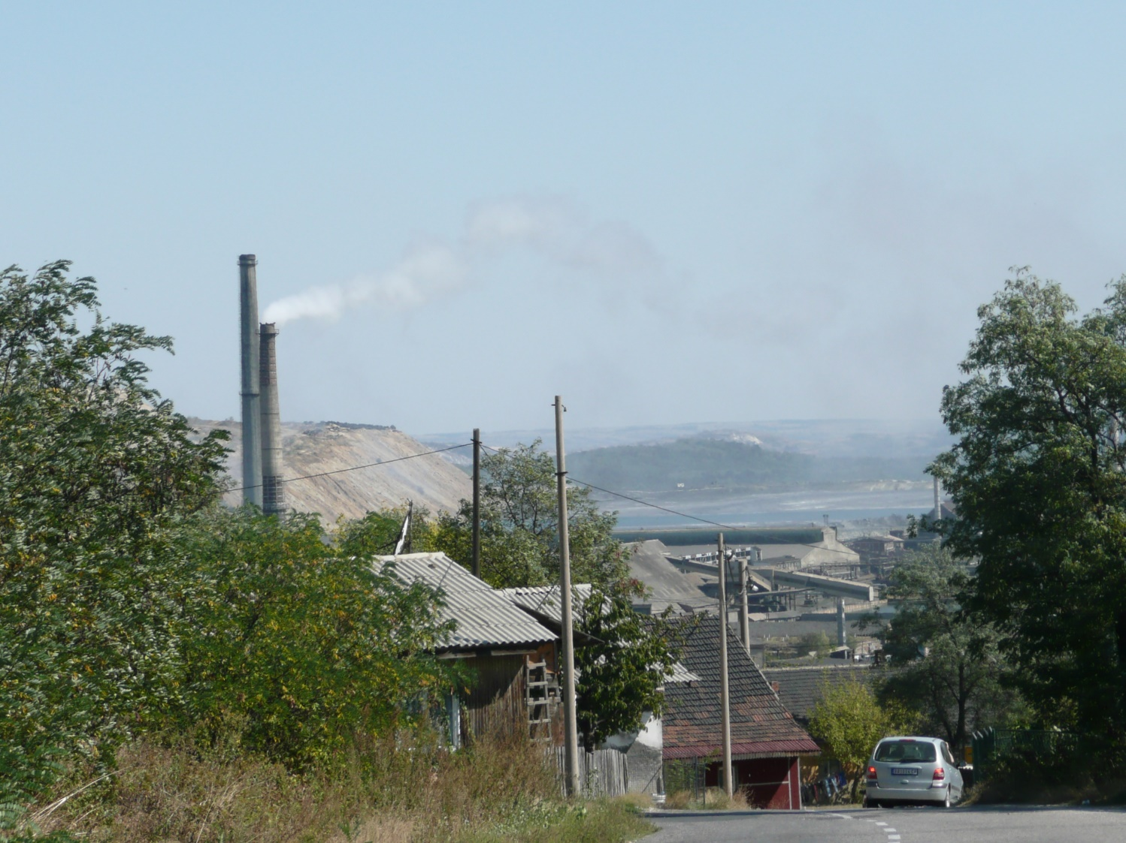

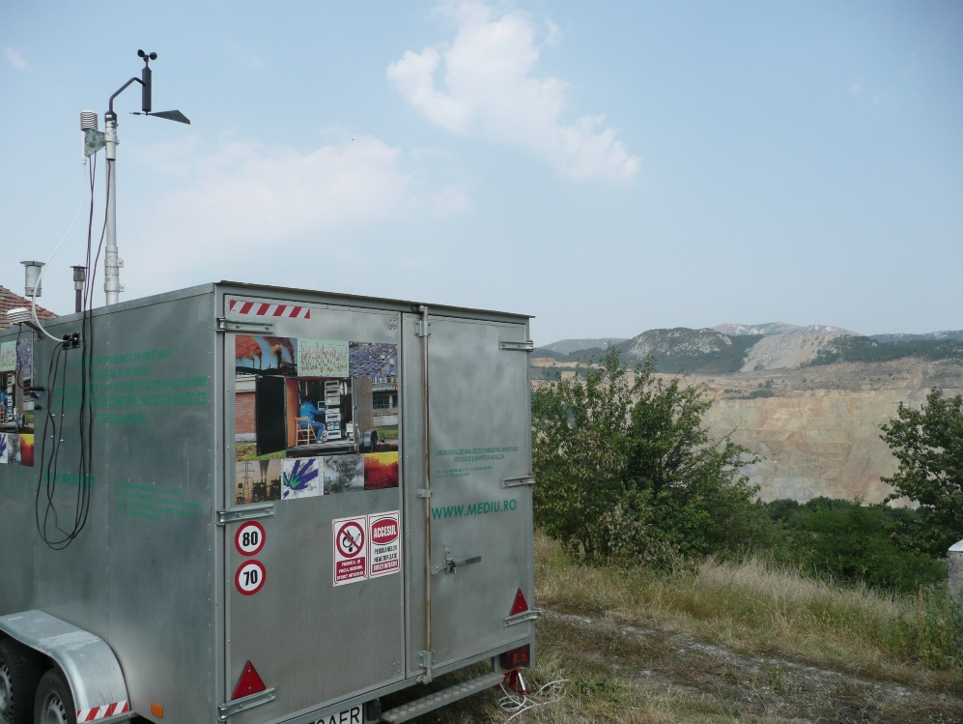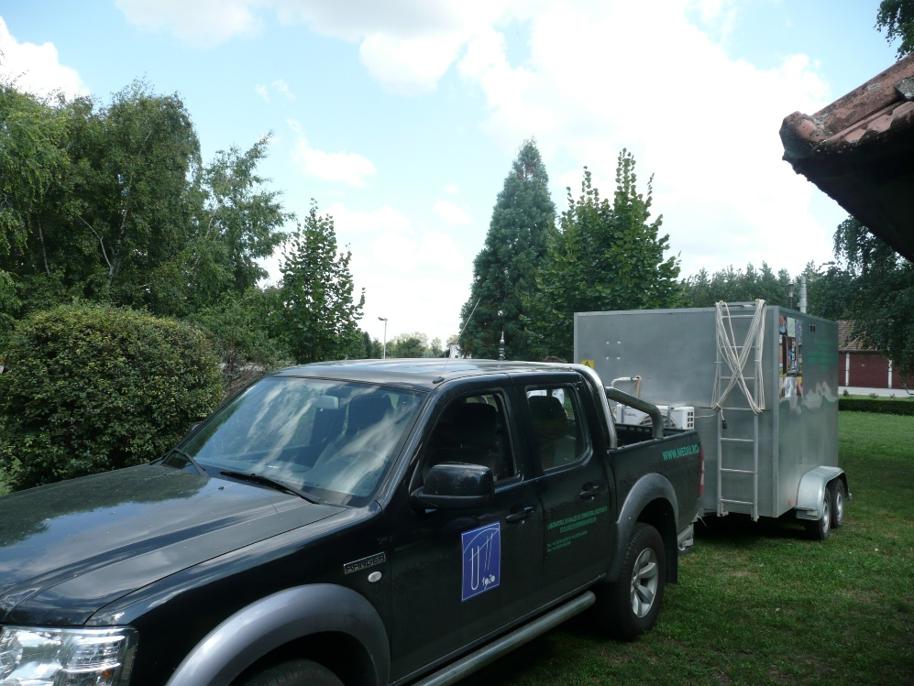

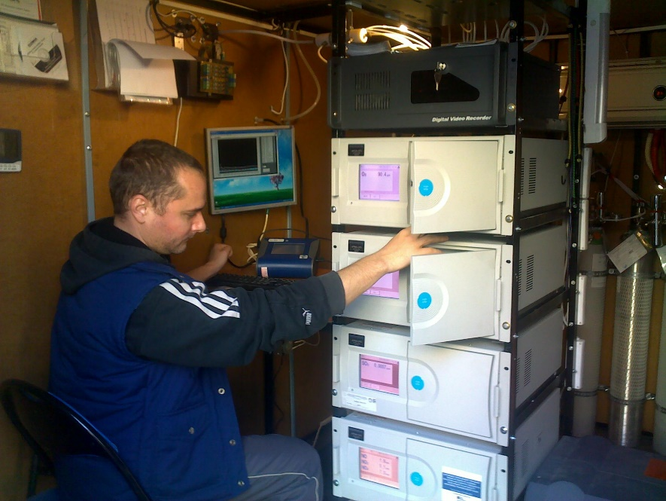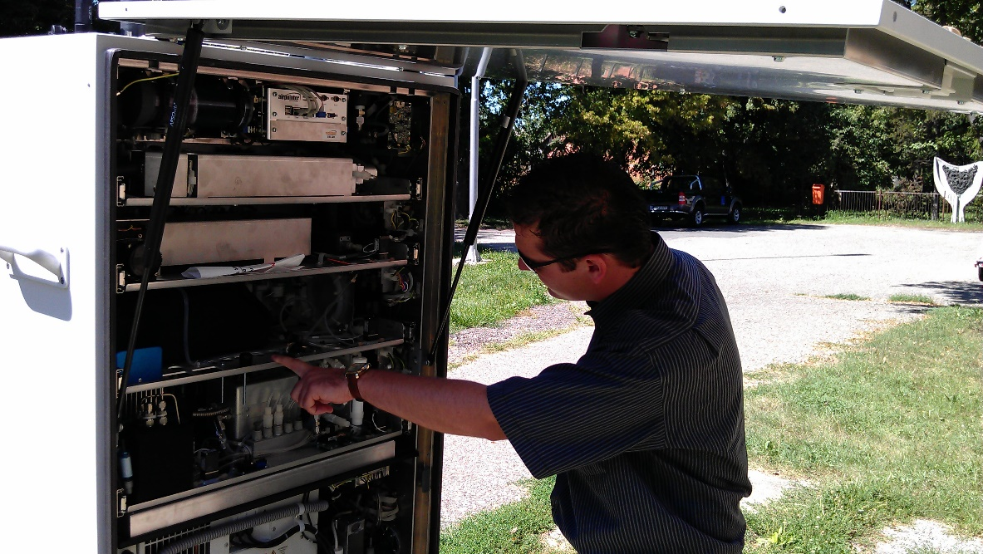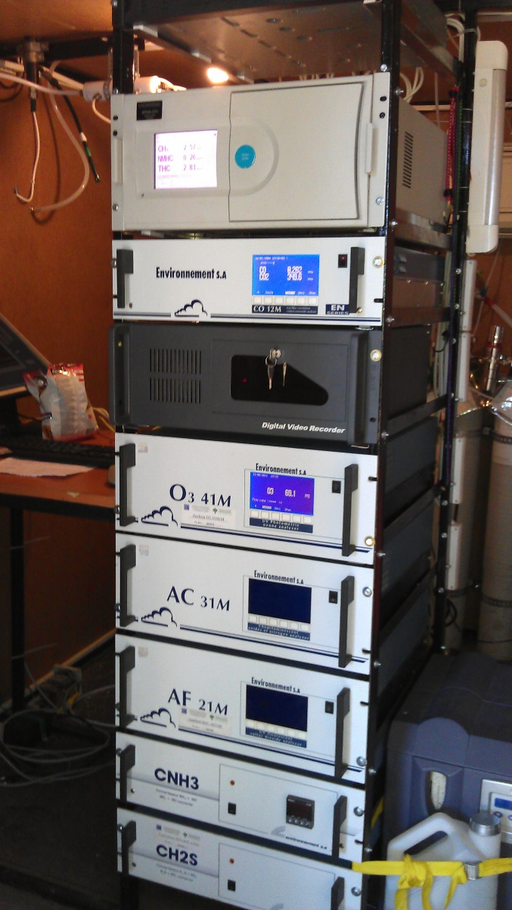

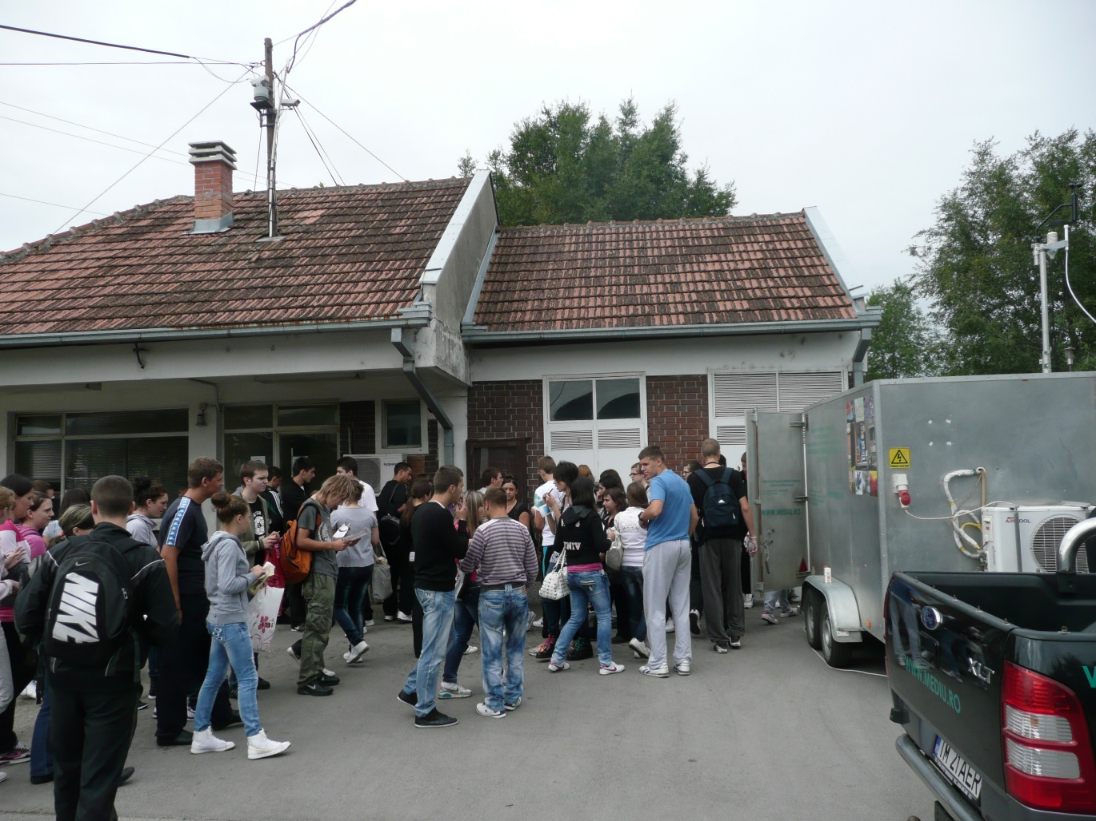

the implementation period (including extensions)
total funds spent/total funds contracted *100
indicators and level of achievement against targets set

