Project information
CALL FOR PROPOSALS | 1
MIS-ETC: | 384
PRIORITY AXIS: | 3. Promoting “people to people” exchanges
MEASURE: | 3.4 Enhance social and cultural integration of border areas
PROJECT TITLE: | Roma Social Inclusion Network
ACRONYM:
DURATION: | 18.12.2010 – 17.12.2011
IPA FUNDS CONTRACTED: | 88.012,4 €
TOTAL FUNDS CONTRACTED: | 103.544 €
ABSORBTION RATE (%): | 39,76%
PROJECT OBJECTIVE(S): | Increase access to employment, education, health and social protection services for Roma population in the border areas through the development of a network of 5 Roma Inclusion Offices.  Strengthen the capacity of local government and civil society to work in partnership to deliver services to disadvantaged groups in the border areas.  Development of Training and Education Programmes. Support for better preparedness for people to find new jobs in the border area.  Improve the access to sexual and reproductive health services for women and young people.  Enhance social and cultural integration of border areas.
SHORT DESCRIPTION OF THE PROJECT: | Cross-border management and coordination has been achieved through the development and provision of training for staff in Roma inclusion offices through a network of 5 regional offices; Identifying needs and priorities, development and provision of training for Roma in 5 municipalities in Serbia and Romania.
DEGREE OF ACHIEVEMENT OF INDICATORS: | Indicator value provisioned in the contract Present indicator value % 6= (5)/(3)*100  Output indicators (1) UM (2) Quantity (3) UM (4) Quantity (5)  Stronger civil society of the border area number 1 number 1 100  Improved local governance in relation to the provision of local services and communities in the border areas number 1 number 1 100  Increased integration of the border communities number 1 number 1 100  Result indicators  Increased people-to –people exchange in the fields of education, culture and sports Number of people participated in cross-border people-to-people exchanges events 250 Number of people participated in cross-border people-to-people exchanges events 255 102  Stronger civil society of the border area Number of NGOs implementing cross-border projects 6 Number of NGOs implementing cross-border projects 13 217  Improved local governance in relation to provision of local services in border communities Establishment of Offices for Roma Inclusion in border area Expansion of Roma Inclusion network to involve other municipalities 5+5 Establishment of Offices for Roma Inclusion in border area Expansion of Roma Inclusion network to involve other municipalities 5+5 100  Increased social and cultural integration of people in the border area Number of cross-border public events organised for integrating people from both side of the border 10 Number of cross-border public events organised for integrating people from both side of the border 10 100  Project indicators  Access to mainstream services improved Number of service providers developing protocols to improve based on consultation with Roma Community 2 model protocols in each municipality Number of service providers developing protocols to improve based on consultation with Roma Community 4 200  Network for Roma inclusion established Number of network members, diversity of network members 10 organisations involved in network Number of network members, diversity of network members 13 130  Increased level of consience of Roma people in border area about the importance of education (formal and informal) Number of people that went through trainings 400 Number of people that went through trainings 575 144
RESULTS ACHIEVED, INCLUDING PHOTOS: | 10 training or education programmes on issues affecting Roma developed and delivered for Roma people in three municipalities: Nova Crna, Novi Knezevac and Zitiste.  Priority needs identified and training and education programmes designed and delivered to members of Roma community.  Creation of Social Cards for Roma people in 5 municipalities and making a data base to help Roma inclusion. Roma Social Cards will be prepared by offices for Roma inclusion. There will also a software for data base be developed that will combine internal and external data. This data base will allow us to have more precise data of how many Roma people are there in Banat region, what conditions they live in and their access to services. The Social Cards would be designed in partnership with members of the Roma community to ensure that the information collected reflects their concerns and is sensitive to their needs.

Partnership information
 |  | COUNTRY | COUNTY/DISTRICT | BUDGET(EURO) | CONTACT DETAILS
LEAD PARTNER: | Municipality of Nova Crnja | Serbia | Middle Banat | 86.894 | Nova Crnja, JNA 110  Tel. +381 23 815 700
PARTNER 2: | Municipality of Zitiste | Serbia | Middle Banat | 0 | Zitiste, Cara Dusana 15  Tel. +381 23 821 050
PARTNER 3: | Municipality of Novi Knezevac | Serbia | North Banat | 0 | Novi Knezevac, Kralja Petra I  Tel. +381 23 82 055
PARTNER 4: | Intercultural Institute Timisoara | Romania | Timis | 16.650 | Timisoara, Bul.16 Decembrie 1989, No.8  Tel. +40256203942

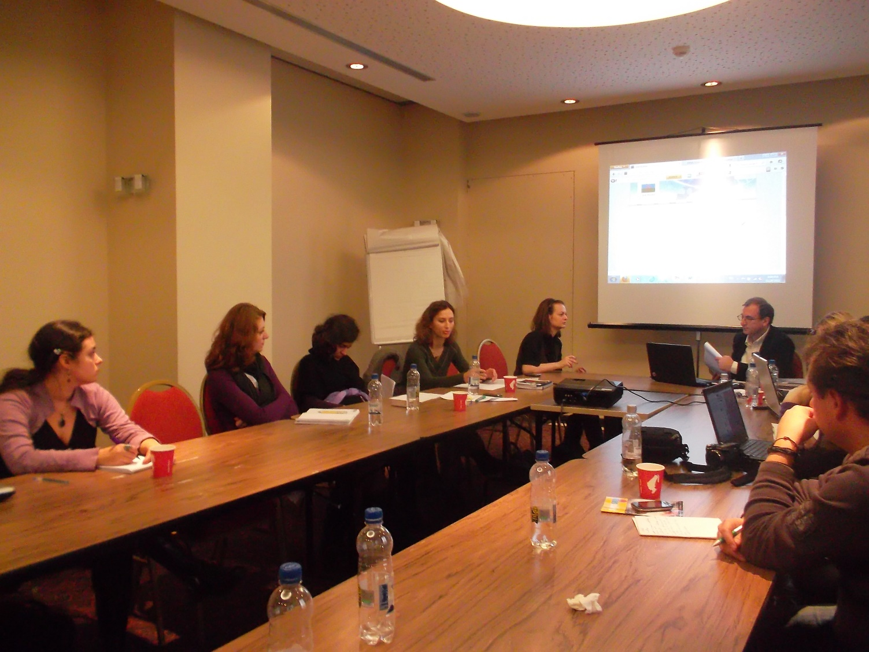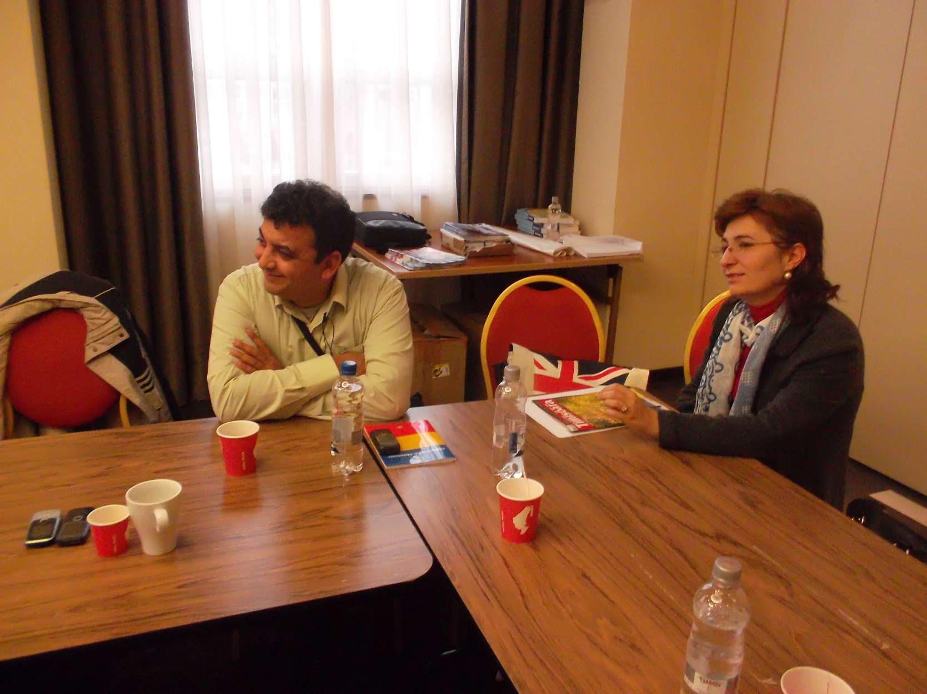

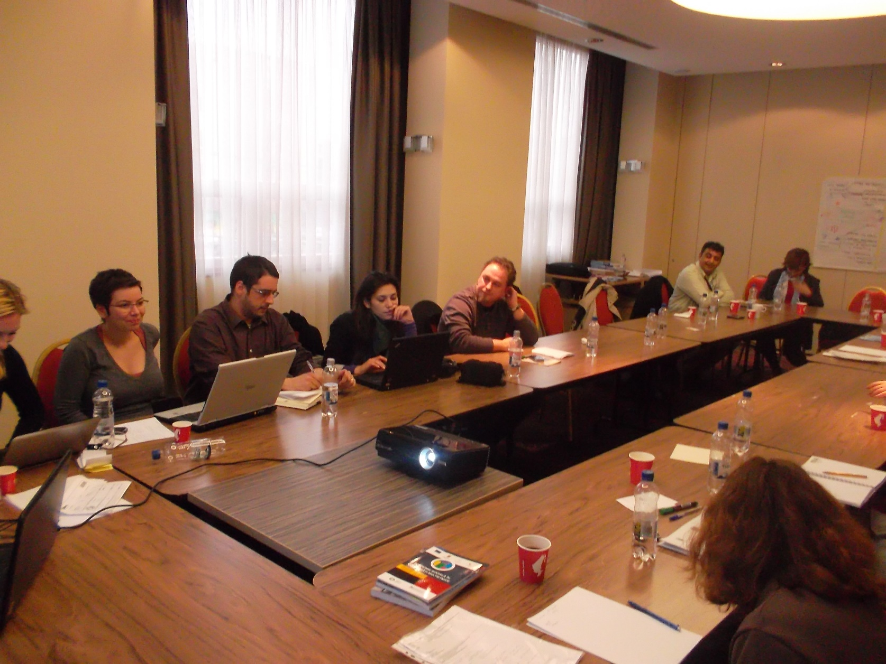

the implementation period (including extensions)
total funds spent/total funds contracted *100
indicators and level of achievement against targets set

