Project information
CALL FOR PROPOSALS | 1
MIS-ETC: | 533
PRIORITY AXIS: | 3 Promoting “people to people” exchanges
MEASURE: | 3.3 Increase educational, cultural and sporting exchange
PROJECT TITLE: | SPORT- TOOL FOR COMMUNICATION BETWEEN NATIONS
ACRONYM: | STCBN
DURATION: | 15.12.2010 – 14.06.2012
IPA FUNDS CONTRACTED: | 198.684,88 €
TOTAL FUNDS CONTRACTED: | 233.746,92 €
ABSORBTION RATE (%): | 66,52%
PROJECT OBJECTIVE(S): | Project objective was to promote educational and sports exchanges between the partner institutions in both Romanian and Serbian border regions.  Increasing the quality of sport and the level of training of teachers by participating in joint training internship, by the development and dissemination of new and modern methods of teaching physical education in general and especially in badminton and gymnastics, encouraging exchanges of any kind between partner institutions.  Initiation and development in both regions of badminton, as a mass-sport.  Development and improvement in all aspects of gymnastics in both border regions to the children of 6-15 years.  Developing arbitration skills at teachers in both border regions.
SHORT DESCRIPTION OF THE PROJECT: | Following the common problems identified in the preparatory phase of the project, the new established partnership decided to address these common problems through a series of activities that, after the project implementation provided improved educational and professional skills for 75 teachers, disemninated the good practice examples and encouraged experience exchanges, identified students capable of performing at high level the sports promoted through the project, improved communication skills in Serbian and Romanian language, increased the level regarding knowledge on national, historical, geographical and religious particularities of both regions.

DEGREE OF ACHIEVEMENT OF INDICATORS: | Indicator value provisioned in the contract Present indicator value % 6= (5)/(3)*100  Output indicators (1) UM (2) Quantity (3) UM (4) Quantity (5)  Increased people-to-people exchange in the fields of education, culture and sports.  Improved quality of life and increased attractiveness of the border communities as a living place.  Improved knowledge of culture, history, society, organisational and institutional structure and language of the neighbouring country  Result indicators  Improving the professional training of teachers of physical education and sports who are able to contribute to the quality in sports Number of teachers of physical education and sports in both regions who participated in training seminars 75 Number of teachers of physical education and sports in both regions who participated in training seminars 75 100%  Disseminate examples of good practice and encourage experience exchange Number of joint seminars of information and organisations in the project 2 Number of joint seminars of information and organisations in the project 2 100%  Number of round tables organized in the project 2 Number of round tables organized in the project 2 100%  Sharing experiences from projects % of the participants presented reports on the experience gained in carrying out projects specific to the event 40 % % of the participants presented reports on the experience gained in carrying out projects specific to the event 40 % 100%  Activities in order to discover students able of performance Number of students able of performance identified in both regions 52 (in each region) Number of students able of performance identified in both regions 52 (in each region) 100%  Number of competitions organised 3 Number of competitions organised 3 100%  Improving social and communication skills and developing spirit of competition and tolerance % of participants are aware of the necessity of improving social and communication skills and developing spirit of competition and tolerance 50% % of participants are aware of the necessity of improving social and communication skills and developing spirit of competition and tolerance 50% 100%  Lifting badminton and gymnastics at the highest peaks of performance No of students (in both regions), very talented, capable of outstanding performance in badminton and gymnastics At least 7 in each region for each sport No of students (in both regions), very talented, capable of outstanding performance in badminton and gymnastics 8 114%  Encourage practicing badminton as a mass sport No of schools in each region that have developed activities specific for badminton 20 (10 in each region) No of schools in each region that have developed activities specific for badminton 20 100%  Encouraging the practice of sport as mass-sport No of schools in each region that have developed activities specific to gymnastics 40 (20 in each region) No of schools in each region that have developed activities specific to gymnastics 40 100%  Improving the physical preparation of athletes capable of performance % of the total number of participants improve their physical training being capable of high physical effort 70% % of the total number of participants improve their physical training being capable of high physical effort 70 100%  Initiating physical education and sport teachers in methods and techniques of arbitration No. of teachers of physical education and sports in both regions that have acquired arbitration skills 46 No. of teachers of physical education and sports in both regions that have acquired arbitration skills 46 100%  Project indicators  Improving communication skills in Serbian language for Serbian teachers and athletes in Timis County No of Serbian teachers and athletes in Timis County that have improved their communication skills in Serbian language 70 No of Serbian teachers and athletes in Timis County that have improved their communication skills in Serbian language 70 100%  Improving communication skills in Romanian language for Romanian teachers and athletes in Central Banat No of Romanian teachers and athletes in Central Banat that have improved their communication skills in Romanian language 50 No of Romanian teachers and athletes in Central Banat that have improved their communication skills in Romanian language 50 100%  Knowledge of national, historical, geographical and religious particularities of both regions No of participants familiarized with national, historical, geographical and religious particularities of both regions 100 No of participants familiarized with national, historical, geographical and religious particularities of both regions 100 100%  Familiarising with the education system and with teaching Physical Education and Sport in both regions No of participants that familiarised with the education system and with teaching Physical Education and Sport in both regions 150 No of participants that familiarised with the education system and with teaching Physical Education and Sport in both regions 150 100%

RESULTS ACHIEVED, INCLUDING PHOTOS: | The project "Sport - Tool for Communication between Nations" was aimed to improve the quality of sport in the cross-border area, especially the development of gymnastics and badminton, contributing to the implementation of badminton as a sporting branch in Serbia.  The priority goals targeted by the project were the initiation and development of badminton and gymnastics in the Romanian-Serbian cross-border region as a sport practiced by everyone, but also as a performance sport. The partners tried to discover students with abilities in performing sports in the mass-education system through the organization of sports competitions as well. They also encouraged the professional development of teachers and their arbitration competencies. On the other hand, the project focused on activities that raised the awareness regarding the social, cultural, linguistic, sporting, historical and religious identities of the Serbian and Romanian ethnicities in the two border regions.  Under the slogan "We walk together in the sport world", two sport competitions were organized for students from Timișoara (Romania) and Zrenjanin (Serbia): "Timișoara Cup" in gymnastics and "Zrenjanin Cup" in badminton, and a symposium dedicated to teachers to approach the "Role of projects in the harmonious development of the athlete".  For teachers, specialised events were organised within the project, for example a round table discussion on "Badminton and gymnastics learning methods and means", a training regarding Badminton Techniques, a seminar about "The Importance of Badminton and Gymnastics Selection", "The Badminton Hope Cup" Sport Competition, the seminar "Modern Means in the Sportive Gymnastics ", the physical training stage "Gymnastics Techniques", the training stage "The Importance of Arbitration in Badminton and Gymnastics" respectively.  The "Sport - Tool for Communication Between Nations" project was funded by the European Union under the Romania – Republic of Serbia IPA Cross-Border Cooperation Programme and it was implemented between December 2010 and June 2012 by the Timiş County School Inspectorate, Timișoara School Sports Club 1 and Zrenjanin Olympic Sports and Training Federation from Serbia.  Description of the activities:  - 75 sport teachers and physical education from both regions participated in three training periods, contributing to the enhancement of the quality in sports and raising the professional training level of teachers;  - the experience exchanges and the dissemination of good practice was achieved through: 2 information seminars, 2 round tables, including a jointly organized special workshops and a symposium;  - ¼ of all participants from both border regions improved their communication and social skills and developed the spirit of sport competition and tolerance;  - 3 major joint sports competitions were held in order to find pupils able to get performance in sport;  - in 10 schools were organized badminton competitions, in order to discover possible talented children;  - 8 athletes capable of performance in badminton and gymnastics were selected (from the total of 500) and they followed a special training programme;  - specific gymnastics activities were held in 20 schools in each region, so that this discipline to be developed and improved and the number of students who may be selected for performance to increase;  - a joint summer school was organized and conducted; 36 athletes who have achieved great results in sports competitions joined the summer school;  - 46 sport teachers and physical education achieved competent arbitration skills.

Partnership information
 |  | COUNTRY | COUNTY/DISTRICT | BUDGET(EURO) | CONTACT DETAILS
LEAD PARTNER: | SCHOOL INSPECTORATE OF TIMIS COUNTY | Romania | Timis | 23.130 | Timisoara, Bld.C.D.Loga Nr. 3  Tel. 0040256305799
PARTNER 2: | SCHOOL SPORTS CLUB NR.1 TIMISDOARA | Romania | Timis | 107.183 | Timisoara, Str.Arh. Horia Creanga 9°  Tel. 0745384686
PARTNER 3: | FEDERATION FOR SCHOOL SPORTS AND OLYMPIC EDUCATION ZRENJANIN | Serbia | Central Banat | 103.433,92 | Zrenjanin, Makedonska 11a  Tel. +38123511268

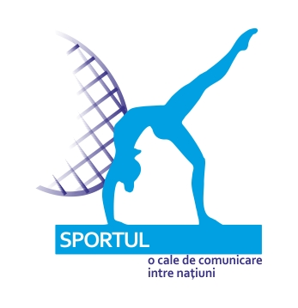

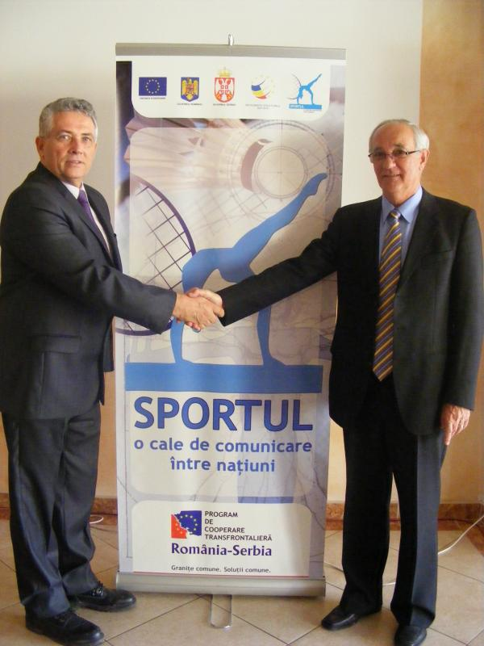
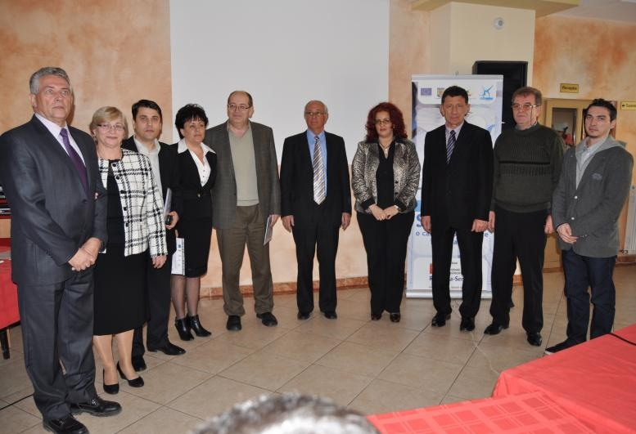

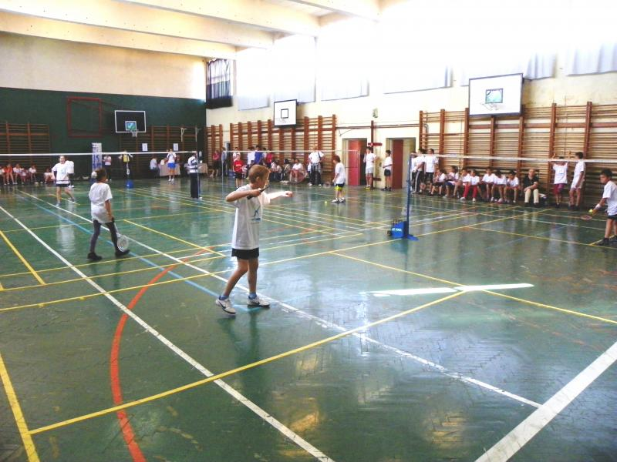
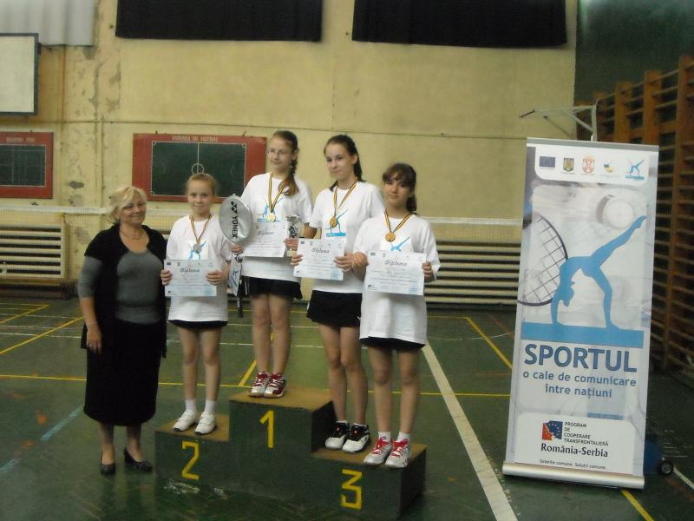
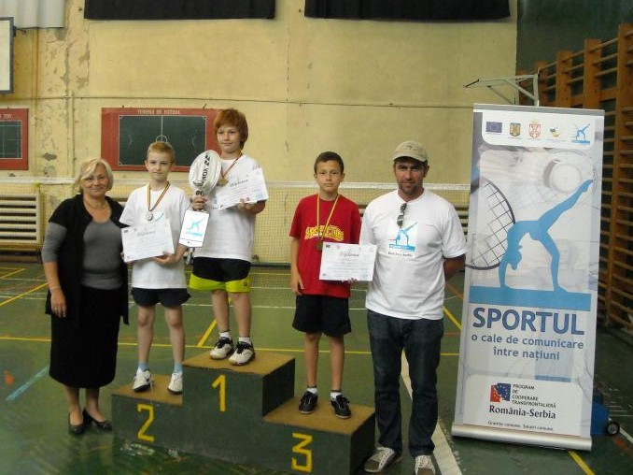
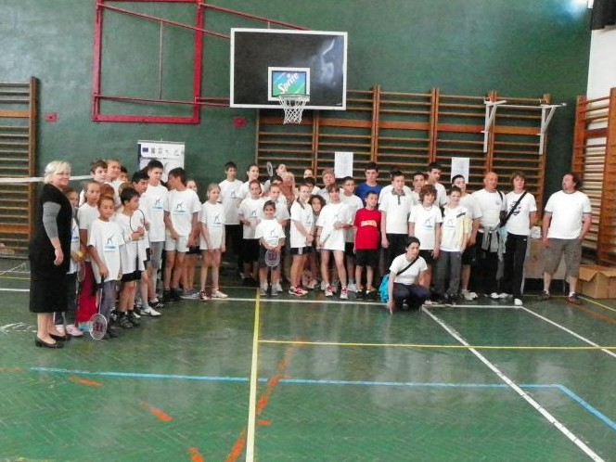
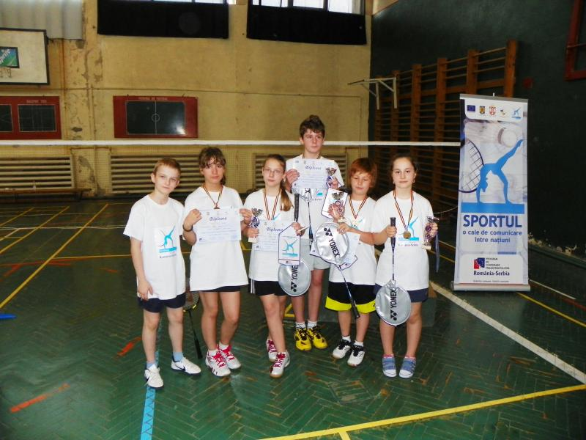

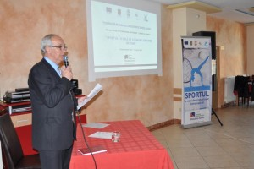
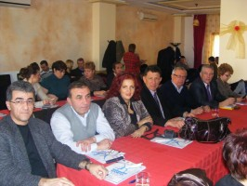
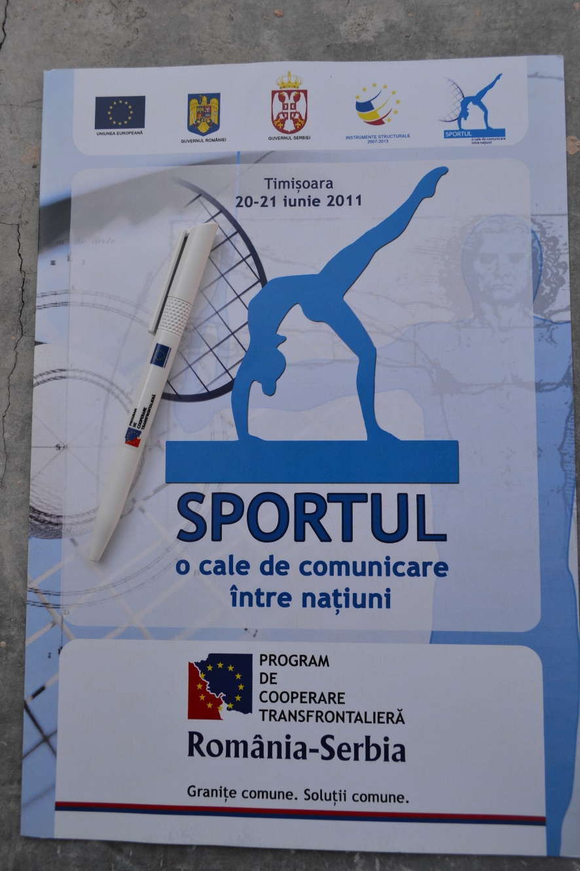
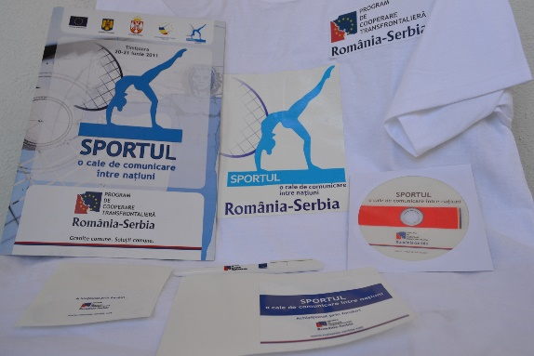
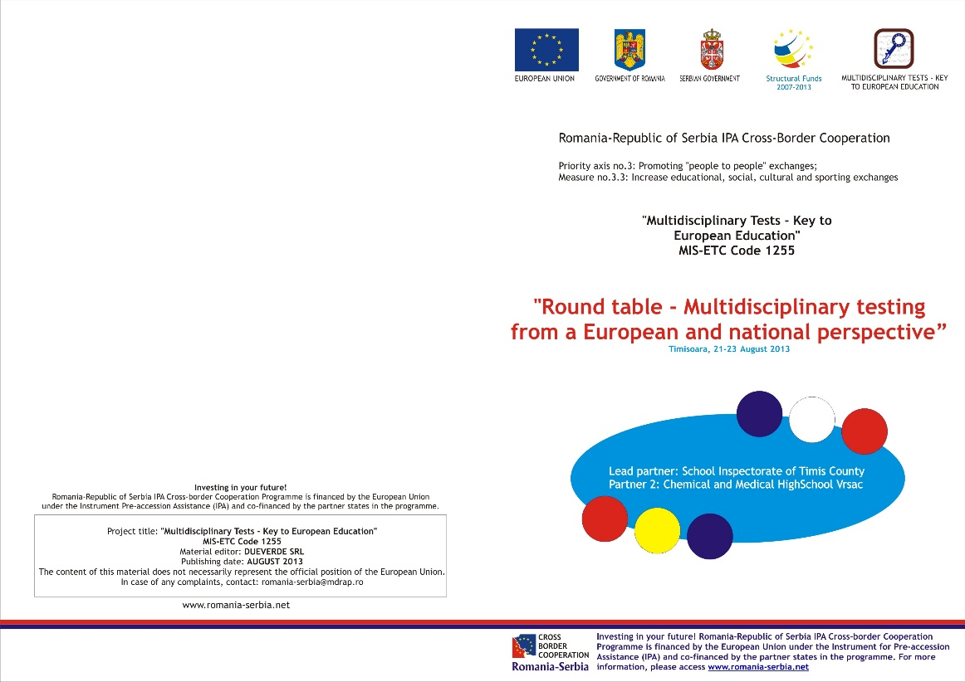
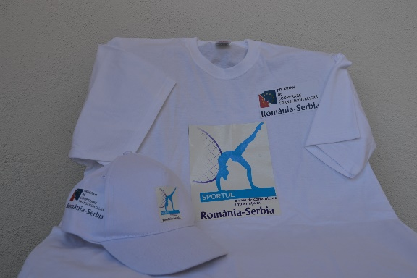

the implementation period (including extensions)
total funds spent/total funds contracted *100
indicators and level of achievement against targets set

