 | Project information
 | CALL FOR PROPOSALS |  | 1
 | MIS-ETC: |  | 508
 | PRIORITY AXIS: |  | 1 Economic and Social Development
 | MEASURE: |  | 1.3 Promote SME development
 | PROJECT TITLE: |  | SME’s Development Support Center of municipalities Plandiste and Deta
 | ACRONYM: |  | SME’s Development Support Center
 | DURATION: |  | 15.12.2010 – 14.03.2012
 | IPA FUNDS CONTRACTED: |  | 298.129,00
 | TOTAL FUNDS CONTRACTED: |  | 350.740,00
 | ABSORBTION RATE (%): |  | 78,79
 | PROJECT OBJECTIVE(S): |  | Improving and raising the level of economic activities in Plandiste and Deta region.  Strengthening the competitiveness of enterprises, business initiatives and innovation.  Creating conditions for sustainable rural economic development.
 | SHORT DESCRIPTION OF THE PROJECT: |  | During this project, the municipality of Plandište (Serbia) together with cross-border neighbour Deta (Romania) created a Center for support of small and medium enterprises.  The Center was focused on three directions:  1) support to enterprises in the textile industry that were created after the big companies disappeared;  2) support for the establishment and development of farms and workers who lost their jobs in the transition of agricultural enterprises;  3) support to the development of a feasibility study in the industrial area and the promotion of new investments in Deta, Romania.
 | DEGREE OF ACHIEVEMENT OF INDICATORS: |  | Indicator value provisioned in the contract Present indicator value % 6= (5)/(3)*100  Output indicators (1) UM (2) Quantity (3) UM (4) Quantity (5)  Improved capacity and cross-border contacts of SMEs and in the R&D sector  People in labour force with qualifications received/improved from joint training  Result indicators  Increased importance of R&D/Innovation in the border area Number of activities, actions, initiatives focusing on promoting the importance of or dealing directly with R&D/Innovation 2 Number of activities, actions, initiatives focusing on promoting the importance of or dealing directly with R&D/Innovation 2 100  New or improved cross-border tourism services and increased SME’s capacity Number of activities, actions, initiatives focusing on promoting tourism in the border area and on promoting SME’s activity. 10 Number of activities, actions, initiatives focusing on promoting tourism in the border area and on promoting SME’s activity. 10 100  New or improved cross-border tourism products, joint marketing approaches/activities or joint tourism information services developed Number of new or improved cross-border tourism products, marketing activities or information services 4 Number of new or improved cross-border tourism products, marketing activities or information services 4 100  Project indicators  SMEs development support institutionalisation Number of institutions that support the development 1 Number of institutions that support the development 1 100  Increase level of economic activity Number of newly established companies 20 Number of newly established companies 20 100  Increased level of awareness about the importance of cooperation and networking among entrepreneurs and other stakeholder Number of promotional events held 10 Number of promotional events held 10 100  Local government closer to SEs and agricultural farms in the cooperation and support Number of supporting actions with active participation of local self-government 8 Number of supporting actions with active participation of local self-government 8 100  Strengthening of the cross-border economic contacts Number of conferences, experts meetings held 11 Number of conferences, experts meetings held 11 100  Increased level of entrepreneurial and professional knowledge and skills Number of participants 60 Number of participants 100 170  Improved marketing approach Number of exhibitions and fashion shows 4 Number of exhibitions and fashion shows 4 100  Better connectedness between entrepreneurs in the region Number of participants on fairs 100 Number of participants on fairs 100 100  Increased level of information Website with data base 1 Website with data base 2 200  Analysis and studies of marketing approach Number of analysis and studies 4 Number of analysis and studies 4 100  Visibility Number of published articles, held press conferences 40 Number of published articles, held press conferences 44 100
 | RESULTS ACHIEVED: |  | One entrepreneurship support center established.  Three support teams were formed: a support team for SMEs in the textile industry, a support team for agriculture activities and a support team for SMEs in Deta.  Adapted space in Miletićevo, Serbia.  One promotional conference was organized.  Two market potentials analysis were created and two textile and agricultural production strategies.  Improved knowledge and skills of entrepreneurs and farmers through organizing educational programs and through study visits.  Organized fashion show Day of textile.  One glass-house production was formed.  Local labour and job market was formed.  One opportunity study was created.  One conference about development opportunities in Deta was organized.  New business infrastructure in Deta improved and promoted.  Governance conference on how to improve and support local development was organized.  Project objectives and activities presented to the professional and the general public.  New links between entrepreneurs in the region and potential partners were established.
Partnership information
 |  |  |  | COUNTRY | COUNTY/DISTRICT | BUDGET(EURO) | CONTACT DETAILS
LEAD PARTNER: |  | Municipality of Plandište |  | Serbia | South Banat | 204.000 | Plandište, Vojvode Putnika 38  Tel. 013 861033
PARTNER 2: |  | Deta Municipality |  | Romania | Timis | 140.740 | Deta, Victoriei  Tel. 40723686786
PARTNER 3: |  | Entrepreneurs General Association of the Municipality Plandište |  | Serbia | South Banat | 6.000 | Plandište, Vojvode Putnika 38  Tel. 060 3055999

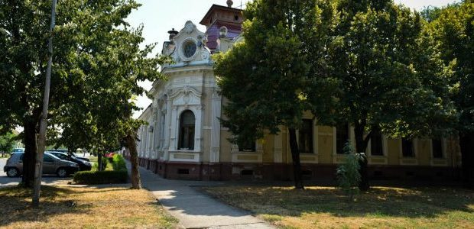
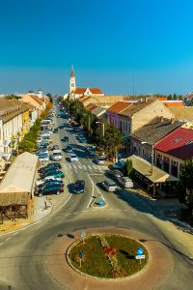
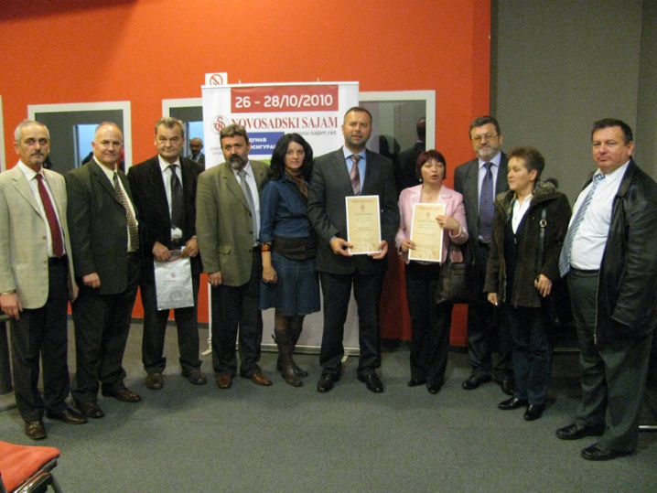

the implementation period (including extensions)
total funds spent/total funds contracted *100
indicators and level of achievement against targets set

