Project information
CALL FOR PROPOSALS | 1
MIS-ETC: | 501
PRIORITY AXIS: | 3 Promoting “People To People” Exchanges
MEASURE: | 3.3Increase educational, cultural and sporting exchange
PROJECT TITLE: | Children without borders
ACRONYM: | ChiBo
DURATION: | 12.02.2011 – 11.12.2011
IPA FUNDS CONTRACTED: | 95.103,95 €
TOTAL FUNDS CONTRACTED: | 111.887,00 €
ABSORBTION RATE (%): | 90,10%

PROJECT OBJECTIVE(S): | To stimulate children interest about the Romanian-Serbian cross-border region.  To enhance children positive thinking about the future and the world.  To amplify children consciousness about local identity and local community values.  To increase the healthy spirit of competition and struggle.  To create new learning strategies.
SHORT DESCRIPTION OF THE PROJECT: | Through the project implementation 360 people were familiarized with cultural elements and way of thinking of the cross-border neighbor in order to recognize the common cultural values and develop a regional approach on problem solving. The project created 2 youth programs designed to increase the life quality of the children. Through the “play houses” and “history circles”, sport, science and art competitions designed and created through the project, through the improved sport infrastructure, the children involved benefited from a better living environment.
DEGREE OF ACHIEVEMENT OF INDICATORS: | Indicator value provisioned in the contract Present indicator value % 6= (5)/(3)*100  Output indicators (1) UM (2) Quantity (3) UM (4) Quantity (5)  Increased people-to-people exchange in the fields of education, culture and sports  Result indicators  Increased social and cultural integration of people in the border areas Number of participants benefiting from cross-border social and cultural events 360 Number of participants benefiting from cross-border social and cultural events 533 148%  Improved knowledge of culture, history, society and language of the neighbouring country Number of participants gained knew knowledge in events promoting the neighbouring country 60 Number of participants gained knew knowledge in events promoting the neighbouring country 60 100%  Project indicators  Increasing the life quality of children in the participant localities. In the selected locations the number of yearly organized youth programs. 2 In the selected locations the number of yearly organized youth programs. 4 200%  Increasing the possibilities to spend interesting leisure time Promoting of activities based on educational aspects and healthy lifestyle. 0.1 (3.5->3.6) Promoting of activities based on educational aspects and healthy lifestyle. 0.1 (3.5->3.6) 100%  Increasing the number of well-trained people. The number of qualified children animators 30 The number of qualified children animators 30 100%  Increasing the number of people-to-people actions. Number of thematic actions with cross-border character. 5 Number of thematic actions with cross-border character. 5 100%
RESULTS ACHIEVED, INCLUDING PHOTOS: | 2 equipped project management offices  1 equipped Children-Center  1 equipped Play House  1 renovated sports-ground  30 children animator  40 local children programs  533 participants in cross-border thematic programs and competitions  1 children festival

Partnership information
 |  | COUNTRY | COUNTY/DISTRICT | BUDGET(EURO) | CONTACT DETAILS
LEAD PARTNER: | Diaspora Foundation | Romania | Timis | 52.818,00 | Timisoara, Putna nr. 7  Tel. +40356446516
PARTNER 2: | Bartok Bela Theoretical Highschool | Romania | Timis | 25.271,00 | Timisoara, G-ral Dragalina nr. 11A  Tel. 0040 256 493031
PARTNER 3: | Civilian Centre "Ci-Fi" | Serbia | North Banat | 33.798,00 | Senta, Glavni trg 18  Tel. +381641604686

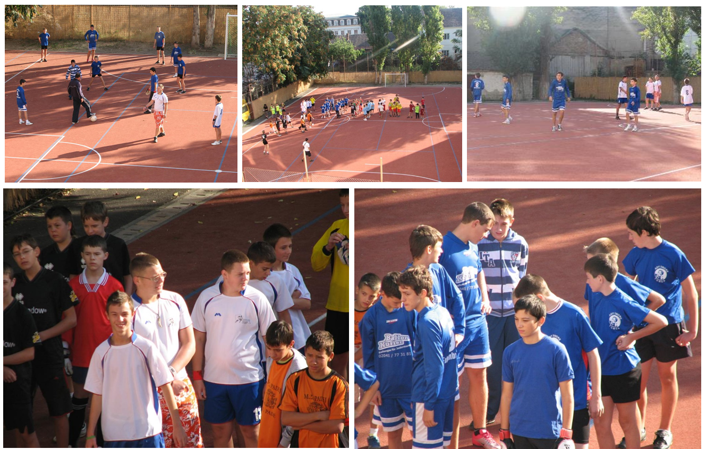

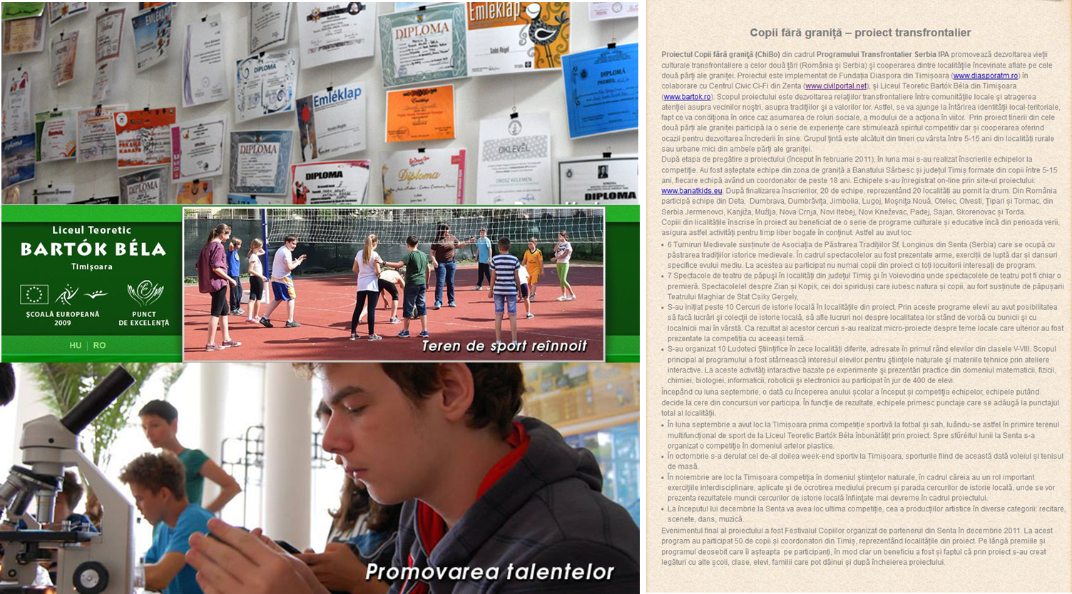

the implementation period (including extensions)
total funds spent/total funds contracted *100
indicators and level of achievement against targets set

