 | Project information
 | CALL FOR PROPOSALS |  | 1
 | MIS-ETC: |  | 493
 | PRIORITY AXIS: |  | 3 Promoting “people to people” exchanges
 | MEASURE: |  | 3.2 Improve local governance in relation to the provision of local services to communities in the border areas
 | PROJECT TITLE: |  | Best practice exchange between Cross - Border Public Administration
 | ACRONYM: |  | BPEx
 | DURATION: |  | 18.12.2010 – 17.12.2011
 | IPA FUNDS CONTRACTED: |  | 143.440,90
 | TOTAL FUNDS CONTRACTED: |  | 168.754,00
 | ABSORBTION RATE (%): |  | 89,04
 | PROJECT OBJECTIVE(S): |  | Promoting the exchange of good practice/ transfer of technical competences between local authorities regarding the provision of local services and local governance: Caras-Severin County Council and Vrsac Municipality.  Valorising the specificity of the public administration in the cross - border area.  Raising the communication capacity between the public authorities in the cross-border area.  Setting up, providing equipment and common training of the border area public authorities’ staff.
 | SHORT DESCRIPTION OF THE PROJECT: |  | The project promoted the exchange of good practice and transfer of technical competences between local authorities regarding the provision of local services and local government, between Caras-Severin County Council in Romania and Vrsac Municipality in Serbia.
 | DEGREE OF ACHIEVEMENT OF INDICATORS: |  | Indicator value provisioned in the contract Present indicator value % 6= (5)/(3)*100  Output indicators (1) UM (2) Quantity (3) UM (4) Quantity (5)  Increased cooperation between local and regional public authorities across the border to finding solutions to joint local problems in the border area  Improved knowledge of culture, history, society, organizational and institutional structure, and language of the neighbouring country  Result indicators  Increased cooperation between local and regional public authorities across the border to finding solutions to joint local problems in the border area Number of activities between local public authorities in tackling joint problems 6 Number of activities between local public authorities in tackling joint problems 6 100  Improved knowledge of culture, history, society, organizational and institutional structure, and language of the neighbouring country Number of participants gained knew knowledge in events promoting/profiling the neighbouring country 120 Number of participants gained knew knowledge in events promoting/profiling the neighbouring country 120 100  Project indicators  Raising the professional capacity of the public administration staff. Number of trained people 8 Number of trained people 27 337
 | RESULTS ACHIEVED: |  | Joint trainings were organized in order for the staff of the public institutions to properly use the project management software.  Starting with late October until middle December 2011 6 workshops and 6 joint sessions according took place. 3 workshops as well as 3 joint sessions took place in Vrsac (Republic of Serbia) and the other 3 workshops and 3 joint sessions took place in Resita (Romania). The target of 120 participants from public administrations and NGOs was reached.
Partnership information
 |  |  |  | COUNTRY | COUNTY/DISTRICT | BUDGET(EURO) | CONTACT DETAILS
LEAD PARTNER: |  | Caras - Severin County Council |  | Romania | Caras- Severin | 118.204,00 | Resita, 1 Decembrie 1918 nr 1  Tel. +40 255 211420
PARTNER 2: |  | Municipality of Vrsac |  | Serbia | South Banat | 50.550,00 | Vrsac, Trg Pobede 1  Tel. 00381-013832435

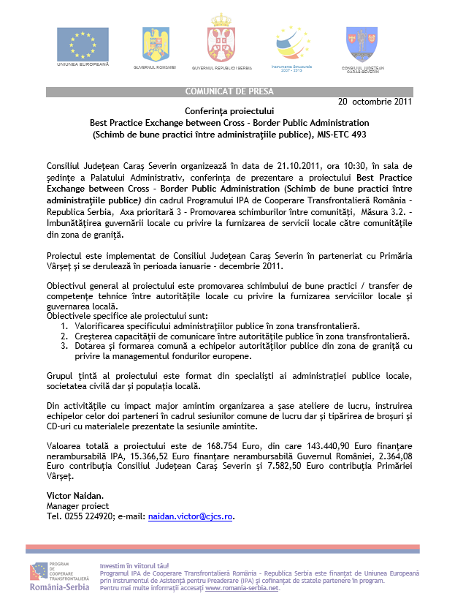

the implementation period (including extensions)
total funds spent/total funds contracted *100
indicators and level of achievement against targets set

