Project information
CALL FOR PROPOSALS | 1
MIS-ETC: | 488
PRIORITY AXIS: | 3 Promoting “people to people” exchanges
MEASURE: | 3.3 Increase educational, cultural and sporting exchange
PROJECT TITLE: | Quality in education, college and universities, using innovative methods and new laboratories
ACRONYM: | QECUUIMNL
DURATION: | 14.12.2010 – 13.06.2012
IPA FUNDS CONTRACTED: | 97.852,00 €
TOTAL FUNDS CONTRACTED: | 115.120,00 €
ABSORBTION RATE (%): | 86,55%

PROJECT OBJECTIVE(S): | Establishment of a cross-border partnerships between educational, cultural and public institutions.  Improvement of a qualitive teaching process.  Development of an educational and a cultural infrastructure.  Raising awareness regarding the project through the dissemination of the results.

SHORT DESCRIPTION OF THE PROJECT: | The whole project was addressing to the Lisbon strategy context specific for the general development of the European community, but also to the regulations specifically stipulated by Bologna process, regarding the homogeneity and coherence of the higher education and the European issue of multiculturalism.  Between the project partners there were already common activities materialized in the past in good educational practices activities, common conferences, common elaboration of scientific articles, and therefore this project came as a continuation of the partnerships between different fields/sectors at a cross-border level creating and proposing for future use new educational functions, joint marketing tools, actions improving multilingual information flow, best practices exchanges between institutions and harmonized regulations.  After the project implementation 400 participants benefited from the cross-border social and cultural events organized while 200 participants gained new knowledge in events promoting the neighbouring country through 4 initiatives that developed and improved the existing educational services.

DEGREE OF ACHIEVEMENT OF INDICATORS: | Indicator value provisioned in the contract Present indicator value % 6= (5)/(3)*100  Output indicators (1) UM (2) Quantity (3) UM (4) Quantity (5)  Stronger civil society of the border area  Increased people-to-people exchange in the fields of education, culture and sports  Increased integration of the border communities and improved local services in the border area  Result indicators  Increased social and cultural integration of people in the border areas Number of participants 400 Number of participants 400 100%  Improved quality of life and increased attractiveness of the border communities as a living place Number of actions 4 Number of actions 4 100%  Improved knowledge of culture, history, society, organizational and institutional structure, and language of the neighbouring country Number of participants 200 Number of participants 200 100%  Project indicators  Number of joint trainings held Pieces 4 Pieces 4 100%  Number of people participating in joint education and training activities Women Men Persons (women, men) 50 (30, 20) Persons (women, men) 50 (30, 20) 100%  Number of people using jointly developed facilities Women Men Persons (women, men) 50 (30, 20) Persons (women, men) 50 (30, 20) 100%  Number of joint innovative events organized pieces 6 pieces 6 100%  Number of sustainable joint developed thematic networks pieces 1 pieces 1 100%  Number of co-operations established among educational institutions pieces 2 pieces 2 100%  Number of training to increase IT understanding pieces 4 pieces 4 100%  Number of joint exhibitions held pieces 4 pieces 4 100%  Number of people involved in training courses persons 20 persons 20 100%  Increase in cross border community cooperation % 50% % 50% 100%  People reached by the awareness raising campaigns persons 5000 persons 5000 100%

RESULTS ACHIEVED | The general objective of the project was to establish a cross border partnerships between educational, cultural and public institutions from Romania and Serbia. During the project implementation the partners tried to improve their educational methods and to share various experience transfers so that the resulted approach would be more empirical. Moreover, the intercultural exchange also raised the capacity of students to adapt to the changing society.  The specific objectives achieved were:  - the improvement of the quality of teaching process;  - we raised the quality of teaching process by bringing new, innovative and attractive methods and approaches to the educational field.  - Development of educational and cultural infrastructure, during the project’s implementation. So, we endowed a management laboratory with the aim of increasing quality in higher education.  The activities were divided in five categories:  - Organizing cross-border conferences in education field  - Editing quality annual guides (Transnational sustainable methods for quality increase in higher education and Quality increase in higher education teaching through innovative methods)  - Realising good practice exchanges through joint innovative events, joint trainings, trainings to increase IT understanding and joint exhibitions in cross-border area.  - Introducing new teaching methods as: e-learning and improving curricula of existing programmes.  Dissemination of the results: Our project results (studies, conference books, syllabus, marketing plan) had a positive impact especially over the education institutions and will be an added value to the educational field for the future.  In order to promote better the project's objectives, activities and results it was made 2 websites of the project available on http://islavici.ro/serbia/pactivitati.php and http://www.uskolavrsac.in.rs/ipaproject/pages.

Partnership information
 |  | COUNTRY | COUNTY/DISTRICT | BUDGET(EURO) | CONTACT DETAILS
LEAD PARTNER: | “Ioan Slavici” Foundation for Culture and Education –University Timisoara | Romania | Timiş | 80.310,00 | Timisoara, 144 Dr. A. Paunescu-Podeanu Street  Tel. +40256 213 108
PARTNER 2: | Preschool Teacher Training College “Mihajlo Pavlov” Vršac | Serbia | South Banat | 34.810,00 | Vrsac, Omladinski trg 1  Tel. 013 831 628

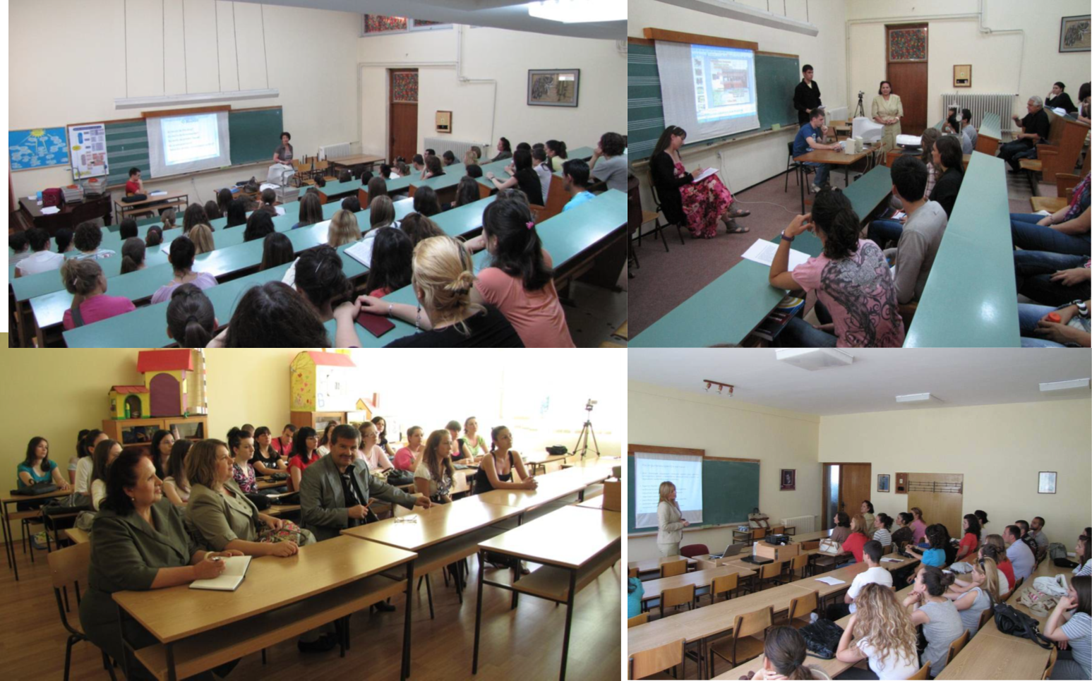
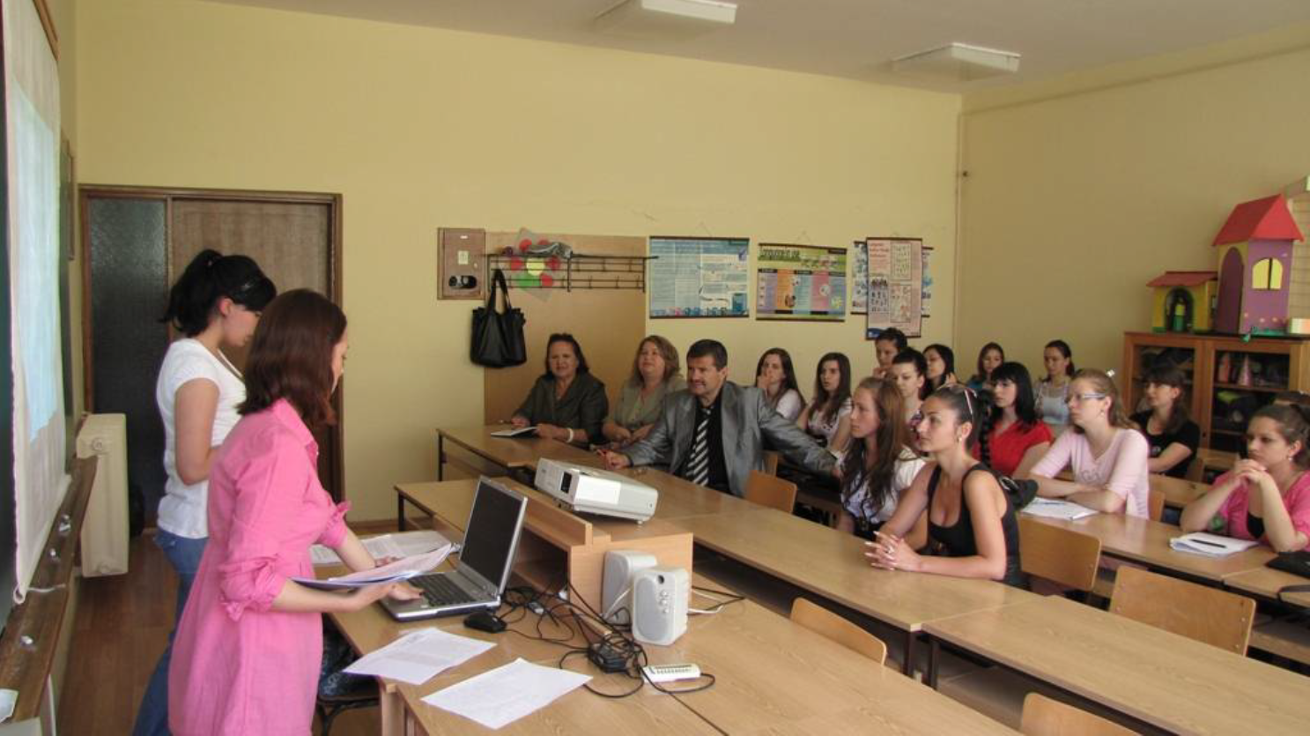

the implementation period (including extensions)
total funds spent/total funds contracted *100
indicators and level of achievement against targets set

