 | Project information
 | CALL FOR PROPOSALS |  |  | 1
 | MIS-ETC: |  |  | 466
 | PRIORITY AXIS: |  |  | 3 Promoting “people to people” exchanges
 | MEASURE: |  |  | 3.3 Increase educational, cultural and sporting exchange
 | PROJECT TITLE: |  |  | JUDO at the Iron Gates
 | ACRONYM: |  |  | JUDO
 | DURATION: |  |  | 16.12.2010 – 15.11.2011
 | IPA FUNDS CONTRACTED: |  |  | 134.232,79
 | TOTAL FUNDS CONTRACTED: |  |  | 157.920,93
 | ABSORBTION RATE (%): |  |  | 93,80
 | PROJECT OBJECTIVE(S): |  |  | - Improving the social and sportive cooperation with Serbia through judo international competitions in Drobeta Turnu Severin – Romania and Bor – Serbia  - Increasing Romanian and Serbian joint approaches in the sports field
 | SHORT DESCRIPTION OF THE PROJECT: |  |  | Having the motto “Mens sana in corpore sano”, the project helped partners to procure specific judo equipment and goods (392 Tatami, 4 Electronic scoreboards, 6 Electronic weighting machines and 30 Kimonos) which were used by both judo clubs in Romania and Serbia, for trainings and competitions. The microbuses allowed judokas to participate at different judo competitions in Romania or Serbia or abroad. Also, 2 Training camps in Romania and Serbia and 1 Judo tournament were organized.
 | DEGREE OF ACHIEVEMENT OF INDICATORS: |  |  | Indicator value provisioned in the contract Present indicator value % 6= (5)/(3)*100  Output indicators (1) UM (2) Quantity (3) UM (4) Quantity (5)  Increased people-to-people exchange in the fields of education, culture and sports – Measurement Number of people participated in cross-border people-to-people exchanges events – 350 (40 – judo training camp, 10 local media,300 judo tournament) 350 Number of people participated in cross-border people-to-people exchanges events – 350 (40 – judo training camp, 10 local media,300 judo tournament) 350 100  Result indicators  Increased social and cultural integration of people in the border areas Number of participants benefiting from cross-border social and cultural events 40 Number of participants benefiting from cross-border social and cultural events 40 100  Improved quality of life and increased attractiveness of the border communities as a living place Number of activities, actions, improving other local living conditions 3 Number of activities, actions, improving other local living conditions 3 100  Project indicators  Improved judo battle spaces in accordance with the International Judo Federation and European Judo Union specifications Number of battle spaces 4 Number of battle spaces 4 100  Improved judo competition conditions Number of electronic scoreboards and weighting machines 10 Number of electronic scoreboards and weighting machines 10 100  Number of competition kimonos 20 Number of competition kimonos 20 100  Increased participation to judo competitions per year Number of judo competitions 11 Number of judo competitions 11 100
 | RESULTS ACHIEVED: |  | Equipment and goods were purchased: 392 Tatami; 4 Electronic scoreboards; 6 Electronic weighting machines; 30 Kimonos; 2 Microbuses.  Judo training camp in Romania: 20 judokas from Drobeta Turnu Severin and 20 from judo Klub Bor benefited from this training in Romania, on 30.05.2011-05.06.2011.  Promotional materials were made: 100 posters, 1 banner, 200 streamers, 100 customized T-shirts, 100 customized caps, 200 customized badges, 100 customized medals, 100 customized diplomas, 6 customized cups have been made available for the judo tournament on 3 July 2011.  Judo tournament: ln addition to the two partner clubs in the project - Mehedinti County Judo Association and Judo Klub Bor, about 40 judo teams from Romania, Serbia, Greece, Bulgaria, Croatia, Hungary (about 400 judokas) participated in the judo tournament held in Drobeta Turnu Severin on 3rd of July 2011.  Judo training camp in Serbia: 20 judoka from Mehedinti County Judo Association and 20 from judo Klub Bor benefited from this training in Savaca camp on 1-8 of August 2011.  Project management: 1 Computer + software and 1 Multifunctional printer were purchased and used in the implementation of the project.  A short video about the project is available at:  https://www.youtube.com/watch?v=mC21IAK1ryU
Partnership information
 |  |  |  |  | COUNTRY | COUNTY/DISTRICT | BUDGET(EURO) | CONTACT DETAILS
LEAD PARTNER: |  | Mehedinti County JUDO Association |  |  | Romania | Mehedinti | 103.665,37 | Drobeta Turnu Severin, 16 Grivitei street  Tel. +40 744 13 65 80
PARTNER 2: |  | Judo Club Bor |  |  | Serbia | Borski | 54.255,56 | Bor, 12, Kralija Petra  Tel. 00381432248
PARTNER 3: |  | Drobeta Turnu Severin City Hall |  |  | Romania | Mehedinti | 0 | Drobeta Turnu Severin, 2 Maresal Averescu Street  Tel. 0040252314379
PARTNER 4: |  | Mehedinti County Council |  |  | Romania | Mehedinti | 0 | Drobeta Turnu Severin, 89 Traian Street  Tel. 00 40 372 52 11 02
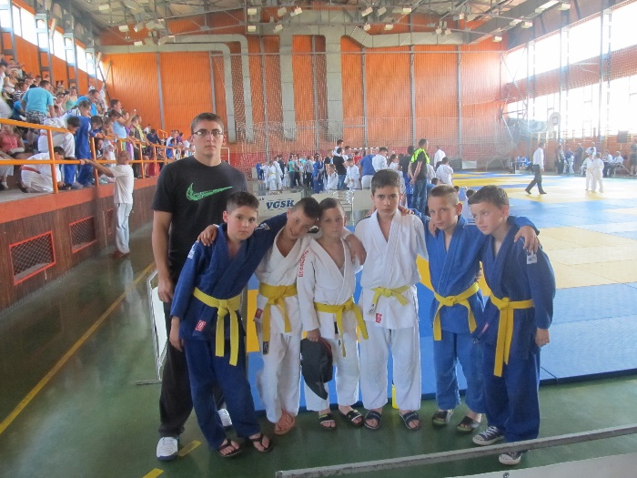
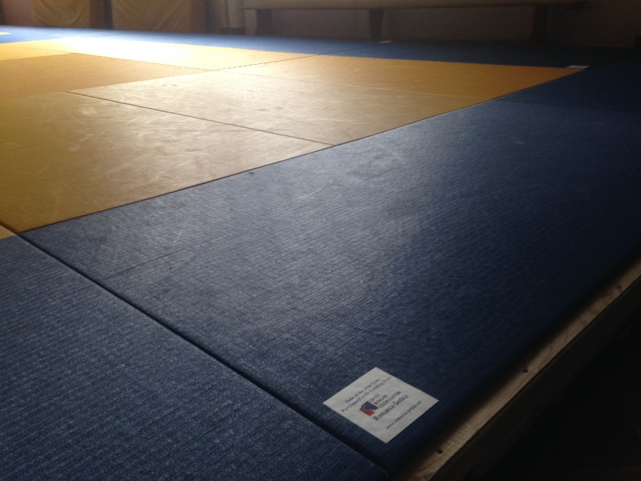
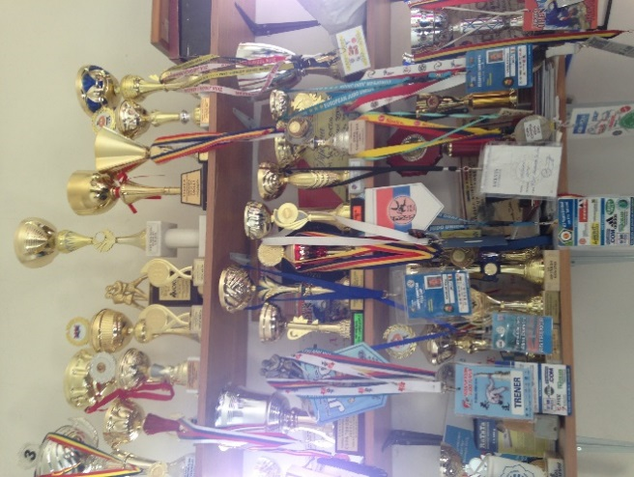
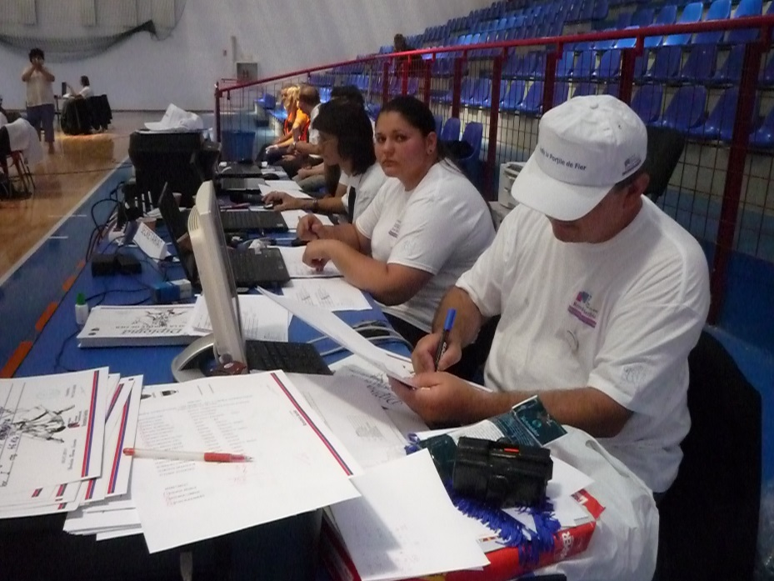
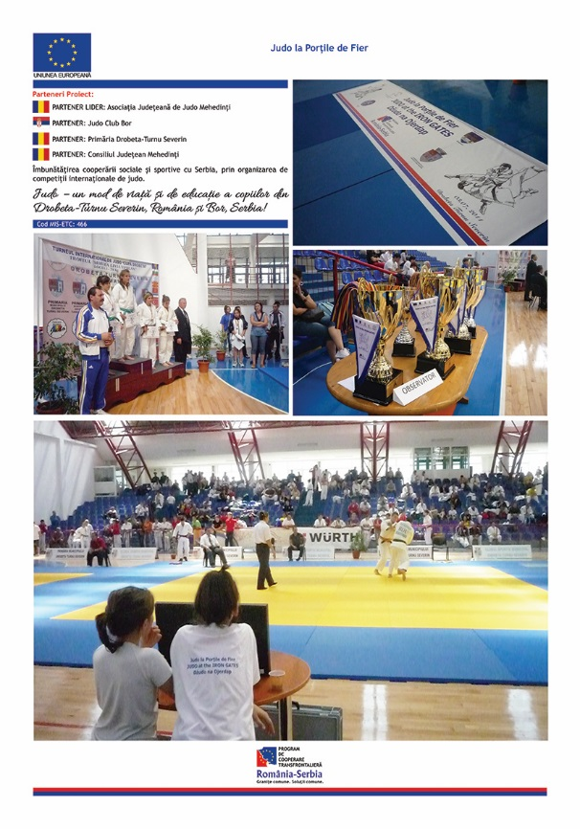

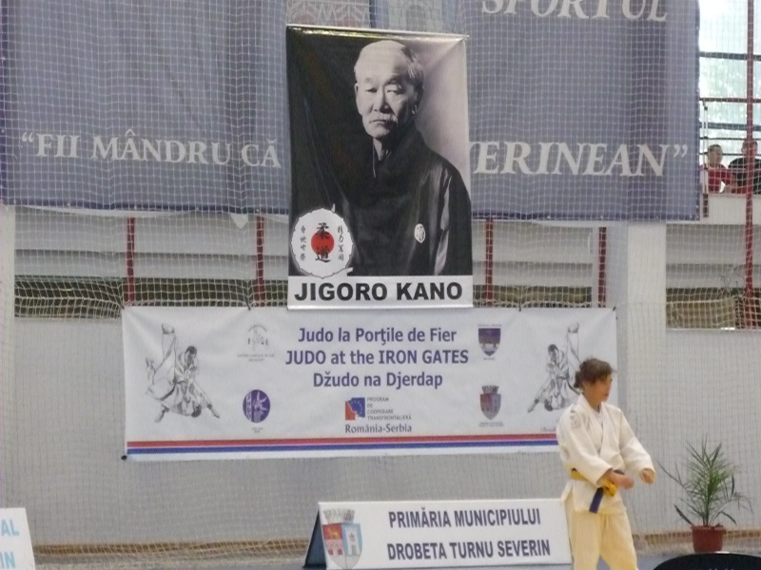

the implementation period (including extensions)
total funds spent/total funds contracted *100
indicators and level of achievement against targets set

