Project information
CALL FOR PROPOSALS | 1
MIS-ETC: | 464
PRIORITY AXIS: | 1 Economic and Social Development
MEASURE: | 1.4 Support increased levels of R&D and innovation in the border region
PROJECT TITLE: | Cross-border network for advanced training and research in environmental protection
ACRONYM: | ROS-NET
DURATION: | 08.02.2011 – 07.08.2012
IPA FUNDS CONTRACTED: | 850.000,00
TOTAL FUNDS CONTRACTED: | 1.000.000,00
ABSORBTION RATE (%): | 86,95
PROJECT OBJECTIVE(S): | To establish an advanced research network in the field of environmental protection.  To evaluate by comparison the state of pollution of a river from Borski area in which mining wastewater is discharged with that of a river from Caras-Severin County.  To research non-conventional methods for the remediation of wastewater from mining exploitations of non-ferrous metals.  To increase the visibility of the network at European level through actions of dissemination of the results obtained.
SHORT DESCRIPTION OF THE PROJECT: | In the two countries, Romania and Serbia, there is a common preoccupation regarding the environment protection and sustainable development. Within this context, the ROS-NET project was devoted to create a common and competitive network within this field starting with two poles: the West University of Timisoara (UVT) and the Mining and Metallurgy Institute Bor (MMI). The sustainability and development of this network was ensured by further addition of other Romanian and Serbian institutes, respectively. Like this, UVT and MMI become reference poles in research, evaluation and remediation of the regions polluted with organic pollutants and inorganic ones. The two research poles became research bases with multiple users and reference centres for the two countries.  The technological transfer of the results obtained within this project contributed to the achievement of a less polluted environment assuring thus the increase of the quality of life in the cross-border areas.  Moreover, this project involved experts who performed common research activities and also organized scientific events (e.g. round tables, workshops, conferences) and contributed to a better connectivity within the two regions, the development of the cross-border collaboration and inter-human relationships, and socio-economic development, respectively.
DEGREE OF ACHIEVEMENT OF INDICATORS: | Indicator value provisioned in the contract Present indicator value % 6= (5)/(3)*100  Output indicators (1) UM (2) Quantity (3) UM (4) Quantity (5)  Improved capacity and cross-border contacts of SMEs and in the R&D sector: The project contribution comes from the establishment of one R&D network and organization of one scientific conference for SMSs and R&D sectors. issue 1 issue 1 100  People in labour force with qualifications received/improved from joint training activities: The project contribution comes by training 30 young participants in specialized modules. participants 30 participants 30 100  Result indicators  Increased importance of R&D/Innovation in the border area Number of activities, actions, initiatives focusing on promoting the importance of or dealing directly with R&D/Innovation 3 activities (3 out of 5 assumed by IPA – 60%) promoting the importance of the R&D – 1 Scientific Conference and 1 activity for publishing scientific papers 1 initiative dealing directly with R&D / innovation – the creation of the scientific network Number of activities, actions, initiatives focusing on promoting the importance of or dealing directly with R&D/Innovation 3 activities (3 out of 5 assumed by IPA – 60%) promoting the importance of the R&D – 1 Scientific Conference and 1 activity for publishing scientific papers 1 initiative dealing directly with R&D / innovation – the creation of the scientific network 100  Project indicators  Increased cross-border cooperation in environment protection Number of actions that contribute to increase the public awareness on environmental protection 1 research network (1 out of 3 assumed by IPA – 33%) Number of actions that contribute to increase the public awareness on environmental protection 1 research network 100  Increased expertise and exchange of experience in the field of environment protection Number of activities increasing expertise and exchange of experience in environmental protection topics 1 scientific conference Number of activities increasing expertise and exchange of experience in environmental protection topics 1 scientific conference 100  Improved knowledge on different environmental-friendly approaches Number of initiatives establishing different environmental-friendly methods 1 (at least) methodology set up for new advanced materials used for waste water treatment Number of initiatives establishing different environmental-friendly methods 1 100  Increased people-to-people exchange in the fields of environmental education and implementation of national and EU environmental legislative framework Number of peoples participated in cross-border exchanges events 30 participants in specific training modules Number of peoples participated in cross-border exchanges events 30 participants 100
RESULTS ACHIEVED: | The advanced research network entity in the field of environmental protection was formed as a result of the project implementation.  2 research teams collaborated in the two countries: 31 people for Romanian team and 20 people in Serbian team, a total of 51 persons working together.  More than 30 Romanian students were selected to participate to learning sessions and to work with researcher obtaining both information and competencies for research activities in environmental sciences.  Pollutants (organic and inorganic) were identified from the analysed water samples and the degree to which the ecosystems were affected by the pollution. Building a database with regard to the degree of pollution of the analysed water streams and the degree to which the ecosystems had been affected by pollution.  The mesoporous multifunctional oxide materials and advanced polymeric materials with pre-established structure and properties were synthesized and characterized.  The proposal of a method of treatment of wastewater (polluted with heavy metals) based on the synthesized materials was written.  2 ISI papers were published and an international scientific conference in the field of environmental protection was organized.  More details regarding the results can be found by accessing http://www.elearning-chemistry.ro/proiect3/index.php?meniuId=52&viewCat=1049&lg=en

Partnership information
 |  | COUNTRY | COUNTY/DISTRICT | BUDGET(EURO) | CONTACT DETAILS
LEAD PARTNER: | WEST UNIVERSITY OF TIMISOARA | Romania | TIMIS | 640.745,00 | TIMISOARA, V. PARVAN Nr.4  Tel. +40 256 592 302
PARTNER 2: | Mining and Metallurgy Institute Bor | Serbia | Borski | 359.255,00 | Bor, Zeleni bulevar 35  Tel. +381 30 436 826

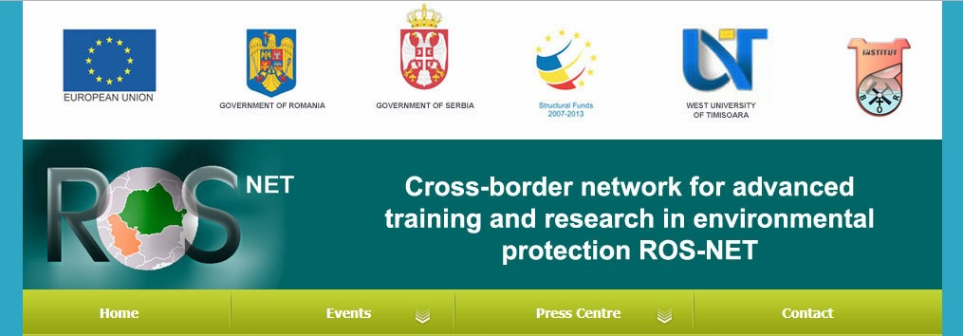

the implementation period (including extensions)
total funds spent/total funds contracted *100
indicators and level of achievement against targets set

