Project information
CALL FOR PROPOSALS | 1
MIS-ETC: | 458
PRIORITY AXIS: | 3 Promoting “people to people” exchanges
MEASURE: | 3.2 Improve local governance in relation to the provision of local services to communities in the border areas
PROJECT TITLE: | Exchange of good practice through e-governance in local public administration
ACRONYM: | EGAP
DURATION: | 01.01.2011 – 30.09.2011
IPA FUNDS CONTRACTED: | 37.799,50 €
TOTAL FUNDS CONTRACTED: | 44.470,00 €
ABSORBTION RATE (%): | 95,85%

PROJECT OBJECTIVE(S): | Improvement of the local governance by exchange of the good practice in the field of e-Governance of the local public administrations.  Increasing the level of information among the citizens and the local business environment on the advantages of electronic governance.  Develop a guide on e-Governance for the public administration.  Participation of the LPA functionaries from Romania and Serbia at a joint seminar for professional training.

SHORT DESCRIPTION OF THE PROJECT: | Whilst e-Government services have rapidly developed at national level in most EU countries, local governments are quite slow in moving the information to online. Considering that most of the interaction between government and citizens goes through local governments, this situation is damaging the perception of e-Government usefulness for citizens.  By establishing the network of cross-border partnership between the local administration - universities – minorities’ organizations, the economic and social cohesion policy of the EU has been promoted. Institutions received the role of contributing to strengthening the cross-border cooperation in the defense of administrative, training and promoting the common exchange of best practices and benefits of e-Governance in their area of residence.  City of Moldova Noua having some administrative responsibilities for the villages: Coronini, Garni, Pojejena, Sicheviţa, Socol. Alibunar municipality encompasses also the town of Karlovac Banatski, and following villages: Dobrich, Kozjak Novi, Ilandža, Seleuš, Vladimirovac, Janošik, Lokva, Nikolinci.  e-Governance guide represents a theoretical, methodological and practical multilingual guide in the field of e-governance at local level. It includes different aspects of electronic governance translated in the languages of local communities and English. It addresses local government authorities, and other public institutions, teaching staff and students from public administration specialization, representatives of business environment and citizens. It aims to guide the reader to understand the importance of e-governance in the current environment, to help him to understand the advantages of e-governance comparatively with the traditional governance systems.

DEGREE OF ACHIEVEMENT OF INDICATORS: | Indicator value provisioned in the contract Present indicator value % 6= (5)/(3)*100  Output indicators (1) UM (2) Quantity (3) UM (4) Quantity (5)  Increased people-to-people exchange in the fields of education, culture and sports  Increased integration of the border communities and improved local services in the border area  Result indicators  Increased cooperation between local public authorities across the border to finding solutions to joint local cross-border problems Number of activities, initiatives between local public authorities in tackling joint problems, local service provision etc. 4 Number of activities, initiatives between local public authorities in tackling joint problems, local service provision etc. 4 100%  Improved knowledge of organisational and institutional structure of the neighbouring country Number of participants who gained knew knowledge in events promoting the neighbouring country 42 Participants who gained knew knowledge in events promoting the neighbouring country 125 298%  Project indicators  Improve the knowledge of citizens and organizations from cross border area regarding the advantages of e-governance Number of flyers distributed 1500 Number of flyers distributed 1500 100%  Improve information level about e-governance and getting feedback from citizens and organizations regarding their satisfaction on the local public services and their favourite e-governance solutions for improving local services Number of persons and organizations informed 300 Number of persons and organizations informed 300 100%
RESULTS ACHIEVED: | • The partners developed a network  • 1 workshop in Romania, in order to exchange good practice in the field of e-governance;  • 1 workshop in Alibunar, Republic of Serbia, in order exchange good practice in the field of e-governance;  • 1 International Seminar "e-Governance: theory and practice" in order to transfer knowledge from specialists in e-governance to project target groups;  • Elaborate and print a multilingual guide: "e-Governance: a guide for local public administration"  • • Print, disseminate, collect and process 300 questionnaires both Caras-Severin, Romania and Alibunar, Serbia and elaborate the "Study regarding the evaluation of the development level of the local e-government"  • Improve knowledge of organizational and institutional structure of the neighboring countries about e-governance advantages;  Print and distribute of 1500 flyers in Caras-Severin, Romania and Alibunar, Serbia.

Partnership information
 |  | COUNTRY | COUNTY/DISTRICT | BUDGET(EURO) | CONTACT DETAILS
LEAD PARTNER: | “Eftimie Murgu” University of Resita | Romania | Caras Severin | 44.470,00 | Resita, Traian Vuia Square 1-4  Tel. +40 255 210227
PARTNER 2: | City Hall of Moldova Nouă | Romania | Caras Severin | 0 | Moldova Nouă, 26, N. Balcescu  Tel. 0255.540.997
PARTNER 3: | Alibunar Municipality | Serbia | Central Banat | 0 | Alibunar, Trg slobode 4  Tel. +381 13 642 105
PARTNER 4: | German Democratic Forum from Caras Severin County | Romania | Caras Severin | 0 | Resita, Oiutuzului 6  Tel. 0255210346

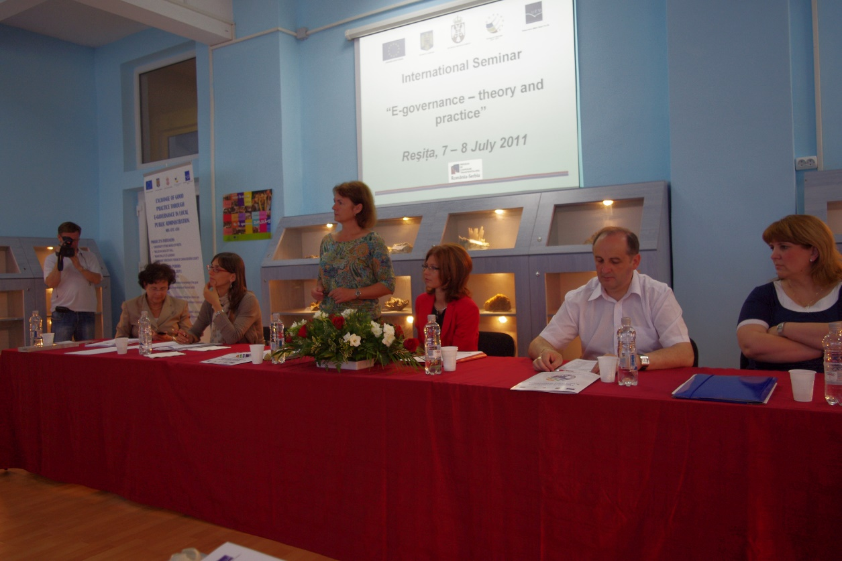
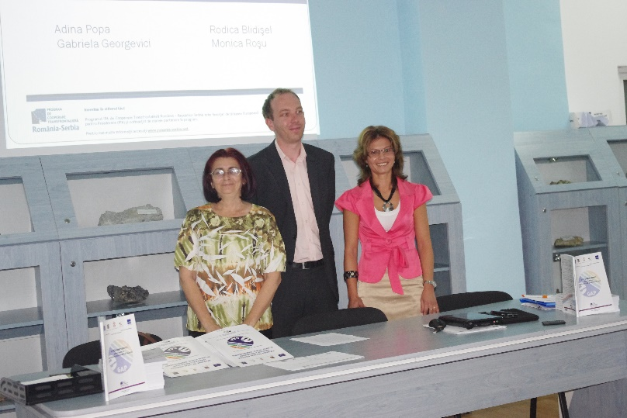
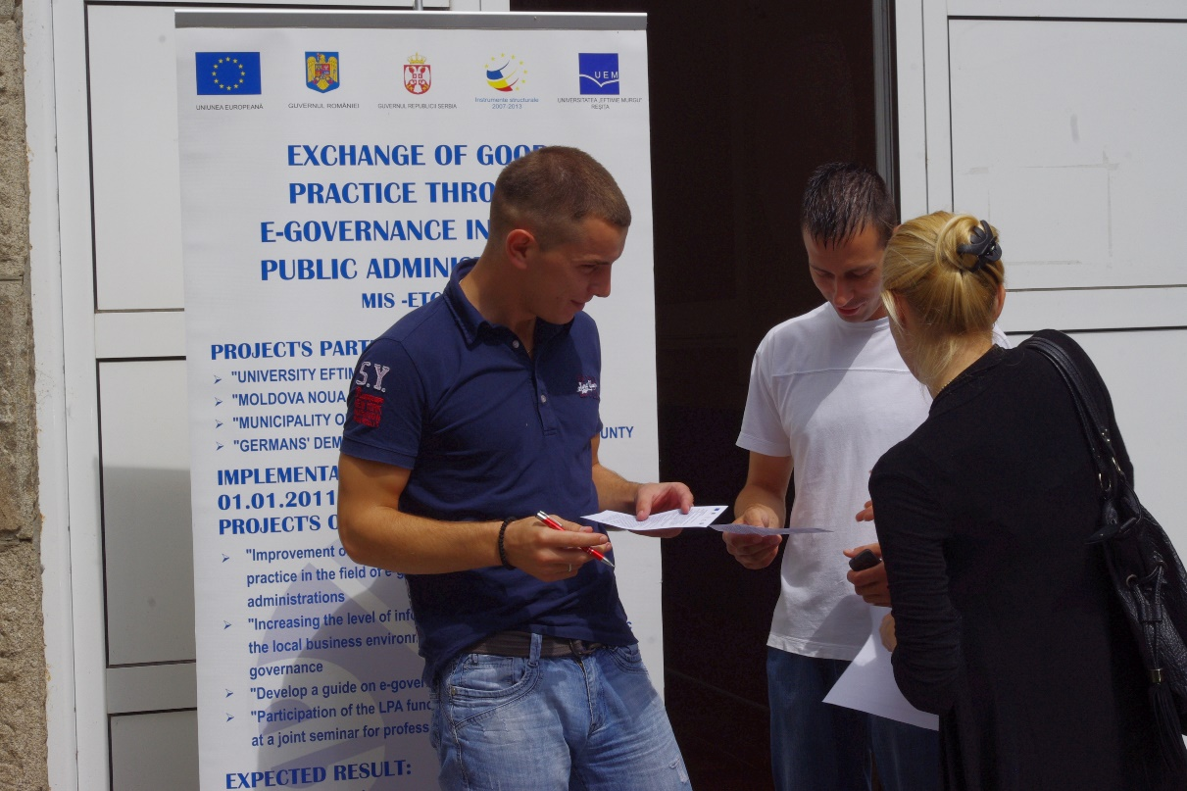
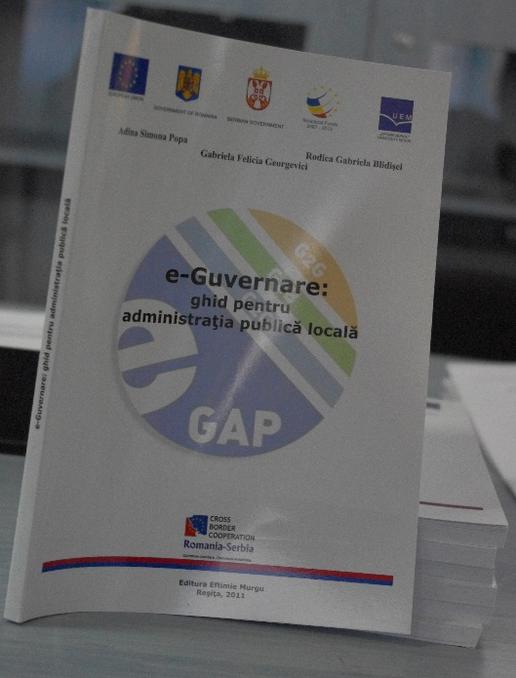

the implementation period (including extensions)
total funds spent/total funds contracted *100
indicators and level of achievement against targets set

