Project information
CALL FOR PROPOSALS | 1
MIS-ETC: | 445
PRIORITY AXIS: | 2 Environment and Emergency Preparedness
MEASURE: | 2.1 Improve systems and approaches to address cross-border environmental challenges, protection and management
PROJECT TITLE: | Back to the future
DURATION: | 16.04.2011 – 15.07.2012
IPA FUNDS CONTRACTED: | 456.025,00
TOTAL FUNDS CONTRACTED: | 536.500,00
ABSORBTION RATE (%): | 86,77

PROJECT OBJECTIVE(S): | - Improvement of the life quality in the border region through development and the use of renewable energies;  - Decreasing pollution and global warming through involving of renewable sources of energy  - Creation of condition for Increasing of energetic efficiency in border region
SHORT DESCRIPTION OF THE PROJECT: | The partnership was created in order to fight the climate change and the use of renewable energy source by installing of geothermal heating system in the Elementary School „Jovan Cvijic” from Zrenjanin. Tapping geothermal energy is an affordable and sustainable solution to reduce our dependency on fossil fuels, but also to reduce the global warming and public health risks that result from their use. Within the project we organised in cross-border partnership some Expert’s conferences: “Global warming and renewable sources of energy” and “Clean air – safer living it.” As a result of the conferences held, we printed the following handbooks “How to help the Earth” and “The Air Pollution Requires Solutions”.
DEGREE OF ACHIEVEMENT OF INDICATORS: | Indicator value provisioned in the contract Present indicator value % 6= (5)/(3)*100  Result indicators UM (2) Quantity (3) UM (4) Quantity (5)  Increased cross-border cooperation in environment protection Number of actions, initiatives protecting the environment or raising public awareness 41 Number of actions, initiatives protecting the environment or raising public awareness 41 100%  Increased expertise and exchange of experience in the field of environment protection Number of actions, increasing expertise or exchange of experience in environment protection 4 Number of actions, increasing expertise or exchange of experience in environment protection 4 100%  Project indicators  Geothermal energy heating / cooling system installed in 1 school Number of public institutions with installed renewable energy heating system 1 Number of public institutions with installed renewable energy heating system 1 100%  Expert’s conferences Number of expert's conference regarding renewable energy 2 Number of expert's conference regarding renewable energy 2 100%  Handbooks printed and disseminated Number of handbooks 2 Number of handbooks 2 100%  Awareness campaign delivered Number of workshops regarding renewable energy 40 Number of workshops regarding renewable energy 40 100%

RESULTS ACHIEVED: | 1. The life quality of the citizens who live in the Centre Banat District and Timis County cross-border area was improved through using of geothermal energy to heat or cool using green air conditioning systems.  2. As a result of the Expert's conferences: "Global warming and renewable sources of energy" and "Clean air-safer living" the partners prepared 2 handbooks "How to help the Earth" and "Air pollution requires solution"  3. Increased awareness of the local population regarding significance of the decreasing of pollution and usage of the new renewable energy sources.  Activities that were realized in order to achieve planned results are the following:  - site survey -technical measurements and preparation of necessary technical documents and reports;  - insulation works in building hosting the Primary School "Jovan Cvijic" in Zrenjanin;  - geothermal system installation in the Primary School "Jovan Cvijic" in Zrenjanin;  - Handbook "Air pollution requires pollution'' with conference materials had been published;  - Promotional materials for target groups have been produced;  - A media campaign activity with TV and newspaper ads had been completed.
Video spot: | https://www.youtube.com/watch?v=FcjfVoisffE

Partnership information
 |  | COUNTRY | COUNTY/DISTRICT | BUDGET(EURO) | CONTACT DETAILS
LEAD PARTNER: | City of Zrenjanin | Serbia | Central Banat | 481.600,00 | Zrenjanin, Trg slobode 10  Tel. 381 23 564 585
PARTNER 2: | Timiş Chamber of Commerce, Industry and Agriculture | Romania | Timiş | 54.900,00 | Timisoara, Piata Victoriei nr. 3  Tel. +40-374160904

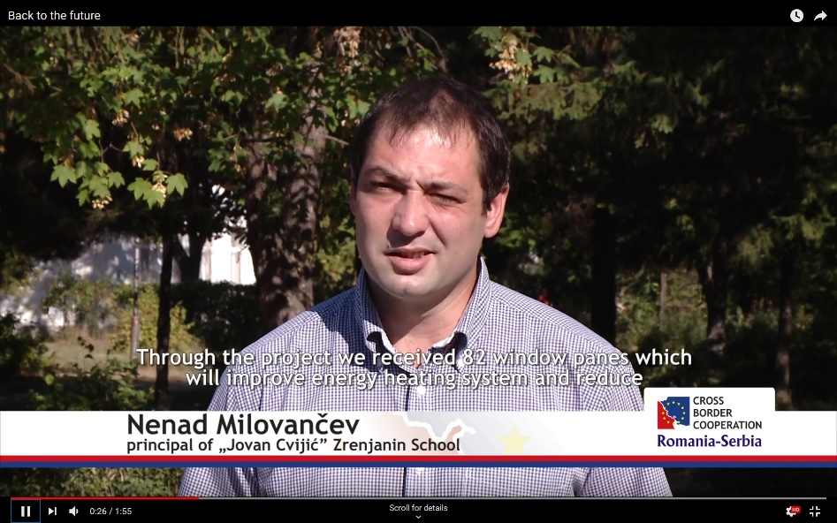
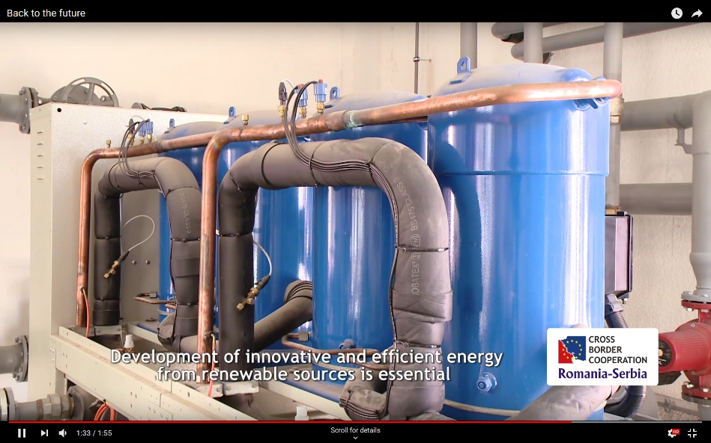
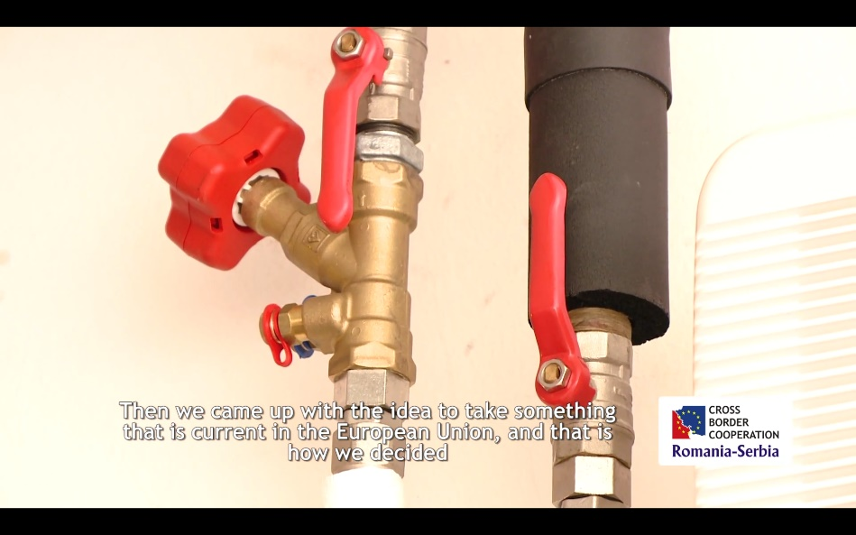

the implementation period (including extensions)
total funds spent/total funds contracted *100
indicators and level of achievement against targets set

