Project information
CALL FOR PROPOSALS | 1
MIS-ETC: | 440
PRIORITY AXIS: | 3 Promoting “people to people” exchanges
MEASURE: | 3.3 Increase educational, cultural and sporting exchange
PROJECT TITLE: | CENTER FOR NUMERICAL SIMULATION & DIGITAL/RAPID PROTOTYPING
ACRONYM: | SIDIRA
DURATION: | 18.12.2010 – 17.12.2011
IPA FUNDS CONTRACTED: | 169.563,10
TOTAL FUNDS CONTRACTED: | 199.486,00
ABSORBTION RATE (%): | 92,22
PROJECT OBJECTIVE(S): | To create a center for Numerical Simulation & Digital/Rapid prototyping for educational purposes and to procure the technical equipment (hardware and software) of this technology.  To conceive, elaborate and publish courses for Numerical Simulation and Digital / Rapid Prototyping technology.  To promote courses in order to educate actual and future students from Romania & Serbia to learn /use the new Digital/Rapid Prototyping technology.  To hold Workshop and conference.  To conceive the WEB site for the project.  To sustain visual & audio & newspaper mass media campaign for expanding the new technology knowledge’s in the region.
SHORT DESCRIPTION OF THE PROJECT: | Numerical Simulation has become a useful part of mathematical modelling of many natural systems in physics, chemistry and biology, human systems in economics, psychology, and social science and in the process of engineering new technology, to gain insight into the operation of those systems or to observe their behaviour.  Digital Prototyping changes the traditional product development cycle from design > build > test > fix to design > analyse > test > build. Instead of needing to build multiple physical prototypes and then testing them to see if they’ll work, companies can conduct testing digitally throughout the process by using Digital Prototyping, reducing the number of physical prototypes needed to validate the design.  Rapid Prototyping can be defined as a group of techniques used to quickly fabricate a scale model of a part or assembly using three-dimensional computer aided design data.  The project offered the possibility to create a centre based on these new technologies for the academic world, to acquire the necessary equipment and to apply these technologies in the education process of an engineering student in Eftimie Murgu University from Resita, Romania and Technical College of Applied Sciences in Zrenjanin, Serbia.  The project created the basis for both the current and the future educational cooperation in using this technology enabling the students to learn how industrial manufacturers use the results of this new technology to accelerate time to market, reduce cost, increase product safety, and improve product quality, primarily reliability and performance.
DEGREE OF ACHIEVEMENT OF INDICATORS: | Indicator value provisioned in the contract Present indicator value % 6= (5)/(3)*100  Output indicators (1) UM (2) Quantity (3) UM (4) Quantity (5)  Increased people-to-people exchange in the fields of education, culture and sports  Result indicators  Increased people-to-people exchange in the fields of education, culture and sports Number of people participated in cross-border people-to-people exchanges events 48 Number of people participated in cross-border people-to-people exchanges events 50 104  Project indicators  Involved students in the fields of education Number of students participated in educational events 32 Number of students participated in educational events 36 112  Educational courses resulted from the project Number of written educational courses resulted from the project 2 Number of written educational courses resulted from the project 2 100  Involved people in the conference activities Number of Involved people in the conference activities 100 Number of Involved people in the conference activities 152 152
RESULTS ACHIEVED: | • The Centre for Numerical Simulation & Digital/Rapid prototyping within Eftimie Murgu University was created and equipped with 3D Scanner, 3D Printer, SolidWorks professional software, CNC Machine Tool, laptop, projector and relevant accessories in order to teach students using a practical approach.  •”Digital prototyping & numerical simulation with Solid Works software” course was published and used in the educational process in both Romania and Serbia.  • “Casting applications with AnyCasting software” course was published and used in the education process in both Romania and Serbia.  • CNC machining & SolidCAM Workshop with Romanian and Serbian students was accomplished. The Workshop with Romanian and Serbian students was held in Zrenjanin (29 November - 30 November 2011).  A short video about the project is available at:  https://www.youtube.com/watch?v=Ykj9vP9k85A

Partnership information
 |  | COUNTRY | COUNTY/DISTRICT | BUDGET(EURO) | CONTACT DETAILS
LEAD PARTNER: | “EFTIMIE MURGU” UNIVERSITY OF RESITA | Romania | CARAŞ-SEVERIN | 151.896,00 | RESITA, P-TA TRAIAN VUIA  Tel. +40 255 210227
PARTNER 2: | TECHNICAL COLLEGE OF APPLIED SCIENCES IN ZRENJANIN | Serbia | SREDNJE-BANATSKI | 47.590,00 | ZRENJANIN, DJORDJA STRATIMIROVIĆA 23  Tel. +38123565005

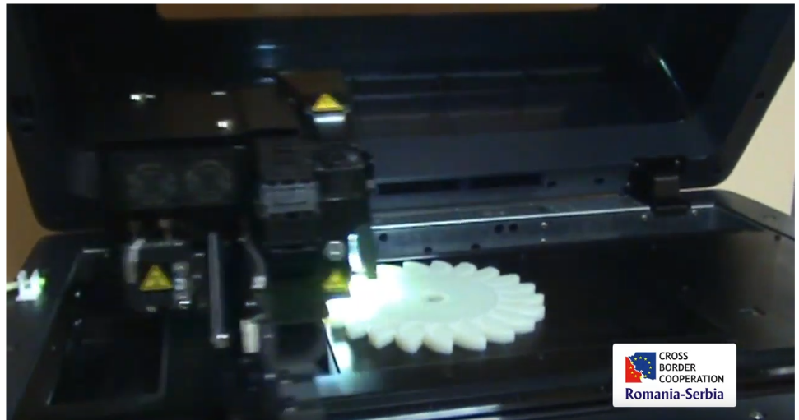
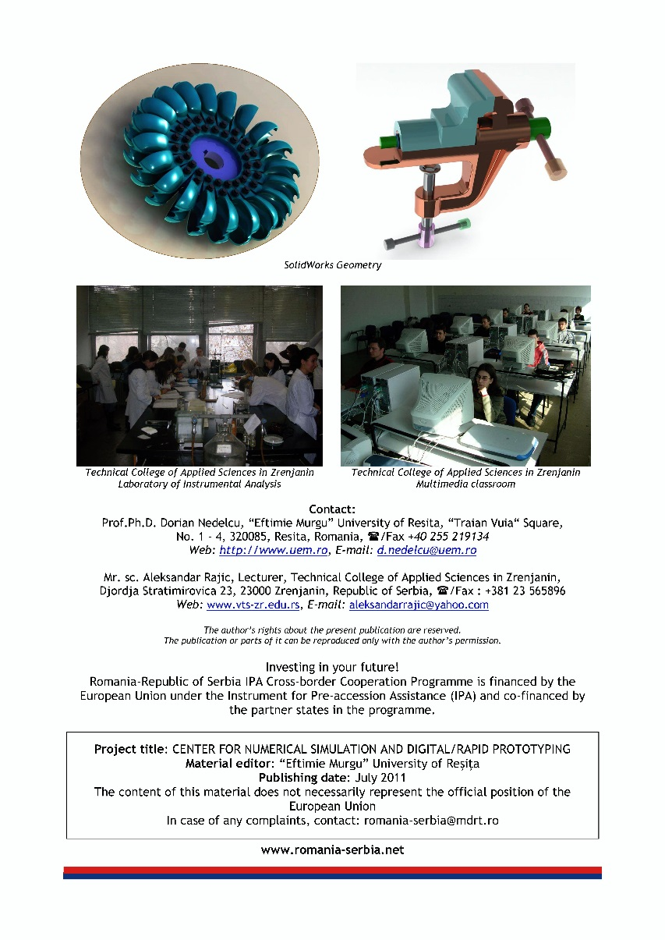
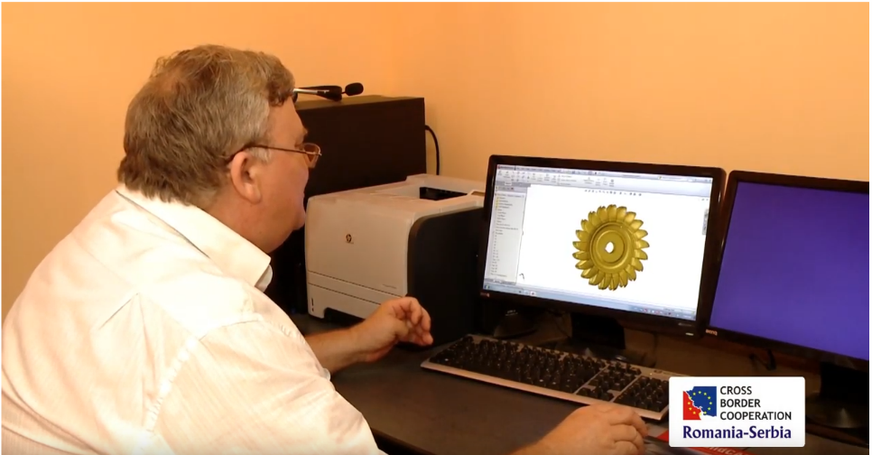

the implementation period (including extensions)
total funds spent/total funds contracted *100
indicators and level of achievement against targets set

