Project information
CALL FOR PROPOSALS | 1
MIS-ETC: | 438
PRIORITY AXIS: | 3 Promoting “people to people” exchanges
MEASURE: | 3.4 Enhance social and cultural integration of border areas
PROJECT TITLE: | Not so different
ACRONYM: | NSD
DURATION: | 03.12.2010-02.12.2011
IPA FUNDS CONTRACTED: | 59.415,00
TOTAL FUNDS CONTRACTED: | 69.900,00
ABSORBTION RATE (%): | 87,90
PROJECT OBJECTIVE(S): | The creation of the conditions that secure equal availability of a good quality education for the children and young who have been discriminated or segregated.  Enhancing social awareness and acceptance of the children with special needs  Creation of conditions for later inclusion of the children with special needs in regular school system
SHORT DESCRIPTION OF THE PROJECT: | The project created a Center for social inclusion of the children with special needs through which 140 children with special needs and 90 teachers benefited from a complete logistic support, trainings on inclusion of children with special needs into regular education groups, through three accredited seminars conducted by the Center. During the work on inclusion, the children with special needs finally felt accepted by other children. Their advanced abilities and skills in many ways contributed to their fitting into the surroundings, making them more secure and independent actors in real life situations.
DEGREE OF ACHIEVEMENT OF INDICATORS: | Indicator value provisioned in the contract Present indicator value % 6= (5)/(3)*100  Output indicators (1) UM (2) Quantity (3) UM (4) Quantity (5)  Joint projects for the social integration of people with disabilities or minorities  Awareness campaigns for promoting equal opportunities and social rights for social disadvantages groups/minorities  Stronger civil society of the border area  Increased integration of the border communities and improved local services in the border area  Result indicators  Increased social and cultural integration of people in the border areas Number of participants benefiting from cross-border social and cultural events 4 Number of participants benefiting from cross-border social and cultural events 4 100  Improved quality of life and increased attractiveness of the border communities as a living place Number of activities, actions, initiatives developing new or improving existing educational and social services, or improving other local living conditions 19 Number of activities, actions, initiatives developing new or improving existing educational and social services, or improving other local living conditions 32 168  Project indicators  Center opening and center equipment acquisition Number of opened Centers 1 Number of opened Centers 1 100  Enrolled children with special needs Number of enrolled children with special needs 140 Number of enrolled children with special needs 190 135  Development factor tests Number of completed tests 4x100 Number of completed tests 4x100 100  Entry surveys Number of parents (households) who took the surveys/ questionnaires 1100 Number of parents (households) who took the surveys/ questionnaires 1100 100  Exit surveys Number of parents (households) who took the surveys/ questionnaires 1100 Number of parents (households) who took the surveys/ questionnaires 1100 100  Educated teachers (entry and exit) Number of educated teachers 90x2 Number of educated teachers 90x2 100  Seminar survey Number of participants (teachers, parent) 90 teachers, 350 parents 52 parents (P2) Number of participants (teachers, parent) 90 teachers, 350 parents 52 parents (P2) 100  Information and publicity Number of press conferences; number of distributed material 5 press conferences and 21460 pieces of printed material Number of press conferences; number of distributed material 5 press conferences and 21460 pieces of printed material 100
RESULTS ACHIEVED: | The expert team worked with children with special needs (148), as well as with the other children present in regular groups, on a daily basis. The cooperation with the parents of children with special needs was more than satisfactory. The parents and the teachers of children with special needs constantly communicated with the expert team on all issues. The children showed great progress during work and their knowledge was upgraded. Their abilities were improved according to their needs.  A short video about the project is available at:  https://www.youtube.com/watch?v=9C3aUOELoYI

Partnership information
 |  | COUNTRY | COUNTY/DISTRICT | BUDGET(EURO) | CONTACT DETAILS
LEAD PARTNER: | Pre-school institute Zrenjanin | Serbia | Central Banat | 64.720,00 | Zrenjanin, Karadžićeva 3a  Tel. +38123510538
PARTNER 2: | Association Rainbow Moldova Noua | Romania | Caraş-Severin | 5.180,00 | Moldova Nouă, Pojejena no 237  Tel. 004 0763 652 955

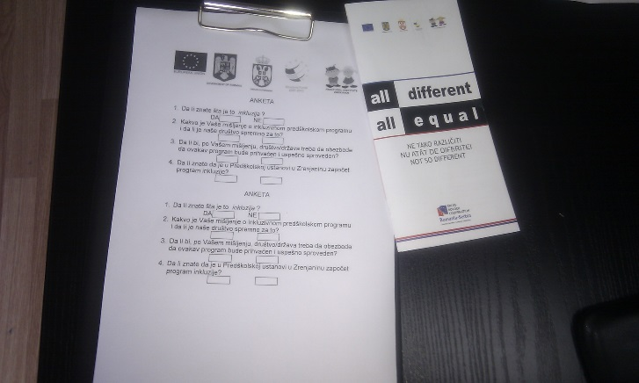
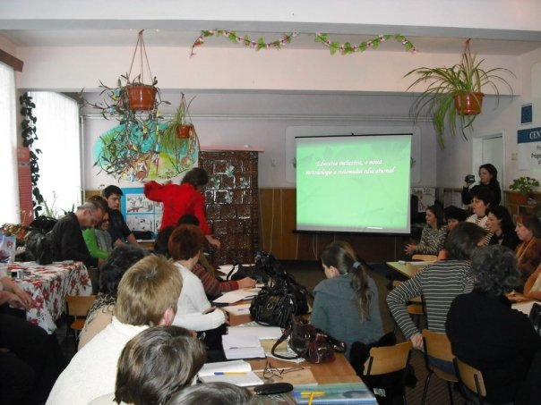
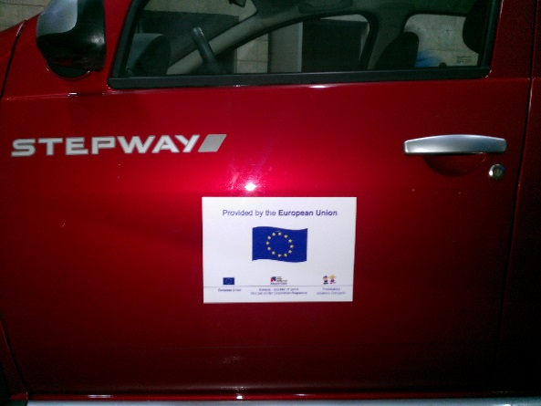

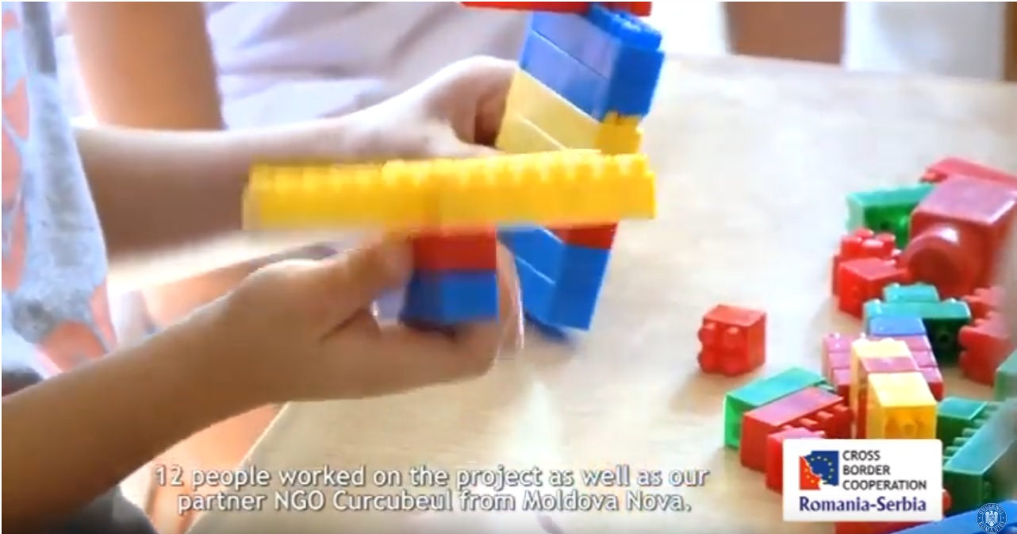

the implementation period (including extensions)
total funds spent/total funds contracted *100
indicators and level of achievement against targets set

