Project information
CALL FOR PROPOSALS | 1
MIS-ETC: | 428
PRIORITY AXIS: | 3. Promoting “people to people” exchanges
MEASURE: | 3.3 Increase educational, cultural and sporting exchange
PROJECT TITLE: | Cultural Heritage in Everyday Life in the Border Areas
ACRONYM: | Cultural heritage
DURATION: | 10.02.2011 – 09.02.2012
IPA FUNDS CONTRACTED: | 80.840,95 €
TOTAL FUNDS CONTRACTED: | 95.107,00 €
ABSORBTION RATE (%): | 79,75%
PROJECT OBJECTIVE(S): | - Promotion of cultural heritage in the context of EU integrations;  - Promotion and preservation of language and customs as cultural heritage in border region;  - Promoting the cross-border cooperation.

SHORT DESCRIPTION OF THE PROJECT: | The partnership was created in order to research the traditions of the national minorities in the cross-border region, respectively the Serbian minority in the Romanian counties of Timiş and Caraș-Severin and the Romanian minority in the Serbian South Banat district. These national minorities have a very specific language, different than the languages of the majority of the Serbian and Romanian population. These specific language dialects are a cultural heritage and the project helped to preserve them by making an Anthology of interesting stories, a Bilingual lexicon and a short-films archive. Beside the language, a group of students studied and analysed the terminology concerning food and cooking, houses, clothing, customs in the family and local community, education, music, religion, fun in spare time, communication between people, traveling and newspapers.
DEGREE OF ACHIEVEMENT OF INDICATORS: | Indicator Indicator value provisioned in the contract Present indicator value % 6= (5)(3)*100  Output indicators (1) UM (2) Quantity (3) UM (4) Quantity (5)  Increased people-to-people exchange in the fields of education, culture and sports Number of participants 1000 Number of participants 1000 100%  Result indicators  Increased social and cultural integration of people in the border areas Number of participants benefiting from cross border social and cultural events 150 students from both country Number of participants benefiting from cross border social and cultural events 150 100%  100 inhabitants of villages in border regions 100 100%  1000 people interested in project activities (students, teachers, parents, relatives, citizens, inhabitants, social institution and other entities) 1000 100%

RESULTS ACHIEVED: | - Formed students research groups (LP, P2, P3)  - The website was designed and published (LP)  - Finished research (LP, P2, P3)  - Workshops were held (LP, P2, P3)  - Bulletins was prepared and printed (LP)  - Lexicon was printed and DVD was finished (LP)  - Bilingual anthology of old stories was finished and printed (LP)  - The musical and linguistic processing of old Serbian and Romanian folk songs was completed (LP)  - Filming activities of short films and video-clips are finished (LP)  - The festival was organized and performed (LP, P2, P3)

Partnership information
 |  | COUNTRY | COUNTY/DISTRICT | BUDGET(EURO) | CONTACT DETAILS
LEAD PARTNER: | Grammar School ”Borislav Petrov Braca” | Serbia | South Banat | 67.569 | Vršac, 1 Mihajla Pupina Street  Tel. +381 13 836448
PARTNER 2: | College “Constantin Diaconovic Loga” | Romania | Timis | 19.184 | Timisoara, 37 B-dul C. D. Loga  Tel. 0256491873
PARTNER 3: | Theoretical Grammar School “Dositej Obradovic” | Romania | Timis | 8.354 | Timisoara, B-dul Dragalina 6  Tel. 0256491624

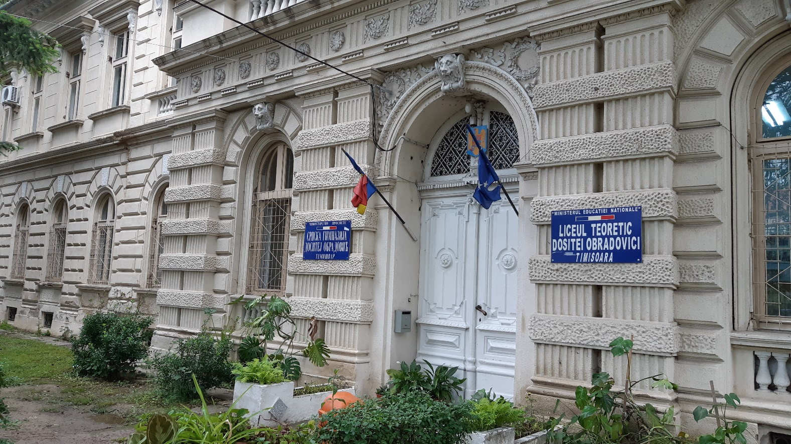
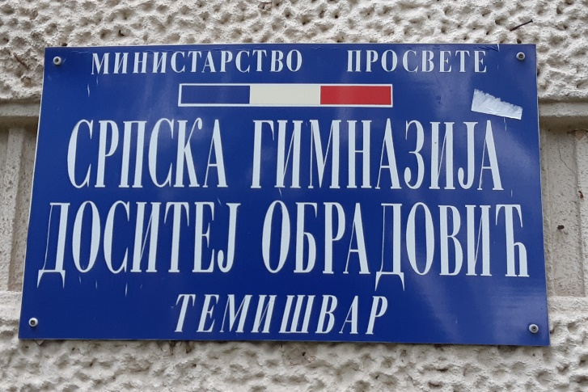
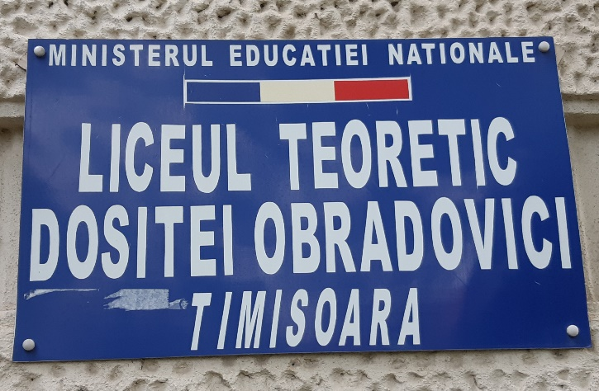

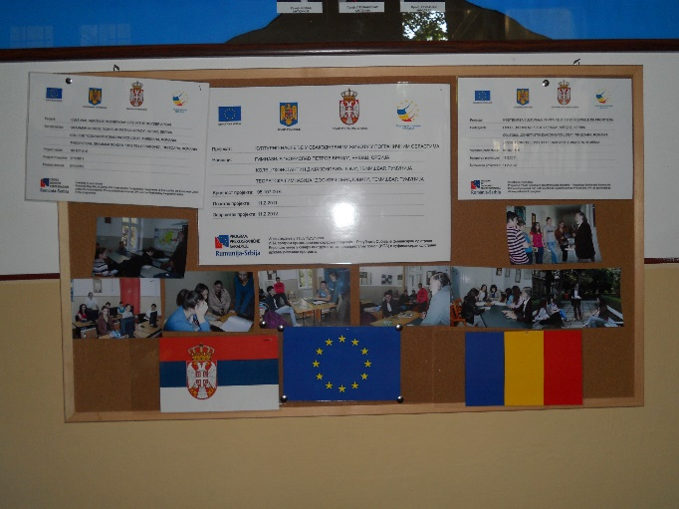
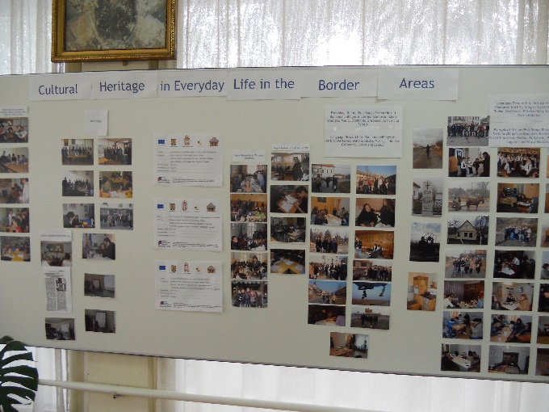

the implementation period (including extensions)
total funds spent/total funds contracted *100
indicators and level of achievement against targets set

